**Protein Isolation of**

**Ribulose-1,5-bisphosphate carboxylase oxygenase**

**Mini-Results**

**Christina Sok**

**March 28, 2022**

**BIOL 3810**

**Hypothesis**

Rubisco (Ribulose-1,5-bisphosphate carboxylase/oxygenase) is an abundant but inefficient protein involved in the Calvin Cycle, in the last step of glycolysis and should be able to be isolated by solubility, charge, and size through the combination of the four different protein isolation techniques: ammonium sulfate precipitation, ion-exchange chromatography, SDS-Page, and Western Blot.

**Results**

**Table 1. Absorbance Spectral Analysis Data**

The wavelength ranging from 200 to 400 (nm) and absorbance data for Rubisco protein samples were obtained via absorbance spectral analysis of ion exchange column chromatography fractions and ammonium sulfate precipitation. 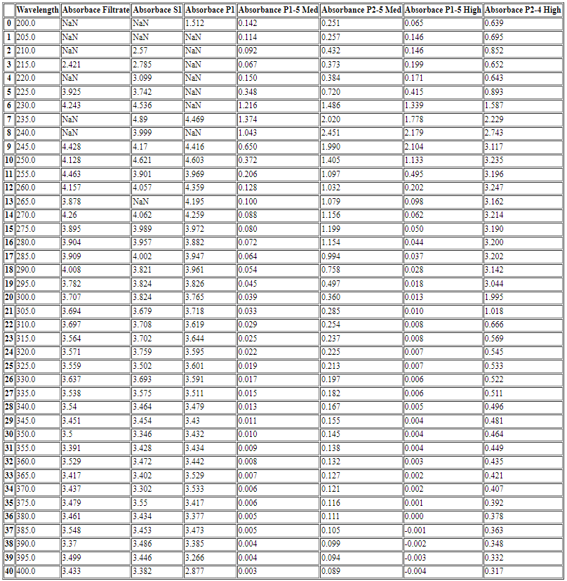

**Figure 1. Spectrum Analysis of Purified RuBisCo Protein**

Ion exchange column chromatography fractions of pellets (P1) and (P2) were subjected to low, medium, and high salt washes containing a mixture of Buffer A (10 mM Tris, pH 8.0, containing 3 mM EDTA) and varying concentration of NaCl (50 mM, 200 mM, and 500 mM respectively). Absorbance at 280 nm is a possible indicator of the presence of protein, Rubisco. The lack of a peak at 280 nm for P1 medium salt fraction and P1 high salt fraction might be an indication of absence of the protein in those fractions.

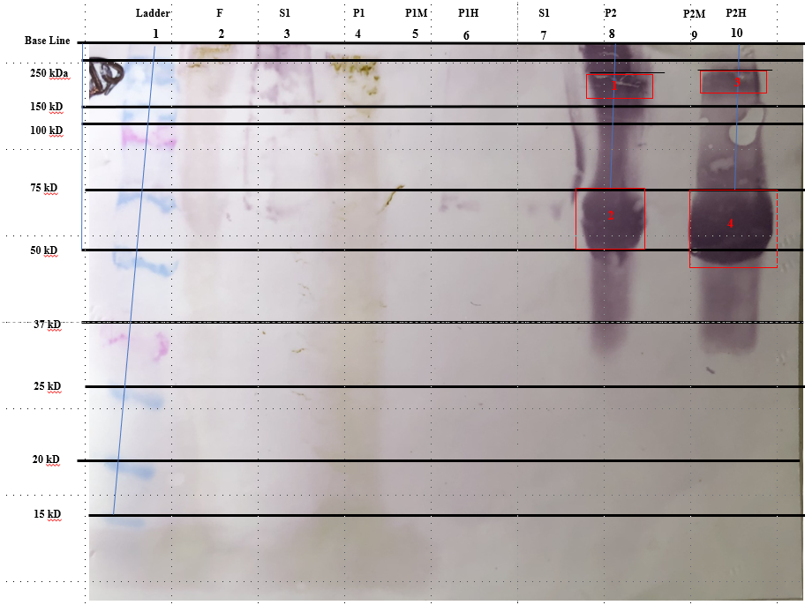

**Figure 2. Western Blot Membrane**

Only four bands are clearly visible on the Western Blot membrane. The first set of bands are located in well 8 containing sample (P2) with the top of the bands corresponding to the distance of 0.838 cm and 4.267 cm respectively. The second set of bands are located in well 10, containing sample (P2H), the high salt fraction of sample (P2). The distance of the (P2H) bands are 0.762 cm and 4.267 pm respectively. The filtrate (F), first supernatant (S1), first pellet (P1) samples should have had bands corresponding to Rubisco protein in the approximate range of 55 kDa, but the protein was likely degraded. The visible are also unlikely to be RuBisCo protein, as they did not travel to the 55 kDa in distance, corresponding to the size of the large subunit of RuBisCo and a possible indicator of its presence.

**Table 2. SDS-Page Analysis**

The migration distance (cm) of standard protein from molecular ladder as the y-axis values and the log10 of molecular weight (kDa) as the x-axis values obtained from SDS-Page analysis and used to generate a standard curve and equation used in calculation of the molecular weight of protein bands on western blot membrane.

|  |  |  |
| --- | --- | --- |
| **SDS-Page Analysis** | | |
| **Migration Distance (cm)** | **Molecular Weight (kDa)** | **Log of Molecular Weight (kDa)** |
| 0.635 | 250 | 2.397940009 |
| 1.8542 | 150 | 2.176091259 |
| 2.54 | 100 | 2 |
| 4.2418 | 75 | 1.875061263 |
| 5.9944 | 50 | 1.698970004 |
| 8.128 | 37 | 1.568201724 |
| 10.0076 | 25 | 1.397940009 |
| 12.2174 | 20 | 1.301029996 |
| 13.7668 | 15 | 1.176091259 |
| NaN | 10 | 1 |

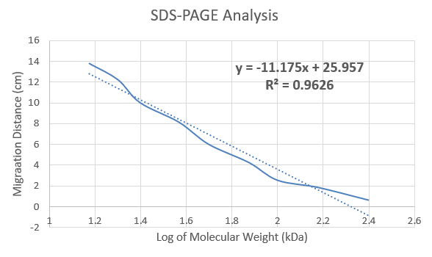

**Figure 3. Standard Curve**

The standard curve generated from the measurement of distance migrated (cm) for each protein standard in the molecular ladder and graphed against the log of the corresponding molecular weights (kDa) resulted in the standard curve equation of y = -11.175x + 25.957.

**Table 3. Tabular Data for Migration Distance (cm) and Molecular Size (kDa) Calculated**

A total of four protein bands were observed on the western blot membrane, measured for distance, and resulted in protein sizes of 194 kDa, 87 kDa, 178 kDa, 87 kDa which are unlikely to be protein, RuBisCo ~55 kDa.

|  |  |  |  |  |
| --- | --- | --- | --- | --- |
| **Calculated Molecular Weights for Observed Protein Bands** | | | | |
| **Band #** | **Well #** | **Sample/Fraction** | **Migration Distance (cm)** | **Calculated Molecular Weight (kDa)** |
| 1 | 8 | P2 | 0.3882 | 194 |
| 2 | 8 | P2 | 4.2672 | 87 |
| 3 | 10 | P2H | 0.762 | 178 |
| 4 | 10 | P2H | 4.2672 | 87 |

**Calculations**

|  |
| --- |
|  |

**Results Conclusion**

According the results of the absorbance spectrum analysis, protein, RuBisCo, is suspected to be contained within Filtrate, S1, P1, and P1M (Med Salt) samples, which are the fractions with peaks at 280 nm wavelength commonly associated with the large subunit of RuBisCo. However, western blot membrane results did not correspond to this finding. The wells associated with the aforementioned fractions were likely degraded.

**Discussion**

**Ammonium sulfate**

Crude RuBisCo protein sourced from 50 grams of de-ribbed spinach leaves were homogenized in 200 ml Buffer I (0.01 M K-PO4 buffer, pH 7.5, containing 0.3 mM EDTA, and 30 grams/L of polyvinylpolypyrrolidone). Homogenate were filtered through two layers of Miracloth, resulting in the filtrate (F) sample. Ammonium sulfate was used in an attempt to isolate protein RuBisCo from the filtrate solution via the difference in solubility. Ammonium sulfate manipulate the solubility of the filtrate solution, precipitating the proteins into a pellet (P1) after 37% concentration is added, stirred for 15 minutes, and centrifuged at 9000xg at 4°C for 15 minutes. In theory all of the proteins, including RuBisCo, should have precipitated into the pellet (P1), but some RuBisCo content was likely retained in the supernatant component (S1) as indicated by the absorbance peak at 280 nm in the absorbance spectrum analysis of the (S1) sample.

Pellet (P2) is obtained after the supernatant (S1) had the addition of 50% concentration ammonium sulfate, stirred for 15 minutes, and centrifuged at 9000xg at 4°C for 15 minutes. Ideally, the 50% concentration ammonium sulfates should have precipitated protein, RuBisCo, into pellet (P2) leaving the supernatant (S2) without that specific protein of interest. This is what likely occurred as the P2-Medium Salt fraction (P2M) and P2-High Salt fraction (P2H) have peaks at 280 nm in their respective absorbance spectrum analysis, which corresponds to the large subunit of RuBisCo. The western blot membrane for P2 and P2H fractions also show protein bands, however they was not a band corresponding to the 55 kDa molecular weight, which acts as indicator for RuBisCo.

**Ion-Exchange Chromatography**

Ion-exchange chromatography was conducted in an attempt to farther separate the proteins content via their net negative charge. The eluted fractions are collected and highest protein contents at 280 nm for each low, medium, and high salt fraction were retained. After which, those fractions were used in absorbance spectra analysis to evaluate for the presence of RuBisCo. Proteins with higher affinities for the positively charged Q-Sepharose ion-exchange column would require higher concentration of salt to be eluted. Protein RuBisCo is most likely to be eluted only after the addition of high concentrations of salt wash. Experimentally, most of the fractions would contain some traces of protein RuBisCo but not in as high concentrations as the samples that should theoretically have the affirmation protein due to solubility (P2) and net-negative charge (High Salt). As confirmation, the absorbance spectrum analysis has a higher peak absorbance at 280nm for P2 and P2H than for P2M. Protein bands were also visible on the P2 and P2H lanes while absent from the P2M lane. This might be a sufficient indicator that medium salt wash has a lower concentration than required to elute certain proteins, perhaps even, RuBisCo.

**Protein Electrophoresis**

The addition of Sodium Dodecyl Sulfate polyacrylamide gel electrophoresis (SDS-Page) adjusts all the protein charges to a net negative making it possible to sperate the various proteins by size (only). 30μL of each of the protein samples were loaded in the order of ladder, Filtrate, S1, P1, P1M (med salt), P1H (high salt), S2, P2, P2M (med salt), P2H (high salt). Gel electrophoresis should have been conducted at 120 volts for 30-50 minutes, however the voltage was adjusted higher to 140-150 volts due to time constraints. Protein in wells containing Filtrate (F), P1, and S1 that should have contained RuBisCo at approximately 55 kDa were degraded as indicated from the gel visualized on the western blot membrane.

**Western Blot &**

Protein gel from protein electrophoresis were transferred to the assembly transfer stack with the orientation of cathode (-), filter paper, gel, membrane, filter paper, and anode (+), then ran against transfer buffer at 100 volts for 1 hour, then stored at 4°C overnight. The proteins were transferred from the gel to a nitrocellulose membrane, placed in Cassin blocking buffer. The membrane was submerged in 15 ml of 1X Tris Buffered Saline with Tween (TBST) for 3 minutes on a rotator table and washed repeatedly. An addition of 5 mL of the primary antibody were added to the membrane, which was subsequently placed on the rotator to incubate at room temperature for 1 hour. The primary antibody was discarded after the 1-hour period. The membrane was resubmerged in 15 mL wash buffer, repeating the previous process. After the disposal of wash buffer, an addition of 5 mL of secondary antibody was made to the membrane and once again left to incubate for a 1-hour period. The secondary antibody was discarded after 1 hour. The membrane was then resubmerged in wash buffer repeatedly, for the last time. Finally, 10mL of the 5-bromo04-chloro-3-indolyl phosphate/nitro blue tetrazolium chloride (BCIP/NBT) chromogenic substrate solution was added on top of the membrane to aid the alkaline phosphates, which are the targets of the secondary antibodies. Western blot utilizes protein primary antibodies to specifically target RuBisCo and secondary antibodies to target the enzyme alkaline phosphatase which should have aided in the visualization of RuBisCo. Once BCIP/NBT waste discarded, the membrane was left to towel dry. The western blot membranes were then obtained and observed for the formation of protein bands. The molecular ladder size (molecular weight) and migration distance were graphed to generate a standard curve. The equation was used to calculate the molecular weight of the four protein bands corresponding to P2 and P2H samples in wells 8 and 10. The migration distance of each of the four protein bands were measured. There was not a band formation at the 55 kDa region where RuBisCo should have been.