**Hypothesis**

**Table 1. Absorbance Spectral Analysis Data**

The wavelength ranging from 200 to 400 (nm) and absorbance data for Rubisco protein samples were obtained via absorbance spectral analysis of ion exchange column chromatography fractions and ammonium sulfate precipitation.

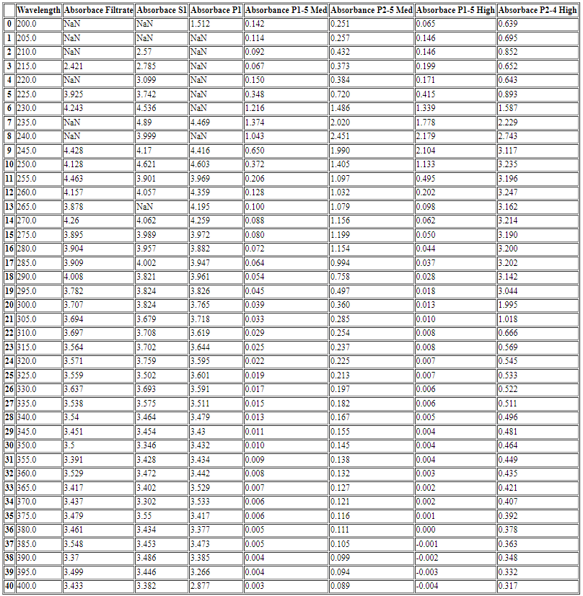

**Figure 1. Spectrum Analysis of Purified RuBisCo Protein**

Ion exchange column chromatography fractions of pellets (P1) and (P2) were subjected to low, medium, and high salt washes containing a mixture of Buffer A (10 mM Tris, pH 8.0, containing 3 mM EDTA) and varying concentration of NaCl (50 mM, 200 mM, and 500 mM respectively). Absorbance at 280 nm is a possible indicator of the presence of protein, Rubisco. The lack of a peak at 280 nm for P1 medium salt fraction and P1 high salt fraction might be an indication of absence of the protein in those fractions.