The SDPA Agent Framework

The agent framework stays on top of the SDPA architecture as an intermediate control layer between the user and the GPI infrastructure. Technically, the agents are implementing an event driven architecture. The main features of the SDPA agents are:
- fault-tolerance
- recoverability
- flexibility and easy (re-)configurability (arbitrary topologies)
- automatic scheduling
- scheduling with constraints
- load balancing

The main components of an agent are:
- the agent statechart (the event processor)
- the job manager
- the scheduler (which contains an worker manager)
- the backup service

The agents can be combined into simple or complex topologies that are considered to be appropriate for solving different types of parallel and distributed problems.

The agent as an event-driven architecture

An agent implements an event-driven architecture. An agent may contain several thread pools, together with some shared event queues. The events are asynchronously produced and consumed. The messages a are sent/received via the wire, using the TCP protocol, and then decoded and forwarded to the daemon stage. The latter one dispatches the events the appropriate state machine which may eventually react performing a transition and executing eventually some action. The message handling is done using the double dispatch pattern .

The agent works with a class hierarchy of events that is rooted into the SDPAEvent. The events are categorized into job events or management events (depending whether they are derived from JobEvent or ManagementEvent). The job events are handled by the job statecharts, while the management events are handled by the daemon statechart.

JobEvents:

CancelJobEvent,
CancelJobAckEvent,
DeleteJobEvent,
DeleteJobAckEvent,
JobFailedAckEvent,
JobFailedEvent,
JobFinishedEvent,
JobFinishedAckEvent,
JobResultsReplyEvent,
JobStatusReplyEvent,
QueryJobStatusEvent,
RetrieveJobResultsEvent,
RunJobEvent,
SubmitJobAckEvent,
SubmitJobEvent

ManagementEvents:

StartUpEvent,
CapabilitiesGainedEvent,
CapabilitiesLostEvent,
ConfigNokEvent,
ConfigOkEvent,
ConfigReplyEvent,
ConfigRequestEvent,
ErrorEvent,
InterruptEvent,
LifeSignEvent,
RequestJobEvent,
SubscribeEvent,
SubscribeAckEvent,
WorkerRegistrationAckEvent,
WorkerRegistrationEvent,

Inter-Agent communication

The inter-agent communication is realized via TCP sockets using the boost asio library. A peer-to-peer communication model was adopted, rather than the classical client server model ( a peer plays both roles in the same time). A key role within this architecture is played by the key value store daemon (kvs), which stores informations about the peers. This may represent a single point of failure, that's whey it should be deployed in a redundant way, with a heart-bit connection.

The agent statechart

The agent statechart consists in three states: Down, Configuring, Up. The transitions between these states are as depicted in the figure below.

The implementation was carried-out using the boost meta state machine library. The implementation can be found in the following files.:
sdpa/daemon/daemonFSM/BMSM/DaemonFSM.hpp and
sdpa/daemon/daemonFSM/BMSM/DaemonFSM.hpp, respectively.

The agent statechart inherits from msm::back::state_machine<>, and from GenericDaemon, which in turn derives from GenericDaemonActions, IComm interface and EventHandler.
The daemon event handler may forward the event to the daemon state machine which triggers the appropriate transition.

struct transition_table : mpl::vector<
// Start Event Next Action Guard
//--------------------------------------------------------------------------------------------------------------------------------------------------------------------
a_row< Down, sdpa::events::StartUpEvent, Configuring, &agentFSM::action_configure>,
_irow< Down, sdpa::events::ErrorEvent >,
//--------------------------------------------------------------------------------------------------------------------------------------------------------------------
a_row< Configuring, sdpa::events::ConfigOkEvent, Up, &agentFSM::action_config_ok>,
a_row< Configuring, sdpa::events::ConfigNokEvent, Down, &agentFSM::action_config_nok >,
_irow< Configuring, sdpa::events::ErrorEvent >,
//--------------------------------------------------------------------------------------------------------------------------------------------------------------------
a_row< Up, sdpa::events::InterruptEvent, Down, &agentFSM::action_interrupt >,
a_irow< Up, sdpa::events::WorkerRegistrationEvent, &agentFSM::action_register_worker>,
a_irow< Up, sdpa::events::DeleteJobEvent, &agentFSM::action_delete_job>,
a_irow< Up, sdpa::events::SubmitJobEvent, &agentFSM::action_submit_job>,
a_irow< Up, sdpa::events::RequestJobEvent, &agentFSM::action_request_job>,
a_irow< Up, sdpa::events::ConfigRequestEvent, &agentFSM::action_config_request>,
a_irow< Up, sdpa::events::ErrorEvent, &agentFSM::action_error_event>
//--------------------------------------------------------------------------------------------------------------------------------------------------------------------
>{};

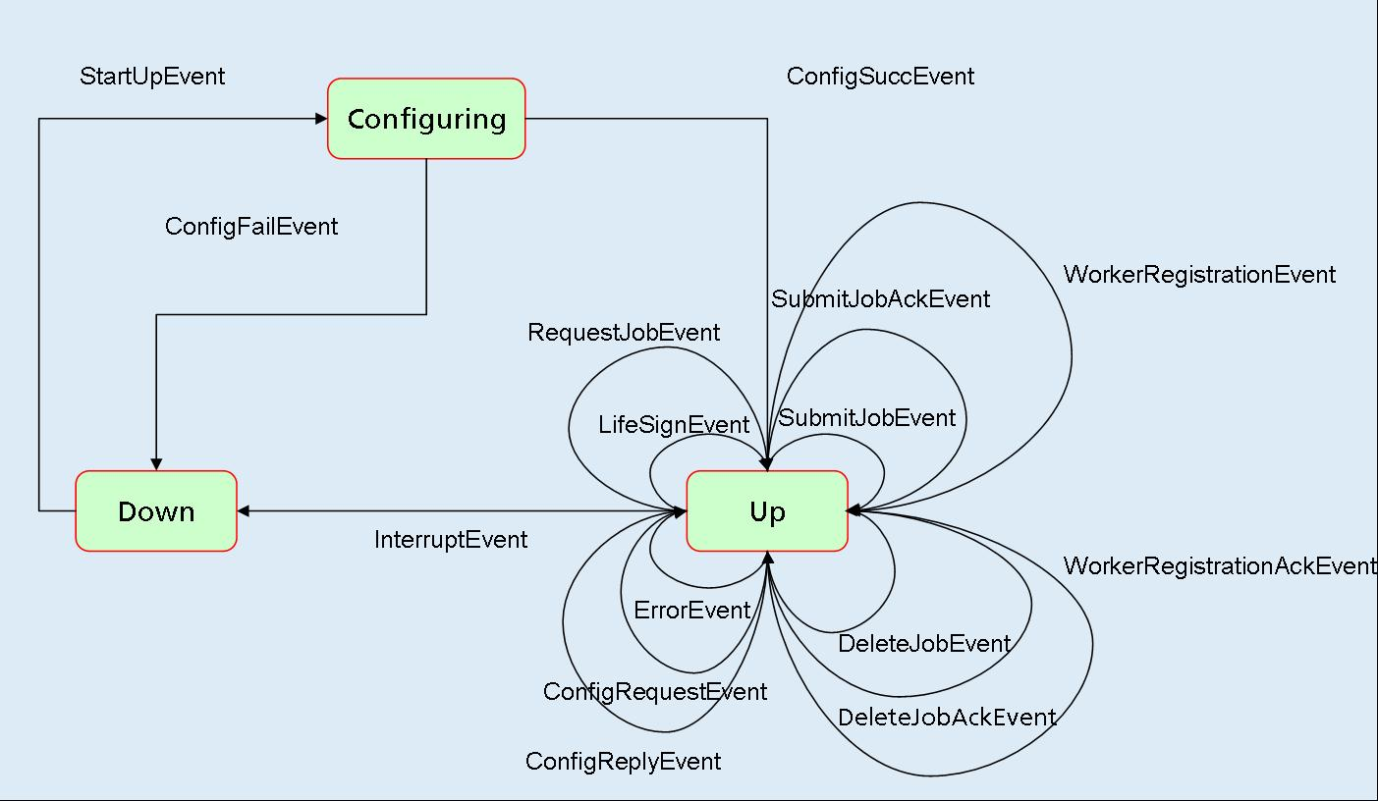

The agent's methods

Public methods

Agent identification and properties

An agent is generally identified by a name and an unique id. An agent may have a rank, an url location
and can receive external jobs up to a certain capacity (maximum number of jobs). The prototype of the corresponding methods are as specified below:

const std::string& name();
const unsigned int& rank() const;
unsigned int& rank();
virtual const std::string url() const;
const unsigned int& capacity() const;
unsigned int& capacity();
const sdpa::worker_id_t& agent_uuid();

Starting an agent

Once it was created (by a factory, eventually), an agent can be started with different parameters. The first parameter specifies whether the agent is to be spawned in request mode (true) or in push mode (false). The other two parameters specify the name of the agent's backup file and the name of the agent's configuration file, respectively.

void start_agent( bool bUseReqModel, const bfs::path& bkpFile, const std::string& cfgFile = "" );
void start_agent( bool bUseReqModel, std::string& strBackup, const std::string& cfgFile = "" );
void start_agent( bool bUseReqModel = true, const std::string& cfgFile = "" ); // no recovery

Shutdowning an agent
An agent can be shutdown by invoking the public method shutdown, with either one parameter, which is the name of the backup file, or without parameters, when no backup of the agent is necessary.

void shutdown(std::string&); // no backup
void shutdown( const bfs::path& backup_path );
void shutdown();

Stopping an agent

The public method stop can be invoked for stopping all the running services started by the agent (scheduler, backup, network, etc.).

void stop();

Adding and removing masters

One or several masters can be dynamically specified for an agent by invoking the public methods addMaster or addMasters ,with either a parameter of type string or a list of strings.

void addMaster(const agent_id_t& );
void addMasters(const agent_id_list_t& );

Similarly, one or several masters can be dynamically removed by invoking the public methods removeMaster or removeMasters.

void removeMaster(const agent_id_t& );
void removeMasters(const agent_id_list_t& );

Interface exposed to the workflow engine

An workflow engine interacts usually with an agent via a restricted set of interface methods with the signature described below.

An workflow engine may submit (encoded) jobs to an agent by specifying a job id, an encoded job description and a list of requirements, which may eventually be empty, if the job has no requirements.
For this purpose an agent provides the callback method below.

virtual void submit(const id_type&, const encoded_type&, const requirement_list_t&=empty_req_list());

An workflow engine may cancel an already submitted job or activity by specifying the job id and a reason for the cancellation. The prototype of the corresponding method is that specified below:

virtual bool cancel(const id_type& id, const reason_type& reason);

An agent can be notified upon the successful execution of a job via the method finished described below, which takes as parameters the id of the job (activity) and the result of its execution.

virtual bool finished(const id_type& id, const result_type& result);

An agent can be notified upon the failure of a job via the failed callback method, which takes as parameters the id of the job (activity) and the result of its execution.

virtual bool failed(const id_type& id, const result_type& result);

An agent can be notified upon the successful cancellation of a job using the method cancelled, which takes as parameters the id of the job.
virtual bool cancelled(const id_type& id);

Capabilities

One can add new capabilities to an agent by calling the public method addCapability with the unique parameter an existing capability.

void addCapability(const capability_t& cpb);

The capabilities of an agent can be obtained using the following method:

void getCapabilities(sdpa::capabilities_set_t& cpbset);

Protected methods

Stages

Method for assigning to the daemon stage an external stage.

void setStage(const seda::Stage::Ptr& stage);

The following methods give return shared pointers to the master and the slave stages.
virtual seda::Stage::Ptr to_master_stage() const;
virtual seda::Stage::Ptr to_slave_stage() const;

Masters and subscribers

This method returns the list of objects containeing information about the masters.

sdpa::master_info_list_t& getListMasterInfo();

Method for notifying the masters about the occurrence of an event of type T:

template <typename T>
void notifyMasters(const T&);

The agent indicated in the first parameter subscribes for a list of jobs described in the second parameter.

void subscribe(const sdpa::agent_id_t&, const sdpa::job_id_list_t&);

Unsubscribe the agent indicated as parameter.

void unsubscribe(const sdpa::agent_id_t&);

Test if the agent given as parameter is a subscriber (if yes, return true).

bool isSubscriber(const sdpa::agent_id_t&);

Test if the agent indicated as first parameter subscribed for the job indicated in the second parameter.

bool subscribedFor(const sdpa::agent_id_t&, const sdpa::job_id_t&);

Configuration

This method returns the currently used configuration.

sdpa::util::Config& cfg();

Sets the default configuration

void setDefaultConfiguration();

Configure the network

virtual void configure_network( const std::string& daemonUrl );

Shutdown the network

virtual void shutdown_network();

Agent information and properties

Check if the calling agent is root of some topology.

virtual bool isTop();

Check if the agent is started

bool isStarted();

Mark the agent as started or not started. When the parameter is missing or is explicitly set on true, set it as started, otherwise set it as not started.

void setStarted(bool bVal = true);

This method tests if the calling agent is configured.

bool isConfigured();

If the parameter is true mark the agent as configured otherwise mark it as not configured.

void setConfigured(bool bVal = true);

This method tests if the calling agent is stopped.

bool isStopped();

If the parameter is true mark the agent as stopped otherwise mark it as not stopped..

void setStopped(bool bVal = true);

This method tests if the slaves are allowed to post requests.

bool reuestsAllowed();

This method marks the flag for allowing requests to true or false, according to the passed parameter.

void setRequestsAllowed(bool bVal = true);

This method updates the time when the last request was posted to the calling agent.

virtual void updateLastRequestTime();

This method return the current state of the calling agent (i.e. Down, Configuring or Up).

virtual sdpa::status_t getCurrentState() ;

This method tests if the calling agent is proprietary of the capability passed as parameter.

bool isOwnCapability(const sdpa::capability_t&);

This method prints information about the job manager and the scheduler.

virtual void print();

Event handling

These methods are used for forwarding an event to one of the stages: daemon, master or slave.

virtual void sendEventToSelf(const sdpa::events::SDPAEvent::Ptr& e);
virtual void sendEventToMaster(const sdpa::events::SDPAEvent::Ptr& e);
virtual void sendEventToSlave(const sdpa::events::SDPAEvent::Ptr& e);

This is the overridden Strategy method implemented by the agents.

virtual void perform(const seda::IEvent::Ptr&);

These are callback methods to be invoked by the events when they are handled.

virtual void handleWorkerRegistrationAckEvent(const sdpa::events::WorkerRegistrationAckEvent*);
virtual void handleConfigReplyEvent(const sdpa::events::ConfigReplyEvent*);
virtual void handleSubmitJobAckEvent(const sdpa::events::SubmitJobAckEvent* );
virtual void handleCancelJobEvent(const sdpa::events::CancelJobEvent*);
virtual void handleCancelJobAckEvent(const sdpa::events::CancelJobAckEvent* );
virtual void handleJobFinishedEvent(const sdpa::events::JobFinishedEvent* );
virtual void handleJobFailedEvent(const sdpa::events::JobFailedEvent* );
virtual void handleJobFinishedAckEvent(const sdpa::events::JobFinishedAckEvent* );
virtual void handleJobFailedAckEvent(const sdpa::events::JobFailedAckEvent* );
virtual void handleQueryJobStatusEvent(const sdpa::events::QueryJobStatusEvent* );
virtual void handleRetrieveJobResultsEvent(const sdpa::events::RetrieveJobResultsEvent* );
virtual void handleCapabilitiesGainedEvent(const sdpa::events::CapabilitiesGainedEvent*);
virtual void handleCapabilitiesLostEvent(const sdpa::events::CapabilitiesLostEvent*);
virtual void handleSubscribeEvent( const sdpa::events::SubscribeEvent* pEvt );

Agent statechart (actions)

This method starts the agent meta state machine.

void start_fsm();

The following methods represent actions to be executed by the agent state machine.

virtual void action_configure( const sdpa::events::StartUpEvent& );
virtual void action_config_ok( const sdpa::events::ConfigOkEvent& );
virtual void action_config_nok( const sdpa::events::ConfigNokEvent& );
virtual void action_interrupt( const sdpa::events::InterruptEvent& );
virtual void action_delete_job( const sdpa::events::DeleteJobEvent& );
virtual void action_request_job( const sdpa::events::RequestJobEvent& );
virtual void action_submit_job( const sdpa::events::SubmitJobEvent& );
virtual void action_config_request( const sdpa::events::ConfigRequestEvent& );
virtual void action_register_worker(const sdpa::events::WorkerRegistrationEvent& );
virtual void action_error_event(const sdpa::events::ErrorEvent& );

Jobs

This method requires the calling agent to schedule the job passed as parameter.

virtual void schedule(const sdpa::job_id_t& job);

This method checks if the job with specified id is already scheduled.

virtual bool isScheduled(const sdpa::job_id_t& job_id);

This method retrieves the list of requirements imposed for the job with specified id.

const requirement_list_t getJobRequirements(const sdpa::job_id_t&) const;

Get a pointer to agent's job manager.

JobManager::ptr_t jobManager() const;

Get the pointer to the object of type Job having the id specified as parameter.

Job::ptr_t& findJob(const sdpa::job_id_t& job_id ) const;

Delete the job object corresponding to the id passed as parameter.

void deleteJob(const sdpa::job_id_t& );

Generate an unique id.

std::string gen_id() { return sdpa::events::id_generator::instance().next(); }

Registration

Post a registration request to all masters.

virtual void requestRegistration();

Post a registration request to the master that corresponds to the information object passed as parameter.

virtual void requestRegistration(const MasterInfo&);

The calling agent registers the worker that produces the event given as parameter.

virtual void registerWorker(const sdpa::events::WorkerRegistrationEvent&);

Workflow engine

Create an workflow engine of the type indicated by the template parameter.

template <typename T> T* createWorkflowEngine();

Return a pointer to the workflow engine usd by the agent

virtual IWorkflowEngine* workflowEngine() const;

Test if the calling agent uses any workfow engine or not.

virtual bool hasWorkflowEngine();

Submit to the workflow engine an workflow with the id and the description passed as parameters.

virtual void submitWorkflow(const id_type&, const encoded_type&);

Tell the workflow engine to cancel the workflow with the given id. The second parameter should be use for indicating the reason.

virtual void cancelWorkflow(const id_type&, const std::string&);

Workers

Tell the agent that the job specified be the second parameter and which was assigned to the worker specified by the first parameter has successfully finished. The result is given in the third parameter.

virtual void activityFinished(const Worker::worker_id_t&, const job_id_t& id, const result_type&);

Tell the agent that the job specified be the second parameter and which was assigned to the worker specified by the first parameter has failed. The result is given in the third parameter.

virtual void activityFailed(const Worker::worker_id_t&, const job_id_t&, const result_type&) ;

Tell the agent that the job specified be the second parameter and which was assigned to the worker specified by the first parameter was cancelled and the reason is given in the third parameter.

virtual void activityCancelled(const Worker::worker_id_t&, const job_id_t&);

The method returns the id of the worker with the rank given as parameter.

virtual Worker::worker_id_t getWorkerId(unsigned int rank);

Find the id of the worker that was assigned the job with the id passed as parameter.

virtual const Worker::worker_id_t& findWorker(const sdpa::job_id_t&) const;

Find the worker object that corresponds to the id passed as parameter.

const Worker::ptr_t& findWorker(const Worker::worker_id_t& worker_id) const;

Retrieve into the second parameter the capabilities of the worker given as first parameter.

void getWorkerCapabilities(const Worker::worker_id_t&, sdpa::capabilities_set_t&);

Serve a job to the worker with the id specified by the first parameter. Tel the agent that the slave was served last time the job with the id specified by the second parameter.

virtual void serve_job(const Worker::worker_id_t&, const job_id_t& last_job_id);

Request a job from the master corresponding to the info object passed as parameter.

virtual void requestJob(const MasterInfo&);

Add a new worker with the id, the capacity, the capacities set, the rank and the unique id passed as parameters.

virtual void addWorker( const Worker::worker_id_t& workerId,
unsigned int cap,
const capabilities_set_t& cpbset,
unsigned int& rank = 0,
sdpa::worker_id_t& agent_uuid = "");

Notify the workers about the occurrence of an event of type specified by the template and passed as parameter.
template <typename T> void notifyWorkers(const T&);

Scheduler

Create a scheduler object and return back a pointer to it. The parameter indicates whether to use the request model (true) or the push model (false);

virtual Scheduler* createScheduler(bool bUseReqModel);

Return a shared pointer to the agent's scheduler object.

Scheduler::ptr_t scheduler() const;

Agent backup

Serialize the agent

template <class Archive>
void serialize(Archive& ar, const unsigned int)

Backup the job manager into the text archive passed as parameter.

void backupJobManager(boost::archive::text_oarchive& oa);

Restore the job manager from the text archive passed as parameter.

void recoverJobManager(boost::archive::text_iarchive& ia);

Backup the scheduler into the text archive passed as parameter.

void backupScheduler(boost::archive::text_oarchive& oa);

Restore the scheduler from the text archive passed as parameter.

void recoverScheduler(boost::archive::text_iarchive& ia);

Observer methods
Callback methods used by the workflow engine

template <typename T>
static void observe_submitted (const T*, typename T::internal_id_type const& );

template <typename T>
static void observe_finished (const T*, typename T::internal_id_type const&, std::string const&);

template <typename T>
static void observe_failed (const T*, typename T::internal_id_type const&, std::string const&);

template <typename T>
static void observe_cancelled (const T*, typename T::internal_id_type const&, std::string const&);

template <typename T>
static void observe_executing (const T*, typename T::internal_id_type const&);

Agent – Workflow engine interaction

The agents and the workflow engine are loosely coupled. The agents interact with the workflow engine through a number of methods grouped into one interface. In a productive environment, a proprietary Petri Net based workflow engine is used. For testing purposes, one may use simple test workflow engines, also. In principle, the agents can be (loosely) coupled with any type of workflow engine.
The workflow engine exposes to the agents the following interface methods:

// an agent can submit an encoded job, with a specified id
void submit(const id_type & id, const encoded_type & )

// an agent can cancel a job with a given id
bool cancel(const id_type & id, const reason_type & reason)

// an agent can notify the workflow engine about that a job finished
bool finished(const id_type & id, const result_type & result)

// an agent can notify the workflow engine about that a job failed
bool failed(const id_type & id, const result_type & result)

// an agent can notify the workflow engine about that a job was cancelled
bool cancelled(const id_type & id)

// an workflow engine can deliver upon request suppplementary information
// about a specific activity
bool fill_in_info (const id_type & id, activity_information_t & info)

An agent exposes to the workflow engine similar methods:

// the agent submits encoded jobs with a either an assigned or empty id
// together with a list of reuired capabilities
void submit(const id_type & id, const encoded_type &, const requirement_list_t&)

// the workflow engine can cancel a job with a given id
bool cancel(const id_type & id, const reason_type & reason)

// an agent can notify the workflow engine about that a job finished
bool finished(const id_type & id, const result_type & result)

/ an agent can notify the workflow engine about that a job failed
bool failed(const id_type & id, const result_type & result)

// an agent can notify the workflow engine about that a job was cancelled
bool cancelled(const id_type & id)

The agent implements methods which explicitly call the callback methods implemented by the workflow engine (submitWorkflow, cancelWorkflow, activityFinished, activityFailed and activityCancelled).

The job manager

The job manager maintains a unique pool of jobs. The jobs can be produced upon the arrival of a external job submission event or upon calling the agent's callback method submit by the workflow engine. The jobs are uniquely identified and they are allocated memory only once. No copies are used and the jobs are referred within the other components via their unique id.

Which are the main characteristics of the job manager?

The job statechart

The life cycle of a job starts once with the reception by the agent of a submit job event. Then, the agent instructs the job manager to allocate memory for the corresponding job and to start the associated state machine. The life cycle ends once with the result delivery to the component who submitted the job or upon explicit deletion request of the submitter. For this purpose, several types of state machines were used, like the state machine compiler, the boost statechart or the boost meta state machine library. Finally, for maintainability reasons, only the last one was retained and is currently used. The implementation of the job state machine can be found in sdpa/daemon/jobFSM/BMSM/JobFSM.hpp.

A job can find itself any time in exactly one of the following states: Pending, Running, Finished, Failed, Cancelling or Cancelled.. The reception of a DispatchJobEvent forces a job state machine to pass into the state running. From this state a job can transit either to the state Finished, Failed or Cancelling depending on the event occurred, as depicted on the corresponding transitions depicted below. In a terminal state the state machine can be asked to deliver the results or the reason.

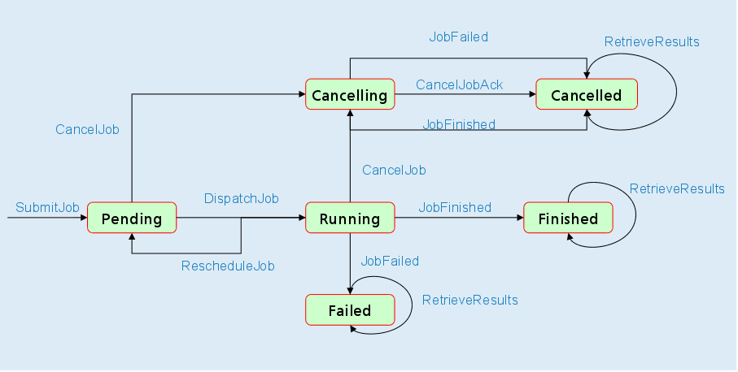
Requirements and capabilities.

The jobs can be submitted not only with a encoded description that can be interpreted by the workflow engine but also with a list of requirements. The requirements can be mandatory or optional. Non fulfillment of a mandatory requirement results immediately into a job failure. Correspondingly, the workers must have “capabilities”, that are to be matched against the job requirements during the scheduling process. The capabilities are assigned unique ids. The workers register initially with a set of capabilities that represent its own capabilities plus those of a subset of its slaves. At runtime, the set of capabilities of each worker is dynamically updated (capabilities are added or deleted) and each time the distance to the slave that owns effectively recalculated (which corresponds to calculating a minimum spanning tree rooted by the agent).

The scheduler

The scheduler tries to match the job requirements with the workers' capabilities. The requirements can be optional or mandatory. If at least one mandatory requirement is not fulfilled, i.e. there is no worker with the corresponding capability, the job is declared failed. Otherwise, the job is assigned to one of the “best matching workers”, i.e. a worker that satisfies all the mandatory requirements and most of the optional requirements.
The scheduler contains a worker manager which is in charge with maintaining a pool of workers that have registered to the agent. The worker manager contains also a common queue, for the jobs that have no requirements. Every worker contain three queues: pending, submitted, acknowledged, each with the ids of the jobs that were assigned or sent to that worker or respectively, acknowledged by that worker.

The Backup service

The agent can be started with a backup service, in which case a periodical backup into a file or a string stream of the main components of the agent is performed (mainly information about the jobs and the workers). The agent can be started with a backup file name as parameter. In this case, the agent tries to recover the backed up information. This is useful in the case of failure of an agent, especially when it was assigned long jobs or many jobs. The backup service runs as a separate thread

Topologies

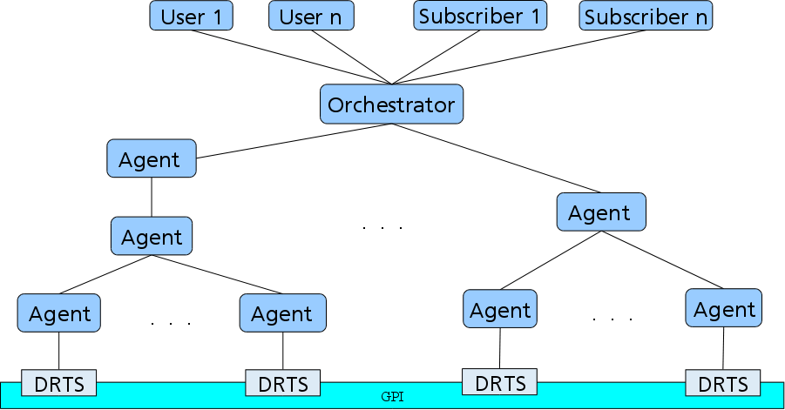
An SDPA agent can have a unbounded number of masters, subscribers or slaves. This makes possible
to create all kind of simple or complex agent topologies, like path, tree or mesh, torus, etc, respectively. Along with SDPA, the most commonly used topologies are of type a path or a tree. The use of a more complex topology of type Torus was illustrated by implementing the Cannon's algorithm for matrix multiplication in parallel (on a Torus).

