<https://developer.dji.com/api-reference/android-api/Components/FlightController/DJIFlightController.html#djiflightcontroller_setonimustatechangedcallback_inline>

通过FlightController获取状态及校正

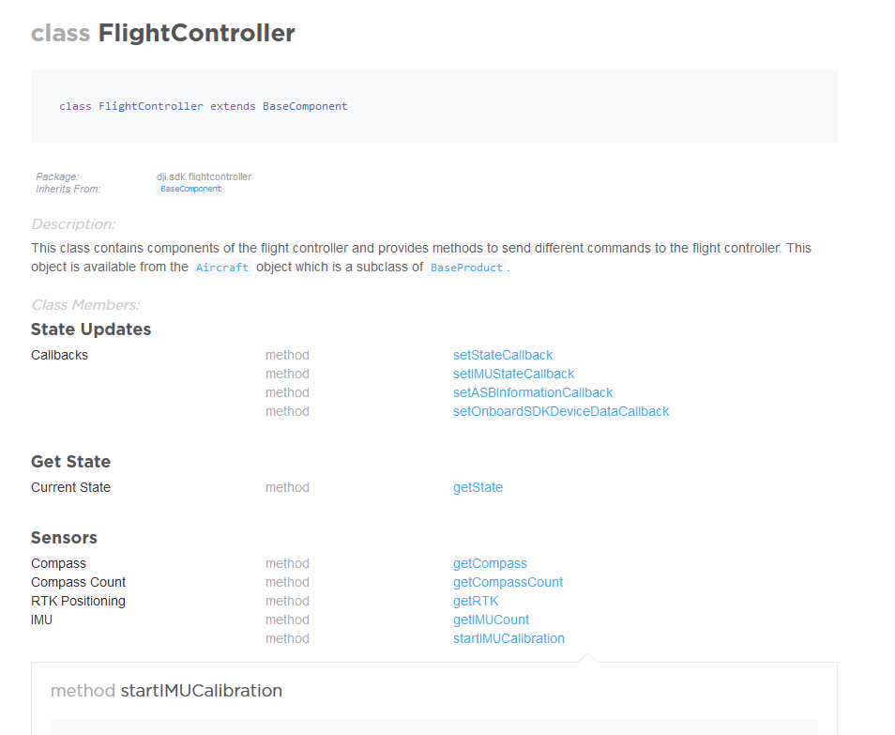

状态：

<https://developer.dji.com/api-reference/android-api/Components/IMUState/DJIIMUState.html#djiimustate_djiimusensorstatus_inline>

Enum for IMU calibration Status.

**Enum Members:**

|  |  |
| --- | --- |
| DISCONNECTED | The IMU sensor is disconnected from the flight controller. |
| CALIBRATING | The IMU sensor is calibrating |
| CALIBRATION_FAILED | Calibrate of the IMU sensor failed. |
| DATA_EXCEPTION | The IMU sensor has a data exception. Calibrate the IMU and restart the aircraft. If afterwards the status still exists, you may need to contact DJI for further assistance. |
| WARMING_UP | The IMU sensor is warming up. |
| IN_MOTION | The IMU sensor is not static; the aircraft may not be stable enough to calculate sensor data correctly. |
| NORMAL_BIAS | The IMU's bias value is normal; the aircraft can safely take off. |
| MEDIUM_BIAS | The IMU's bias value is medium; the aircraft can safely take off. |
| LARGE_BIAS | The IMU's bias value is large; the aircraft cannot take off. IMU calibration is needed. |
| UNKNOWN | The IMU sensor's status is unknown. |