1. 禁飞区信息

<https://www.dji.com/cn/flysafe/geo-map>

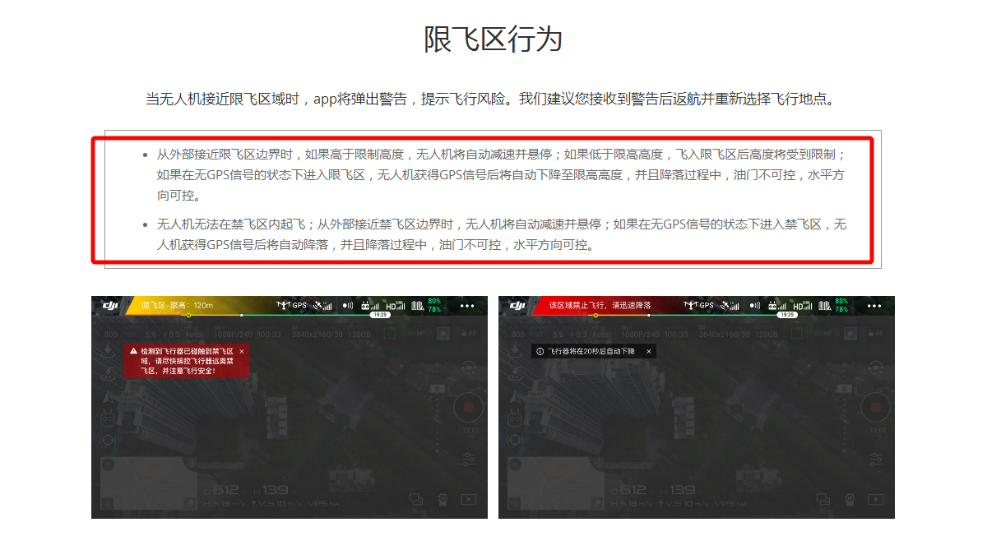

图片来源：<https://bbs.dji.com/forum.php?mod=viewthread&tid=207866>