# 一、遥控器说明

<https://developer.dji.com/cn/document/b29c3ec9-6a41-4afe-b058-77b87d882e2f>

### F模式（功能）

在功能模式下，飞机使用所有可用的定位辅助系统 (类似于P模式) 并且支持所有的高级功能，例如 [智能任务](https://developer.dji.com/document/aab56894-31c7-4f38-b12d-616d312965a6) and [智能方向控制l](https://developer.dji.com/document/6cd164ef-b5f5-46dd-b56d-82d274d3dc6c#ioc-intelligent-orientation-control)。

如果飞手在执行任务或虚拟摇杆命令时需要重新获得手动控制，则应将飞行模式开关移出F模式。

是否允许切换飞行模式：先开开关再设置才有效。

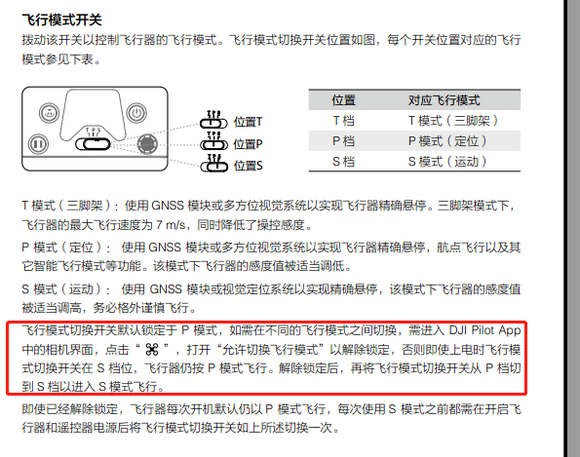

# 二、遥控器模式

<https://developer.dji.com/api-reference/android-api/Components/FlightController/DJIFlightController.html#djiflightcontroller_djiflightcontrollerremotecontrollerflightmode_inline>

###### enum RemoteControllerFlightMode

|  |
| --- |
| @EXClassNullAway  enum RemoteControllerFlightMode |

|  |  |
| --- | --- |
| *Package:* | dji.common.flightcontroller |
| *SDK Key:* | [FlightControllerKey.CURRENT_MODE](https://developer.dji.com/api-reference/android-api/Components/KeyManager/DJIFlightControllerKey.html#flightcontrollerkey_current_mode_key) |

##### Description:

Flight modes that map to the flight mode switch on the remote controller.

##### Enum Members:

|  |  |
| --- | --- |
| P | Positioning mode. GNSS and Vision Positioning Systems are used for positioning if they are available. For products without F mode, intelligent functions such as missions and intelligent orientation control can be performed in P-mode. |
| S | Sport mode. The maximum flight speed and responsiveness of the aircraft is increased in this mode. |
| A | Attitude mode. The GNSS and Vision Positioning Systems are not used for positioning. The aircraft only uses the barometer to maintain altitude. If receiving a GNSS signal, the aircraft can automatically return home if the Remote Controller signal is lost and if the Home Point has been recorded successfully. |
| G | Gentle mode. The sensitivity and speed of aircraft will be substantially decreased in gentle mode. |
| M | Manual mode. The aircraft will not stabilize its altitude nor attitude in manual mode. This mode is for advanced pilots only, and should only be used when the pilot understands the risk of operating in this mode. Any damage to the product when operating in this mode will not be covered under warranty. It is supported by stand-alone A3 and N3 and can be enabled in Assistant 2. |
| F | Function mode. Performs the same as Positioning mode with intelligent functions such as missions and intelligent orientation control enabled. |
| T | Tripod Mode. This mode drops the aircraft's maximum speed and significantly reduces the control stick sensitivity of the remote controller to give the user the precision needed for accurate framing. It is only supported by Mavic 2. |

三、锁定飞行模式

<https://developer.dji.com/api-reference/android-api/Components/FlightController/DJIFlightController.html#djiflightcontroller_djiflightorientationmode_inline>

Flight Assistance

enum

[ControlMode](https://developer.dji.com/api-reference/android-api/Components/FlightController/DJIFlightController.html#djiflightcontroller_djiflightcontrollercontrolmode_inline)

enum

[FlightOrientationMode](https://developer.dji.com/api-reference/android-api/Components/FlightController/DJIFlightController.html#djiflightcontroller_djiflightorientationmode_inline)

###### enum FlightOrientationMode

|  |
| --- |
| @EXClassNullAway  enum FlightOrientationMode |

|  |  |
| --- | --- |
| *Package:* | dji.common.flightcontroller |
| *SDK Key:* | [FlightControllerKey.ORIENTATION_MODE](https://developer.dji.com/api-reference/android-api/Components/KeyManager/DJIFlightControllerKey.html#flightcontrollerkey_orientation_mode_key) |

##### Description:

Tells the aircraft how to interpret flight commands for forward, backward, left and right. See the *Flight Controller User Guide* for more information.

##### Enum Members:

|  |  |
| --- | --- |
| COURSE_LOCK | The aircraft should move relative to a locked course heading. |
| HOME_LOCK | The aircraft should move relative radially to the Home Point. |
| AIRCRAFT_HEADING | The aircraft should move relative to the front of the aircraft. |