Step1:

进入Glassdoor 主页：<https://www.glassdoor.com/member/home/index.htm>

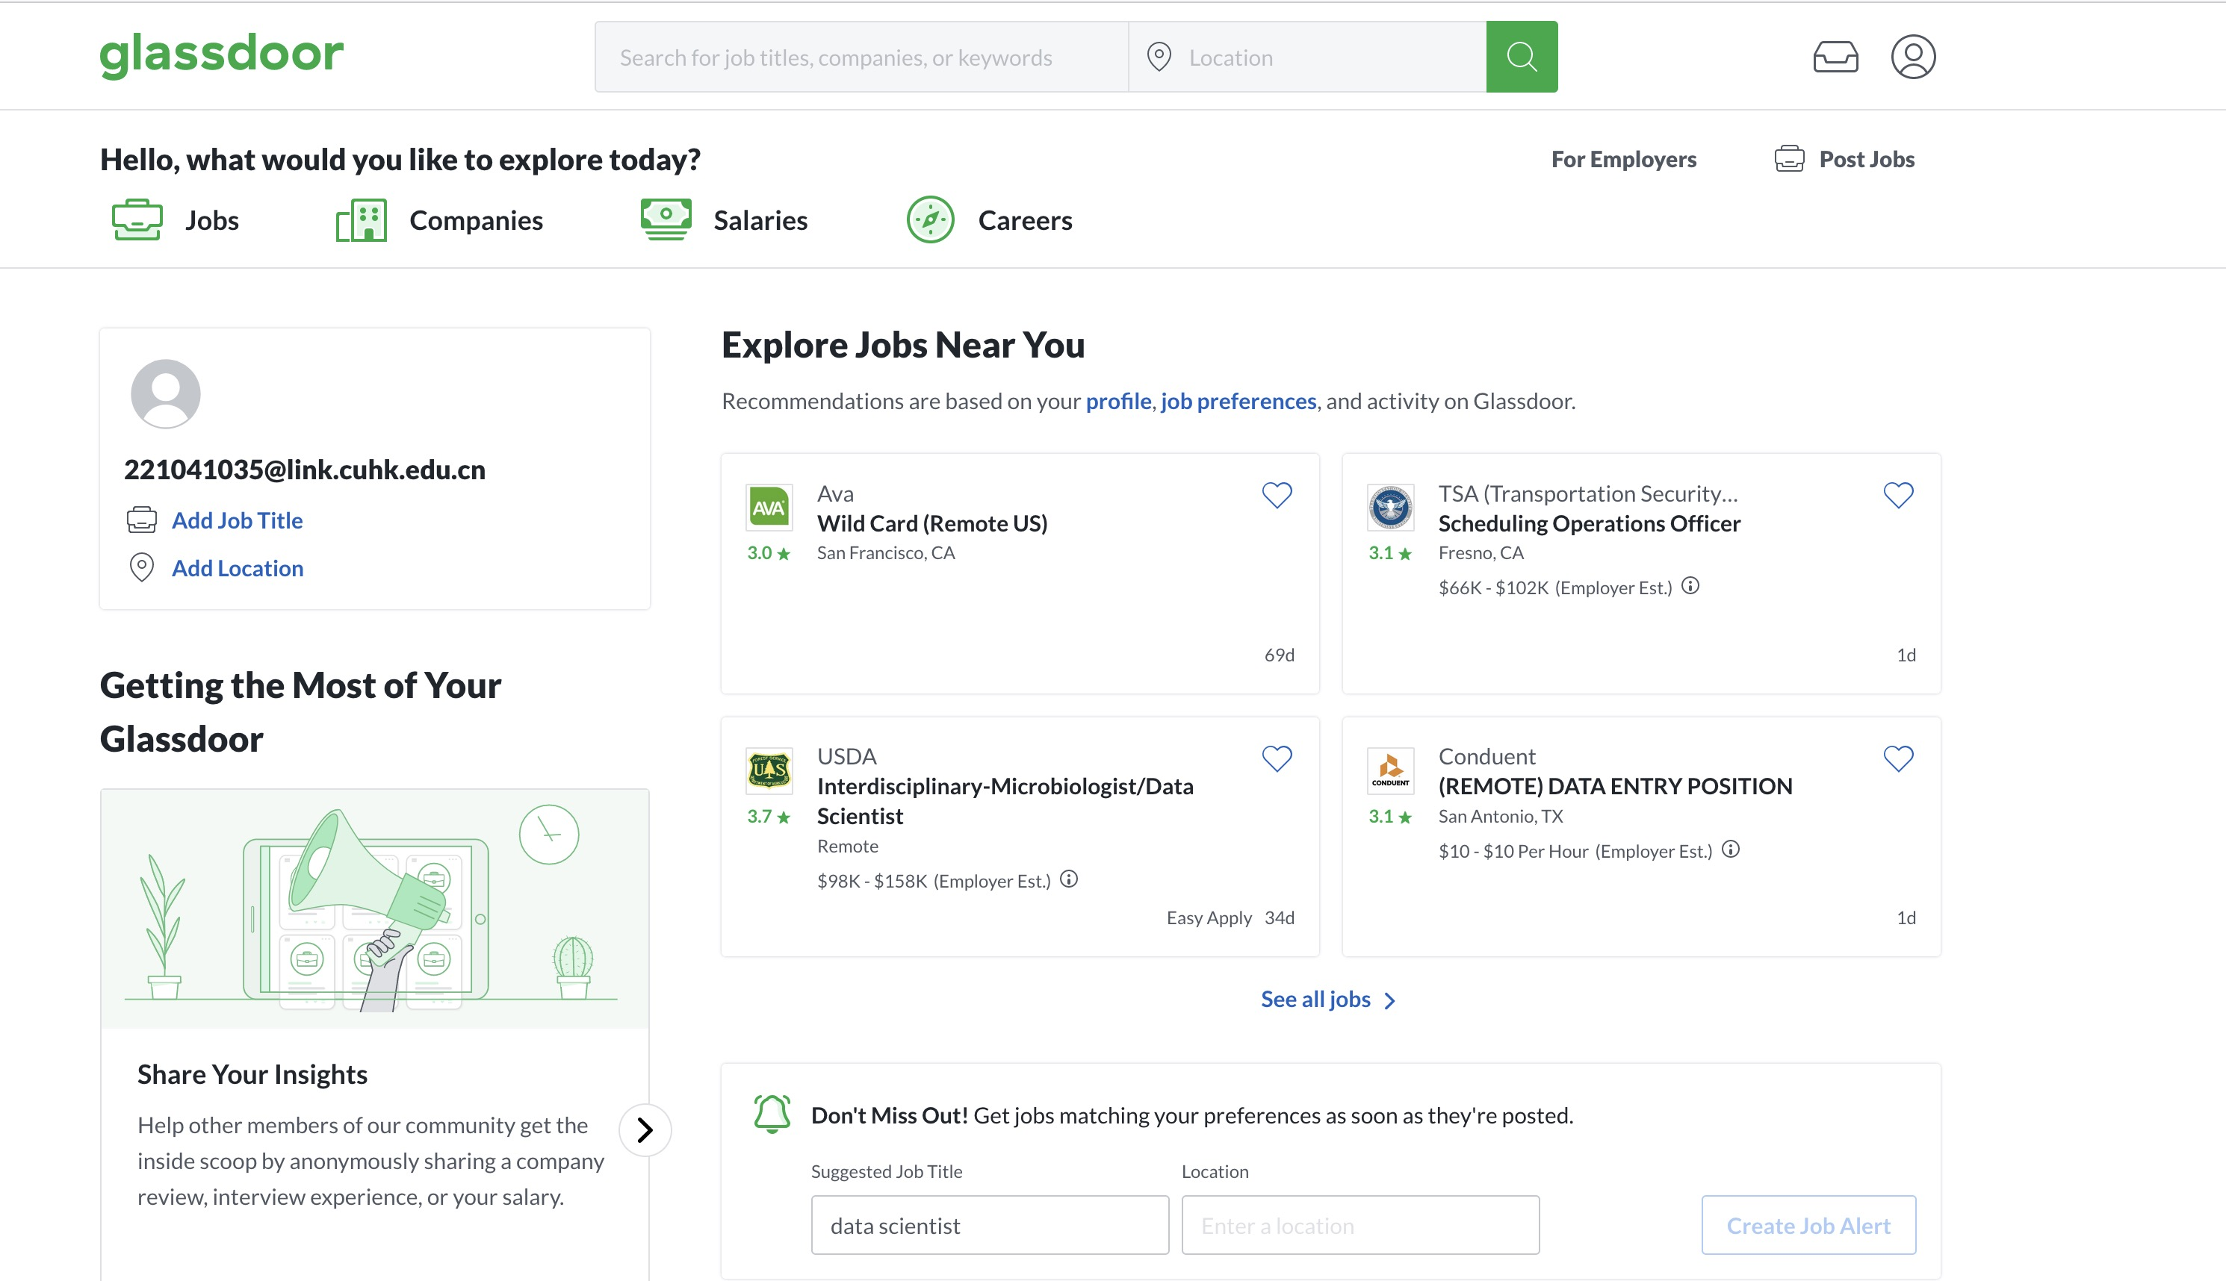

Step2:

点击companies，选择discover companies

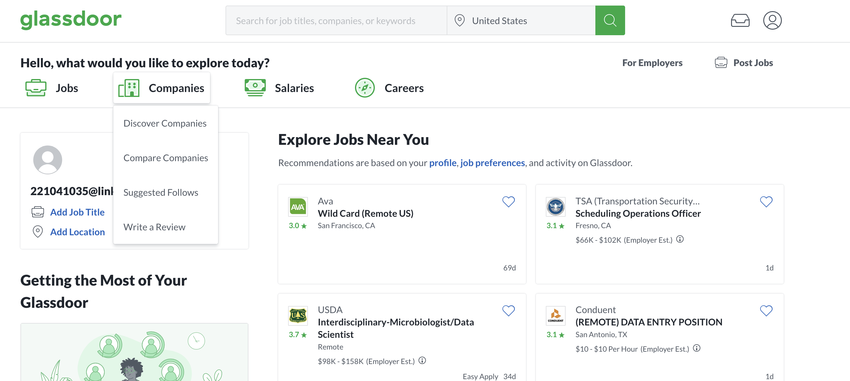

Step3: 下拉该页面，左侧有几个空

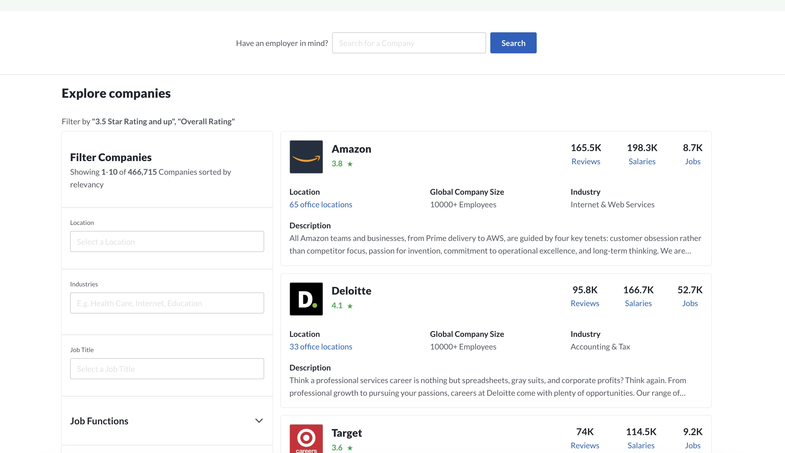

**Step4: 在这个筛选的空里面分别填 不同的内容。**

* 1. **New York State,US + retail & wholesale**

[https://www.glassdoor.com/Reviews/index.htm?overall_rating_low=3&page=**1**&locId=**428**&locType=S&locName=**New%20York%20State,%20US**&sector=**10022**&filterType=RATING_OVERALL](https://www.glassdoor.com/Reviews/index.htm?overall_rating_low=3&page=1&locId=428&locType=S&locName=New%20York%20State,%20US&sector=10022&filterType=RATING_OVERALL)

* 1. **New York State,US + information Technology**

https://www.glassdoor.com/Reviews/index.htm?overall_rating_low=3&page=**1**&locId=**428**&locType=S&locName=**New%20York%20State,%20US**&sector=**10013**&filterType=RATING_OVERALL

* 1. **New York State,US + financial services**

[https://www.glassdoor.com/Reviews/index.htm?overall_rating_low=3&page=1&locId=**428**&locType=S&locName=**New%20York%20State,%20US**&sector=**1001**0&filterType=RATING_OVERALL](https://www.glassdoor.com/Reviews/index.htm?overall_rating_low=3&page=1&locId=428&locType=S&locName=New%20York%20State,%20US&sector=10010&filterType=RATING_OVERALL)

**2.1 California, US + retail & wholesale**

[https://www.glassdoor.com/Reviews/index.htm?overall_rating_low=3&page=**1**&locId=**2280**&locType=S&locName=**California,%20US**&sector=**10022**&filterType=RATING_OVERALL](https://www.glassdoor.com/Reviews/index.htm?overall_rating_low=3&page=1&locId=2280&locType=S&locName=California,%20US&sector=10022&filterType=RATING_OVERALL)

**2.2 California, US + information Technology** https://www.glassdoor.com/Reviews/index.htm?overall_rating_low=3&page=**1**&locId=**2280**&locType=S&locName=**California,%20US**&sector=**10013**&filterType=RATING_OVERALL

**2.3 California, US + financial services**

[https://www.glassdoor.com/Reviews/index.htm?overall_rating_low=3&page=**1**&locId=**2280**&locType=S&locName=**California,%20US**&sector=**10010**&filterType=RATING_OVERALL](https://www.glassdoor.com/Reviews/index.htm?overall_rating_low=3&page=1&locId=2280&locType=S&locName=California,%20US&sector=10010&filterType=RATING_OVERALL)

**3.1 New Jersey, US + retail & wholesale**

[https://www.glassdoor.com/Reviews/index.htm?overall_rating_low=3&page=**1**&locId=**39**&locType=S&locName=**New%20Jersey,%20US**&sector=**10022**&filterType=RATING_OVERALL](https://www.glassdoor.com/Reviews/index.htm?overall_rating_low=3&page=1&locId=39&locType=S&locName=New%20Jersey,%20US&sector=10022&filterType=RATING_OVERALL)

**3.2 New Jersey, US + information Technology**

[https://www.glassdoor.com/Reviews/index.htm?overall_rating_low=3&page=**1**&locId=**39**&locType=S&locName=**New%20Jersey,%20US**&sector=**10013**&filterType=RATING_OVERALL](https://www.glassdoor.com/Reviews/index.htm?overall_rating_low=3&page=1&locId=39&locType=S&locName=New%20Jersey,%20US&sector=10013&filterType=RATING_OVERALL)

**3.3 New Jersey, US + financial services**

[https://www.glassdoor.com/Reviews/index.htm?overall_rating_low=3&page=**1**&locId=**39**&locType=S&locName=**New%20Jersey,%20US**&sector=**10010**&filterType=RATING_OVERALL](https://www.glassdoor.com/Reviews/index.htm?overall_rating_low=3&page=1&locId=39&locType=S&locName=New%20Jersey,%20US&sector=10010&filterType=RATING_OVERALL)

4.1 **Texas, US** + **retail & wholesale**

https://www.glassdoor.com/Reviews/index.htm?overall_rating_low=3&page=**1**&locId=**1347**&locType=S&locName=**Texas,%20US**&sector=**10022**&filterType=RATING_OVERALL

4.2 **Texas, US** + **Information Technology**

https://www.glassdoor.com/Reviews/index.htm?overall_rating_low=3&page=**1**&locId=**1347**&locType=S&locName=**Texas,%20US**&sector=**10013**&filterType=RATING_OVERALL

4.3 **Texas, US** + **financial services**

https://www.glassdoor.com/Reviews/index.htm?overall_rating_low=3&page=**1**&locId=**1347**&locType=S&locName=**Texas,%20US**&sector=**10010**&filterType=RATING_OVERALL

5.1 **Florida, US + retail & wholesale**

https://www.glassdoor.com/Reviews/index.htm?overall_rating_low=3&page=**1**&locId=**3318**&locType=S&locName=**Florida,%20US**&sector=**10022**&filterType=RATING_OVERALL

5.2 **Florida, US** + **Information Technology**

https://www.glassdoor.com/Reviews/index.htm?overall_rating_low=3&page=**1**&locId=**3318**&locType=S&locName=**Florida,%20US**&sector=**10013**&filterType=RATING_OVERALL

5.3 **Florida, US** + **financial services**

[https://www.glassdoor.com/Reviews/index.htm?overall_rating_low=3&page=**1**&locId=**3318**&locType=S&locName=**Florida,%20US**&sector=**10010**&filterType=RATING_OVERALL](https://www.glassdoor.com/Reviews/index.htm?overall_rating_low=3&page=1&locId=3318&locType=S&locName=Florida,%20US&sector=10010&filterType=RATING_OVERALL)

以上一共5个不同的location，及其对应在url里面的code是：

{'New%20York%20State,%20US':'428', 'California,%20US':'2280', 'New%20Jersey,%20US':'39', 'Texas,%20US':'1347', 'Florida,%20US':'3318'}

三个不同的行业，及其对应在url里面的code是：

{ retail & wholesale: '10022', Information Technology：'10013'； financial services：'10010'}

共计15个链接

每一个链接打开如图所示，每页有10个公司

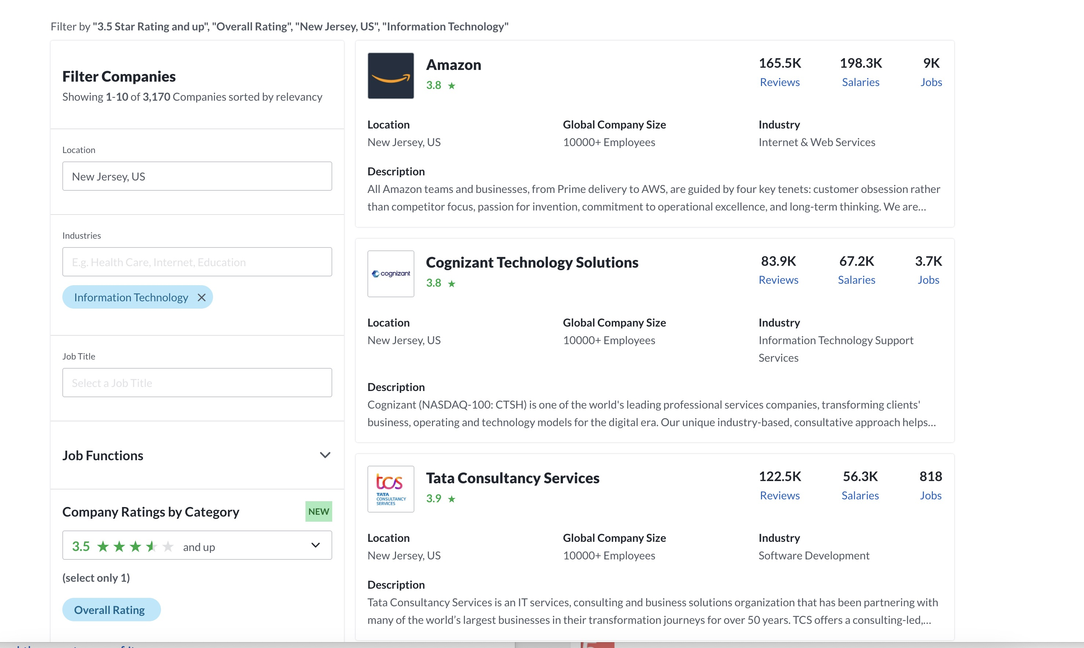

每个公司的信息中，需要爬取红圈中圈出的8个信息

每个链接爬取100页，1000个公司

最后生成15个xlsx文件，每个文件表格结构如下：

|  |  |  |  |  |  |  |  |
| --- | --- | --- | --- | --- | --- | --- | --- |
| Name | Overall rating | Location | Global company size | Reviews | salaries | jobs | industry |
|  |  |  |  |  |  |  |  |