When choosing to run it locally, this application is confirmed to not work with specific versions of Python, such as 3.9. Setting up the application with Docker, which we highly recommend for local users, will handle this issue for you automatically during the “build”.   
  
If you choose not to use Docker, we recommend installing Python 3.7.8 and connecting it to the PATH, as per the readme. Users who wish to have multiple versions of Python installed should adhere to the steps at the end of this document for instructions on how to control which Python the PATH will point to.

Here is an example of a Python error you may see if Python is not installed correctly OR the wrong versions of Python is connected to the PATH:

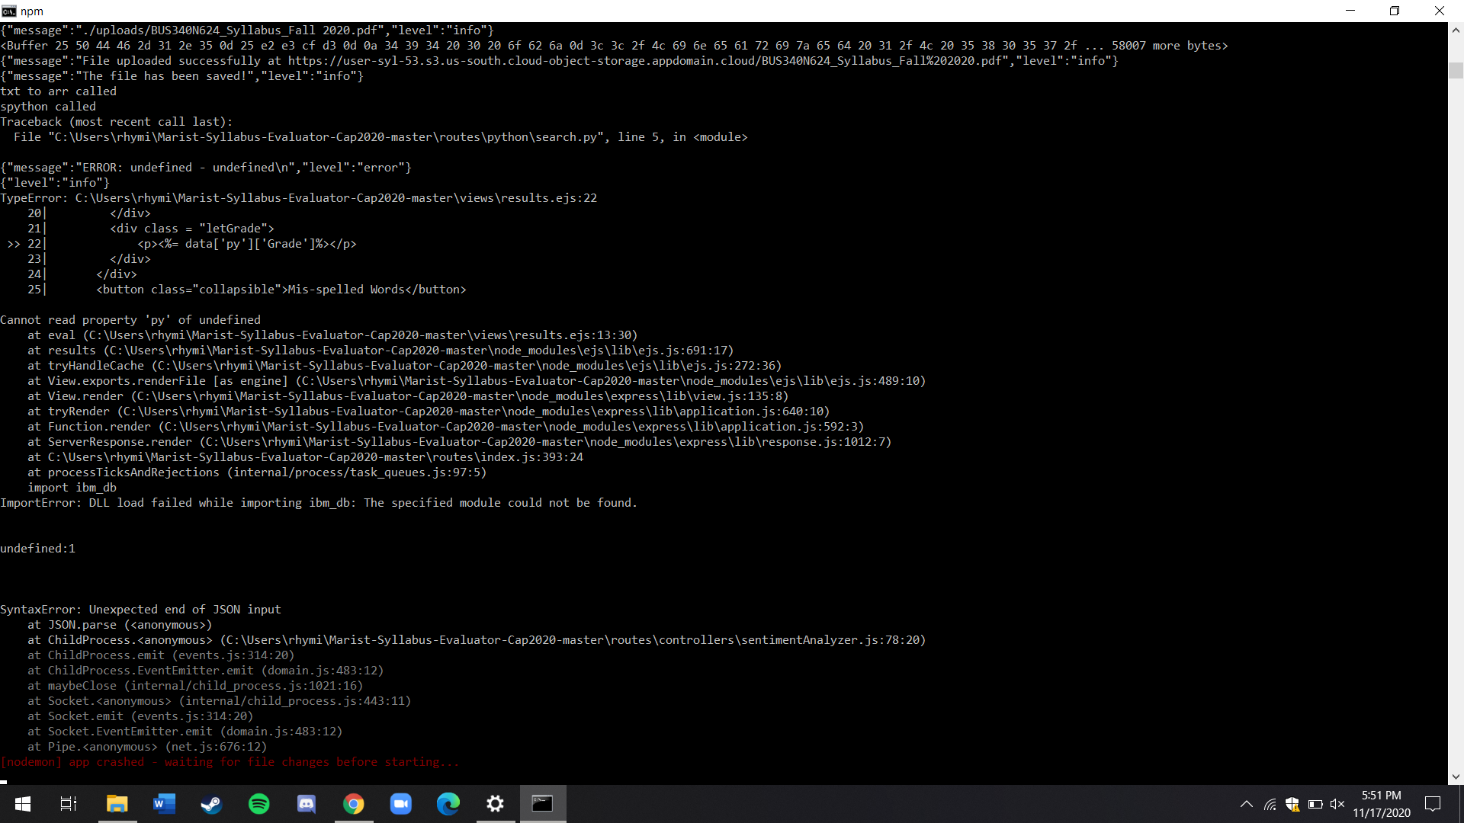

If you are experiencing this issue, when you are in the command line, type “python --version”, and it should return “Python 3.7.8”. If it returns nothing, make sure you’ve installed Python 3.7.8 with the “Add Python to PATH” option selected. If it returns a different version of Python (ex: “Python 3.9”) even though you have Python 3.7.8 installed, you can force the system to choose Python 3.7.8 by doing the following (Windows Users):

1. Open Advanced System Settings.
2. Open “Environment Variables”
3. Open the “Path” variable under “User Variables” (Caution: If you installed for Python for all users, you will find
4. Move the two folders with “Python37” in the file path above the others
5. Press OK
6. Restart the Command Line