Swe 645 hw3
Chao Chen G01476331
Overview：
This was a full-stack design. I used Vue as the front-end, Spring Boot + AWS RDS as the back-end, and after completing the application, I containerized it and uploaded it to DockerHub. Through Jenkins, I implemented the CI/CD pipeline for the application.
- Frontend: Single Page Application (SPA) built with Vue.js
- Backend: RESTful API service built with Spring Boot
- Database: Newly created MySQL database on AWS RDS
- Containerized deployment: Both the front-end and back-end are packaged using Docker images and deployed to the Kubernetes cluster managed by Rancher.
- Automation: Jenkins Pipeline enables continuous integration (CI) and continuous deployment (CD)
- Url: http://54.235.178.80:30623/

Frontend part(Vue):
- Frontend directory: vue-survey-app
- Pre-requisite requirements: Node.js, VS Code, Vue CLI have been installed.
  - https://nodejs.org
  - Choose the LTS version, download the.msi (for Windows) file, install it and restart the cmd. Use the command "node -v" to verify if the installation is successful. After seeing the version number, use the command "npm -v" to verify if npm is installed successfully. Similarly, once you see the version number, it indicates that npm is installed successfully.
  - Use npm to globally install Vue CLI: npm install -g @vue/cli
  - Verify whether Vue CLI has been installed successfullyVerify whether Vue CLI has been installed successfully
- Building the project using Vue CLI:
vue create vue-survey-app
- Open the vue-survey-app in VS Code. Right-click in the /src/components directory and create 1. SurveyForm.vue and SurveyList.vue two components.
Introduce the functions and codes of each file
- SurveyForm.vue
- Function:
- This is a form component used for collecting user survey information.
- Mainly responsible for the UI display of the form and the processing of user input, and calling the backend API to send data upon submission.
- Content summary:
- It includes form fields such as name, contact information, survey date, single-choice, multiple-choice, and comment area.
- Use v-model for bidirectional binding of user input data.
- In the `submit` method, the form data is sent to the backend `/api/surveys` interface via `axios/fetch`.
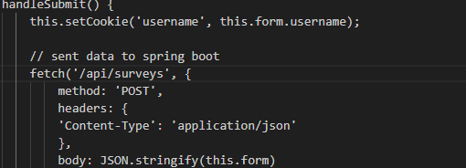
- After the form is submitted successfully, a prompt or the form will be reset.
- SurveyList.vue
- Function:
- This is a list component used to display all the records of the survey forms.
- It also supports the deletion and update of a specific piece of survey data.
- Content summary:
- When the page loads, all the survey records in the backend database are retrieved through the API and displayed in the table.
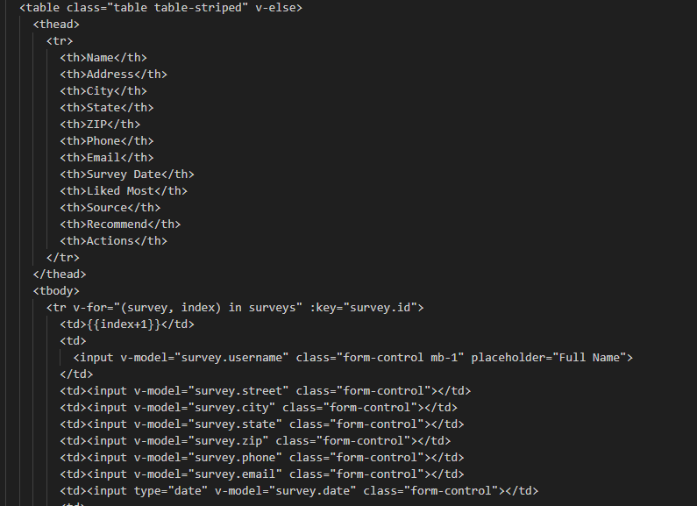
- In each row of the table, there is a delete button (which calls DELETE /api/surveys/{id}) and an update button.
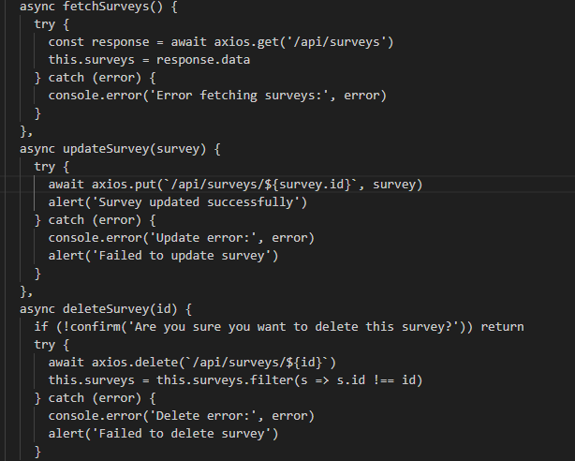
- You can directly operate and record on the page without having to navigate to a separate editing pag.
- App.vue
- Function:
- The root component of a Vue application provides the overall page structure.
- Used to render the common area of the page (such as the navigation bar) and the router-view placeholder to switch between the SurveyForm and SurveyList pages.
- Content summary:
- The template section includes the global navigation (such as the menus "Fill Form" and "View Form List").
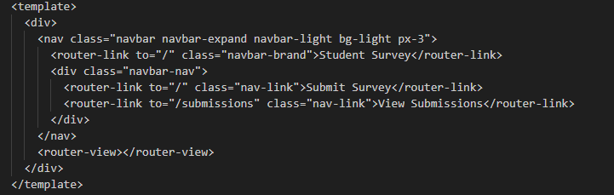
- Use <router-view/> to control the display of child route components.
- The style section defines the global CSS, such as page layout, background, etc.
- main.js
- Function:
- The entry file of the Vue application is responsible for initializing the application and mounting it onto the #app element in index.html.
- A router was introduced for page navigation, and the Bootstrap style library was globally loaded.
- Content summary:
- Use `createApp(App)` to create an application instance.
- By registering the routing functionality with `.use(router)`, and finally mounting it onto the DOM.
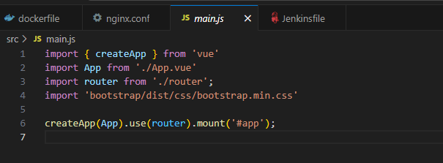
- nginx.conf
- Function:
- When accessing the / path, directly return the static page (index.html) packaged by Vue frontend.
- When the browser makes a request starting with /api/, Nginx will forward the request to the Spring Boot backend.
- Content summary:
- try_files $uri $uri/ /index.html:
- First, find the corresponding file/directory in the specified path.
- If not found, it will uniformly return index.html (to solve the 404 error issue of Vue Router's front-end routing)
- proxy_pass http://survey-backend-service:8081/api/:
- survey-backend-service: This is the name of the Kubernetes Service. It enables access to the backend Pods via K8s DNS.
- 8081: The port of the backend Spring Boot container (server.port = 8081).
- /api/ remains consistent: When Vue front-end makes a request to /api/... , the backend can correctly match the interface of the Controller.
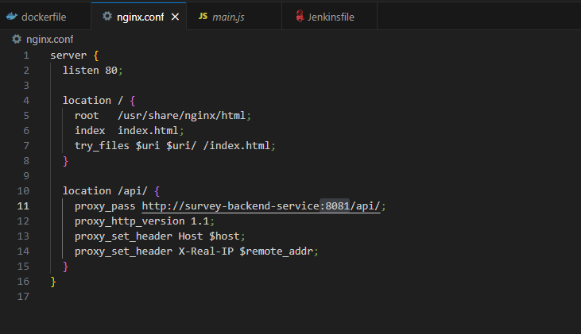

Backend part(Spring Boot):
- Generate and download the Maven Spring Boot project from https://start.spring.io/ • Download the zip and extract it to a folder and then open it in Eclipse EE
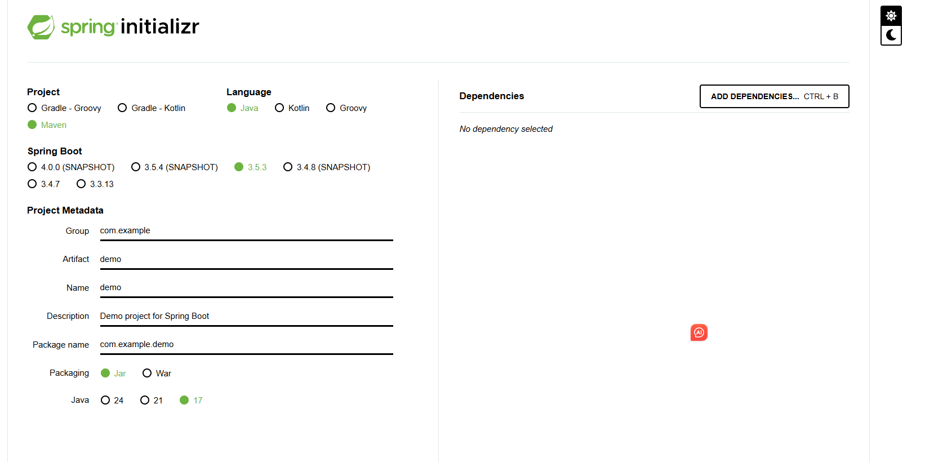
- Download Eclipse EE and open the Spring Boot project.
https://www.eclipse.org/downloads/
- Select in the src/main/java folder. Right-click to create the "edu.gmu.springboot.survey","edu.gmu.springboot.survey.controller" , "edu.gmu.springboot.survey.model" , "edu.gmu.springboot.survey.repository" package.
- Create a new SurveyController class under "edu.gmu.springboot.survey.controller", a new Survey.java class under "edu.gmu.springboot.survey.model", and a new SurveyRepository interface under "edu.gmu.springboot.survey.repository".
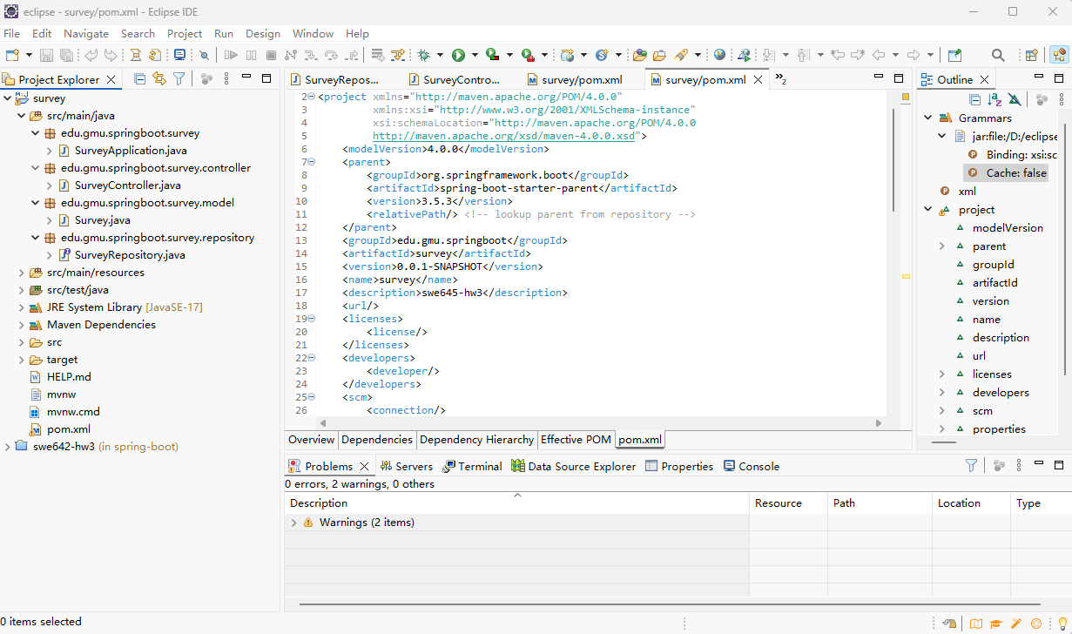
SurveyController
- Function: To implement RESTful API functionality and be responsible for data exchange between the front end and the back end.
- Specific logic:
- When the front-end Vue page makes an API call (such as submitting a form via POST or fetching a list via GET), the Controller receives the request.
- Call the repository to access the database.
- Return the data to the front end.
Survey.java:
- Function: Defines the field structure of the database table.
Each field corresponds to a column in the database, for example:
username → username
email → email inbox
likes → likes the aspects of the school
Spring Boot + JPA will automatically use it to create tables or map the database.
SurveyRepository:
- Function: Handles database access without the need to write SQL.
Spring Data JPA automatically helps you implement the CRUD (create, read, update, delete) methods for the database.
- I used the Lombok dependency and used the @Data annotation to automatically generate methods such as Getters and Setters, thereby reducing the amount of boilerplate code. Therefore, it is necessary to add the following <dependency> tag in the dependencies section of pox.xml.
<dependency>
<groupId>org.projectlombok</groupId>
<artifactId>lombok</artifactId>
<version>1.18.30</version> <scope>provided</scope>
</dependency>
- If you don't have a database, please go to the database operation section first.
- Set the "Application.proterties" property, enter our database account name and password in it, and specify the Spring Boot port as 8081.
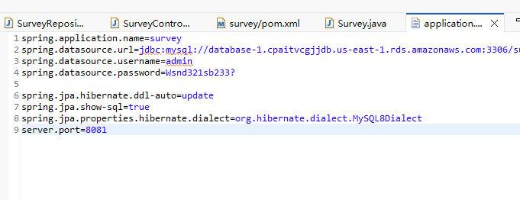
- Application.java is the main class, its function: the entry point of the Spring Boot application, it has a built-in Tomcat startup point, and contains the public static void main() method. The startup command is: mvn spring-boot:run
- Start the Spring Boot application
- We need to first download and configure Maven
https://maven.apache.org/download.cgi
- Locate the "Files" column on the page and click to download the Binary zip archive:apache-maven-3.9.6-bin.zip
- After decompression, we need to set the environment variables.
- Open the "Environment Variables" settings window of the system. In the "System Variables" section, locate and edit the "Path", and add:
D:\apache-maven-3.9.10\bin
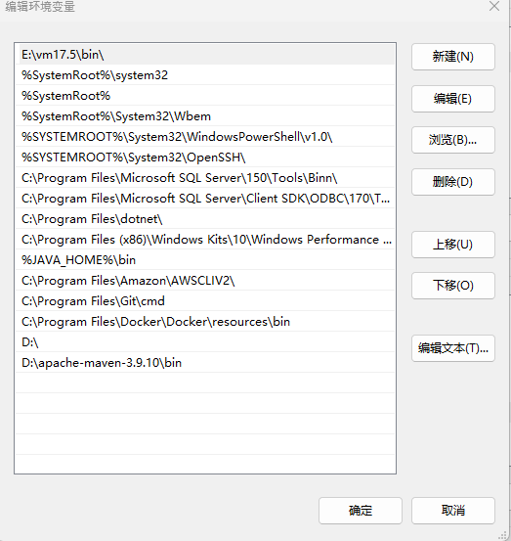
- Add a new system variable:
Variable name: MAVEN_HOME
Variable value: D:\apache-maven-3.9.10

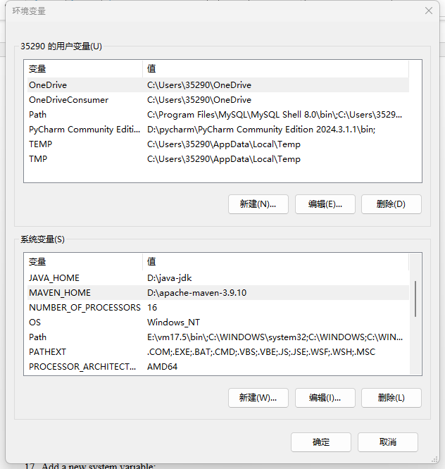
- To verify the success, open the command line (Win+R → enter cmd), and input:
mvn -v
- After achieving success, you should first navigate to the project directory:
cd C:\Users\35290\OneDrive\Desktop\2025 summer\swe642\swe642-hw3
- Then, run the Spring Boot using the Maven command:
mvn spring-boot:run
- I have previously submitted a survey form on the page set up in Vue, so I can view the relevant data here:
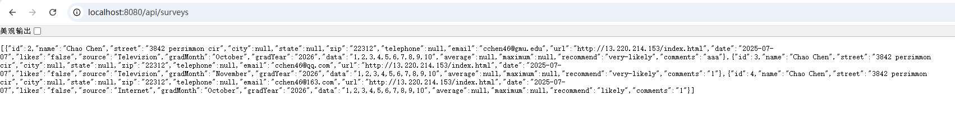
- When you also see this, it indicates that your Spring Boot has been successfully running.
Database:
I created an RDS database on AWS. In the search box on AWS, enter "RDS", click "Aurora and RDS", and select the "Databases" option from the right sidebar. Click the "Create a Database" button on the top right corner, select "Standard Created", "MySql", "Sandbox", enter the database password, confirm the database password, and leave the others as default. Then click "Create a Database." .
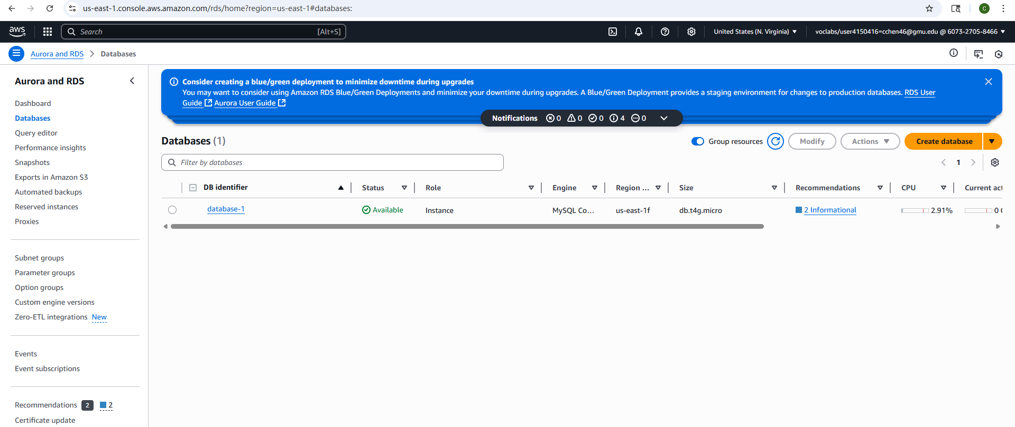Moverover, install the MySQL client.
sudo apt-get install mysql-client –y
Use the MySQL command to connect to RDS on ec2.
mysql -h <RDS-endpoint> -P 3306 -u <username> -p
-h: Your RDS endpoint address
-P 3306: Port number. The default port number for MySQL is 3306.
-u: Database username
-p: After inputting, it will prompt you to enter the password.
It is necessary to open the IP access for the RDS 3306 port for the EC2 instance in the RDS security group.
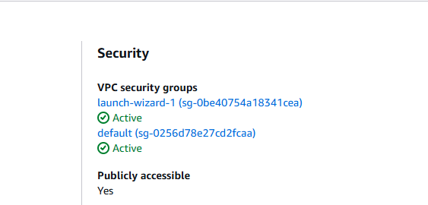"launch-wizard-1 (sg-0be40754a18341cea)" is the security group corresponding to my EC2 instance.
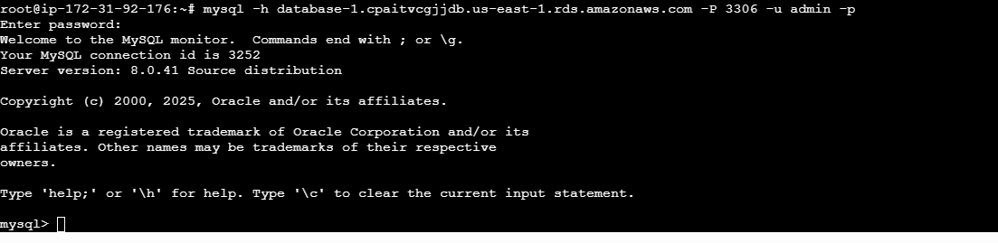mysql> indicates that the database connection has been successful.
CI/CD pipeline:
Docker:
Since there are both the front-end and back-end parts, we need two corresponding dockerfiles, which are located in the root directories of the Vue and Spring Boot projects respectively.
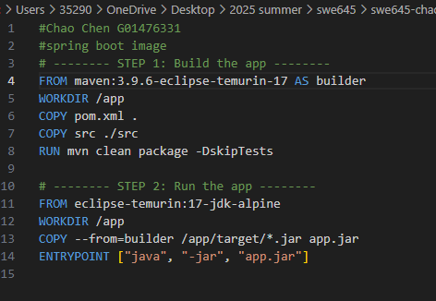
The Dockerfile of Spring Boot is divided into two steps. The first step is to build the project using Maven and JDK 17, generating a JAR file. The second step is to only copy the JAR file that was generated in the first step, without including Maven or the source code. The resulting image is very small, more secure, and faster.
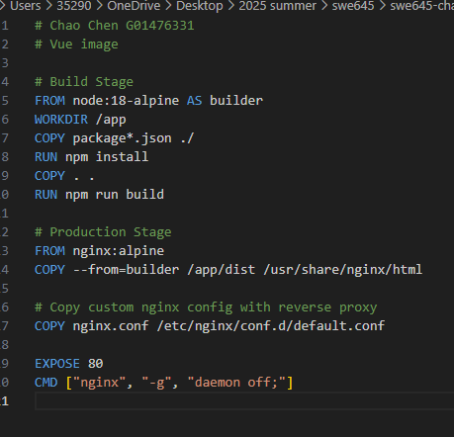
The Dockerfile for Vue is also divided into two steps, similar to Spring Boot. This is done to reduce the size of the image. The first step involves installing dependencies and building the front-end using Node 18. The second step involves deploying Vue static files using Nginx, and simultaneously setting up reverse proxy using nginx.conf.
After both Dockerfiles were set up, I entered their respective root directories in the terminal of Docker Desktop and used command statements to create and push them to my DockerHub. Remember to log in before the push.
docker build –t survey-frontend:latest .
docker push chaochen46/survey-frontend:latest
docker build –t survey-backend:latest .
docker push chaochen46/survey-backend:latest
Kubernetes：
- I did not directly create the deployment.yaml files for the frontend and backend using Rancher. Instead, I used YAML injection.
- For example, the file backend-deployment.yaml, I specified to use the apps/v1 API version, the resource type was deployment, the name was survey-backend, it was deployed in the default namespace, and the label was app=survey-backend.
- In the spec section, since I did not specify the number of replicas this time, I only specified one replica. The selector was defined, and the deployment would manage the pods with the label app=survey-backend.
- In the pod section, the label was set as app=survey-backend, corresponding to the matchLabels in the spec. The pod's spec section specified that the container name of the pod was survey-backend, the image was chaochen46/survey-backend:latest, and it would pull the latest version from DockerHub. The imagePullPolicy was set to Always: every time the Pod starts, it will check and pull the latest version from DockerHub.
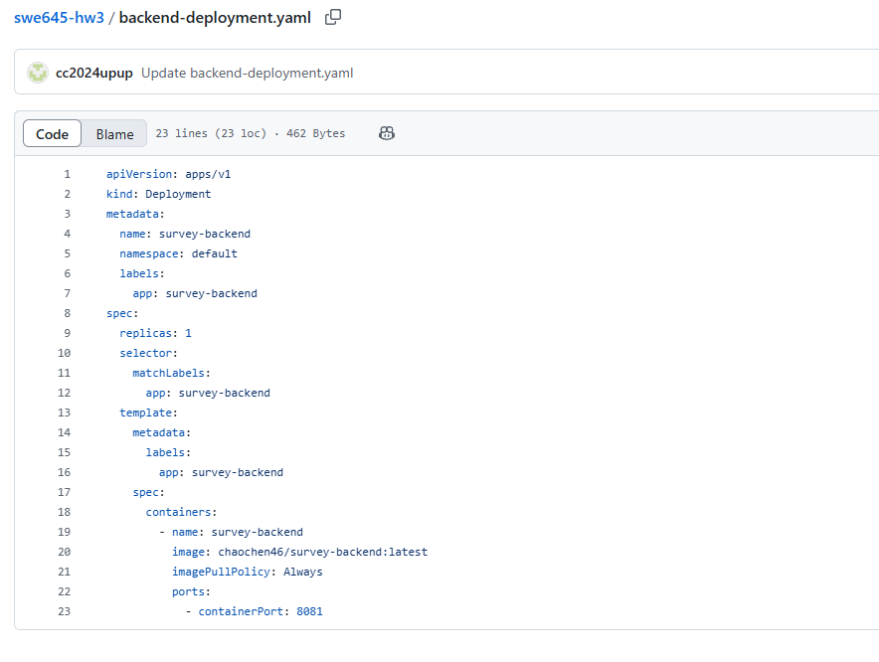
- Similarly, I also created frontend-deployment.yaml, survey-backend-service.yaml and survey-frontend-service.yaml, and injected them through YAML on Rancher, thereby adding them to the Kubernetes cluster.
- Among them, I set the "survey-backend-service" to the ClusterIP type because I don't want the external network to have direct access to my backend program.Among them, I set the "survey-backend-service" to the ClusterIP type because I don't want the external network to have direct access to my backend program. And I want users to be able to access my front-end website, so the survey-frontend-service is of the NodePort type, with the port set to 30623. Users can access the front-end page via http://<EC2 IP>:30623. And I want users to be able to access my front-end website, so the survey-frontend-service is of the NodePort type, with the port set to 30623. Users can access the front-end page via http://<EC2 IP>:30623
Jenkins：
- On Jenkins, create a new project, enter the project name, select "pipeline", select "GitHub project", input the GitHub URL, select "Poll SCM", and enter "* * * * *" (Jenkins will check every minute whether the GitHub resources have been updated.) Select the pipeline script from the SCM, choose Git, enter the repository URL, and finally click Save.
- If no DockerHub credentials have been set, click "Manage Jenkins" on the right side, then click "Credentials". Create a DockerHub credential, set the ID, the username to be the DockerHub username, and the password to be the DockerHub password.
- Create a Jenkinsfile to implement CI/CD automated build + DockerHub push + Kubernetes rolling update.
- Set a global variable named "COMMIT_HASH" to obtain the commit hash of the current git repository. Each time a new image is built, use this hash as the tag to ensure the uniqueness of the image. This supports version rollback and rollback operations, avoiding the need to always use "latest" when building, and makes it easier to consistently use the old Docker image.
- When building the front-end and back-end images, DockerHub credentials are required. However, since the GitHub repository is of public nature, no credentials are needed. At the same time, use the previously obtained hash as the tag.
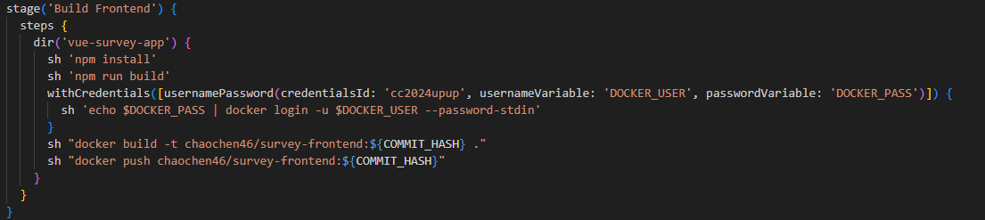
- During the deployment process, the container images in the front-end and back-end deployments will be updated to the newly established front-end and back-end images. The kubectl set image command will trigger a Kubernetes rolling update, causing the Pods to be rebuilt one by one and pulling the new images to prevent the continued use of the old ones.
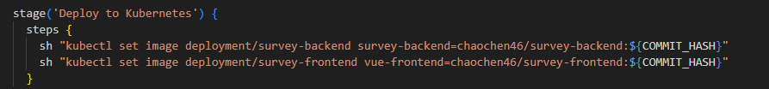
- Tags that are hardcoded in the YAML file will be overwritten. For example, in the front-end YAML, it is written as "proxy2", but after deployment by Jenkins, it will be changed to "${COMMIT_HASH}".
- Upload the spring boot project folder "survey", the Vue project folder "vue-survey-app", the Jenkinsfile, the front-end and back-end deployment.yaml files, and the service.yaml file to the repository cc2024upup/swe645-hw3 in GitHub.
- Click "Build Now" for the Jenkins project or wait one minute for the Jenkins project to automatically start. If there is a failure, check the error output in the console output and view which step failed in the Pipeline Overview.
- If successful, visit the page at http://54.235.178.80:30623/ to view it.
- Make sure you can successfully submit the form, successfully update or modify the form, indicating that the front-end and back-end connections are successful and the project is completed.
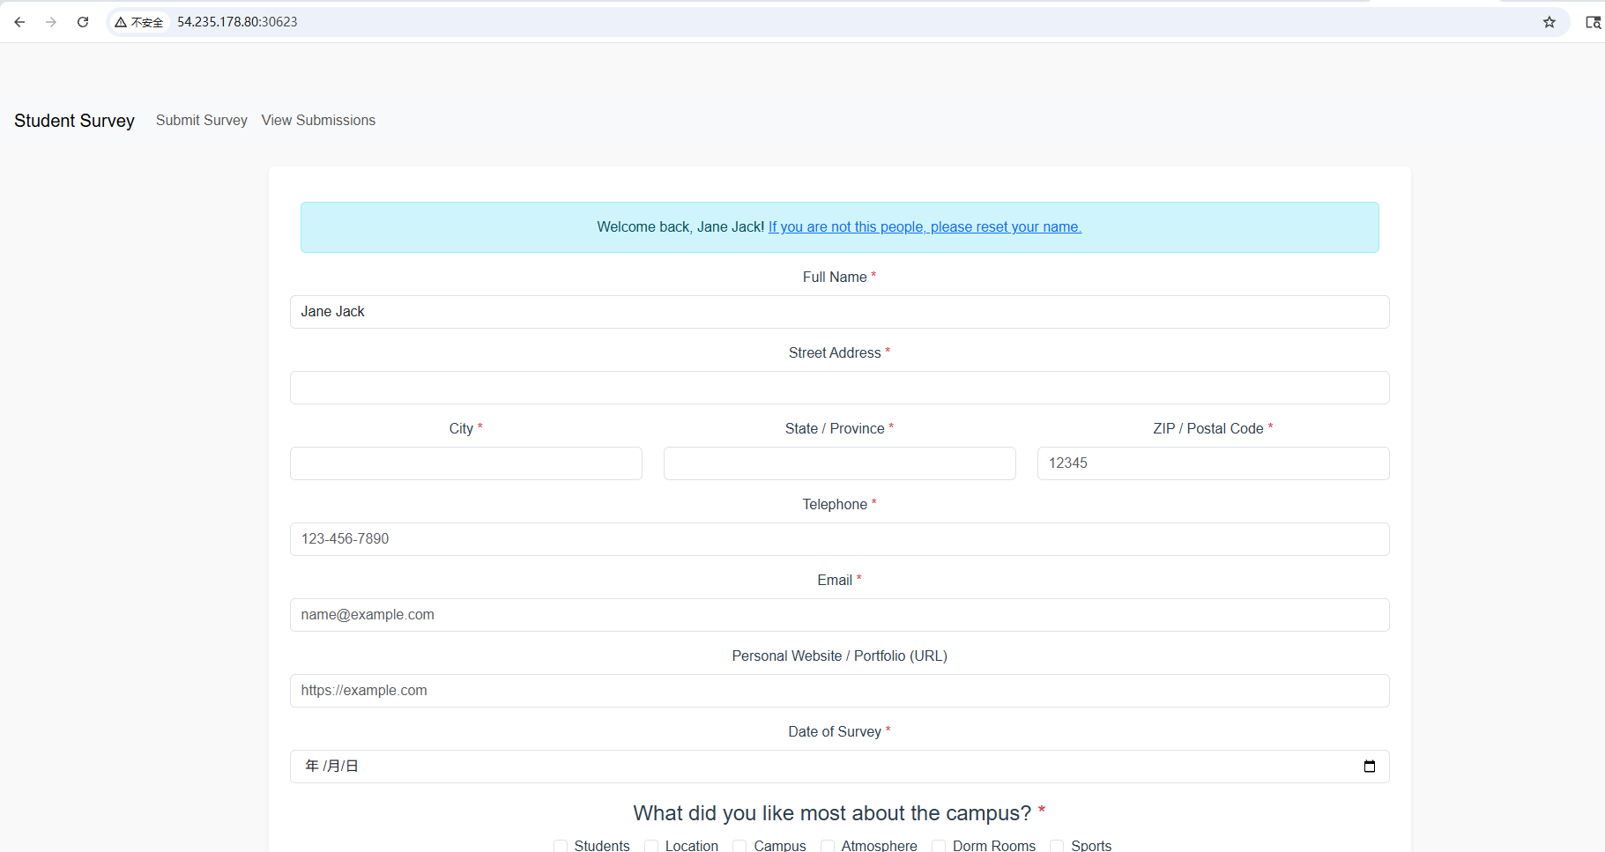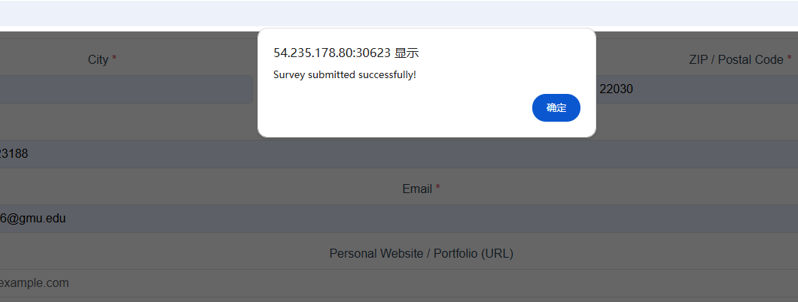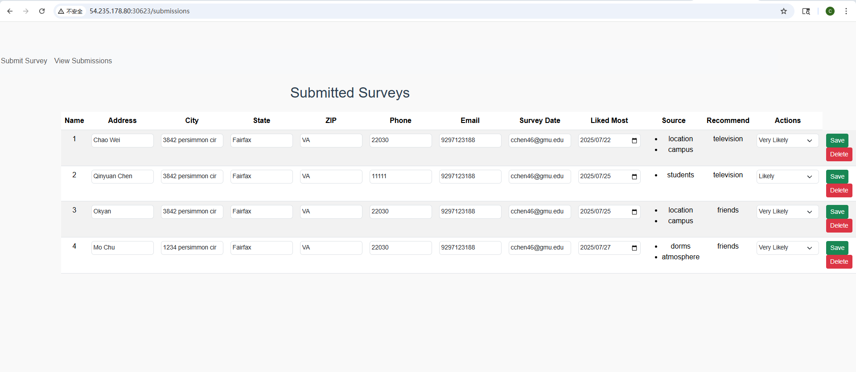

- You can modify the content of the front-end page, update the files in the GitHub repository, wait for the Jenkins response, for example, if I change the welcome message on the form page and replace "people" with "user".
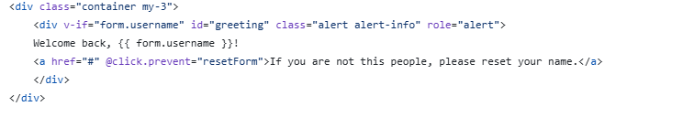
to
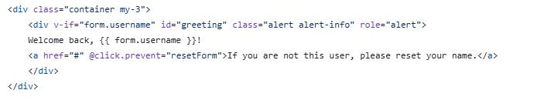
- It can be seen that Jenkins automatically updates.
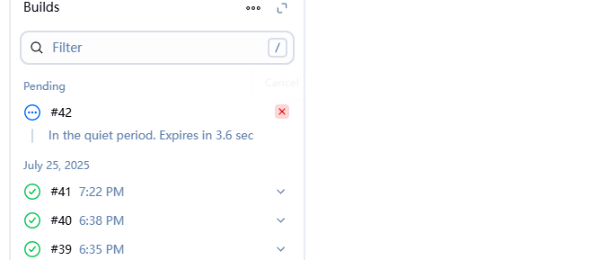
- After the pipeline is successfully built, go back to the page, press Ctrl + F5 to refresh the page. You will notice that the "people" on the page has been changed to "user".
