Scanning Documents

# BEFORE USING THE SCANNER

**REVIEW ALL FOLDER DOCUMENTS:**

Folders may contain different sized documents: letter size (8 ½” x 11”), legal (8 ½” x 14”). Ledger (11” x 17”), maps, surveys, and other larger sized documents. Before you scan, you MUST go through the folder contents and perform the following:✓

|  |  |
| --- | --- |
| * Paper clipped together | Remove all paper clips; after scanning, re-clip the document set with an archival stainless-steel paper clip |
| * Stapled together | Remove all staples using the metal micro-spatula (located in the supply drawer behind the work counter). With the spatula, carefully bend the ends of the staple up to a vertical position, then slide the spatula under the staple and gently pull it out of the document. After scanning, paper clip the document set together with an archival stainless-steel paper clip. |
| * Glued | Gently try to pull glued pages apart; please see a Staff member for assistance or direction if the pages do not easily separate. |
| * Bound | Remove the document binding if possible; please see a Staff Member for assistance or direction if the pages do not easily separate. |
| * Printed on both sides of the paper | If the document can go through the document feeder, and it is two sided, you will need to change the settings to scan both sides.  If it cannot go through the document feeder, you do not need to change the settings. Please be sure to scan both sides manually. |
| * Folded in half, third, or with other documents inside * Multiple sized pages in a document | Open and separate each folded document to select proper scanner page size setting. Change the page size setting from the default (letter) to the appropriate page size; An incorrect setting will result in data loss on your scan.  You can also scan all pages at the ledger setting, but you will need to correctly crop pages as needed to reflect the correct size.  *For odd-sized scans, use a larger setting to ensure that the scan contains all document data.* |
| * “Onion skin” paper | This tissue-like paper will tear in the document feeder. They need to be placed flat on the glass. |
| * Faint printing | Adjust density setting adjustment and retain the same setting for multiple page documents. |
| * Print visible from opposite side | Use Prevent Bleed Through for each page of affected documents. |

# USING THE KYOCERA SCANNER

**LOCATION**:

The Kyocera Scanner is located in NRB 203 (room picture here)

**CLEAN GLASS**

Before you begin to scan, clean the scanner’s glass surface, including all edges of the glass panel. Glass surface wipes are stored under the work counter in NRB 217.

*Leaving any dust or residue on the glass surface creates streaks on your scans and extra time for digital restoration of the image*.

**LOGIN** The login code for the Kyocera is **21701**

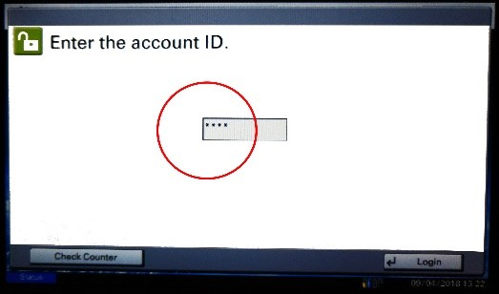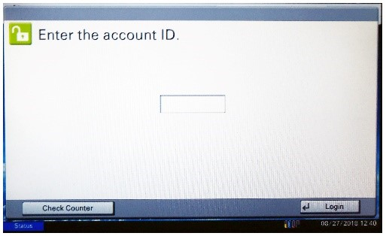

**SET UP SCREENS**

## SELECT SCANNING FUNCTION--The correct program is MINING ARCHIVES

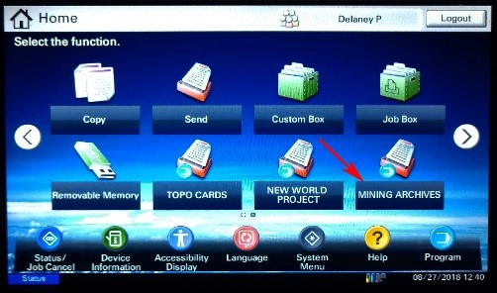

## FILE NAME

### Advanced Setup File Name Entry

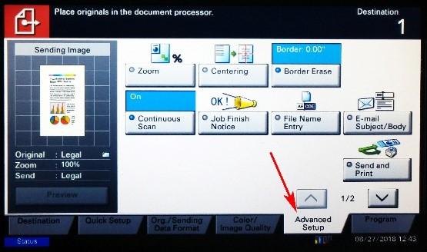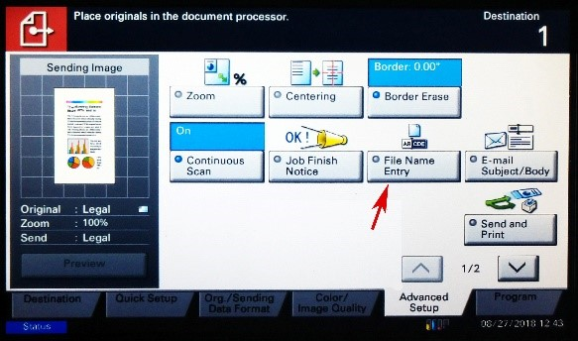

**Backspace to delete “doc”**

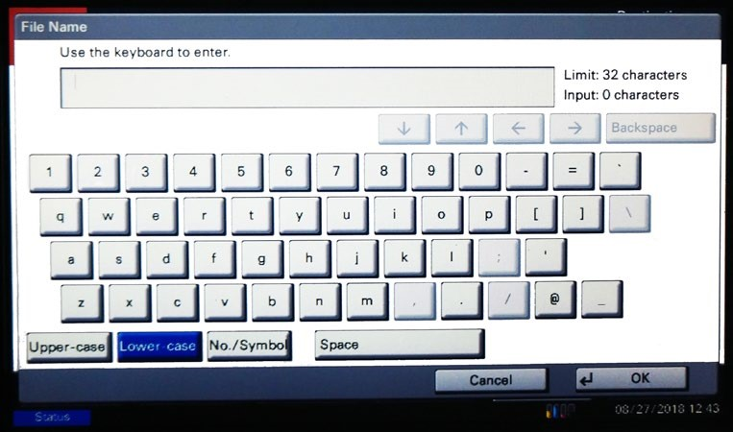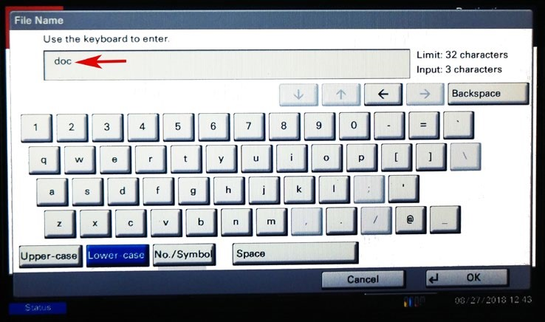

**Enter file Name Click OK**

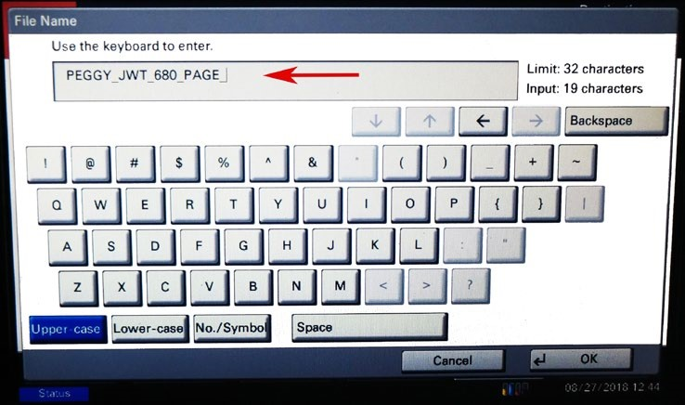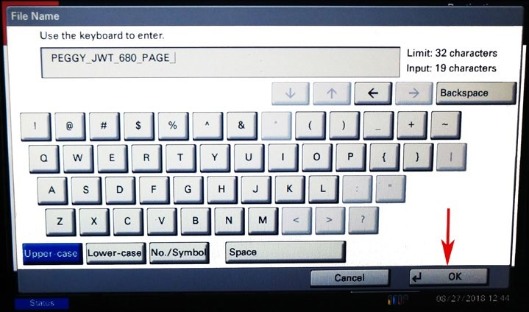

## QUICK SET UP

## 

The Mining Archives program settings apply to the majority of documents. Some documents may require settings changes, including: **Document size, 1-2 sided documents, Density, Color, and Resolution (dpi), PDF quality, document sending format**.

### ORIGINAL DOCUMENT TYPE

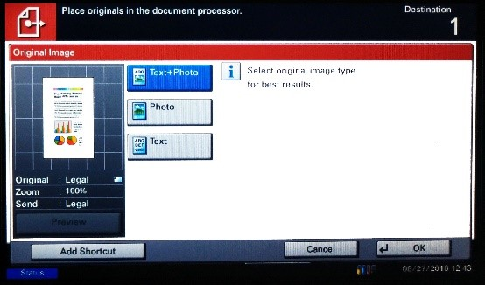*Use the Text/Photo setting, unless directed otherwise by staff.*

### PDF QUALITY

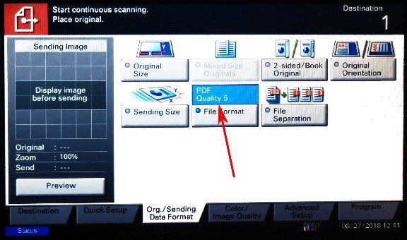

*Use PDF Quality 5 (the program setting), unless directed otherwise by staff.*

***DOCUMENT ORIENTATION***

**Letter Portrait**

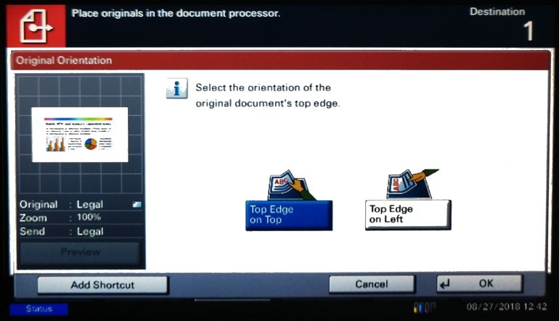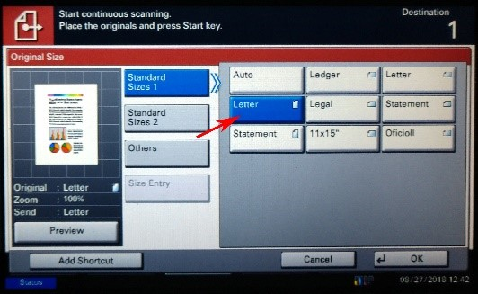

*Use this setting when you sheet feed the letter-sized documents vertically.*

**Letter Landscape**

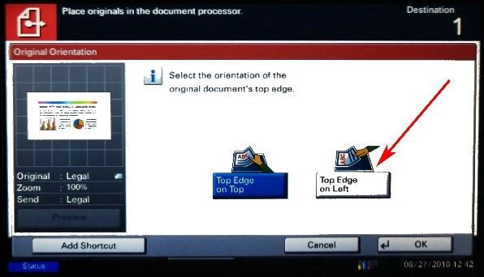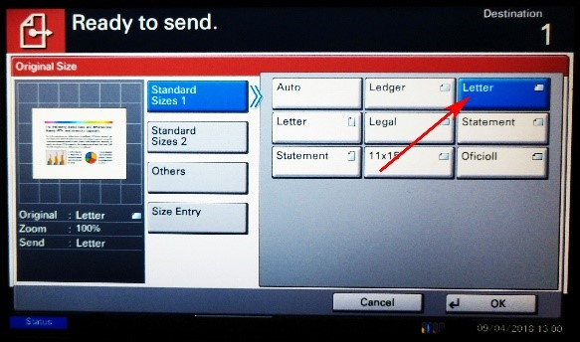

*Use this setting when you sheet feed the letter-sized documents horizontally*.

**Legal Landscape**

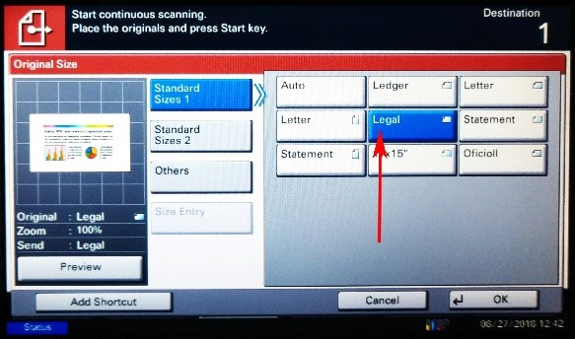

**Ledger Landscape**

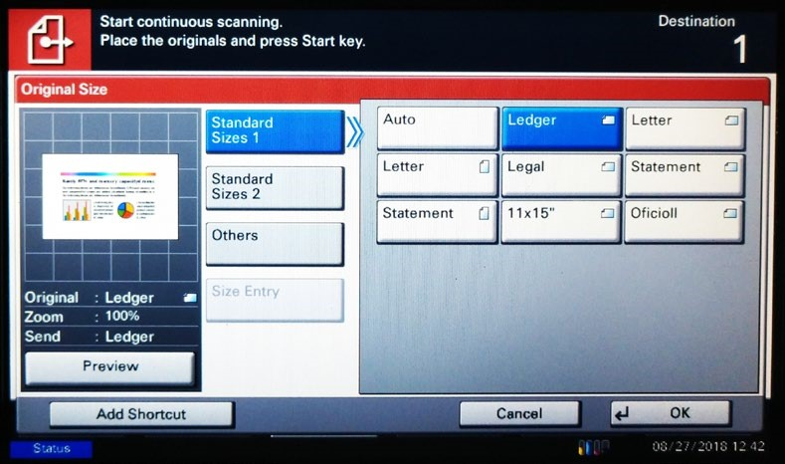

***DOCUMENT SIZE*** *– Select the size of your document*

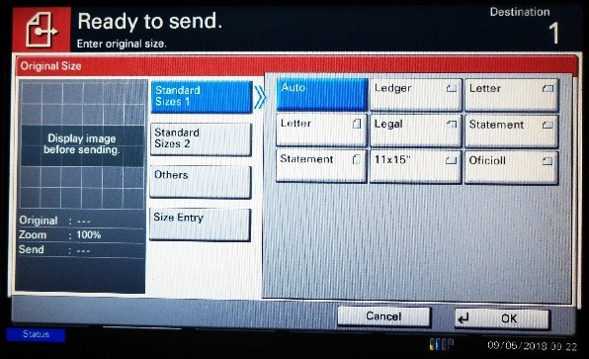

*Select from the standard document sizes listed;* ***Auto*** *programs to the size of the first document scanned.*

***1-2 SIDED SCANNING***

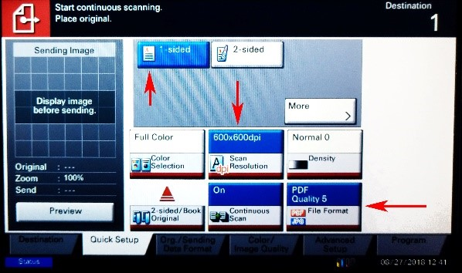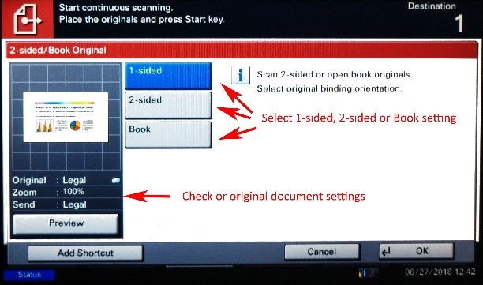

### BOOK SCANNING

*For books bound on the sides, use the Left/Right setting; for books bound on the top, use the Top setting.*

***DOCUMENT COLOR****- Use the program settings, unless instructed by staff*

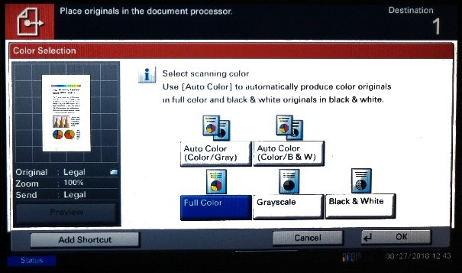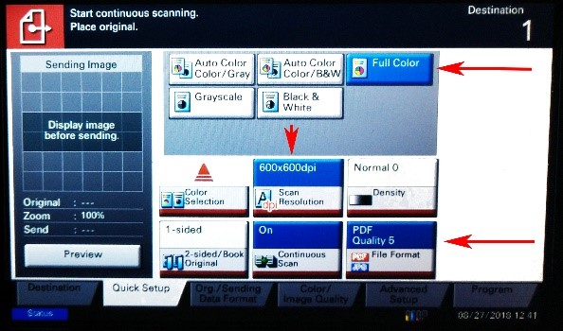

### DOCUMENT SHARPNESS

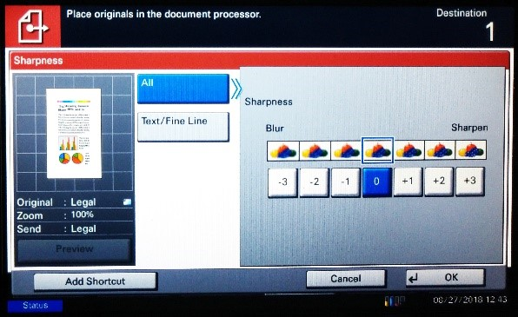

*The program settings work well in most cases; you can make the image sharper by selecting one of the options on this scale, but you will lose some pixilation in doing so.*

***DOCUMENT DENSITY***

*Use the program settings, unless directed otherwise by staff.*

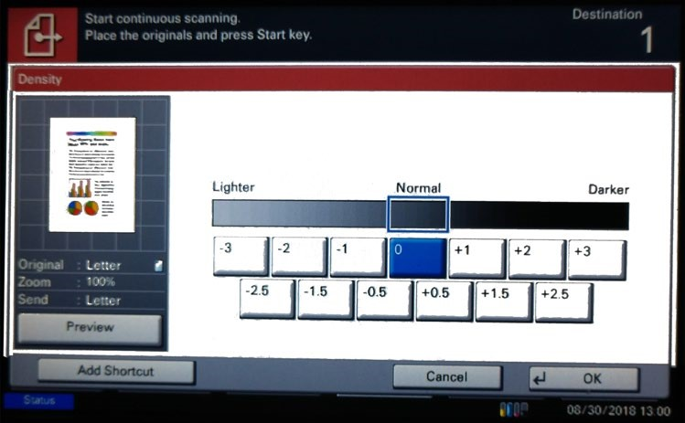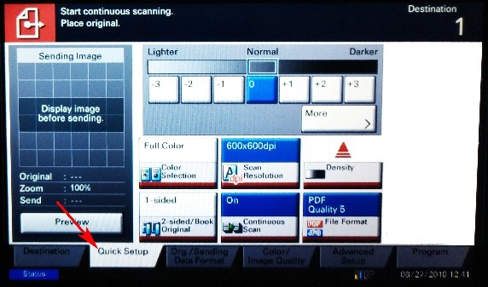

*To increase the density, choose settings with plus symbols. You can refine the scan density if you are not satisfied with the first result.*

### DPI SETTING

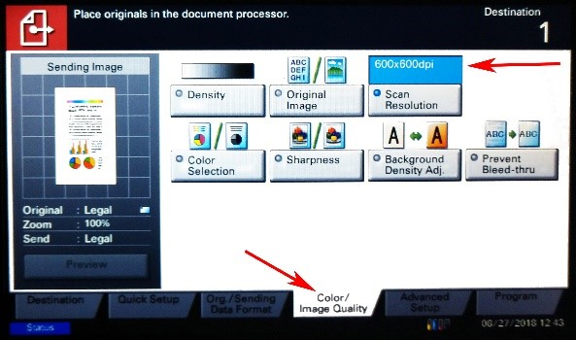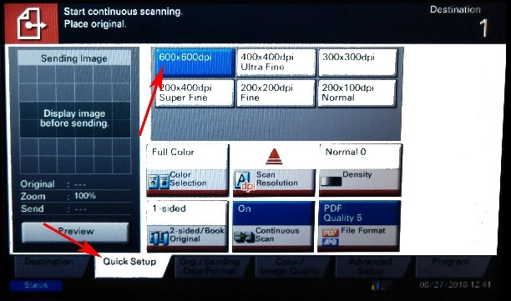

*Use 300 dpi x 300 dpi (the program setting) unless the document is fragile or will not be retained by the MBMG. Discuss any questions with a staff member.*

***ORIGINAL/SENDING DATA FORMAT***

#### SEND IMAGE AS SAME AS ORIGINAL