

DATA PRESERVATION STUDENT EMPLOYEE HANDBOOK

**April 2021**

TABLE OF CONTENTS

DATA PRESERVATION PROGRAM 2

JOB DESCRIPTION: 2

EMPLOYMENT CERTIFICATION FORMS 3

WORK SCHEDULE 3

ORIENTATION AND TRAINING 4

ORIENTATION 4

TRAINING 4

MOODLE 4

**New Employee Training Checklist** 5

**New Employee Training Checklist (cont.)** 5

**New Employee Training Checklist (cont.)** 6

EMERGENCY PROCEDURES: 7

TIME CARDS/PAYMENT SCHEDULE 9

SIGNING IN 9

WORKPLACE ETIQUETTE/BEHAVIOR 10

CLOTHING 10

PERSONAL HYGIENE/FRAGRANCES 10

USE OF OFFICE COMPUTERS 11

PERSONAL USE OF PRINTERS/COPIERS 11

PERSONAL ELECTRONIC DEVICES 11

CONFIDIENTALITY 11

WORKPLACE BEHAVIOR 11

BREAKS 12

SUPPLIES, EQUIPMENT USE & MAINTENAnCE, STUDENT BOXES 12

WORKSTATION MAINTENANCE 12

COPIER/SCANNER USE AND MAINTENANCE 13

STUDENT BOXES 13

EMPLOYMENT TERMINATION 13

## data Preservation Program

In 1919, the Montana State Legislature established the Montana Bureau of Mines and Geology (MBMG). The MBMG now possesses an irreplaceable collection of mining-related data about Montana's mineable resources.

Our repository includes more than 12,000 mining-related maps and thousands of files for almost 5,000 Montana mining properties. The information in individual files varies widely and ranges from engineering, geologic, and historical reports to photographs, mineral surveys, photographs correspondence, and some production information.

When we receive new donations, Data Preservation staff organize and catalogue the files. Objects of enduring value are physically restored as needed, digitized, optimized, and made accessible to the public.

## JOB DESCRIPTION:

**Data Preservation Assistant: Student**

Department: Montana Bureau of Mines and Geology

Employment Detail: Temporary, Part-Time

Hiring Zone: $10.25/hr

Union Affiliation: None

**Primary Duties**: Assist with preserving and archiving of a variety of historic mining, geologic, seismic, and water, oil and gas, coal, and aerial photography information. The position will require extensive use of computer and scanning technology. Successful candidate must be able to lift 25-30 pounds. Responsibilities include, but are not limited to:

* Correctly cataloguing existing and new collections into Microsoft Access databases;
* Cleaning and preparing newly acquired physical collection specimens (e.g., maps, property files, aerial photos, etc.) for long term archival storage;
* Assist with mining property files and maps digitization;
* Assist with reorganization and verification of existing holdings to ensure inventory accuracy.

**Required Qualifications:**

* Advanced computer, copier and scanner skills;
* Excellent attention to detail; precise data entry and filing skills;
* Follows directions exactly;
* Excellent communication and customer service skills.

**Preferred Qualifications:**

* General knowledge of library organization systems.

**How to Apply:**

* Cover letter that addresses the above-mentioned qualifications;
* Resume
* 3 references and complete reference contact information.

## EMPLOYMENT CERTIFICATION FORMS

1. New Employees: Upon receiving an offer of employment, the student must complete the New Employee packet, available from the Enrollment Services, Student Success Center (SSC) , Room 3.126. For more information about Student Employment Opportunities, please see <http://www.mtech.edu/onestop/financial-aid/student-employment/>
2. Returning Employees: Each returning student must complete a new Student Employee Certification form for each academic term in work. Please see a Staff Member for a copy of the form.

## WORK SCHEDULE

**Regular work hours are from 8:00 a.m. to 4:30 p.m., Monday through Friday**.

The Mining Archives Office is closed weekends and on Montana Tech-recognized holidays. Work schedules outside normal office hours must be approved by the Director of the MBMG.

Student work availability, seniority, attendance, and the availability of computer workstations determine your schedule. If you have changes to your availability, please notify supervisors by email as soon as possible to update schedule.

Students may request a change to their normal work schedule by contacting a Staff Member via email, phone, or text with as much notice as possible.

Frequent schedule changes are discouraged and repeated schedule change requests may result in a permanent change in the student’s scheduled hours and re-employment in subsequent terms.

Students may make up missed worked hours on any available computer workstation. Students making up hours will need to move to a different station if a student previously scheduled to work at that station arrives. **Please review the online work schedule for computer station availability when making up missed hours**.

## ORIENTATION AND TRAINING

ORIENTATION**:** Each newly hired student will complete the department’s orientation. The orientation will include an overview of administrative policies and procedures, safety and emergency procedures.

TRAINING**:**

Each Fall term, every student will complete Montana Tech’s required FERPA and EEO training videos. Upon completing of this training, each student will submit a certificate of completion to a Staff Member.

Students will also complete a series of Photoshop training sessions to assist them in becoming proficient in digital document restoration. Students will work on a series of “test” property files to practices different Photoshop techniques. Upon satisfactory completion of the training exercises, Mining Archives Staff will assign archival files to them for restoration.

## Training resources

The Student Handbook, student orientation, Photoshop training, and other procedures are available at : <https://data-preservation-documentation.onrender.com/>

Mining Archives staff will provide new and returning student employees with this link to begin their orientation and training. Student employees must complete orientation and training during their scheduled work hours, and the link is accessible at any time to reference or to refresh training.

| **New Employee Training Checklist** | |
| --- | --- |
|  | |
| Employee Name |  |
| Training Start Date |  |
| Training End Date |  |

|  |  |  |  |
| --- | --- | --- | --- |
| **Administrative Orientation** | | **Reviewed** | **Completed** |
|  | Sign-In Sheet |  |  |
|  | Schedule Check/Station Identified |  |  |
|  | Mapping Network Drive |  |  |
|  | Property File Page Count |  |  |
|  | Review Folders in Student Folder with Printed Map |  |  |
|  | Schedule Changes and Contacts |  |  |
|  | Digital Devices and Other Distractions |  |  |
|  | Station Cleaning |  |  |
|  | Student Work Box |  |  |
|  | Work Counter/Supplies/Tools |  |  |
|  | Shut Down Stations |  |  |
|  | Location/Arrangement Map/Property Files |  |  |

| **New Employee Training Checklist (cont.)** |
| --- |

|  |  |  |  |
| --- | --- | --- | --- |
| **Safety CHECKLIST** | | **Practiced** | **Completed** |
|  | Emergency Evacuation Instructions |  |  |
|  | Emergency Instructions |  |  |
|  | Evacuation Area Location and Exit Routes |  |  |
|  | Fire Extinguisher Locations |  |  |
|  | AED Locations |  |  |
|  | Bomb Threats |  |  |

|  |  |  |  |
| --- | --- | --- | --- |
| **Scanner Skills CHECKLIST** | | **Practiced** | **Completed** |
|  | Log In |  |  |
|  | Preset Programs |  |  |
|  | Page Size/Orientation |  |  |
|  | Density |  |  |
|  | Prevent Bleed Through |  |  |
|  | File Name Entry |  |  |
|  | Single/Double Page |  |  |
|  | Scan with Feeder or “on the glass” |  |  |
|  | Finish Scan |  |  |
|  | Logging out |  |  |
|  | Scanner Cleaning |  |  |
|  | Printing Source Paper Trays and Output Trays |  |  |

|  |  |  |  |
| --- | --- | --- | --- |
| **Skills CHECKLIST** | | **Practiced** | **Completed** |
|  | Photoshop Basic Tools |  |  |
|  | Background Construction |  |  |
|  | Using Layers |  |  |
|  | Using Lasso Tool |  |  |
|  | Straightening Pages |  |  |
|  | Brush Tool Tips |  |  |
|  | Healing Brush Tool Tips |  |  |
|  | More Brush Tool Tip |  |  |
|  | Dodge, Burn, and Clone Stamp Tool Tips |  |  |
|  | Pattern Stamp Tips |  |  |
|  | Dust and Scratches Filter Tips |  |  |
|  | Lasso, Polygonal Lasso, and Magnetic Lasso Tips |  |  |

| **New Employee Training Checklist (cont.)** |
| --- |

|  |  |  |  |
| --- | --- | --- | --- |
|  | Levels and Curves Adjustments |  |  |
|  | Spot Healing Brush and Patch Tool Tips |  |  |
|  | Free Transform |  |  |
|  | Color Range Copy and Paste |  |  |
|  | Blank Page Instructions |  |  |
|  | Darkening Light Text |  |  |
|  | Color Range |  |  |
|  | Shared Photoshop Tips |  |  |
|  | Access Database File Tracking |  |  |
|  | Recreating Text |  |  |
|  | File Naming |  |  |
|  | Cropping Tool |  |  |
|  | Style Sheet |  |  |

### EMERGENCY PROCEDURES:

Each student employee will be trained on Montana Tech’s Emergency procedures and will participate in Emergency Evacuation drills when they occur during work hours.

During a drill or actual emergency evacuation, all staff and students will leave the NRB and proceed to Assembly Area 3 (see below)

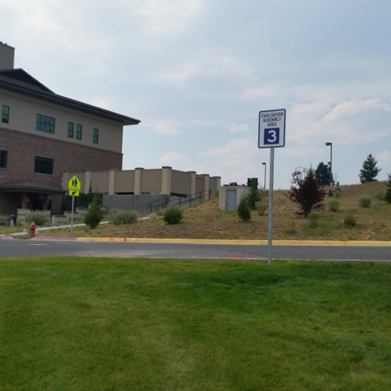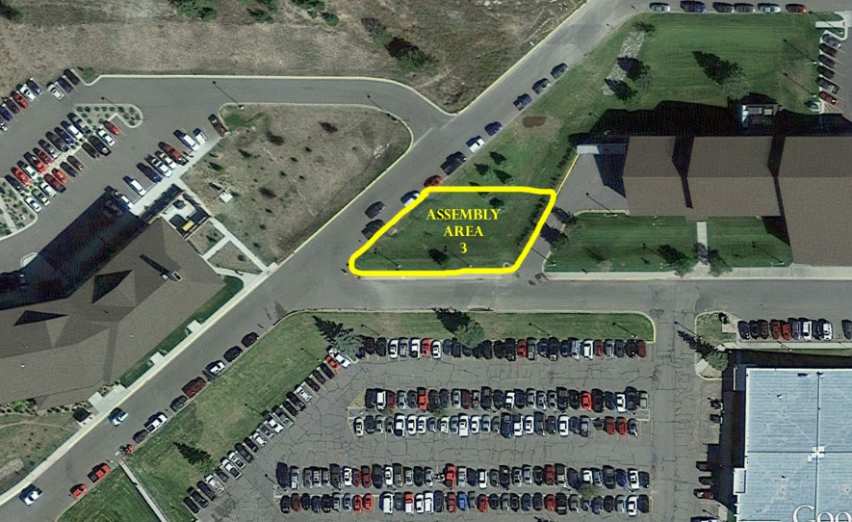

When you reach the assembly area:

1. Login into My Mtech through your phone’s browser and scroll down to the I’m Safe banner and press “I just evacuated a Montana Tech building or am sheltering in place”
2. If you do not use a cell phone or not registered to use the app, please sign in manually with an emergency assistant at the assembly area. They should be wearing an orange vest, carrying an orange flag, and holding a clipboard.

**YOU MUST USE THE APP OR SIGN IN MANUALLY FOR BOTH DRILLS AND ACTUAL EMERGENCIES.** These are the only ways that emergency personnel can account for your location or render assistance if you did not safely evacuate a building. A brief summary of emergency procedures follows. These instructions are posted in both NRB 202 and NRB 217 for easy reference.

This section will be updated with information about the Montana Tech App as more information becomes available.

**EMERGENCY INSTRUCTIONS**

**WHERE YOU ARE LOCATED**

**NATURAL RESOURCES BUILDING:**

**Room 217**

**Room 202**

**For any emergency posing an immediate threat to safety & health, property or the environment, follow the emergency response plan below.**

Err on the side of caution. If the nature of the emergency is unknown or the procedures to follow for a particular emergency are unknown, follow this basic emergency plan. Use common sense when responding to emergencies.

If human life is in danger, such as with an explosion or large fire, evacuate the building first, and call 911 and Maintenance from outside the building. Otherwise, call 911 & Maintenance first.

If an act of violence occurs, you may need to lockdown where you are. Close and lock doors and windows, turn off lights, lie on the floor and be quiet.

In the event of a radiation or hazardous materials event or some similar situation, shelter-in-place. Go to interior room (one without windows), if available, close doors and windows, seal gaps around any openings. Turn off ventilation if possible.

**Call 911 and identify:**

**Who you are**

**Exact Location of emergency**

**Nature of emergency**

**Number of injured people**

**Any hazardous materials involved**

**Evacuate building – pull fire alarm. For a bomb threat, DO NOT pull fire alarm; use the telephone. Notify occupants in person.**

**Call EH&S (4463) & Campus Security (4357), who will notify Physical Plant.**

**Be available to meet emergency responders.**

**Lockdown or shelter-in-place if situation warrants.**

## TIME CARDS/PAYMENT SCHEDULE

1. Student employees will be paid on a bi-weekly payroll. Preprinted timecards must be completed by each student ***no later than end on the last day of the pay period***. Late timecards will be processed on the next regularly scheduled payroll.
2. All timecards must be completed in ink. Be sure to double check that:

1) student ID number is correct;

2) hours on your timecard match those logged in on the computer-tracking sheet;

3) weekly total hours are correct; and

4) time card is signed and dated.

Students who are unable to complete their time card, due to unplanned absences from work, may submit their hours to a Staff Member by phone or email. The Staff Member will review the timecard for accuracy and ensure the timecard is submitted to the Payroll department. The student must go to Payroll to sign the card upon their return to campus. **This is an exception to procedure and is rarely used.**

## SIGNING IN

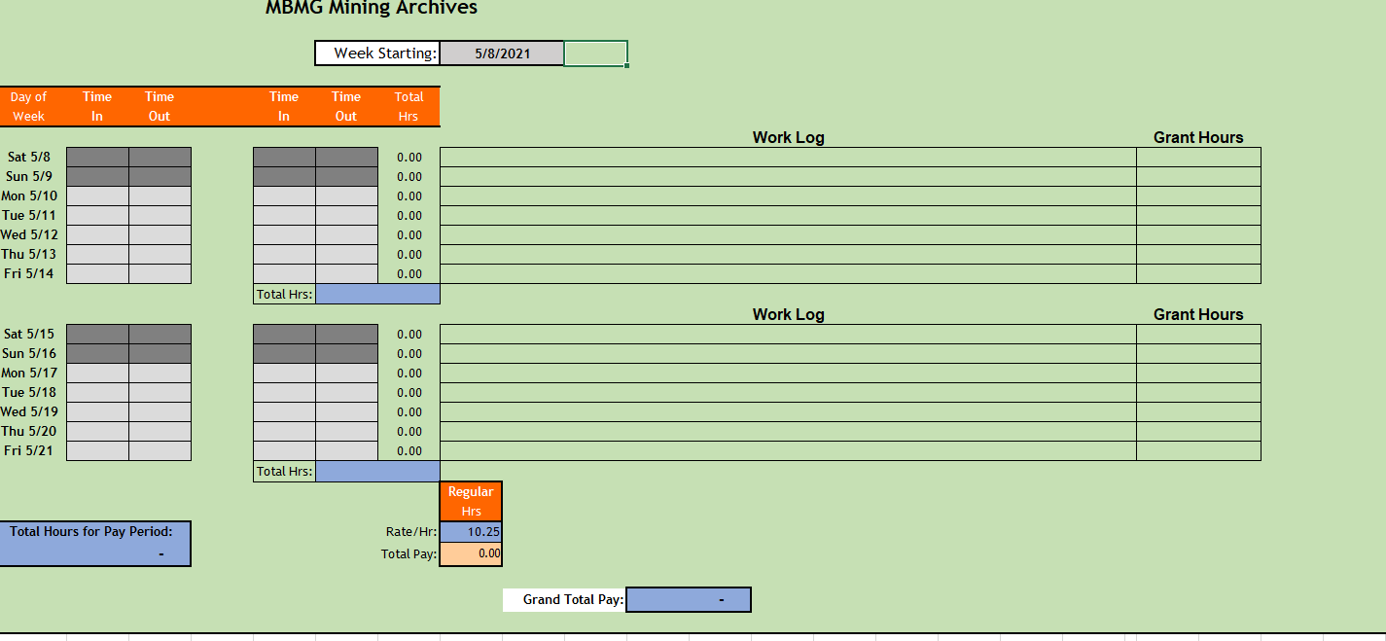

Each student has an Excel spreadsheet to record their work. Accurately signing in and out on the left side of the sheet calculates your daily worked hours and assists in completing Montana Tech time cards.

Students will sign in and out on their Timekeeping and Work Log for that pay period (mbmgs1a/Mining Archives/Working Folder/#Tracking Spreadsheets). Please be accurate when signing in and out.

In the Work Log portion, please record the work you completed. If you are working on the county property files, please record both the county and the property names. If you are working on a grant funded project, please record that and note the number of hours in the far-right column.

Please use the quarter system when filling in hours on your timecards.

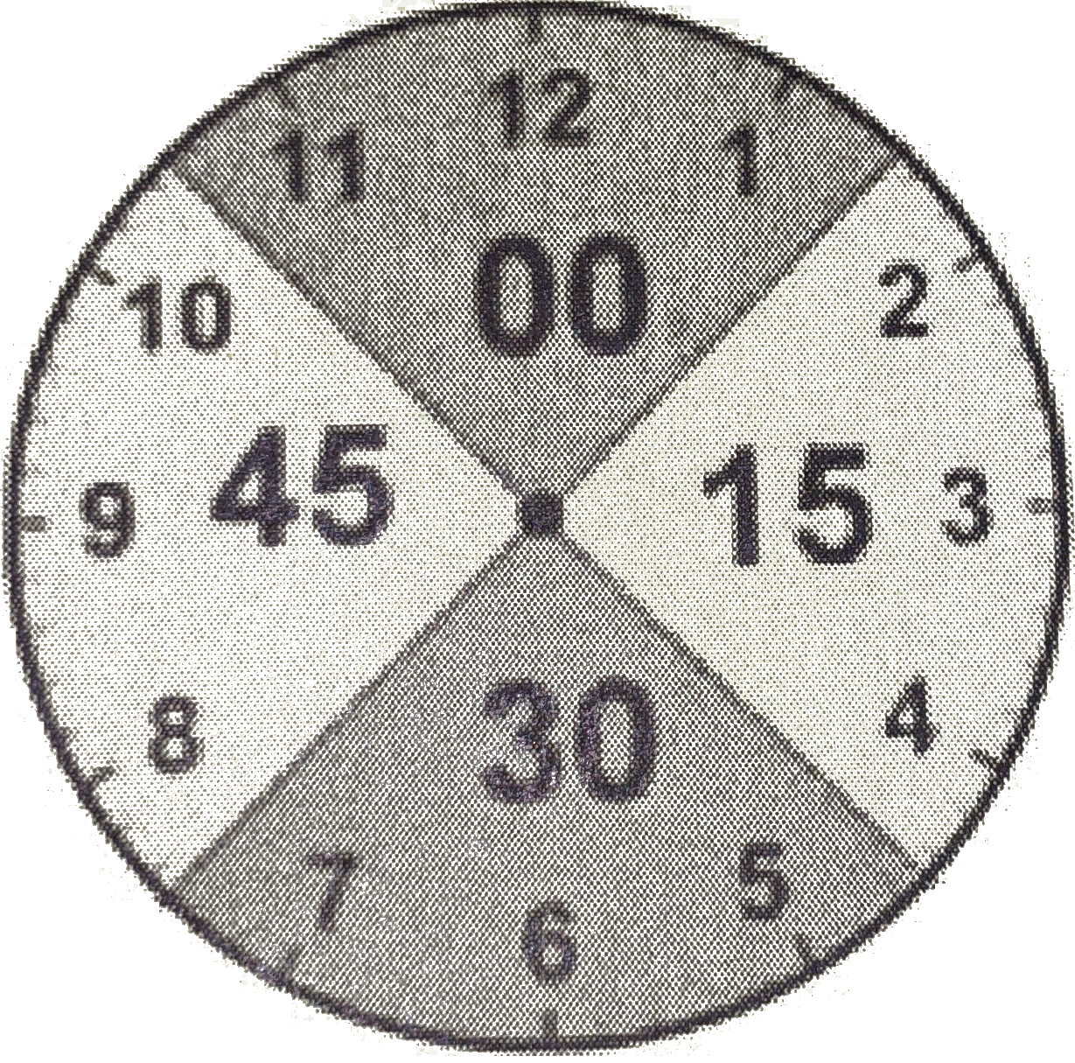

## WORKPLACE ETIQUETTE/BEHAVIOR

Our department wants to convey a professional approach in the way we:

✔ conduct ourselves ✔our appearance

✔our service to customers ✔ our work ethic

### CLOTHING

The work we perform in Mining Archives often involves desk and computer work. It may sometimes involve moving large boxes, rock specimens and core, climbing ladders, and lifting heavy boxes and files. Due to the variety of work tasks an employee may perform, casual attire in the office is acceptable with the following conditions:

* Wear clothes that are in good repair for the job you will be performing in the department;
* Do not wear anything that may be considered offensive by co-workers or visitors
* If you are in doubt if a clothing item is acceptable, ASK. Yoga pants, hats, sweatpants, bare midriffs, low cut tops and bottoms, sleepwear, and open toed shoes are not acceptable.

### PERSONAL HYGIENE/FRAGRANCES

Anyone in close contact with others should bathe or shower REGULARLY. Go easy on perfumes, fragrant soaps, or after-shave, as some people are extremely sensitive to even mild fragrances. If you have questions about any of the clothing or hygiene policies, please direct them to the a Staff Member.

### USE OF OFFICE COMPUTERS

Office computer are for department use only. **NEVER** load software on any department computer. Violation of this policy is grounds for immediate termination. ***Reading web articles, playing games, watching TV or movies, or any other video streaming on computers, personal cell phones, or other personal devices during working hours is not permitted.***

### PERSONAL USE OF PRINTERS/COPIERS

Printing and copying for personal use (including coursework) is discouraged. Printers and copiers for student use are available in several labs and designated office throughout the Montana Tech Campus.

If you need to make a personal copy (paper), please see a Staff Member. You will be charged $0.10 for each hard copy made. Double-sided copies are as two single copies.

### PERSONAL ELECTRONIC DEVICES

#### CELLPHONES.

Use of cellphones during scheduled work hours is PROHIBITED. Please inform your friends, family and other contacts that you will not interact with them electronically during your scheduled hours. Department staff will note violations of this policy. A third violation is grounds for termination.

**DEVICES/HEADPHONES.**

Students may listen to music or audio books using their devices and headphones. If you are listening to audio that has an attached video, you must minimize that screen so that it does not distract you from your work.

#### LAPTOPS.

Use of student laptops during scheduled work hours is NOT ALLOWED.

### CONFIDIENTALITY

We DO NOT provide personal information about our customers, students, or staff members to anyone. Refer any such requests to any available Staff Member .

### WORKPLACE BEHAVIOR

The Mining Archives department strives for a positive and collaborative work environment by supporting the following behaviors:

1. *Positive communication*. All employees will treat each other with kindness, respect and appreciation. Our office welcomes and embraces differences in culture, dress, and ethnicity. Communication that creates fear, domination, bullying, sexual harassment or intimidation is not acceptable and not tolerated. Be aware and use the information from Montana Tech’s mandatory FERPA and EEO training when communicating in the office.

Please be considerate of other professionals working in adjacent offices. **In all work spaces and in the hallways, conversations should be held quietly.**

1. *Collaboration*.Recognize that each individual in our office has unique talents and expertise. Be willing to share them with each other in the department. If you find a better way to do your job, share it with other employees in the office. Working together, our employees develop the best solutions to problems and the best product we can deliver to our customers.
2. *Commitment to excellence.* We are here to complete our work in an efficient, professional, and productive manner. Strive to create and deliver quality work in our department. Take responsibility for your actions and decisions.
3. *Work productively.* Casual conversation among employees is acceptable, as long as it does not negatively affect an employee’s productivity.

### BREAKS

Student employees are encouraged to take a 15-minute break for each 2 consecutive hours they work. Students may also take a 30-minute, unpaid meal. Students are encouraged to eat in the NRB third floor conference room.

## SUPPLIES, EQUIPMENT USE & MAINTENAnCE, STUDENT BOXES

### WORKSTATION MAINTENANCE

When your work shift is over, turn your computer off and wipe clean your computer monitor, keyboard and workstation. It is a sanitary habit to get into that helps prevent the spread of Covid, colds, and flu in the office. Turn your keyboard upside down and shake it out. Use canned air to blow out any stubbornly lodged dust or debris.

Personal items should not interfere with work areas; remove, clean, and organize them after each shift. You may store personal items in your assigned storage. Throw away loose tissues, even if unused. Return files to compact storage, submit them for quality assurance, or place them in your work mailbox. Any other papers must be removed or placed in your work mailbox.

Cleaning supplies are located in the shelves at our work counter. If you need additional cleaning supplies, please notify a Staff Member.

### COPIER/SCANNER USE AND MAINTENANCE

The Kyocera Scanner/Copier is located in NRB 203 across the hall from the Mining Archives department. When using the machine, please wipe the glass top before and after its use. (Kyocera use and cleaning will be part of New Employee Orientation).

Be sure to discard all removed staples in a nearby trashcan. Take any paper clips, folders, rubber bands, and other items that may be included with the file you are working on with you when you are finished.

If a toner cartridge needs to be replaced, please see a Staff Member for assistance.

### STUDENT BOXES

Each student employee is assigned a mailbox and a storage drawer, located at the computer work stations. Students will place the files they are working on into their folder at the end of each work session. Staff will place time cards, important announcements, and instructions to student employees in the boxes as well.

## EMPLOYMENT TERMINATION

1. Each student will notify a Staff Member (via email or in writing) of their intent to terminate employment two weeks prior to their final day of employment.
2. Students will make every effort to complete work on their currently assigned file prior to their last day of employment. If work completion is not feasible, please notify a Staff Member so they can re-assign the file to another student.
3. Students must complete and sign their time card for the current period and submit it to a Staff Member. Failure to do so may result in a delay of payment.