**C++ Part II (INFO1-CE9265) Spring 2015 – Homework 5**

Clement Chan

**Question 1:**

**Main.cpp**

#include<iostream>

#include<string>

using namespace std;

int fibonacci(int n){

int f0 = 1;

int f1 = 1;

if(n == 0){

return f0;

}else if(n==1){

return f1;

}else if (n > 1){

return fibonacci(n-1) + fibonacci(n-2); //Adding the second number with the first number

}

}

int main(){

//Generating the first 20 numbers in the Fibonacci Sequence out of the function below

for(int i=0; i<21; i++){

cout<<"F"<< i << " in fibonacci sequence is: " << fibonacci(i)<<endl;

}

return 0;

}

**Output**

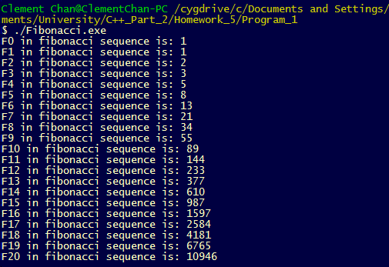

**Question 5:**

Hanoi Tower

**Main.cpp**

#include <iostream>

#include <stdio.h>

#include <string.h>

using namespace std;

class HanoiPost{

public:

static string hanoi(int, int, int);

};

string HanoiPost::hanoi(int nDisks, int from, int to){

int help;

string Move_Nmin1_1_2, Move_Nmin1_2_3 , Move_N, mySol;

if(nDisks == 1){

cout<<from << " -> " << to << endl;

return from + " -> " + to + '\n';

}

else{

help = 6 - from - to;

Move_Nmin1_1_2 = hanoi(nDisks-1, from, help);

Move_N = from + "->" + to + '\n';

cout<< from << " -> " << to << endl;

Move_Nmin1_2_3 = hanoi(nDisks-1, help, to);

mySol = Move_Nmin1_1_2 + Move_Nmin1_2_3 + Move_N;

return mySol;

}

}

int main(){

int n = 3;

int n1 = 4;

int n2 = 5;

HanoiPost HP;

string StepstoSol;

cout<<"The scenario with "<< n << " bricks is with the following moves: " << endl;

StepstoSol = HP.hanoi(n,1,3);

cout<<" " << endl;

cout<<"The scenario with " << n1 << " bricks is with the following moves: " << endl;

StepstoSol = HP.hanoi(n1,1,3);

cout<<" " << endl;

cout<<"The scenario with " << n2 << " bricks is with the following moves: " << endl;

StepstoSol = HP.hanoi(n2,1,3);

cout<<" " << endl;

return 0;

}

**Output**

