**C++ Part I (INFO1-CE9264) Fall 2014 – Homework 4**

Clement Chan

**Question 1 – Rainfall**

#include <iostream>

#include <stdio.h>

#include <cmath>

using namespace std;

//Define the number of arrays and size

const int NUM_MONTHS = 12;

double average_monthly_rainfall[NUM_MONTHS];

double prev_months[NUM_MONTHS];

double diff[NUM_MONTHS];

//Define the Method classes that will input the average and actual arrays

void Inputaverage();

void Input_prev_months(int month_integer);

void calcdiff(double a[], double b[], double c[], int month);

void Output(double a[], double b[], double c[], int month, char option);

//Main Body

int main(){

int month;

char opt;

char ans;

Inputaverage();

cout<< "Please enter the current month in the following format (Jan = 1, Feb = 2, Mar = 3 , Apr = 4 ... ): " << endl;

cin >> month;

Input_prev_months(month);

calcdiff(average_monthly_rainfall, prev_months, diff, month);

do{

cout<<"Please choose how to display the data : (c for chart, t for table)"<<endl;

cin >> opt;

Output(average_monthly_rainfall, prev_months, diff, month, opt);

cout<<"Choose another display option? (y/n)" << endl;

cin >> ans;

} while (ans == 'y' || ans == 'Y');

return 0;

}

//InputAverage Definition

void Inputaverage(){

double input_average_rainfall;

cout<<"Enter average rainfall (mm) since January: " << endl;

for(int i = 0; i < NUM_MONTHS; i++){

if(i == 0){

cout << "Jan: " <<endl;

}

if(i == 1){

cout << "Feb: " <<endl;

}

if(i == 2){

cout << "March: " <<endl;

}

if(i == 3){

cout << "April: " <<endl;

}

if(i == 4){

cout << "May: " <<endl;

}

if(i == 5){

cout << "Jun: " <<endl;

}

if(i == 6){

cout << "Jul: " <<endl;

}

if(i == 7){

cout << "Aug: " <<endl;

}

if(i == 8){

cout << "Sep: " <<endl;

}

if(i == 9){

cout << "Oct: " <<endl;

}

if(i == 10){

cout << "Nov: " <<endl;

}

if(i == 11){

cout << "Dec: " <<endl;

}

cin >> input_average_rainfall;

average_monthly_rainfall[i] = input_average_rainfall;

};

}

//InputPreviousMonths Definition

void Input_prev_months(int month_integer){

double rainfall;

month_integer -= 1;

cout<< "Enter the monthly rainfall in the previous 12 months: " << endl;

for (int i = 0 ; i < NUM_MONTHS ; i++){

if((month_integer + (i+1)) % 12 == 0){

cout << "Pre Jan : " <<endl;

}

if((month_integer + (i+1)) % 12 == 1){

cout << "Pre Feb: " <<endl;

}

if((month_integer + (i+1)) % 12 == 2){

cout << "Pre March: " <<endl;

}

if((month_integer + (i+1)) % 12 == 3){

cout << "Pre April: " <<endl;

}

if((month_integer + (i+1)) % 12 == 4){

cout << "Pre May: " <<endl;

}

if((month_integer + (i+1)) % 12 == 5){

cout << "Pre Jun: " <<endl;

}

if((month_integer + (i+1)) % 12 == 6){

cout << "Pre Jul: " <<endl;

}

if((month_integer + (i+1)) % 12 == 7){

cout << "Pre Aug: " <<endl;

}

if((month_integer + (i+1)) % 12 == 8){

cout << "Pre Sep: " <<endl;

}

if((month_integer + (i+1)) % 12 == 9){

cout << "Pre Oct: " <<endl;

}

if((month_integer + (i+1)) % 12 == 10){

cout << "Pre Nov: " <<endl;

}

if((month_integer + (i+1)) % 12 == 11){

cout << "Pre Dec: " <<endl;

}

cin >> rainfall;

prev_months[i] = rainfall;

};

}

//Calculate difference calculations

void calcdiff(double a[], double b[], double c[], int month){

month -= 1;

for (int i = 0 ; i < NUM_MONTHS ; i++){

double temp = a[(month + (i+1)) % 12];

double temp1 = b[i];

c[i] = temp - temp1;

}

}

//Output

void Output(double a[], double b[], double c[], int month, char option){

char* month_name;

month -= 1;

for (int i = 0; i < NUM_MONTHS ; i++){

double temp = a[(month + (i+1)) % 12]; //collect all the arrays value for average

double temp1 = b[i]; // collect all the arrays value for previous 12 months

if((month + (i+1)) % 12 == 0){

month_name = "Jan";

}

if((month + (i+1)) % 12 == 1){

month_name = "Feb";

}

if((month + (i+1)) % 12 == 2){

month_name = "Mar";

}

if((month + (i+1)) % 12 == 3){

month_name = "Apr";

}

if((month + (i+1)) % 12 == 4){

month_name = "May";

}

if((month + (i+1)) % 12 == 5){

month_name = "Jun";

}

if((month + (i+1)) % 12 == 6){

month_name = "Jul";

}

if((month + (i+1)) % 12 == 7){

month_name = "Aug";

}

if((month + (i+1)) % 12 == 8){

month_name = "Sep";

}

if((month + (i+1)) % 12 == 9){

month_name = "Oct";

}

if((month + (i+1)) % 12 == 10){

month_name = "Nov";

}

if((month + (i+1)) % 12 == 11){

month_name = "Dec";

}

if (option == 'c'){

cout << "Ave Rainfall in " << month_name << " " << "|";

for(int j = 1; j <= temp; j+=5){

cout<< '*';

}

cout<< " "<<endl;

cout << "Pre Rainfall in " << month_name << " " << "|";

for(int j = 1; j <= temp1; j+=5){

cout << '*';

}

cout<< " " << endl;

}

if (option == 't'){

cout << "Month" << " " << "Ave Rainfall" << " " << "Pre Rainfall" << " " << "Diff" << endl;

cout << month_name << " " << a[(month + (i+1)) % 12] << " " << b[i] << " " << c[i] << endl;

}

}

}

**Output:**

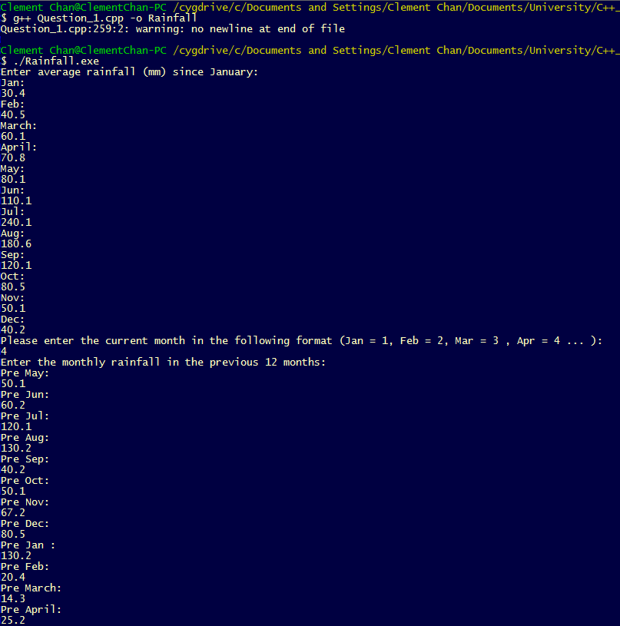

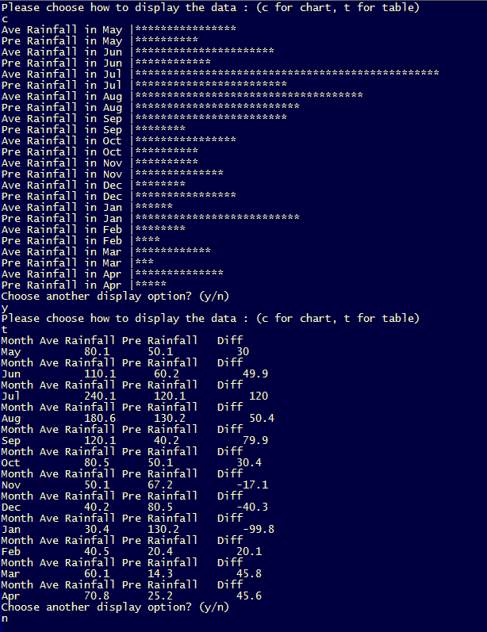

**Question 2 – Standard Deviation**

#include <stdio.h>

#include <math.h>

#include <iostream>

using namespace std;

const int MAX_NUM = 100;

double FULL_LIST[MAX_NUM];

double std_deviation_calc(double a[], int size);

int main(){

double standard_dev;

double p_list[] = {10,20,5,3,1};

int size_of_p_list = sizeof(p_list) / sizeof(double); //since each number included are double, therefore size 8 of double is divided.

standard_dev = std_deviation_calc(p_list, size_of_p_list);

cout<<"Standard Deviation of the array is: " << standard_dev;

return 0;

}

//Standard deviationa calculation

double std_deviation_calc(double a[], int size){

double sum = 0;

double temp;

double average;

double std;

double sum_x_x_ave = 0;

for(int i = 0; i < size; i++){

FULL_LIST[i] = a[i];

temp = a[i];

sum += temp;

}

average = sum / size;

for(int i=0; i < size; i++){

temp = FULL_LIST[i];

FULL_LIST[i] = pow(temp - average, 2.0);

temp = FULL_LIST[i];

sum_x_x_ave += temp;

}

std = sqrt(sum_x_x_ave/size);

return std;

}

**Output:**

**Question 3 – Student’s Scores**

**Stack.h**

#include <cstddef>

//Define the structure class

struct node{

int data;

node *next;

};

node *Head = NULL;

//Define the class that uses data structures

class PushPop{

public:

void push(int element);

int pop();

};

void PushPop::push(int element){

node *temp = new node();

temp -> data = element;

temp -> next = Head;

Head = temp;

}

int PushPop::pop(){

int result;

node *temp = new node();

result = Head -> data;

temp = Head -> next;

delete Head;

Head = temp;

return result;

}

**Question_7.cpp**

#include "Stacks_Class.h"

#include <iostream>

#include <stdio.h>

using namespace std;

//Define global variablses and Arrays

int count_scores[] = {0,0,0,0,0,0};

int count_students = 0;

void EnterScores(int &scs);

void InsertBucket(int &scs);

void Output(int a[]);

int main(){

char ans;

int scores;

//Calling the stack class

PushPop PP;

do{

EnterScores(scores);

PP.push(scores);

InsertBucket(scores);

cout<<"Is this the whole list ? (y/n)" << endl;

cin >> ans;

} while(ans == 'n' || ans == 'N');

//Displaying inputed scores

int student_s[count_students];

for(int i = (count_students -1) ; i >= 0 ; i--){

student_s[i] = PP.pop();

}

for (int i = 0; i < count_students ; i++){

cout << "Student " << i + 1 << " score is " << student_s[i] << endl;

}

//Displaying count statistics

Output(count_scores);

}

void EnterScores(int &scs){

cout << "Please enter the student's score (0-5): " << endl;

cin >> scs;

if(scs > 5 || scs < 0){

printf("Please Re-enter");

exit(0);

}

count_students++;

}

void InsertBucket(int &scs){

count_scores[scs] += 1;

}

void Output(int a[]){

for (int i = 0; i < 6 ; i++){

cout << a[i] << " grade(s) of " << i << endl;

}

}

**Output:**

Inserting data:

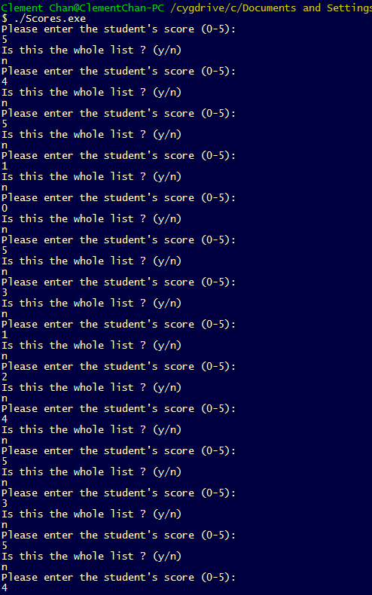

Output of results:

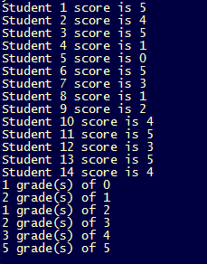

**Question 4—Plane’s Seats**

#include <stdio.h>

#include <iostream>

using namespace std;

//Define the size of rows and columns

const int Row = 7;

const int Col = 5;

char seatmap[Row][Col];

//Function designs

void seatmapdesign();

void DisplaySeat();

void InsertSeat(int &rows, char &columns, int &intcolumns);

void MarkSeat(int &rows, int &intcolumns);

int main(){

int r;

char c;

char ans;

int ic;

seatmapdesign();

do{

DisplaySeat();

InsertSeat(r, c, ic);

MarkSeat(r,ic);

DisplaySeat();

cout << "Mark Another seat? (y/n)" << endl;

cin >> ans;

}while (ans == 'y' || ans == 'Y');

return 0;

}

void seatmapdesign(){

for(int j = 0; j < Col ; j++){

for(int i = 0; i < Row ; i++){

if(j == 0) {

if(i == 0){

seatmap[i][j] = '1';

}

if(i == 1){

seatmap[i][j] = '2';

}

if(i == 2){

seatmap[i][j] = '3';

}

if(i == 3){

seatmap[i][j] = '4';

}

if(i == 4){

seatmap[i][j] = '5';

}

if(i == 5){

seatmap[i][j] = '6';

}

if(i == 6){

seatmap[i][j] = '7';

}

}

if(j == 1) {

seatmap[i][j] = 'A';

}

if(j == 2) {

seatmap[i][j] = 'B';

}

if(j == 3) {

seatmap[i][j] = 'C';

}

if(j == 4) {

seatmap[i][j] = 'D';

}

};

};

}

void DisplaySeat(){

int j = 0;

for(int i = 0; i < Row ; i++){

cout<<seatmap[i][j]<< " " << seatmap[i][j+1] << " " << seatmap[i][j+2] << " " <<

seatmap[i][j+3]<< " " << seatmap[i][j+4] << endl;

};

}

void InsertSeat(int &rows, char &columns, int &intcolumns){

cout << "Please enter the seat row: " << endl;

cin >> rows;

cout << "Please enter seat letter: " << endl;

cin >> columns;

if(columns == 'A'){

intcolumns = 1;

}

if(columns == 'B'){

intcolumns = 2;

}

if(columns == 'C'){

intcolumns = 3;

}

if(columns == 'D'){

intcolumns= 4;

}

}

void MarkSeat(int &rows, int &intcolumns){

rows -=1;

seatmap[rows][intcolumns] = 'X';

}

**Output:**

