**C++ Part II (INFO1-CE9265) Spring 2015 – Homework 5**

Clement Chan

**Question 1:**

**Main.cpp**

#include<iostream>

#include<string>

using namespace std;

int fibonacci(int n){

int f0 = 1;

int f1 = 1;

if(n == 0){

return f0;

}else if(n==1){

return f1;

}else if (n > 1){

return fibonacci(n-1) + fibonacci(n-2); //Adding the second number with the first number

}

}

int main(){

//Generating the first 20 numbers in the Fibonacci Sequence out of the function below

for(int i=0; i<21; i++){

cout<<"F"<< i << " in fibonacci sequence is: " << fibonacci(i)<<endl;

}

return 0;

}

**Output**

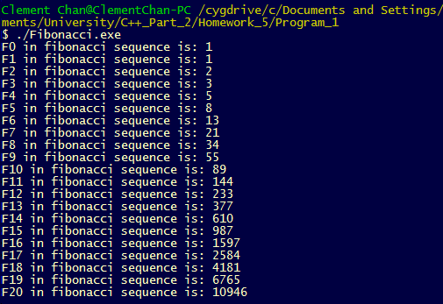

**Question 5:**

Hanoi Tower

**Main.cpp**

#include <iostream>

using namespace std;

class HanoiPost{

private:

int post_1[64];

int post_2[64];

int post_3[64];

public:

void initialize_post();

void Display_post();

void Move_Top_1_to_2();

void Move_123(int);

void Move_31(int);

void Move_12(int);

};

//Function to create the three posts with all the stones located in one post (post 1)

void HanoiPost::initialize_post(){

for(int i=0; i<64; i++){

post_1[i] = (64-i);

post_2[i] = 0;

post_3[i] = 0;

}

}

void HanoiPost::Move_Top_1_to_2(){

post_2[0] = post_1[0];

post_1[0] = 0;

}

//Function to display all the stones in each post

void HanoiPost::Display_post(){

for(int i=0; i<64; i++){

cout<<post_1[i]<<","<<post_2[i]<<","<<post_3[i]<<endl;

}

}

//Move all the stones below to the third pole

void HanoiPost::Move_123(int i){

if(i > 0){

int a;

a = post_1[i-1];

post_2[i-1] = a;

post_3[i-1] = a;

post_2[i-1] = 0;

post_1[i-1] = 0;

cout<<post_1[i-1]<<","<<post_2[i-1]<<","<<post_3[i-1]<<endl;

}

if(i == 0){

cout<<post_1[0]<<","<<post_2[0]<<","<<post_3[0]<<endl;

i++;

}

if(i < 64 && i > 0){

Move_123(i+1);

}

}

//Move all the stones below to the third pole

void HanoiPost::Move_31(int i){

if(i > 0){

int a;

a = post_3[i-1];

post_1[i-1] = a;

post_3[i-1] = 0;

cout<<post_1[i-1]<<","<<post_2[i-1]<<","<<post_3[i-1]<<endl;

}

if(i == 0){

cout<<post_1[0]<<","<<post_2[0]<<","<<post_3[0]<<endl;

i++;

}

if(i < 64 && i > 0){

Move_31(i+1);

}

}

void HanoiPost::Move_12(int i){

if(i > 0){

int a;

a = post_1[i-1];

post_2[i-1] = a;

post_1[i-1] = 0;

cout<<post_1[i-1]<<","<<post_2[i-1]<<","<<post_3[i-1]<<endl;

}

if(i == 0){

cout<<post_1[0]<<","<<post_2[0]<<","<<post_3[0]<<endl;

i++;

}

if(i < 64 && i > 0){

Move_12(i+1);

}

}

int main(){

HanoiPost HP;

HP.initialize_post();

cout<<"The original stones are put in the corresponding posts: (Left-Post_1, Middle-Post_2, Right-Post_3)" << endl;

HP.Display_post();

cout<<" "<< endl;

cout<<"The moving all the stones one by one to post_3 except the top: " << endl;

HP.Move_123(0);

cout<<" "<< endl;

cout<<"Move the top from post_1 to post_2 ... " << endl;

HP.Move_Top_1_to_2();

cout<<" "<< endl;

cout<<"The New Set looks like below " << endl;

HP.Display_post();

cout<<" "<< endl;

cout<<"Now we move all the stones to Post_1 from Post_3 " << endl;

HP.Move_31(0);

cout<<" "<< endl;

cout<<"Now we move all the stones to Post_2 from Post_1 to complete the moves " << endl;

HP.Move_12(0);

cout<<"The process ended and we completed the Hanoi Tower by moving 64 stones recursively..." << endl;

return 0;

}

**Output**

