**C++ Part II (INFO1-CE9265) Spring 2015 – Homework 6**

Clement Chan

**Question 4:**

#include <iostream>

#include <cstring>

#include <stdio.h>

using namespace std;

template <class T>

T calc_abs(char num_ops, T x, T y){

if(num_ops == '+'){

T total = x + y;

if(total <0){

total = -(total);

}

throw total;

}

else if(num_ops == '-'){

T total = x - y;

if(total <0){

total = -(total);

}

throw total;

}

else if(num_ops == '*'){

T total = x * y;

if(total <0){

total = -(total);

}

throw total;

}

else if(num_ops == '/'){

if(y == 0){

throw "No";

}

else{

T total = x / y;

if(total < 0){

total = -(total);

}

throw total;

}

}

}

template <class T>

void abs_tc_final(char num_ops, T x, T y){

try{

calc_abs(num_ops, x, y);

}

catch(T a){

cout<<"The total absolute function is: " << a << endl;

}catch(...){

cout<<"Numbers cannot divide by zero.." << endl;

}

}

int main(){

cout<<"Results for float variables: " <<endl;

float x = 10.32;

float y = 5.21;

abs_tc_final('+', x, y);

abs_tc_final('-', x, y);

abs_tc_final('*', x, y);

abs_tc_final('/', x, y);

cout<<" " <<endl;

cout<<"Results for int variables: " <<endl;

int x1 = 10;

int y1 = 3;

abs_tc_final('+', x1, y1);

abs_tc_final('-', x1, y1);

abs_tc_final('*', x1, y1);

abs_tc_final('/', x1, y1);

cout<<" " <<endl;

cout<<"Results for double variables: " <<endl;

double x2 = 5.567;

double y2 = 6.689;

abs_tc_final('+', x2, y2);

abs_tc_final('-', x2, y2);

abs_tc_final('*', x2, y2);

abs_tc_final('/', x2, y2);

cout<<" "<<endl;

cout<<"Results for char variables: " <<endl;

char x3 = 'm';

char y3 = 'n';

abs_tc_final('+', x3, y3);

abs_tc_final('-', x3, y3);

abs_tc_final('*', x3, y3);

abs_tc_final('/', x3, y3);

cout<<" "<<endl;

//Check for Exceptions

abs_tc_final('/', 5, 0);

}

Output

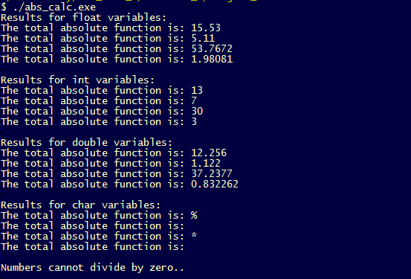

**Question 5:**

Item_Class.h

#ifndef ITEM_SET_H

#define ITEM_SET_H

#include <iostream>

#include <cmath>

#include <stdlib.h>

#include <cstring>

using namespace std;

template <class T>

class set_item{

private:

T *items;

int size;

public:

set_item();

set_item(int the_size);

set_item(const set_item &st);

~set_item();

//Setters and getters

void add_new_item(T the_item);

int get_num_items() const;

void show_items() const;

};

#endif

Item_Class.cpp

#include "item_class.h"

template <class T>

set_item <T> :: set_item(){

cout << "This is Default Constructor ... " << endl;

items = new T[10];

size = 0;

}

template <class T>

set_item <T> :: set_item(int the_size){

items = new T[the_size];

size = the_size;

}

template <class T>

set_item <T> :: set_item(const set_item &s_t){

size = s_t.get_num_items();

delete[] items;

items = new T[size];

}

template <class T>

set_item <T> :: ~set_item(){

cout << "This is Destructor ... " << endl;

delete[] items;

}

template <class T>

void set_item <T> :: add_new_item(T the_item){

items[size] = the_item;

size ++;

}

template <class T>

int set_item <T> :: get_num_items() const{

return size;

}

template <class T>

void set_item <T> :: show_items() const{

for(int i=0; i<size; i++){

cout << "The entered items in the set are: " << items[i] << endl;

}

}

Main.cpp

#include "item_class.h"

#include "item_class.cpp"

int main(){

set_item<int> ST;

set_item<double> ST_double;

set_item<string> ST_str;

set_item<char> ST_char;

cout<< " " <<endl;

/********* For Integer ************/

cout<< "For Integer ... " <<endl;

ST.add_new_item(3);

ST.add_new_item(5);

ST.add_new_item(6);

ST.add_new_item(15);

ST.add_new_item(150);

cout<<"The number of items entered: "<<ST.get_num_items()<<endl;

ST.show_items();

cout<< " " <<endl;

/********** For double ************/

cout<< "For double ... " <<endl;

ST_double.add_new_item(4.5);

ST_double.add_new_item(5.111);

ST_double.add_new_item(2.332);

ST_double.add_new_item(1.234);

ST_double.add_new_item(0.5318);

cout<<"The number of items entered: " << ST_double.get_num_items()<<endl;

ST_double.show_items();

cout<< " " <<endl;

/******** For Strings **********/

cout<< "For Strings ... " <<endl;

string a = "hi, how are you?";

string b = "ok, I am fine";

string c = "Today is freezing";

string d = "So hot!";

ST_str.add_new_item(a);

ST_str.add_new_item(b);

ST_str.add_new_item(c);

ST_str.add_new_item(d);

cout<<"The number of items entered: " << ST_str.get_num_items()<<endl;

ST_str.show_items();

cout<< " " <<endl;

/******* For char ************/

cout<< "For char ... " <<endl;

ST_char.add_new_item('a');

ST_char.add_new_item('b');

ST_char.add_new_item('c');

ST_char.add_new_item('d');

ST_char.add_new_item('e');

cout<<"The number of items entered: " << ST_char.get_num_items()<<endl;

ST_char.show_items();

cout<< " " <<endl;

return 0;

}

Output

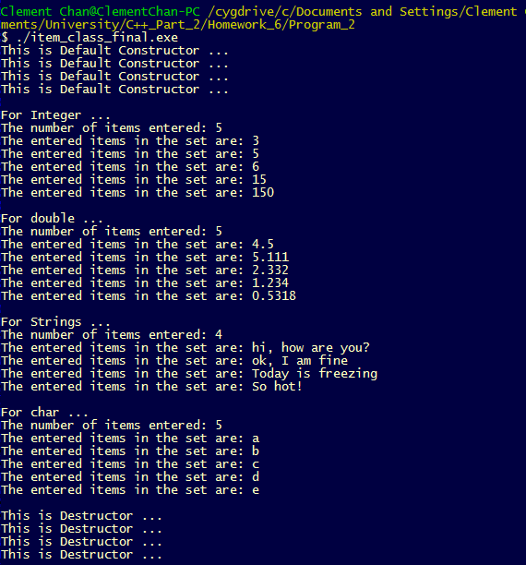

**Additional Question:**

template_array.h

#ifndef Array_H

#define Array_H

#include <iostream>

#include <typeinfo>

template <typename T> class Array{

private:

int size;

T *arr;

public:

Array(int the_size); //Parameterized Constructor

void setArray(int loc, T value);

void getArray();

};

//Method Definition

template<class T>

Array<T>::Array(int the_size){

size = the_size;

arr = new T [size];

}

template<class T>

void Array<T> :: setArray(int loc, T value){

arr[loc] = value;

}

template<class T>

void Array<T> :: getArray(){

for(int i=0; i<size; i++){

std::cout<<arr[i]<<" " << "Type: " << typeid(arr[i]).name()<<std::endl;

}

std::cout<<"------------------"<<std::endl;

}

#endif

template_array.cpp

#include "template_array.h"

int main(){

Array<int> Array_int(3);

Array<float> Array_float(5);

Array<char> Array_char(2);

//Inputting Array for int type

Array_int.setArray(0,3);

Array_int.setArray(1,2);

Array_int.setArray(2,1);

//Inputting Array for float type

Array_float.setArray(0,0.5);

Array_float.setArray(1,1.4);

Array_float.setArray(2,3.23);

Array_float.setArray(3,1.22);

Array_float.setArray(4,4.7);

//Inputting Array for char type

Array_char.setArray(0,'T');

Array_char.setArray(1,'F');

//Getting different entries with different typedef

Array_int.getArray();

Array_float.getArray();

Array_char.getArray();

return 0;

}

Output

