**C++ Part II (INFO1-CE9265) Spring 2015 – Homework 9**

Clement Chan

**Iterator.cpp**

#include <iostream>

#include <list>

using namespace std;

int main() {

list<int> List;

list<int>::iterator iter;

for(int i=0; i < 33; i++){

List.push_back(i-3);

}

cout << "This is the original list: " << endl;

for(list<int>::iterator iter = List.begin(); iter != List.end(); ++iter){

cout << *iter << endl;

}

iter = List.begin();

while(iter != List.end()){

if(*iter % 3 == 0){

iter = List.erase(iter);

}

++iter;

}

cout << " " << endl;

cout << "This is the modified list: " << endl;

for(list<int>::iterator iter = List.begin(); iter != List.end(); ++iter){

cout << *iter << endl;

}

return 0;

}

**Output**

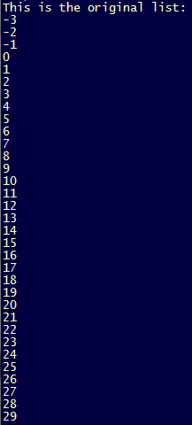 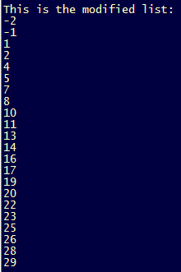

Moving all elements that are divisible by 3