**C++ Part I (INFO1-CE9264) Fall 2014 – Homework 5**

Clement Chan

**Question 2 – CounterType**

#include<iostream>

#include<stdio.h>

using namespace std;

class CounterType{

private:

int number;

public:

void SetCount(int);

void IncreaseCount();

void DecreaseCount();

int ReturnCount();

int Display();

};

void CounterType::SetCount(int a){

number = a;

if (number < 0){

printf("The number entered is negative.");

exit(0);

}

}

void CounterType::IncreaseCount(){

number += 1;

if(number < 0){

printf("The number becomes negative.");

exit(0);

}

}

void CounterType::DecreaseCount(){

number -= 1;

if(number < 0){

printf("The number becomes negative.");

exit(0);

}

}

int CounterType::ReturnCount(){

return number;

}

int CounterType::Display(){

printf("The Count is %d", number);

}

int main(){

int countinput;

char InDe;

char ans;

CounterType CT;

cout<<"Please enter the number: " <<endl;

cin>>countinput;

CT.SetCount(countinput);

do{

cout<<"Increase Count or Decrease Count? (I for increase, D for

Decrease)"<<endl;

cin >> InDe;

if(InDe == 'D'){

CT.DecreaseCount();

}

if(InDe == 'I'){

CT.IncreaseCount();

}

CT.Display();

cout << " " << endl;

cout << "Increase and Decrease again?" << endl;

cin >> ans;

} while (ans =='Y'|| ans == 'y');

}

**Output**

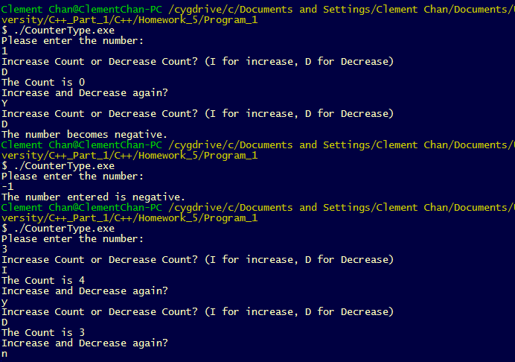

**Question 3 – Point**

#include<iostream>

#include<cstdio>

using namespace std;

class Point{

private:

double x_coordinates;

double y_coordinates;

public:

void set(double, double);

void move(double, double);

void rotate90clockwise();

const double retrieve_x(){return x_coordinates;};

const double retrieve_y(){return y_coordinates;};

};

void Point::set(double a, double b){

x_coordinates = a;

y_coordinates = b;

}

void Point::move(double a, double b){

x_coordinates += a;

y_coordinates += b;

}

void Point::rotate90clockwise(){

int i = 0; //This is the integer to make sure that each time rotate90clockwise called only ran 1 condition, so that the if conditions will not be repeated in 1 call.

if (x_coordinates >= 0 && y_coordinates >= 0 && i == 0){

y_coordinates *= -1;

i++;

}

if (x_coordinates >= 0 && y_coordinates <= 0 && i == 0){

x_coordinates *= -1;

i++;

}

if (x_coordinates <= 0 && y_coordinates <= 0 && i == 0){

y_coordinates *= -1;

i++;

}

if (x_coordinates <= 0 && y_coordinates >= 0 && i == 0){

x_coordinates *= -1;

i++;

}

}

int main(){

Point P;

P.set(0,4);

P.move(5,4);

P.rotate90clockwise();

P.rotate90clockwise();

P.move(1,1);

cout<<"X's coordinates is: " << P.retrieve_x()<<endl;

cout<<"Y's coordinates is: " << P.retrieve_y()<<endl;

}

**Output**

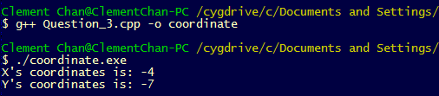

**Question 8 – Money**

#include<iostream>

#include<cstdio>

using namespace std;

class Money{

private:

int num_of_dollar;

int num_of_cents;

public:

double dollar_amount;

double cents;

double cents_amount;

double total_monetary;

void set(int,int);

void transform();

double monetary_amount();

};

void Money::set(int a, int b){

num_of_dollar = a;

num_of_cents = b;

}

void Money::transform(){

dollar_amount = num_of_dollar;

cents = num_of_cents; //Pass the Integer into a double and then perform division

cents_amount = cents / 100; // Perform division so that the number of cents can return a double value in the end

total_monetary = dollar_amount + cents_amount;

cout << "Dollars Amount is: " << dollar_amount << endl;

cout << "Cents Amount is: " << cents_amount << endl;

}

double Money::monetary_amount(){

return total_monetary;

}

int main(){

Money M;

M.set(7,90);

M.transform();

cout<<"The total amount given input is: " << M.monetary_amount() << endl;

M.set(90,150);

M.transform();

cout<<"The total amount given input is: " << M.monetary_amount() << endl;

}

**Output**

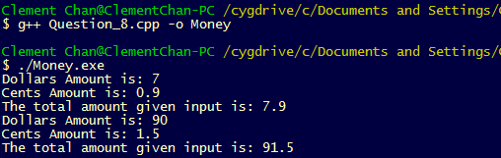

**Question 10 – Temperature**

#include<iostream>

#include<cstdio>

using namespace std;

class Temperature{

private:

double Kelvin;

public:

void setTempKelvin(double);

void setTempFahrenheit(double);

void setTempCelsius(double);

void ShowResult();

};

void Temperature::setTempKelvin(double a){

Kelvin = a;

}

void Temperature::setTempFahrenheit(double b){

double Fahrenheit = b;

Kelvin = (50/9)*(Fahrenheit - 32) + 273.15;

}

void Temperature::setTempCelsius(double c){

double Celsius = c;

Kelvin = Celsius + 273.15;

}

void Temperature::ShowResult(){

cout<< "The Temperature in Kelvin is: " << Kelvin << endl;

}

int main(){

char unit;

double temp;

char ans;

Temperature T;

do{

cout << "Please enter the temperature unit (Celsius = C, Kelvin = K, Fahrenheit = F): " << endl;

cin >> unit;

cout << "Please enter the temperature given the unit you entered previously: " << endl;

cin>>temp;

if (unit == 'C' || unit == 'c')

{T.setTempCelsius(temp);}

if (unit == 'F' || unit == 'F')

{T.setTempFahrenheit(temp);}

if (unit == 'K' || unit == 'K')

{T.setTempKelvin(temp);}

T.ShowResult();

cout << "Re-calculate?" <<endl;

cin>>ans;

}while(ans=='Y'|| ans =='y');

}

**Output**

