**C++ Part I (INFO1-CE9264) Fall 2014 – Homework 9**

Clement Chan

Question 1 – Sentence.cpp

#include <iostream>

#include <string>

using namespace std;

int main(){

char CapLetters[26]={'A','B','C','D','E','F','G','H','I','J','K','L','M','N','O','P','Q','R','S','T','U','V','W','X','Y','Z'};

char Letters[26]={'a','b','c','d','e','f','g','h','i','j','k','l','m','n','o','p','q','r','s','t','y','v','w','x','y','z'};

char fullstop ='.';

char comma = ',';

int double_space = 0;

//Define string for the input

string Line;

//Define char array for the changes

char Line1[Line.length()];

cout << "Please enter the line that you want to evaluate: " <<endl;

getline(cin, Line);

for(int i = 0; i < Line.length(); i++){

Line1[i] = Line[i];

if(Line[i] == fullstop){

Line1[i] = fullstop;

}

}

for(int i = 0; i < Line.length(); i++){

for(int j = 0; j < 26; j++){

//Defining scenarios when Capital letters replacement is needed

if(i == 0 && Letters[j] == Line[0]){

Line1[0] = CapLetters[j];

}else if(i > 0 && Line[i] == CapLetters[j]){

Line1[i] = Letters[j]; //Any capital letters in the middle of the sentence to be

changed to normal letters.

}else if(i > 0 && (Line[i]==fullstop && Line[i+1] == ' ') && Line[i+2] == Letters[j]){

Line1[i+2] = CapLetters[j];

}

}

//Calculating double space if occured

if(Line[i] == ' ' && Line[i+1] == ' ' ){

double_space += 1;

}

}

//Moving double space to single space

int blank_space = 0;

char Line_final[Line.length() - double_space + 1];

for(int i = 0 ; i < Line.length() - double_space + 1; i++){

Line_final[i] = ' ';

}

for(int i=1; i < Line.length() + 1; i++){

if(Line1[i] ==' ' && Line1[i-1]==' '){

blank_space += 1;

}

if(Line1[i-1] != ' '){

Line_final[(i-1)-blank_space] = Line1[i-1];

}

}

//Showing the changes

cout<<"The transformed Line is: ";

for(int i=0; i < (Line.length() - double_space + 1);i++){

cout<<Line_final[i];

}

return 0;

}

Output

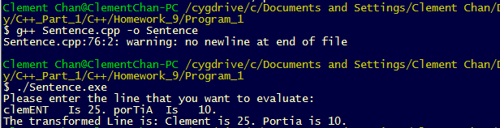

Question 2 – Count of words.cpp

#include <iostream>

#include <string>

using namespace std;

int main(){

char CapLetters[26]={'A','B','C','D','E','F','G','H','I','J','K','L','M','N','O','P','Q','R','S','T','U','V','W','X','Y','Z'};

char Letters[26]={'a','b','c','d','e','f','g','h','i','j','k','l','m','n','o','p','q','r','s','t','y','v','w','x','y','z'};

char fullstop ='.';

char comma = ',';

int double_space = 0;

int count_word = 0;

//Create the counts for each letter in an array

int Count_Letter[26];

char Letter[26][26];

for(int i=0; i < 26; i++){

Count_Letter[i] = 0;

Letter[i][1] = Letters[i];

Letter[i][2] = CapLetters[i];

}

//Define string for the input

string Line;

//Define char array for the changes

char Line1[Line.length()];

cout << "Please enter the line that you want to evaluate: " <<endl;

getline(cin, Line);

for(int i = 0; i < Line.length(); i++){

Line1[i] = Line[i];

if(Line[i] == fullstop){

Line1[i] = fullstop;

}

}

for(int i = 0; i < Line.length(); i++){

for(int j = 0; j < 26; j++){

//Defining scenarios when Capital letters replacement is needed

if(i == 0 && Letters[j] == Line[0]){

Line1[0] = CapLetters[j];

}else if(i > 0 && Line[i] == CapLetters[j]){

Line1[i] = Letters[j]; //Any capital letters in the middle of the sentence to be changed to normal letters.

}else if(i > 0 && (Line[i]==fullstop && Line[i+1] == ' ') && Line[i+2] == Letters[j]){

Line1[i+2] = CapLetters[j];

}

}

//Calculating double space if occured

if(Line[i] == ' ' && Line[i+1] == ' ' ){

double_space += 1;

}

}

//Moving double space to single space

int blank_space = 0;

char Line_final[Line.length() - double_space + 1];

for(int i = 0 ; i < Line.length() - double_space + 1; i++){

Line_final[i] = ' ';

}

//Setting up Line_final data

for(int i=1; i < Line.length() + 1; i++){

if(Line1[i] ==' ' && Line1[i-1]==' '){

blank_space += 1;

}

if(Line1[i-1] != ' '){

Line_final[(i-1)-blank_space] = Line1[i-1];

}

}

//Calculating the arrays and final arrays for the sentence

for(int i = 0; i < Line.length() - double_space + 1; i++){

//Filling in the 3 dimensional count array

for(int j = 0; j < 26; j++){

if(Letter[j][1] == Line_final[i] || Letter[j][2] == Line_final[i]){

Count_Letter[j] += 1;

}

}

if((Line_final[i] == fullstop && Line_final[i+1] == ' ') || (Line_final[i] == comma && Line_final[i+1] == ' ') || Line_final[i] == ' '){

count_word += 1;

}

if(Line_final[i] == fullstop && Line_final[i+1] == ' ' && Line_final[i+2] != ' '){

count_word -= 1;

}

}

//Showing the changes

cout<<"The transformed Line is: ";

for(int i=0; i < (Line.length() - double_space + 1);i++){

cout<<Line_final[i];

}

cout<< " " << endl;

//Displaying the count and changes

cout << "The number of words in the sentence is: " << count_word << endl;

for(int i = 0; i < 26; i++){

if(Count_Letter[i] > 0){

cout << Count_Letter[i] << " " << Letter[i][1] << endl;

}

}

return 0;

}

Output

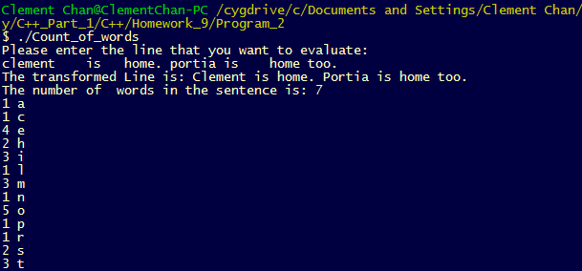

Question 3 – First Name Middle Name Last Name. cpp

#include <iostream>

#include <string>

using namespace std;

int main(){

string LastName, FirstName, MiddleName;

int count = 0;

char CapLetters[26]={'A','B','C','D','E','F','G','H','I','J','K','L','M','N','O','P','Q','R','S','T','U','V','W','X','Y','Z'};

char Letters[26]={'a','b','c','d','e','f','g','h','i','j','k','l','m','n','o','p','q','r','s','t','y','v','w','x','y','z'};

cout << "Please enter Name (First Name, Middle Name, Last Name, enter - if no Middle Name): " << endl;

cin >> FirstName >> MiddleName >> LastName;

// Search for MiddleName's first letter

char Mid_Name_Arr[MiddleName.length()];

char Mid_Name;

for(int i = 0; i < MiddleName.length(); i++){

Mid_Name_Arr[i] = MiddleName[i];

}

for(int i = 0; i < 26; i++){

if(Mid_Name_Arr[0] == Letters[i]){

Mid_Name = CapLetters[i];

}else{

Mid_Name = Mid_Name_Arr[0];

}

}

if(Mid_Name != '-'){

cout << LastName << ", " << Mid_Name << ". " << FirstName << endl;

}else if(Mid_Name == '-'){

cout << LastName << ", " << FirstName << endl;

}

return 0;

}

Output

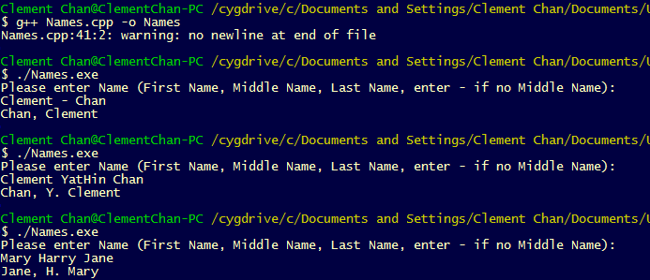

Question 4 – Replace Love.cpp

#include <iostream>

#include <string>

using namespace std;

int main(){

//Define string for the input

string Line;

//Define char array for the changes

char Line1[Line.length()];

cout << "Please enter the line that you want to evaluate: " <<endl;

getline(cin, Line);

//Inputting string values into the character array

for(int i = 0; i < Line.length(); i++){

Line1[i] = Line[i];

}

for(int i = 0; i < Line.length(); i++){

int finaloutput = (i + 5);

//Replace at the sentence's beginning

if(Line[0] != ' ' && Line[1] != ' ' && Line[2] != ' ' && Line[3] != ' ' && Line[4] == ' '){

Line1[0] = 'L';

Line1[1] = 'o';

Line1[2] = 'v';

Line1[3] = 'e';

}

//Replace at the middle sentence

if((Line[i] == ' ' || Line[i] == '.' || Line[i] == '\n') && Line[i+1] != ' ' && Line[i+2] != ' ' && Line[i+3] != ' ' && Line[i+4] != ' ' && Line[i+5] == ' '){

if(Line[i] == '.' || Line[i] == '\n'){

Line1[i+1] = 'L';

Line1[i+2] = 'o';

Line1[i+3] = 'v';

Line1[i+4] = 'e';

}else{

Line1[i+1] = 'l';

Line1[i+2] = 'o';

Line1[i+3] = 'v';

Line1[i+4] = 'e';

}

}

if((Line[i] == ' ' || Line[i] == '.' || Line[i] == '\n') && Line[i+1] != ' ' && Line[i+2] != ' ' && Line[i+3] != ' ' && Line[i+4] != ' ' && finaloutput == Line.length()){

Line1[i+1] = 'l';

Line1[i+2] = 'o';

Line1[i+3] = 'v';

Line1[i+4] = 'e';

}

}

//Displaying the original Line below

cout<<"The input line is: ";

for(int i = 0 ; i < Line.length(); i++){

cout << Line[i];

}

cout<< " " << endl;

cout<<"The replaced line is: ";

//Displaying the replaced line below

for(int i = 0; i < Line.length(); i++){

cout << Line1[i];

}

return 0;

}

Output

