**C++ Part II (INFO1-CE9265) Spring 2015 – Homework 3**

Clement Chan

**Question 1:**

Main.cpp

#include <iostream>

#include <fstream>

using namespace std;

inline int Max(int a, int b){

if(b>a){

return b;

}else{

return a;

}

}

inline int Min(int a, int b){

if(b<a){

return b;

}else{

return a;

}

}

int main(){

ifstream Instream;

int n = 1; //Counter

int Maximum = 0;

int Minimum = 0;

int temp;

Instream.open("Integer.txt");

if(Instream.is_open()){

cout<<"The Stream is Opened..."<<endl;

}else{

cout<<"There is no file to open..."<<endl;

exit(1);

}

while(!Instream.eof()){ // Instream numbers

Instream >> temp;

if(n == 1){

Maximum = temp;

Minimum = temp;

}

Maximum = Max(Maximum, temp);

Minimum = Min(Minimum, temp);

n++;

}

Instream.close();

//Summary

cout<<"The number of integers in the file is: " << n << endl;

cout<<"The maximum of the streamed file array of integer is: "<< Maximum << endl;

cout<<"The minimum of the streamed file array of integer is: "<< Minimum << endl;

return 0;

}

**Output**

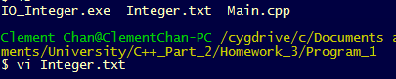

Integer File:



Final Output:

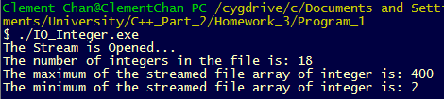

**Question 2:**

Main.cpp

#include <iostream>

#include <fstream>

using namespace std;

inline int Max(int a, int b){

if(b>a){

return b;

}else{

return a;

}

}

inline int Min(int a, int b){

if(b<a){

return b;

}else{

return a;

}

}

int main(){

ifstream Instream;

int n = 1; //Counter

int Maximum = 0;

int Minimum = 0;

int temp;

Instream.open("Integer.txt");

if(Instream.is_open()){

cout<<"The Stream is Opened..."<<endl;

}else{

cout<<"There is no file to open..."<<endl;

exit(1);

}

while(!Instream.eof()){ // Instream numbers

Instream >> temp;

if(n == 1){

Maximum = temp;

Minimum = temp;

}

Maximum = Max(Maximum, temp);

Minimum = Min(Minimum, temp);

n++;

}

Instream.close();

//Summary

cout<<"The number of integers in the file is: " << n << endl;

cout<<"The maximum of the streamed file array of integer is: "<< Maximum << endl;

cout<<"The minimum of the streamed file array of integer is: "<< Minimum << endl;

return 0;

}

**Output**



Integer File:



Final Output:

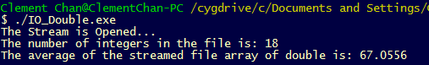

**Question 6:**

Main.cpp

#include <iostream>

#include <fstream>

#include <string>

using namespace std;

void SortnOut(double list[], int size, char* file){

int j;

double temp;

for(int i=1; i<size; i++){

temp = list[i];

for(int j = i-1; j>=0; j--){

if(list[j] > temp){

list[j+1] = list[j];

list[j] = temp;

}

}

}

for(int i=0; i<size; i++){

cout<<list[i]<<endl;

}

ofstream Outfile(file);

for(int i=0; i<size; i++){

if(i != size - 1){

Outfile << list[i]<< "," << endl;

}else{

Outfile << list[i] << " ";

}

}

Outfile.close();

}

int main(){

ifstream Instream("Integer.txt"), Instream_2("Double.txt");

int n = 1; //Integer File Counter

int n1 = 1; //Double File Counter

string temp;

string temp1;

double number;

double number1;

//Check if Integer file is open

if(Instream.is_open()){

cout<<"The Stream is Opened..."<<endl;

}else{

cout<<"There is no file to open..."<<endl;

exit(1);

}

//Check if Double file is open

if(Instream_2.is_open()){

cout<<"The Stream is Opened..."<<endl;

}else{

cout<<"There is no file to open..."<<endl;

exit(1);

}

while(!Instream.eof()){ // Counter the number of lines

getline(Instream, temp);

n++;

}

while(!Instream_2.eof()){ // Counter the number of lines

getline(Instream_2, temp1);

n1++;

}

Instream.close();

Instream_2.close();

ifstream Instream_1("Integer.txt"), Instream_3("Double.txt");

int total = n+n1-1;

double arr[n];

double arr1[n1];

double arr_total[total];

n = 1;

n1 = 1;

while(!Instream_1.eof()){ // Counter the number of lines

getline(Instream_1, temp);

number = atof(temp.c_str());

arr[n-1] = number;

n++;

}

while(!Instream_3.eof()){ // Counter the number of lines

getline(Instream_3, temp1);

number1 = atof(temp1.c_str());

arr1[n1-1] = number1;

n1++;

}

for(int i=0; i<total; i++){

if(i < n){

arr_total[i] = arr[i];

}else{

arr_total[i-1] = arr1[i-n];

}

}

SortnOut(arr_total, total-1, "Sorted.txt");

Instream_1.close();

Instream_3.close();

return 0;

}

**Output**

Before executing the program:



Double.txt: Integer.txt:

 

After executing the program:



Final_Sorted_List:

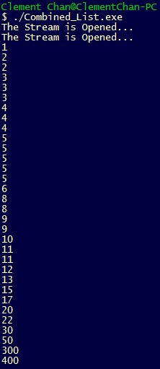

**Question 8:**

Main.cpp

#include <iostream>

#include <fstream>

#include <string>

using namespace std;

double average(int arr[], int size){

double ave = 0;

for(int i=0; i<size; i++){

ave += arr[i];

}

ave /= size;

return ave;

}

int main(){

char a,b,c;

string temp;

int number_of_lines;

int n = 1; //count of lines

int n1 = 0; //count of space

int k = 0; //count of names

int k1 = 0; //count of scores

int temp1;

ifstream Instream("Grades.txt"), Instream_1("Grades.txt");

//Check if Grade file is open

if(Instream.is_open()){

cout<<"The Stream is Opened..."<<endl;

}else{

cout<<"There is no file to open..."<<endl;

exit(1);

}

while(!Instream.eof()){ // Counter the number of lines

getline(Instream, temp);

n++;

}

cout<<"The number of lines is: " << n << endl;

Instream.close();

char last_name[n][15];

char first_name[n][15];

int score_arr[n][10];

double ave[n];

//Initializing all the names array

for(int i=0; i<n; i++){

for(int j=0; j< 15; j++){

last_name[i][j] = ' ';

first_name[i][j] = ' ';

}

}

//Initializing all the scores array

for(int i=0; i<n; i++){

for(int j=0; j< 10; j++){

score_arr[i][j];

}

}

//Check if Grade file is open

if(Instream_1.is_open()){

cout<<"The Stream is Opened..."<<endl;

}else{

cout<<"There is no file to open..."<<endl;

exit(1);

}

n=0;

//Intake of words and lines

while(!Instream_1.eof()){ // Counter the number of lines

a = Instream_1.get();

//cout << "a is:" << a << endl;

if(a != ' ' && n1 == 0){

last_name[n][k] = a;

k++;

}

else if(a != ' ' && n1 == 1){

first_name[n][k] = a;

k++;

}

else if(a != ' ' && n1 > 1){

b = Instream_1.get();

c = Instream_1.get();

//cout << "b is:" << b << endl;

//cout << "c is:" << c << endl;

if(c != ' '){

temp1 = 100;

score_arr[n][k1] = temp1;

k1++;

n1+=1;

}

else{

temp1 = a - '0';

temp1 *=10;

temp1+= (b - '0');

//cout<<temp1<<endl;

score_arr[n][k1] = temp1;

k1++;

}

}

if(a == '#'){

n+=1;

n1 = 0;

k1 = 0;

k = 0;

}

else if(a == ' '){

//Reset all the arrays back to starting point

n1 += 1;

k = 0;

}

}

//Updating the average scores into the average array

for(int i = 0; i < n; i++){

ave[i] = average(score_arr[i], 10);

}

//Output informationa to new file

ofstream Outfile("Grades_Output.txt");

for(int i=0; i<n; i++){

for(int j=0; j<15; j++){

if(last_name[i][j] == ' ' && j !=14){

Outfile << "";

}else if(last_name[i][j] == ' ' && j ==14){

Outfile << " ";

}

else{

Outfile << last_name[i][j];

}

}

for(int j=0; j<15; j++){

if(first_name[i][j] == ' '){

Outfile<<"";

}else if(first_name[i][j] == ' ' && j ==14){

Outfile << " ";

}

else{

Outfile<< first_name[i][j];

}

}

for(int j=0; j<10; j++){

Outfile <<" " << score_arr[i][j] << ",";

}

Outfile << "Average of the student is: " << ave[i] << "." << endl;

}

Instream_1.close();

return 0;

}

**Output**

Before execution



Grades.txt –

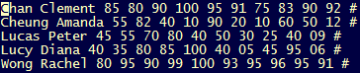

After execution:

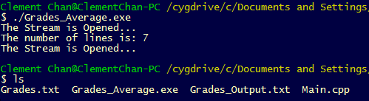

Grades_Output.txt:

