Web App with a DB backend

R09921A24陳玥蓁

我要做一個簡易的Web App，內有login並輸入信箱帳號與logout的功能，在此選擇利用flask做為DB backend，html做為frontend。

(Flask is a micro web framework for building website with python)

Step.1

pip install flask

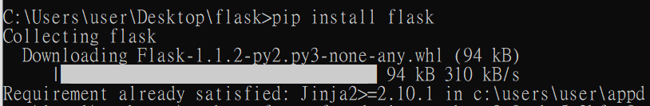

Step.2先做一些簡單測試:

*Import flask*

Create an instance of a flask web application

Define the pages that will be on our website

Define how we can access this page with “route”

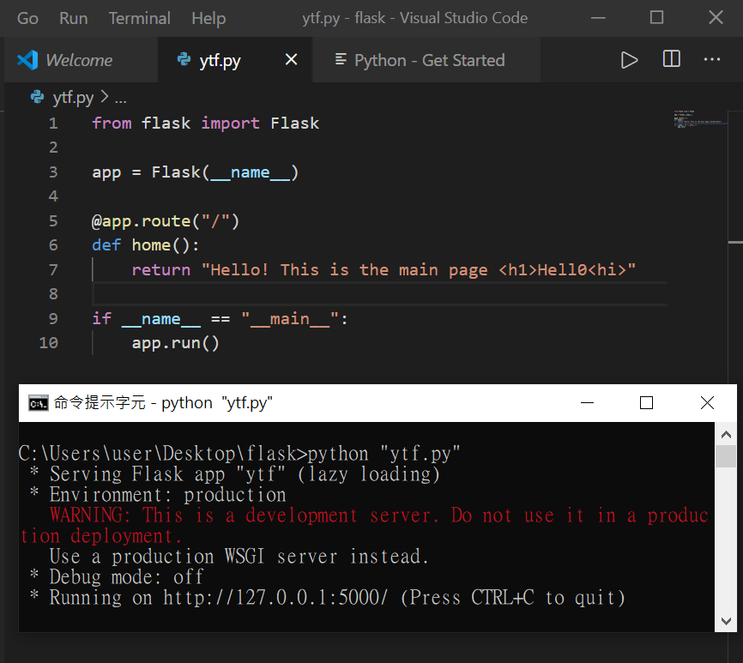

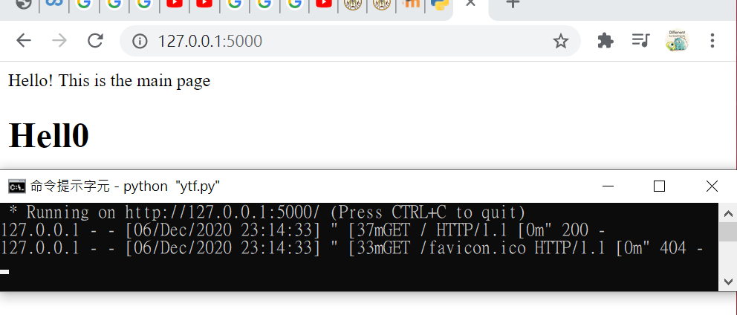

Step.3 [Add HTML templates]

*Import render_template*

(Allows us to grab a html file and render that as our web page)

Create html files (need to be put in a specific directory)

Template inheritance: (so that you don’t need to repeat your html codes)

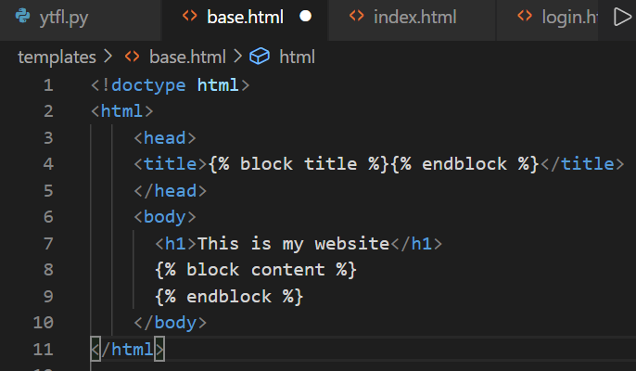

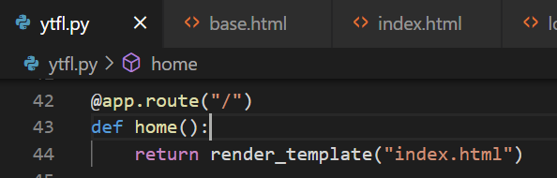

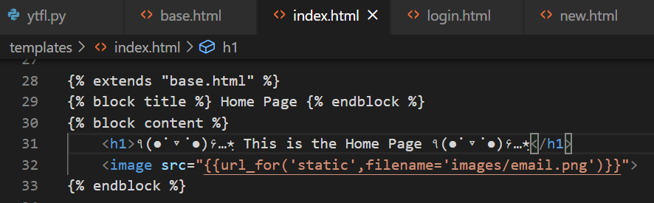

Step.4 [Add Bootstrap]

<https://getbootstrap.com/docs/4.5/components/navbar/>

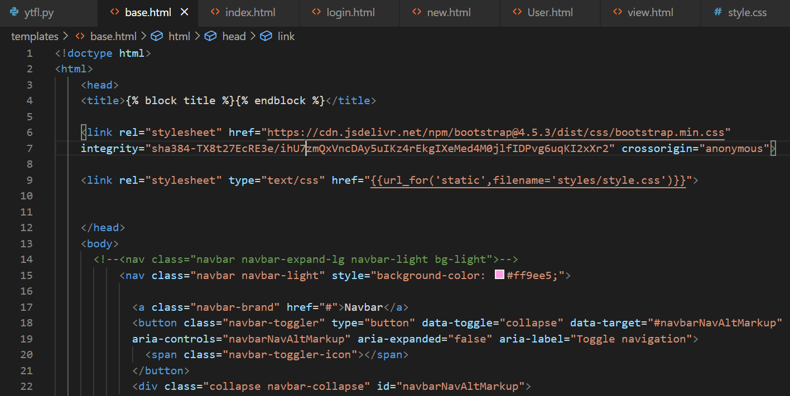

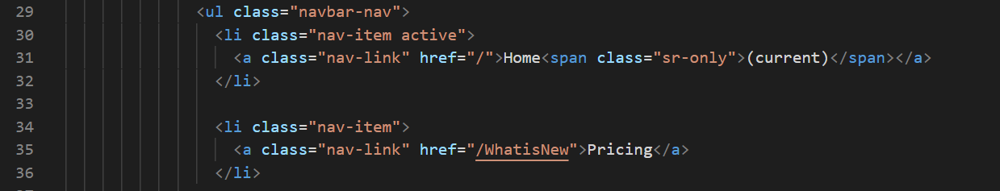

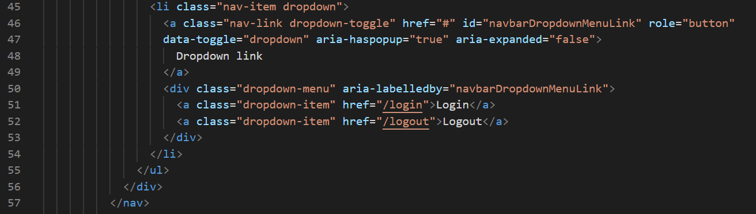

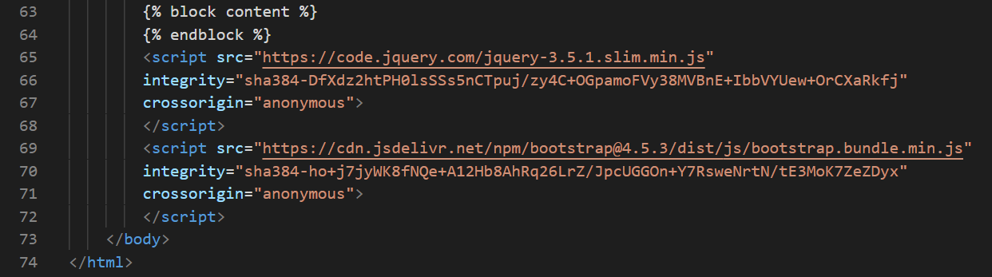

Step.5 [HTTP methods: GET/POST]

GET is the most common way of sending information to a website/client

POST is doing it securely, send secure information that’s encrypted；not stored on the actual web server unless we send it to the database

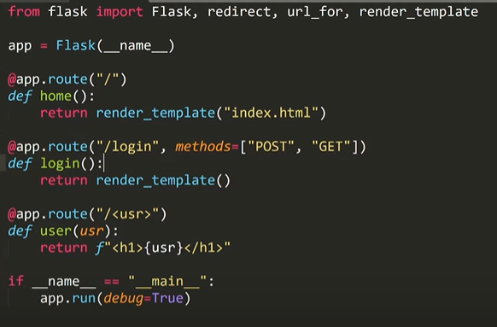

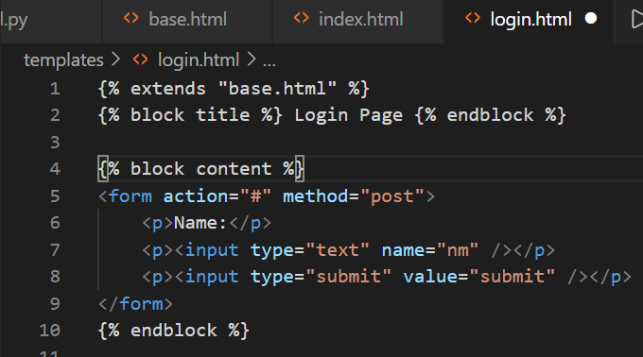

*Import request*

Step.6 [Sessions]

Sessions are temporary, stored on the web server(not stored on the client side) and are for quick access of information between all different pages of your website.

*Import session*

Step.7 [Message flashing]

Let user know what they actually did and what’s going on

*Import flash*

Step.8 [Static files]

Custom CSS & images

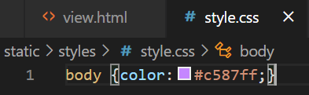This makes words in every body of pages turn purple

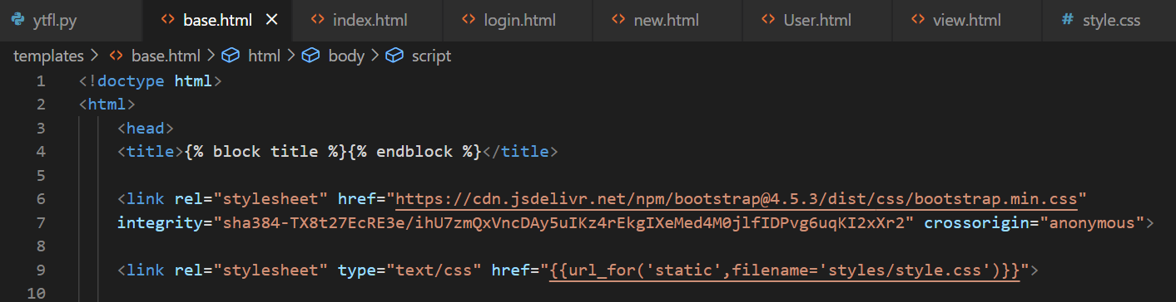

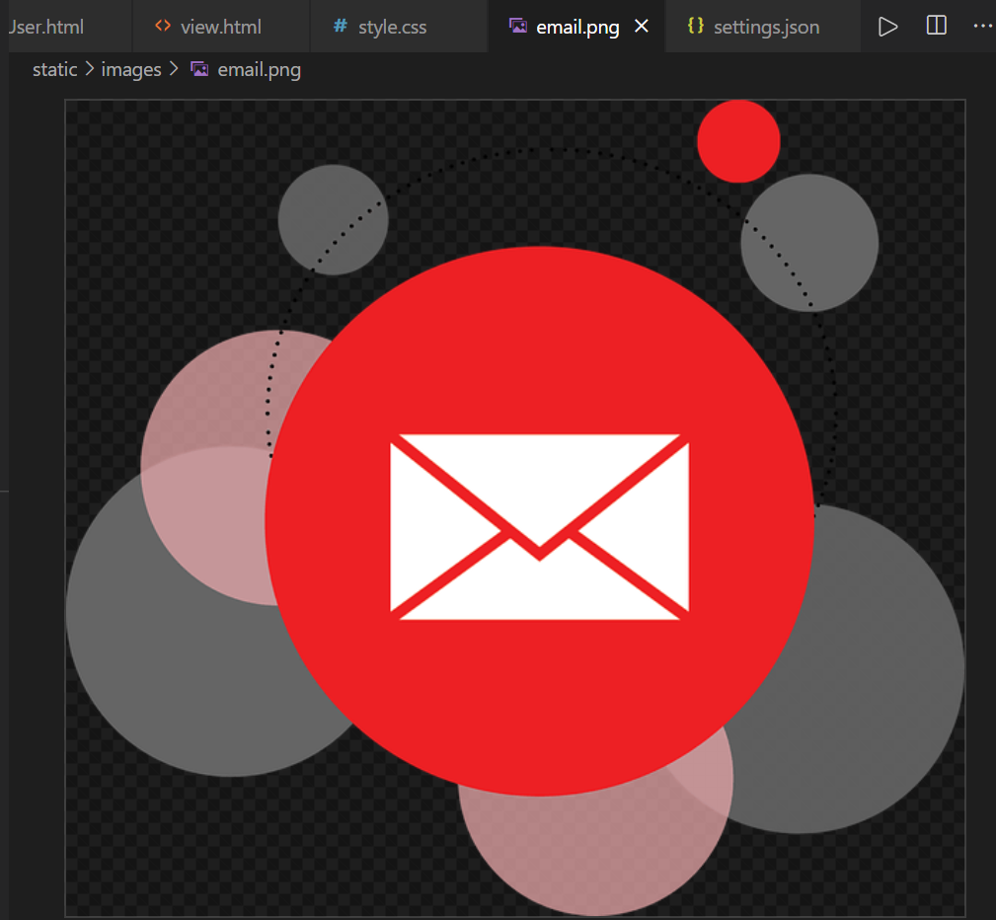

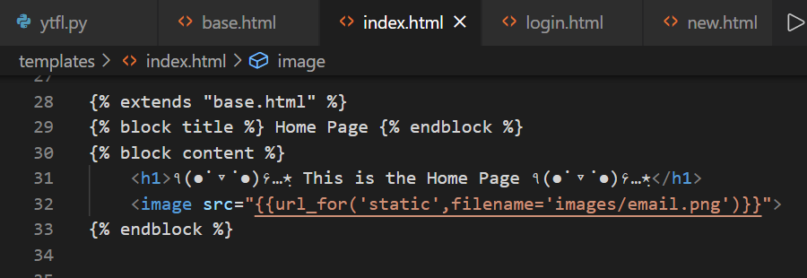

Results:

This is my home page

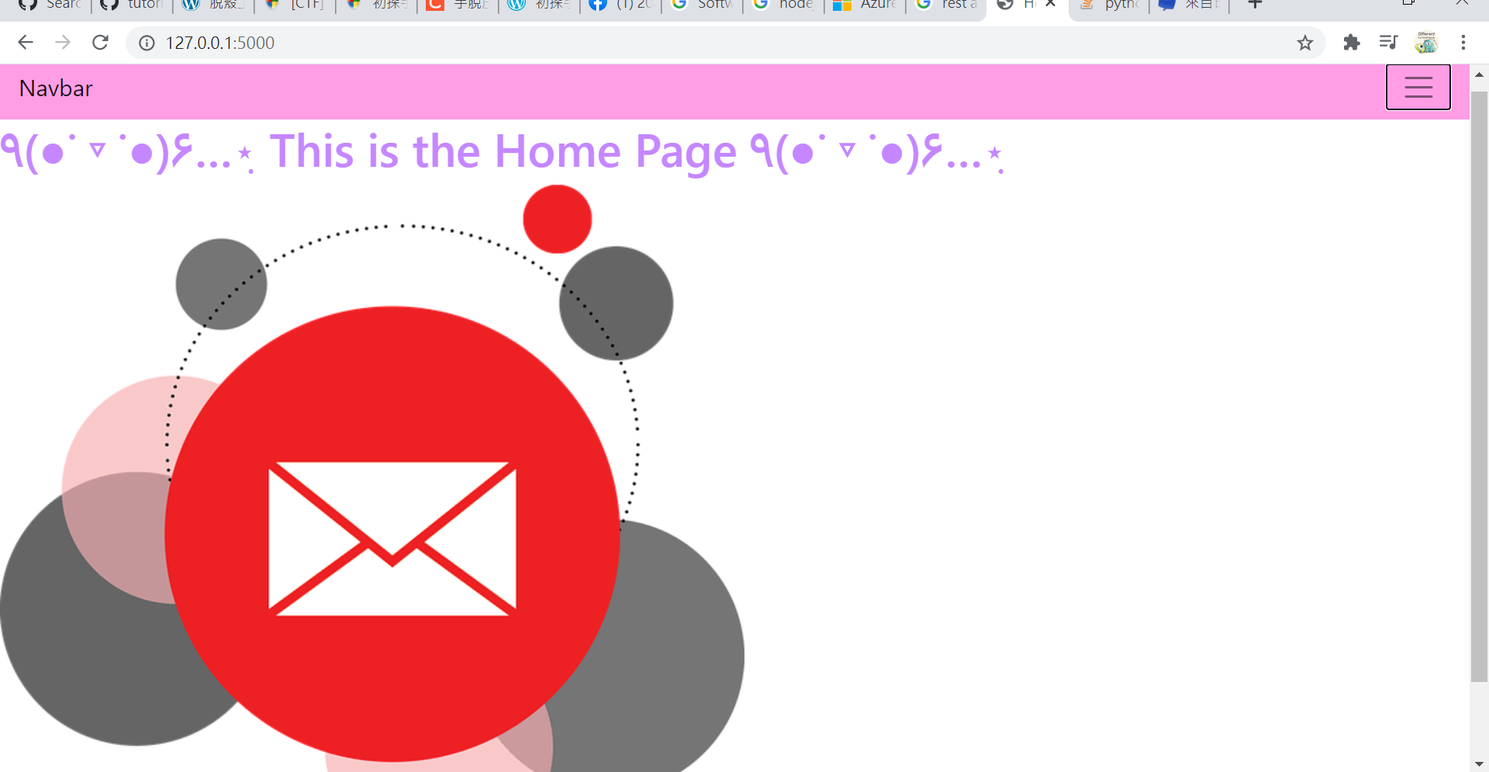

Click the icon on the right

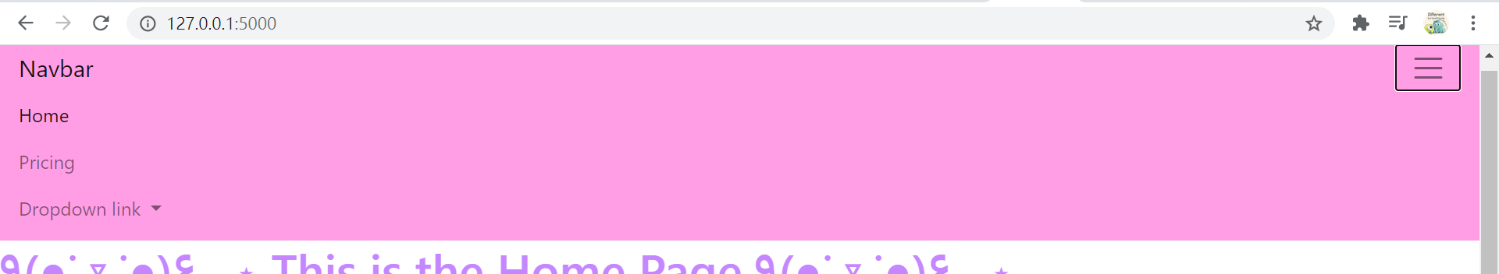

There are more to click in the dropdown link

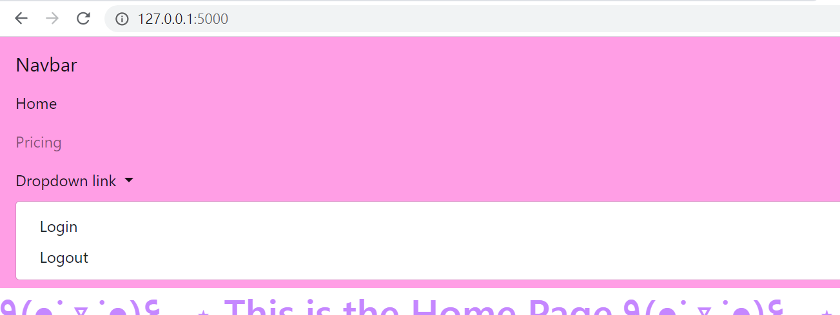

After clicking on “Login” and fill in any user’s name

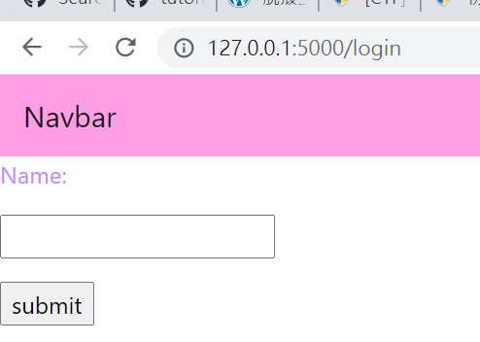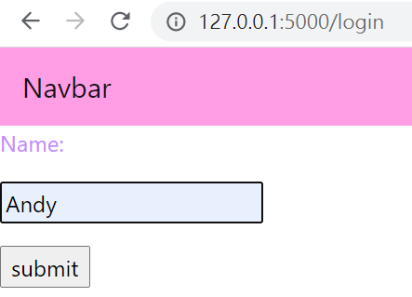

After submitting, you’ll have to enter the user’s email

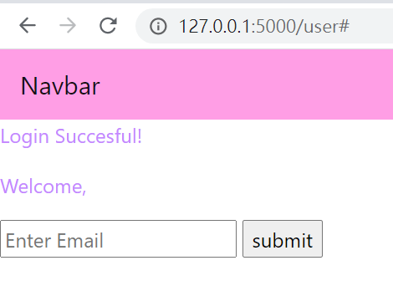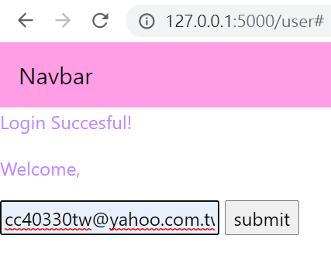

After clicking “Logout”, the page will redirect to the login page

