VRBS LocateAnything Pipeline Result Archive With Visuals
Project: /mnt/si00068187c7/default/myc/projects/vrbs_locateanything | Final run: dengnan_locateanything_all_full_qwen35_prompt0606_contextcopy
Summary
This image-rich archive documents the final VRBS LocateAnything pipeline. It includes step-level visual outputs, per-query input and prediction panels, and the final evaluation metrics from the 10-question full test run.
- Final precision at IoU 0.5: 10000.00% (10 correct out of 10 queries).
- The pipeline uses Qwen/Qwen3.5-0.8B for isolated category extraction, LocateAnything for 2D proposals, and the distilled Qwen3.6 VLM for tag selection.
- Each query copies only the first-round video memory as base context; previous second-round question/answer state is not reused.
Step Visuals
Step 1 shows the user-person image and the scene image supplied to each query.
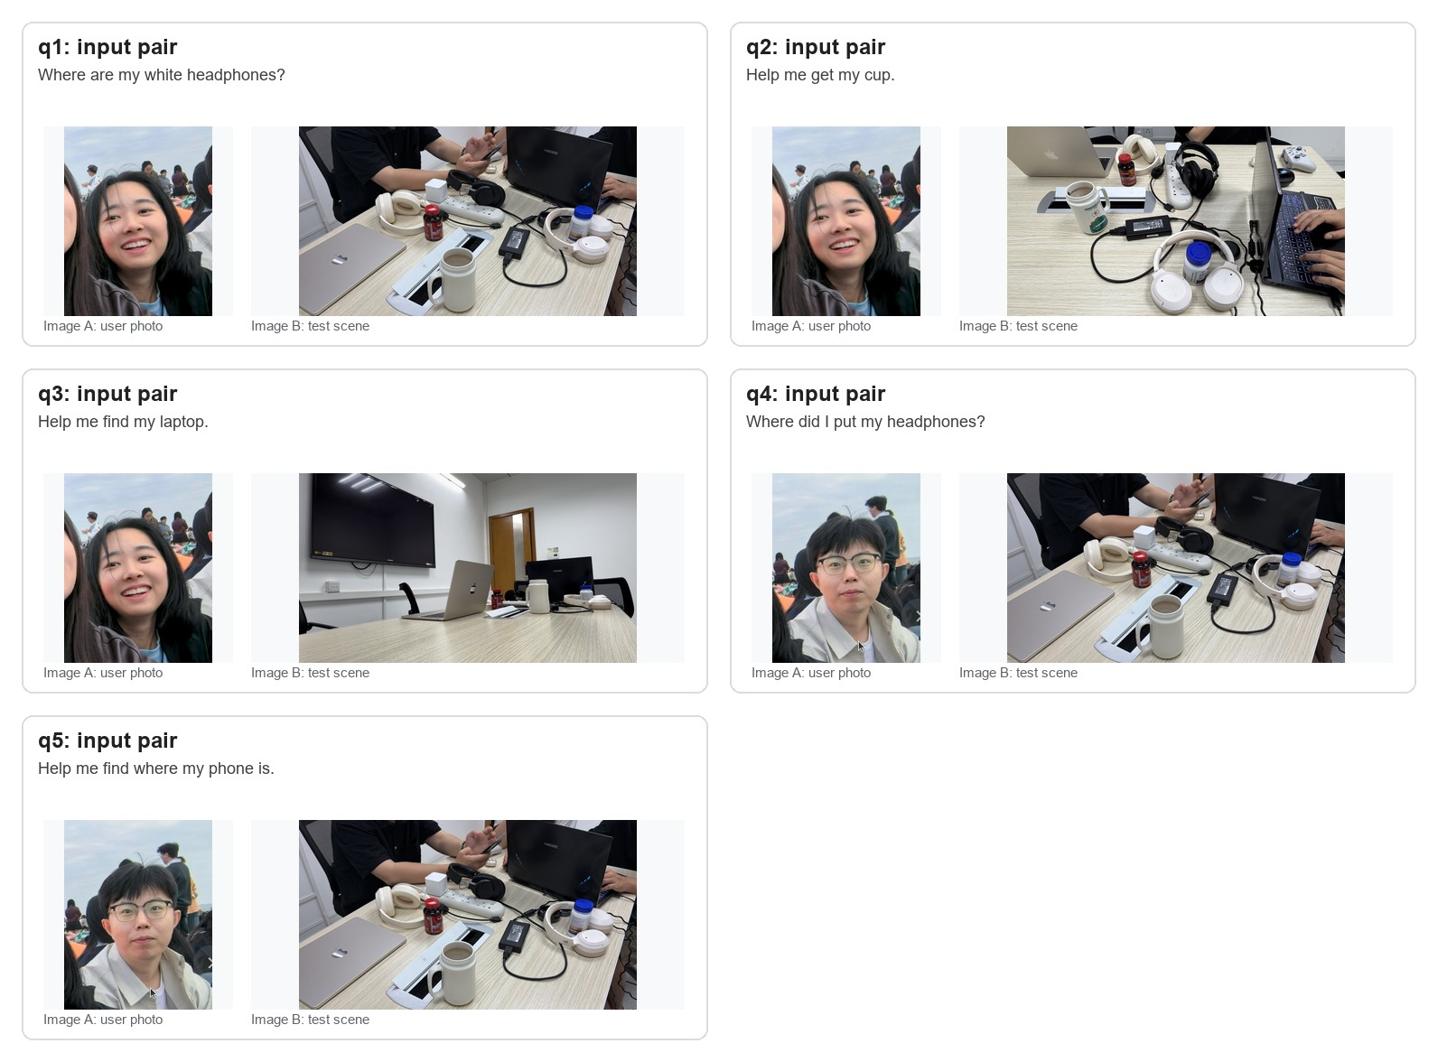
Figure 1.1. Step 1 inputs: user photo and target scene pairs.
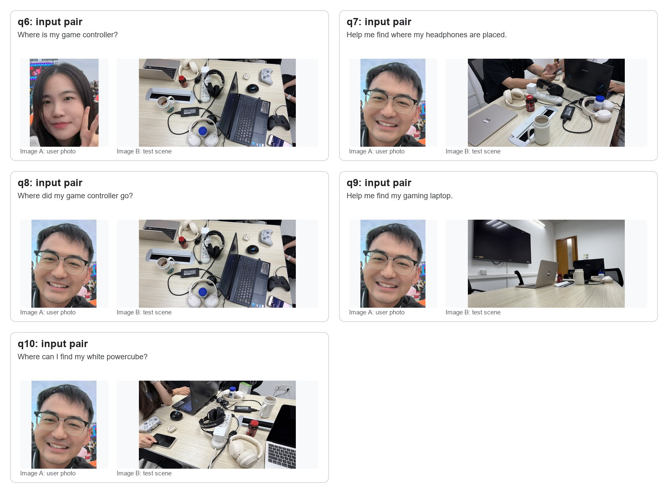
Figure 1.2. Step 1 inputs: user photo and target scene pairs.
Step 2 shows the small language model output used as the LocateAnything grounding phrase.
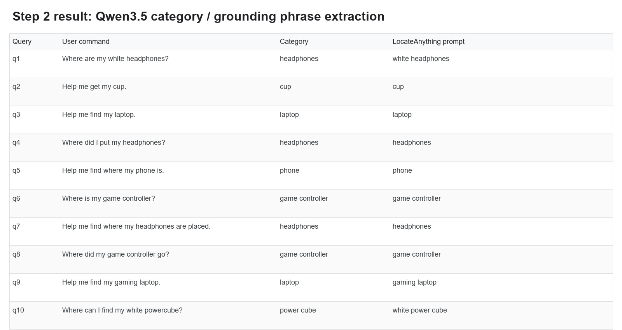
Figure 2. Step 2 category extraction and grounding phrase results.
Step 3 shows LocateAnything 2D proposals rendered as numbered tags on the test scene image.
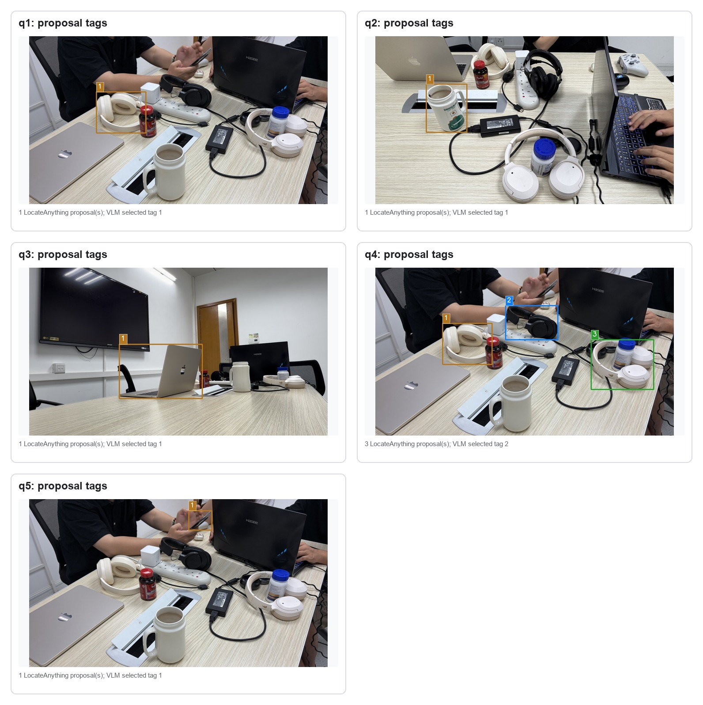
Figure 3.1. Step 3 tagged proposal images.
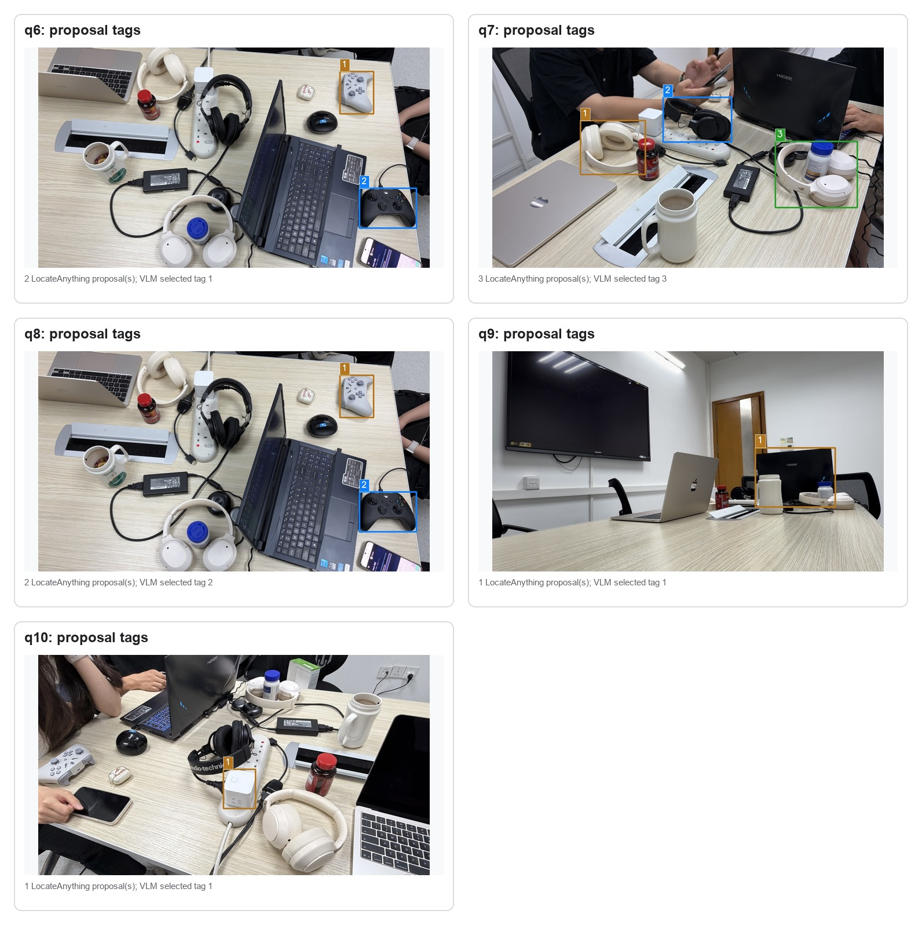
Figure 3.2. Step 3 tagged proposal images.
Step 4 shows the first-round video understanding memory. The full memory is kept in the local text artifact and copied as isolated base context for every query.
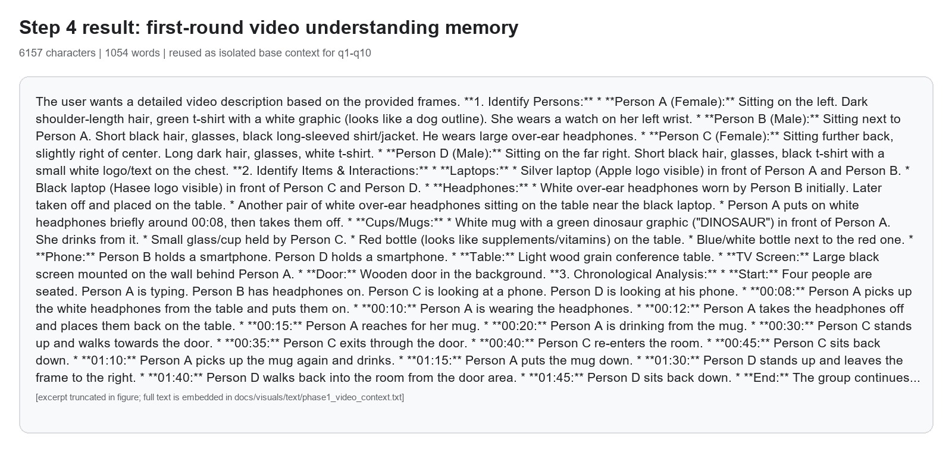
Figure 4. Step 4 video memory summary and excerpt.
Step 5 and Step 6 are shown together below: the VLM-selected tag is converted back to a 2D bbox and evaluated against the ground-truth box.
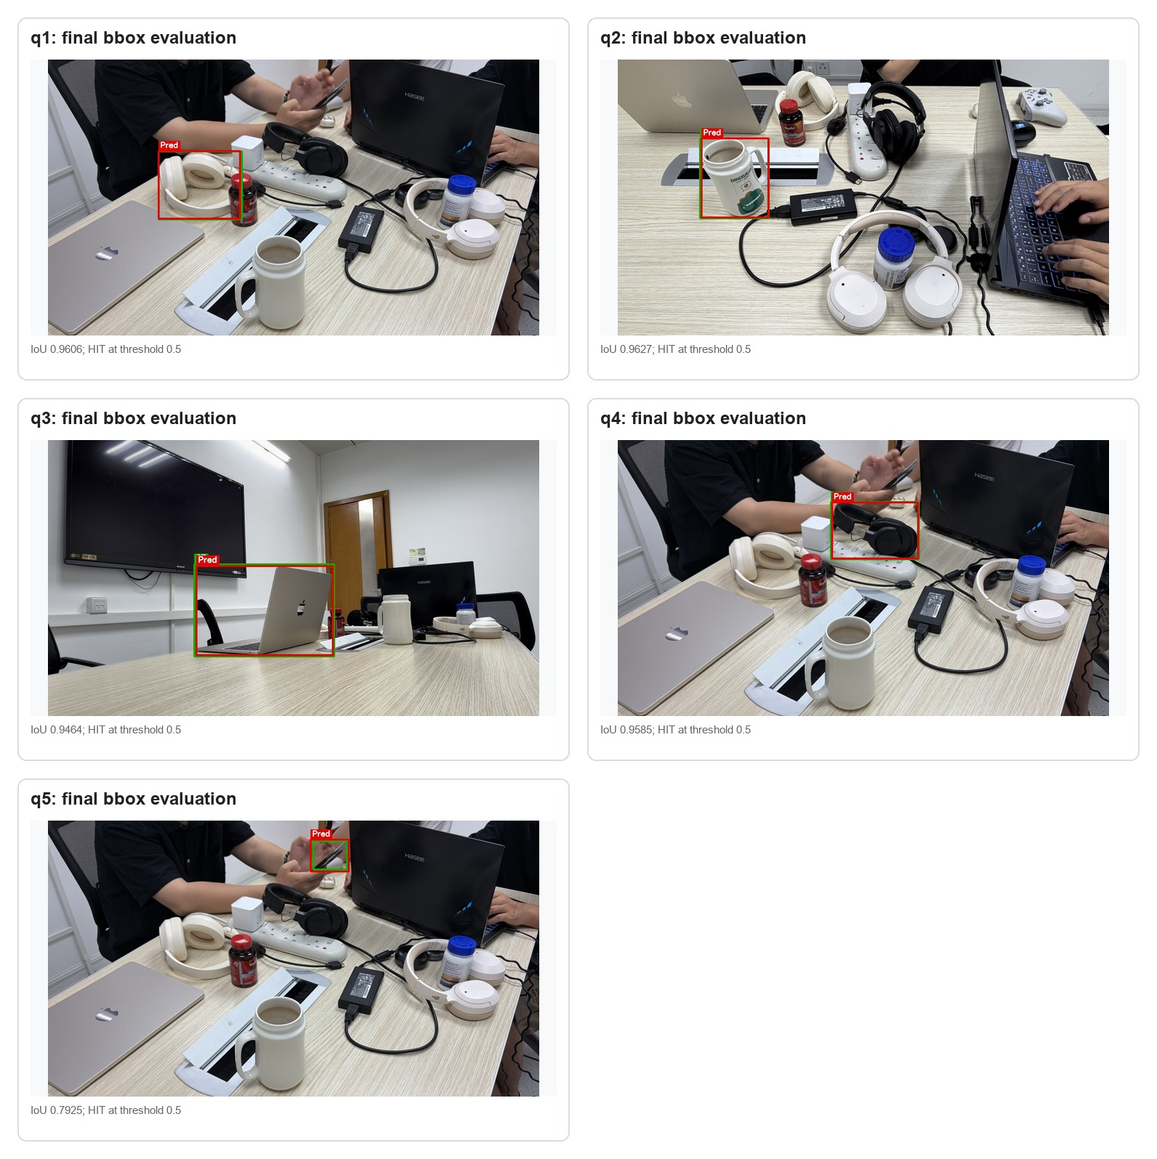
Figure 5.1. Step 5-6 selected bbox evaluation images.
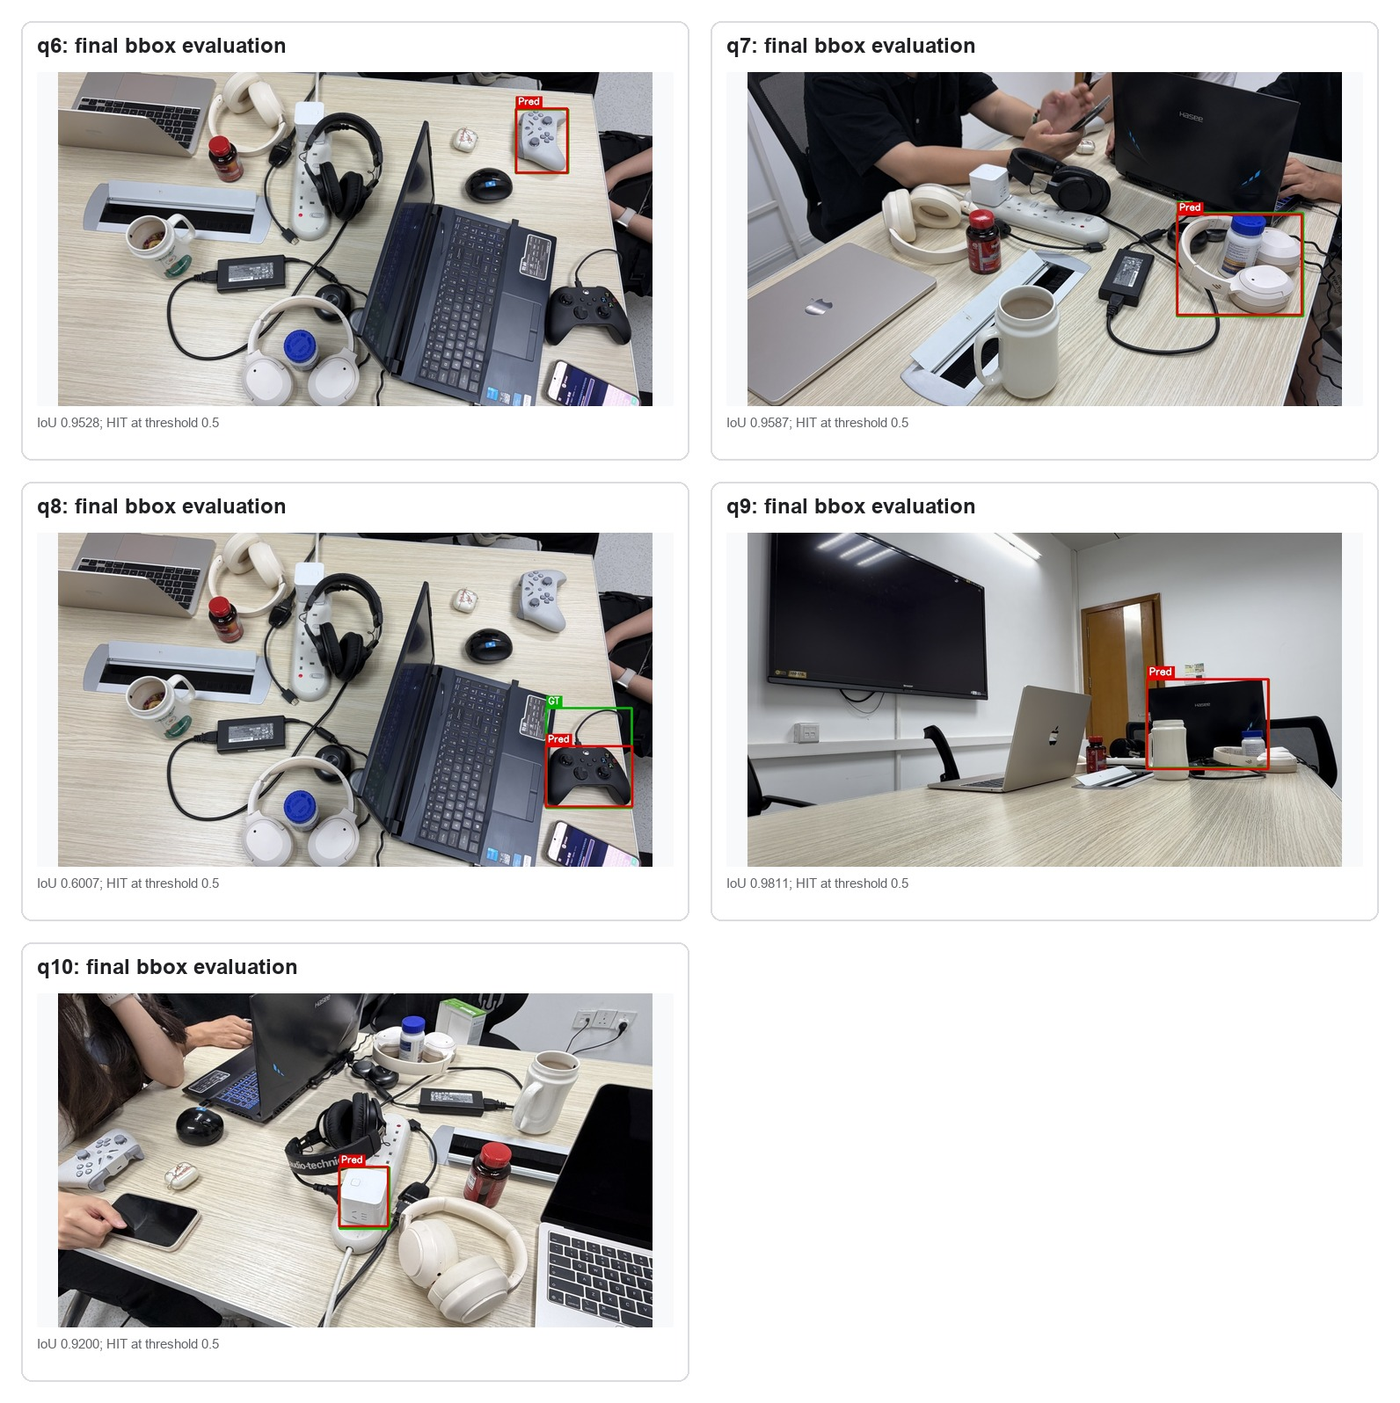
Figure 5.2. Step 5-6 selected bbox evaluation images.
Per-Query Results
Query | User command | Grounding phrase | Props | Tag | IoU | Result
q1 | Where are my white headphones? | white headphones | 1 | 1 | 0.9606 | HIT
q2 | Help me get my cup. | cup | 1 | 1 | 0.9627 | HIT
q3 | Help me find my laptop. | laptop | 1 | 1 | 0.9464 | HIT
q4 | Where did I put my headphones? | headphones | 3 | 2 | 0.9585 | HIT
q5 | Help me find where my phone is. | phone | 1 | 1 | 0.7925 | HIT
q6 | Where is my game controller? | game controller | 2 | 1 | 0.9528 | HIT
q7 | Help me find where my headphones are placed. | headphones | 3 | 3 | 0.9587 | HIT
q8 | Where did my game controller go? | game controller | 2 | 2 | 0.6007 | HIT
q9 | Help me find my gaming laptop. | gaming laptop | 1 | 1 | 0.9811 | HIT
q10 | Where can I find my white powercube? | white power cube | 1 | 1 | 0.9200 | HIT
Per-Query Visual Appendix
Each panel shows the query's Image A user photo, the tagged Image B proposal image, and the final evaluation visualization.
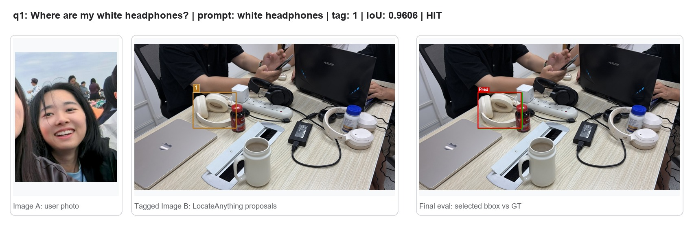
Figure A.q01. Per-query input, proposal, and final bbox result.
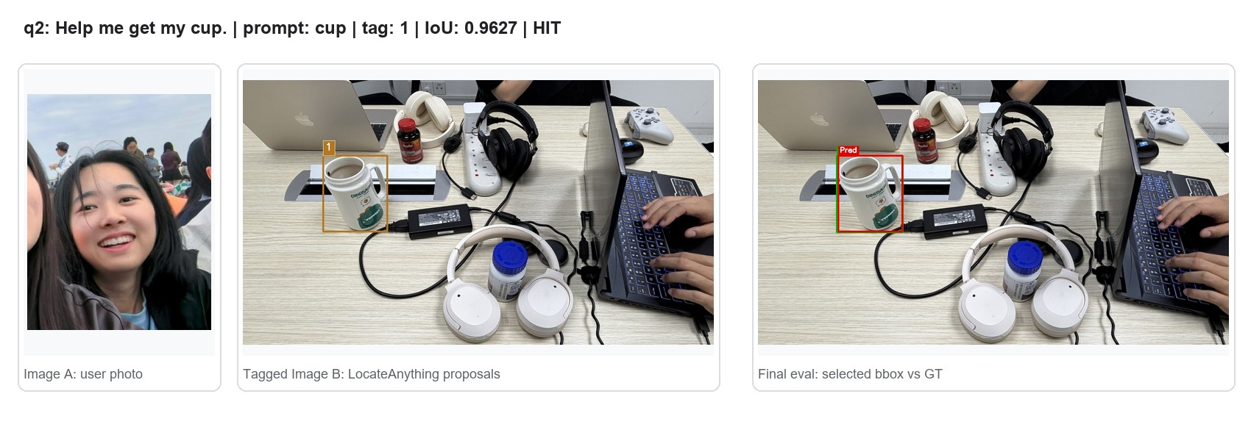
Figure A.q02. Per-query input, proposal, and final bbox result.
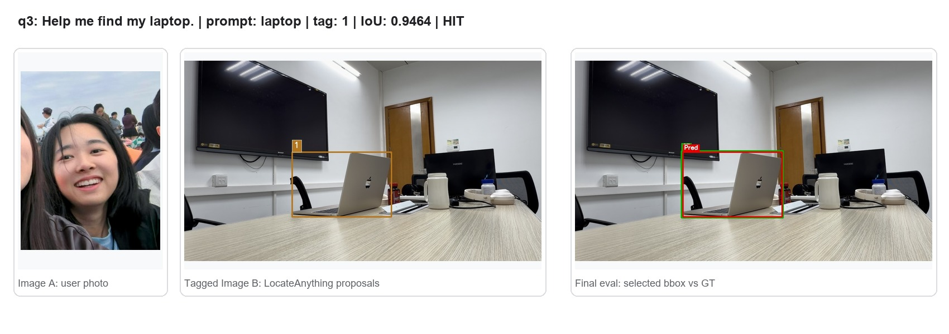
Figure A.q03. Per-query input, proposal, and final bbox result.
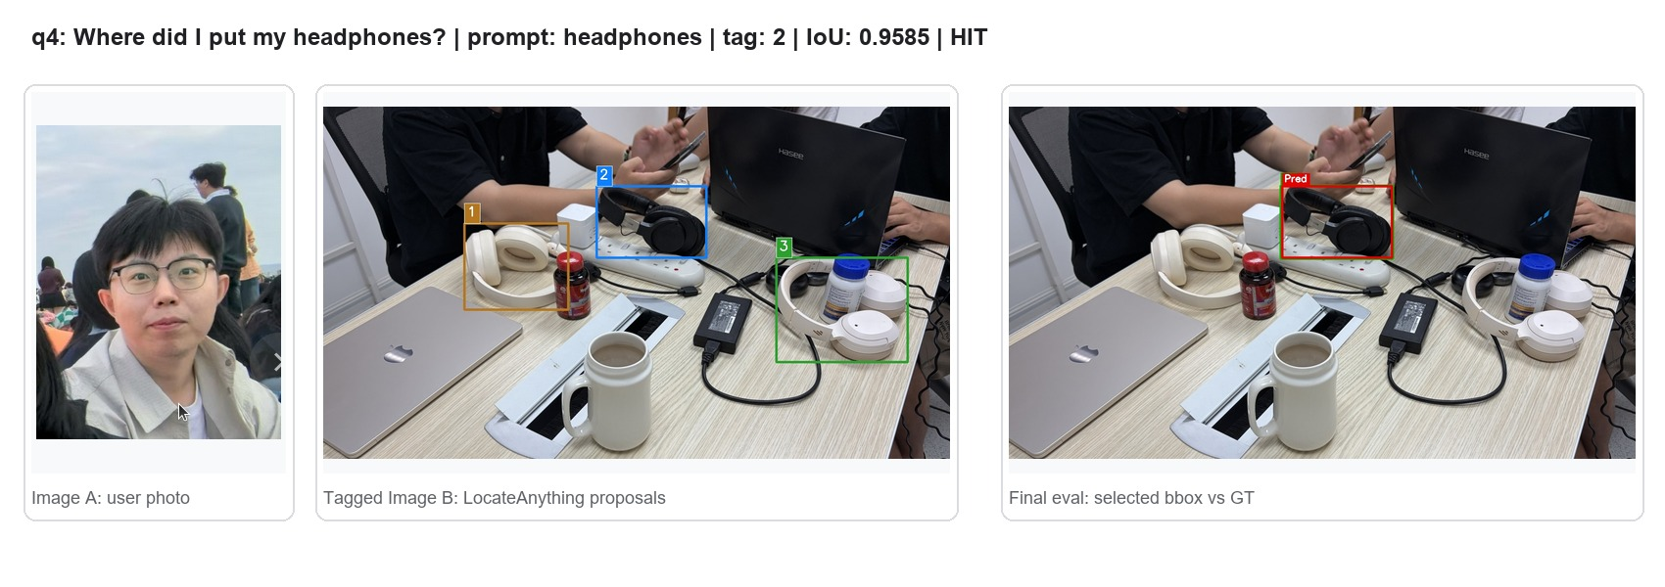
Figure A.q04. Per-query input, proposal, and final bbox result.
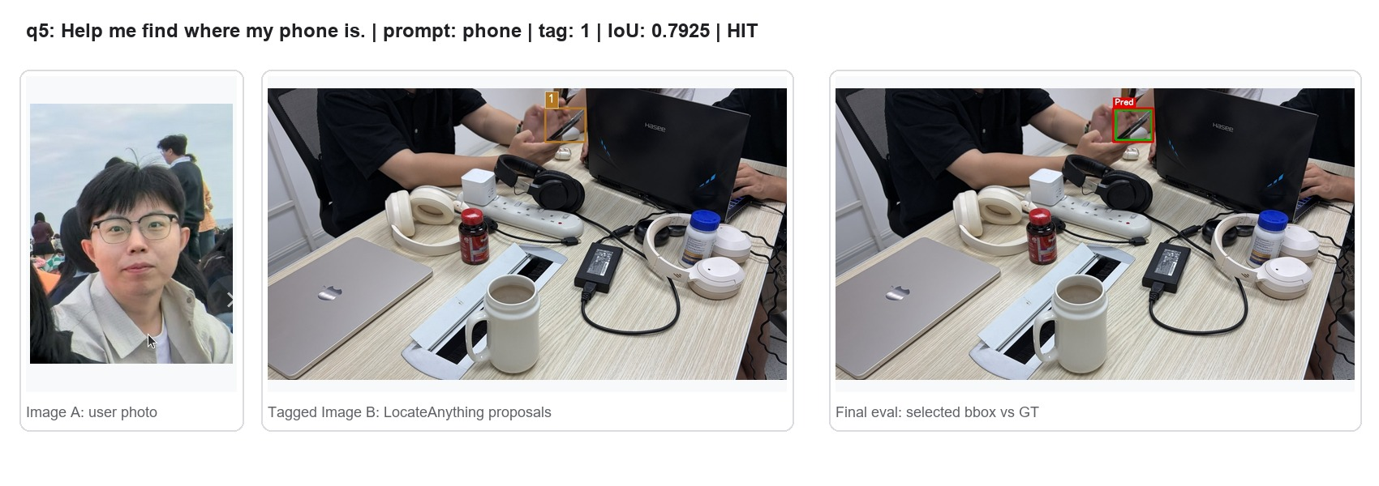
Figure A.q05. Per-query input, proposal, and final bbox result.
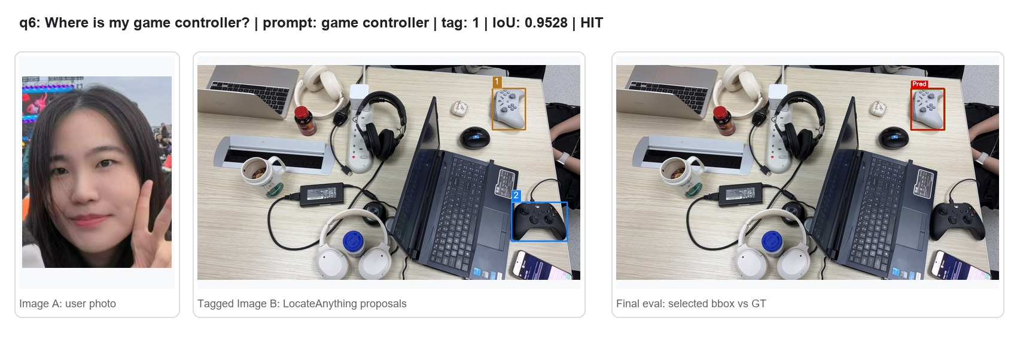
Figure A.q06. Per-query input, proposal, and final bbox result.
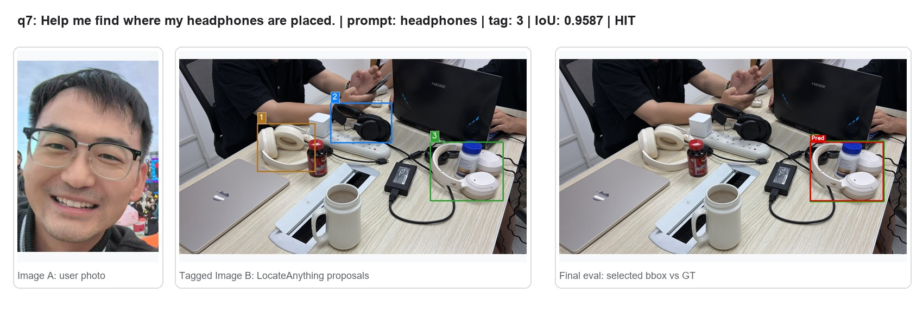
Figure A.q07. Per-query input, proposal, and final bbox result.
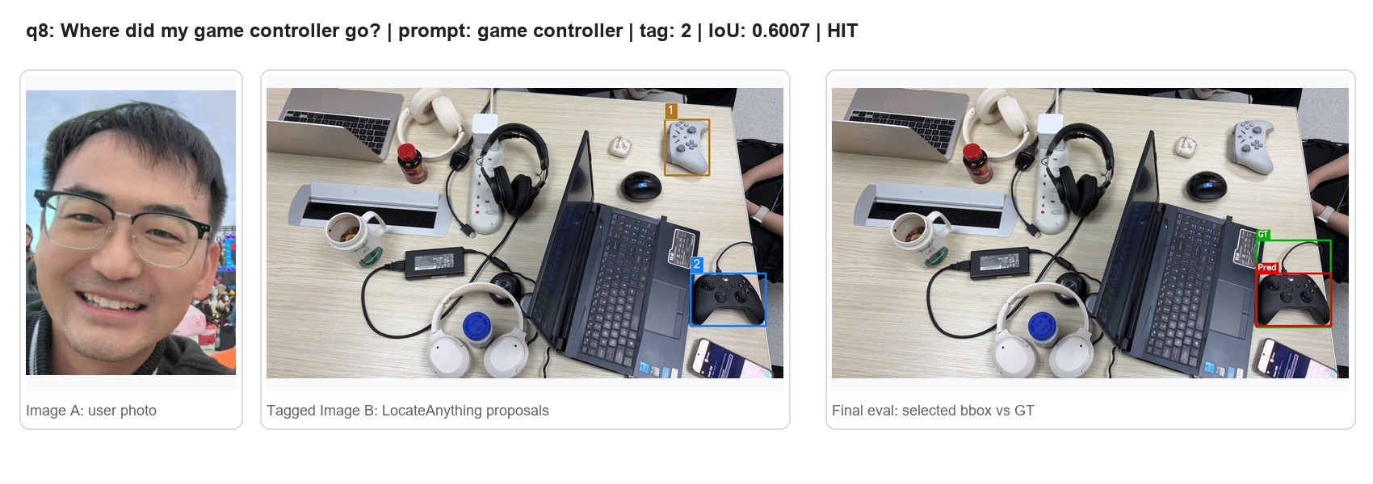
Figure A.q08. Per-query input, proposal, and final bbox result.
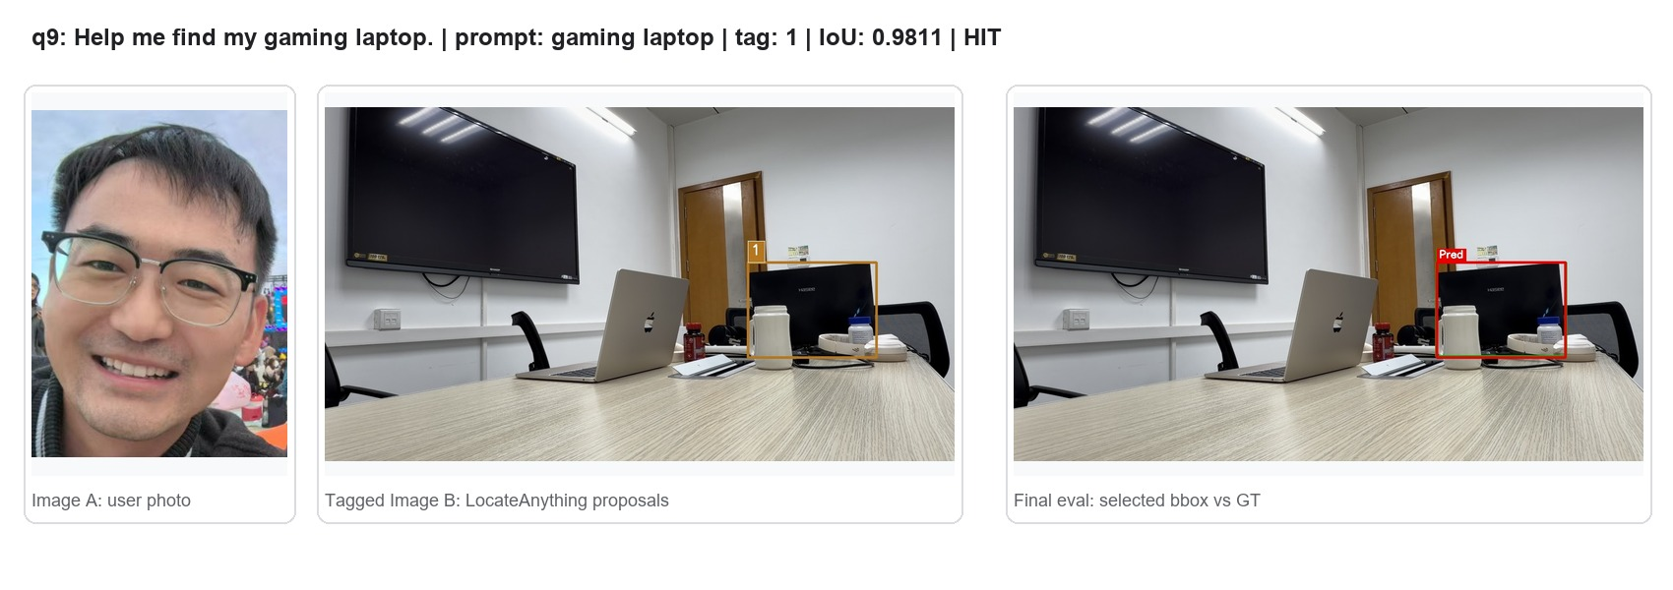
Figure A.q09. Per-query input, proposal, and final bbox result.
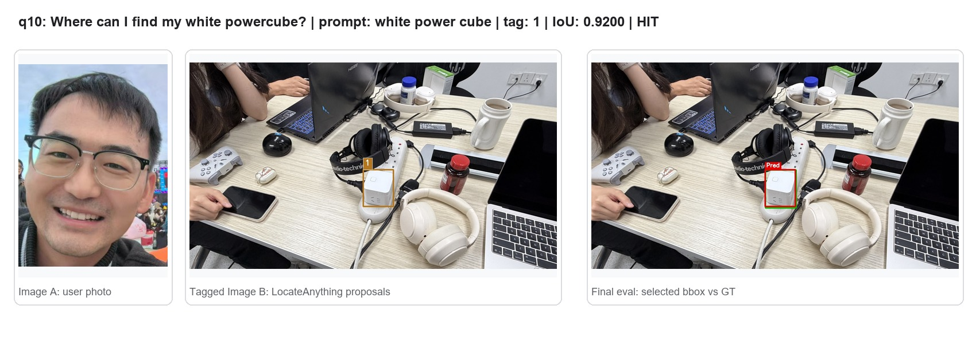
Figure A.q10. Per-query input, proposal, and final bbox result.
Artifacts
Artifact | Path / file
Project code | /mnt/si00068187c7/default/myc/projects/vrbs_locateanything
Final output directory | /mnt/si00068187c7/default/myc/data/VRBS/output/dengnan_locateanything_all_full_qwen35_prompt0606_contextcopy
Downloaded local visual assets | docs/visuals
Generated composite figures | docs/visuals/generated
Main entrypoint | run_pipeline.py
Prompt definitions | src/prompts.py
Result summary | docs/visuals/text/results.json

