VRBS LocateAnything Two-Video Result Archive
Unified pipeline and latest evaluation results for dengnan and shoes
Generated on 2026-06-12 13:06 from the latest remote outputs. This document summarizes the end-to-end pipeline, the shared prompt strategy, per-video metrics, visual outputs, and remaining improvement points.

Executive Summary
Video case | Questions | Correct | Precision@0.5 | Oracle upper bound | Latest output directory
dengnan | 10 | 10 | 100.00% | 10/10 | /mnt/si00068187c7/default/myc/data/VRBS/output/dengnan_hybrid_prompt_deterministic_select_full
shoes | 4 | 2 | 50.00% | 3/4 | /mnt/si00068187c7/default/myc/data/VRBS/output/shoes_hybrid_prompt_deterministic_select_full

- The same latest run_pipeline.py and prompt set now supports both videos without case-specific prompt branches.
- dengnan recovered to 10/10 after retaining functional subtype prompts such as gaming laptop and making VLM tag selection deterministic.
- shoes remains 2/4: q1 is limited by proposal quality, while q2 has a correct proposal but the VLM selects the wrong tag.

Unified Pipeline
Step | Input | Processing | Output
1. Video understanding | Case video | Distilled Qwen3.6 VLM builds first-round video memory; context is cached and reused. | phase1_video_context.txt
2. Target extraction | Original ask_*.txt user command | Qwen/Qwen3.5-0.8B extracts object category and explicit attributes. | category_predictions.jsonl
3. Proposal generation | Scene image + LocateAnything prompt | LocateAnything generates 2D candidate boxes. | q*_proposals.json
4. Tag rendering | Scene image + proposals | Numeric tags are rendered on Image B so the VLM can choose a proposal. | q*_tagged.jpg
5. VLM tag selection | Image A, tagged Image B, original user command, video memory | Qwen3.6 VLM selects one numbered tag with deterministic sampling. | vlm_tag_selection.log
6. Evaluation | Selected bbox + GT boxes | IoU is computed and counted as hit when IoU >= 0.5. | results.json and vis_q*.jpg

Prompt And Code Strategy
Code path: /mnt/si00068187c7/default/myc/projects/vrbs_locateanything/run_pipeline.py
- LocateAnything prompt is broad for colors and brands: white headphones -> headphones, NIKE shoes -> shoes, black boots -> boots.
- Functional subtype terms are retained when explicitly written: gaming laptop remains gaming laptop because the subtype changes which laptop should be proposed.
- VLM tag selection always receives the original detailed user command. This fixes the earlier issue where NIKE shoes was simplified to shoes before tag selection.
- Second-round questions are independent: each query copies only the phase1 video memory and does not inherit previous question-answer context.
- VLM tag selection uses deterministic sampling for stability and is instructed to prioritize the matched person-item association over visual salience.

Dengnan Case
Input directory: /mnt/si00068187c7/default/myc/data/VRBS/input/dengnan
Latest output directory: /mnt/si00068187c7/default/myc/data/VRBS/output/dengnan_hybrid_prompt_deterministic_select_full
Result: 10 / 10 correct, Precision@IoU=0.5 = 100.00%. Oracle proposal upper bound = 10/10.

Dengnan Per-Question Results
Q | User command | LA prompt | Props | Tag | IoU | Result | Oracle
q1 | Where are my white headphones? | headphones | 3 | 1 | 0.9606 | Hit | tag 1 / 0.9606
q2 | Help me get my cup. | cup | 1 | 1 | 0.9627 | Hit | tag 1 / 0.9627
q3 | Help me find my laptop. | laptop | 1 | 1 | 0.9464 | Hit | tag 1 / 0.9464
q4 | Where did I put my headphones? | headphones | 3 | 2 | 0.9585 | Hit | tag 2 / 0.9585
q5 | Help me find where my phone is. | phone | 1 | 1 | 0.7925 | Hit | tag 1 / 0.7925
q6 | Where is my game controller? | game controller | 2 | 1 | 0.9528 | Hit | tag 1 / 0.9528
q7 | Help me find where my headphones are placed. | headphones | 3 | 3 | 0.9453 | Hit | tag 3 / 0.9453
q8 | Where did my game controller go? | game controller | 2 | 2 | 0.6007 | Hit | tag 2 / 0.6007
q9 | Help me find my gaming laptop. | gaming laptop | 1 | 1 | 0.9811 | Hit | tag 1 / 0.9811
q10 | Where can I find my white powercube? | power cube | 1 | 1 | 0.9509 | Hit | tag 1 / 0.9509

Dengnan Visuals
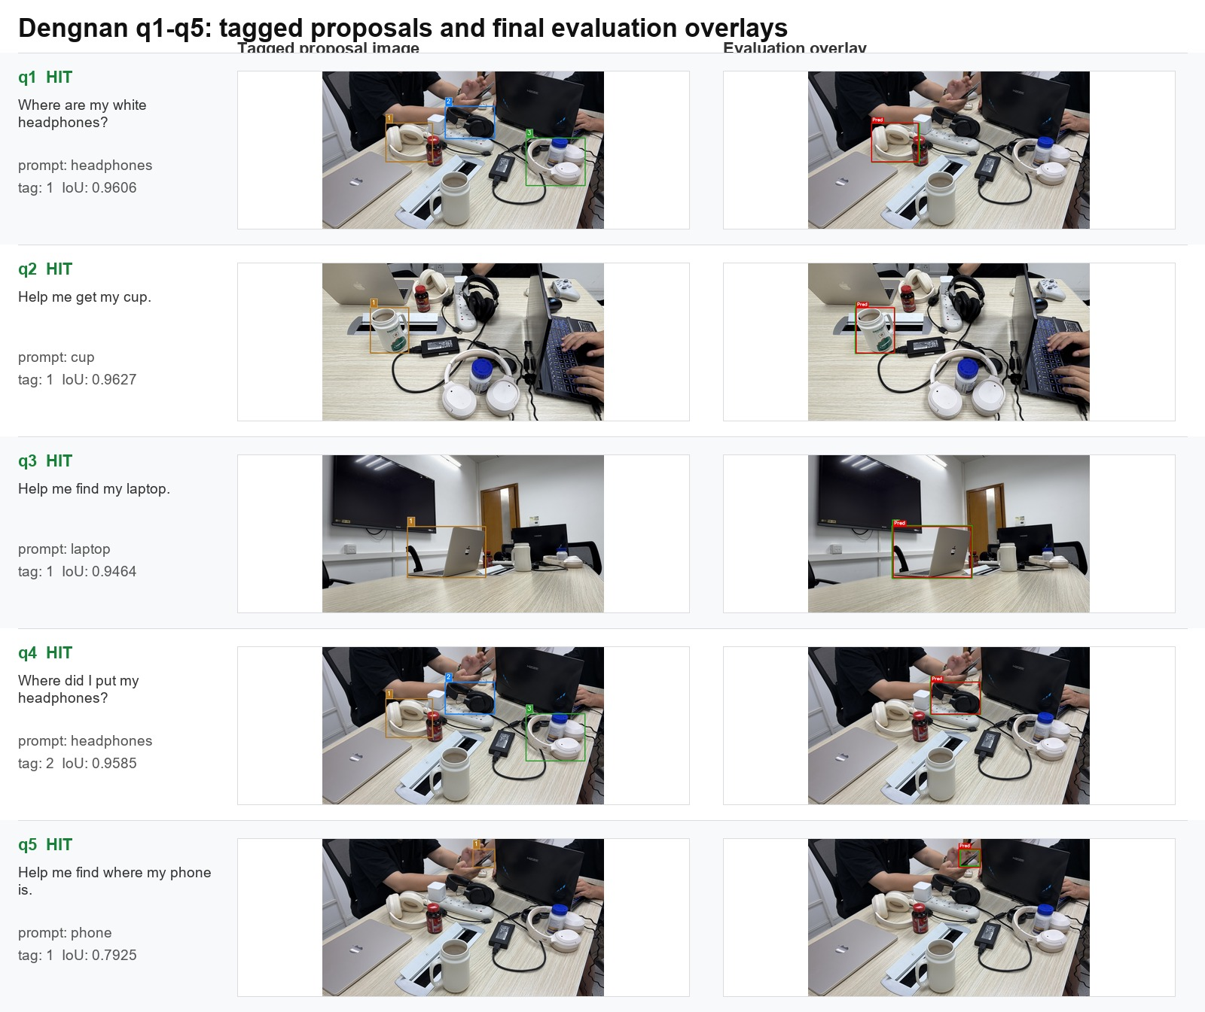
Figure D1. Dengnan tagged proposals and evaluation overlays.
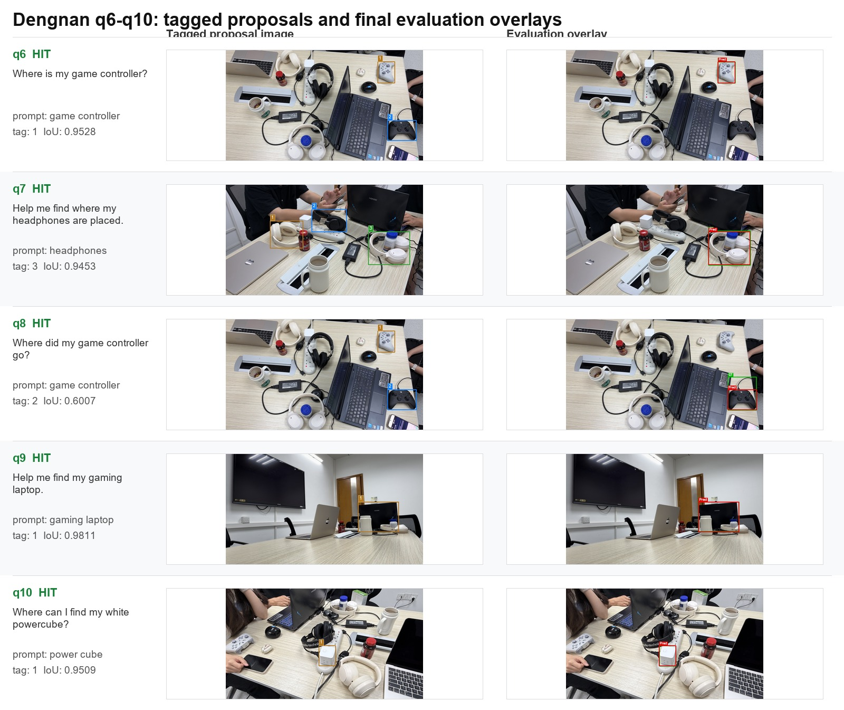
Figure D2. Dengnan tagged proposals and evaluation overlays.

Shoes Case
Input directory: /mnt/si00068187c7/default/myc/data/VRBS/input/shoes
Latest output directory: /mnt/si00068187c7/default/myc/data/VRBS/output/shoes_hybrid_prompt_deterministic_select_full
Result: 2 / 4 correct, Precision@IoU=0.5 = 50.00%. Oracle proposal upper bound = 3/4.

Shoes Per-Question Results
Q | User command | LA prompt | Props | Tag | IoU | Result | Oracle
q1 | Where are my NIKE shoes, please frame them out for me. | shoes | 12 | 10 | 0.0000 | Miss | tag 7 / 0.4598
q2 | Where are my black boots, please frame them out for me. | boots | 4 | 1 | 0.0000 | Miss | tag 4 / 0.6648
q3 | Where are my NIKE shoes, please frame them out for me. | shoes | 12 | 11 | 0.5534 | Hit | tag 11 / 0.5534
q4 | Where are my black boots, please frame them out for me. | boots | 4 | 1 | 0.6218 | Hit | tag 1 / 0.6218

Shoes Visuals
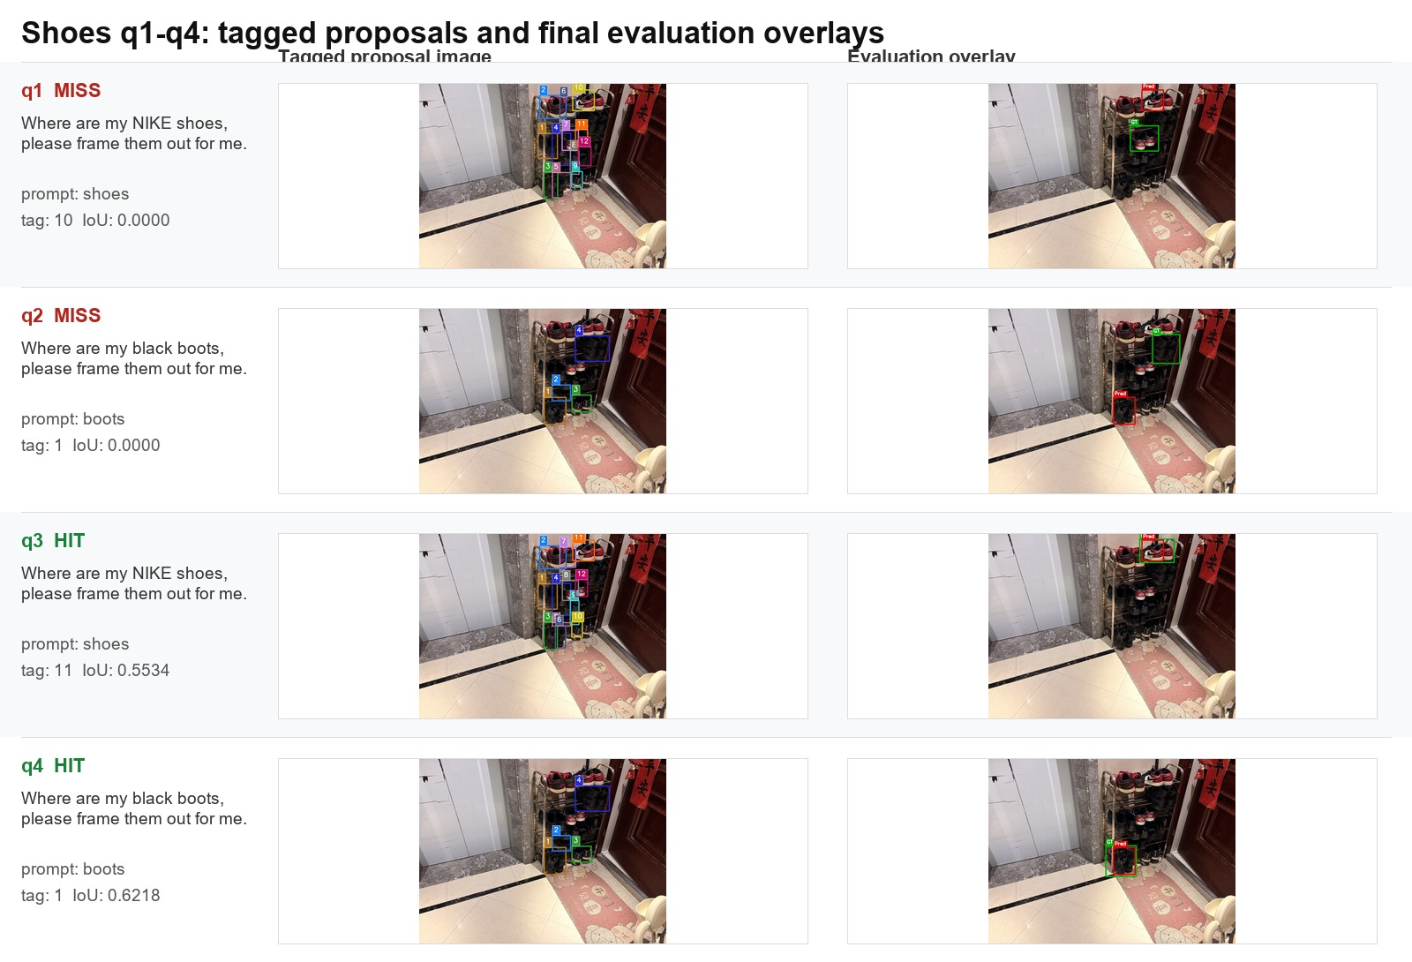
Figure S1. Shoes tagged proposals and evaluation overlays.

Failure Analysis And Improvement Directions
Case / query | Observed issue | Evidence | Likely improvement
shoes q1 | Best proposal is close but below threshold. | Oracle tag 7 IoU = 0.4598; selected tag 10 IoU = 0.0000. | Improve proposal generation for shoes: try higher max proposals, crop/zoom scene, or alternate prompt ensemble such as shoes + sneakers while keeping VLM question detailed.
shoes q2 | Correct proposal exists but VLM chooses wrong tag. | Oracle tag 4 IoU = 0.6648; selected tag 1 IoU = 0.0000. | Improve tag selection with candidate crop comparison, per-tag short descriptions, or a two-stage selector that first filters by person-item match then picks tag.
dengnan q9 | Previously failed when gaming was stripped. | Latest prompt keeps gaming laptop and reaches IoU = 0.9811. | Keep functional subtype modifiers while stripping colors/brands for broad proposals.
dengnan q6 | Previously selected the other controller. | Latest deterministic prompt selects tag 1 with IoU = 0.9528. | Maintain deterministic selection and person-item association priority.

Artifacts
Artifact | Path
Project | /mnt/si00068187c7/default/myc/projects/vrbs_locateanything
Run script | /mnt/si00068187c7/default/myc/projects/vrbs_locateanything/run_pipeline.py
Dengnan latest results | /mnt/si00068187c7/default/myc/data/VRBS/output/dengnan_hybrid_prompt_deterministic_select_full/text/results.json
Shoes latest results | /mnt/si00068187c7/default/myc/data/VRBS/output/shoes_hybrid_prompt_deterministic_select_full/text/results.json
Dengnan visual outputs | /mnt/si00068187c7/default/myc/data/VRBS/output/dengnan_hybrid_prompt_deterministic_select_full/images
Shoes visual outputs | /mnt/si00068187c7/default/myc/data/VRBS/output/shoes_hybrid_prompt_deterministic_select_full/images

