APPENDIX A NODE AND ELECTION YEAR SELECTION

A.1 Candidate variables and the final nine nodes
The 16 candidate variables were assessed for substantive scope, cross-year availability and measurement comparability. Nine were retained for the policy-attitude and policy-related-belief network, and seven were not included (Table A1). All 16 exist in the ANES Time Series Cumulative Data File (CDF), February 5, 2026 release; 14 have substantive responses in all five main years. The exceptions are environmental spending in 2004 and defence spending in 2012.
Table A1 Disposition of 16 candidate variables and selection of nine nodes
Variable | Item | Decision | Basis and verification
VCF0806 | Government health insurance | Retained | Healthcare responsibility; usable responses in all five main years.
VCF0809 | Government jobs and living standards responsibility | Retained | Employment and living standards responsibility, distinct from healthcare provision.
VCF0838 | Abortion policy | Retained | Policy content beyond spending and immigration; four ordered substantive categories.
VCF0839 | Government services and spending | Retained | General government provision; overlap with specific spending items examined by node-removal sensitivity analysis.
VCF0879a | Preferred immigration level | Retained | Preferences for increasing, maintaining or reducing immigration.
VCF0888 | Federal crime spending | Retained | Crime-related spending preferences, retaining increase, same and decrease categories.
VCF0890 | Federal public-school spending | Retained | School spending preferences, retaining increase, same and decrease categories.
VCF0894 | Federal welfare spending | Retained | Welfare spending preferences, retaining increase, same and decrease categories.
VCF9223 | Immigration employment effects | Retained | Beliefs about employment consequences, distinct from preferred immigration levels.
VCF0830 | Government aid to Black people | Not included | Responses exist in all five years; the direct 2012 source-to-CDF mapping remains unverified.
VCF0843 | Defence spending | Not included | The 2012 scale is not comparable; this CDF field has no substantive values that year.
VCF9047 | Environmental spending | Not included | No usable CDF values in 2004; the official 2012 source has been confirmed.
VCF9049 | Social Security spending | Not included | Responses exist in all five years; the documented scope decision maintains the fixed nine-node set.
VCF0301 | Party identification | Not included | Political identity rather than a policy-attitude node.
VCF0803 | Ideological self-placement | Not included | General political self-identification rather than a policy-attitude node.
VCF0846 | Importance of religion | Not included | Religious orientation lies outside the selected policy scope; CDF coding is binary throughout.
Note: The five main years are 2004, 2012, 2016, 2020 and 2024. The defence-spending issue concerns scale comparability, not non-administration. Binary coding is not itself a reason to exclude religious importance.

A.2 Election year selection
The main analysis covers five waves: 2004, 2012, 2016, 2020 and 2024. The first, 2004, is the earliest wave in which all nine selected nodes were asked: VCF9223 was not available in earlier studies, so a common nine-node set cannot be formed before that year.
The 2008 wave is excluded from the main comparison. Four of the nine items (VCF0806, VCF0809, VCF0838 and VCF0839) used separate OLD and NEW questionnaire versions or were administered through branching, which left comparable complete cases almost entirely within the OLD questionnaire version. Of the 2,322 respondents interviewed in 2008, 756 answered all four affected items validly, and only 724 had complete data on all nine nodes.
The 2008 nine-node matrix could still be estimated and was positive definite, so this is not an estimation problem. The issue is comparability: an analysis restricted to a version-specific subset would confound wave differences with questionnaire version.

A.3 Education group coverage
Education-group analyses cover 2012, 2016, 2020 and 2024. The 2004 degree-educated subsample was smaller and had sparse item-pair response combinations, so it was not included in these analyses. The overall 2004 network remains in the main analysis.
VCF0110 codes 1–3 identify respondents without a college degree; code 4 identifies those with a college or advanced degree. Education is used as a demographic grouping variable, not as a direct measure of political sophistication or political elite status.

APPENDIX B RECODING AND SAMPLE CONSTRUCTION

B.1 Node recoding
Non-substantive codes were first converted to missing values. Six nodes were then reverse-coded to align their substantive interpretation. Valid categories were retained, and the items were not converted to a common liberal–conservative scale.
Table B1 Node recoding rules
Variable | Valid original codes | Recoding | Meaning of higher values
VCF0806 | 1–7 | 8 − x | Greater support for government health insurance
VCF0809 | 1–7 | 8 − x | Greater support for government responsibility for jobs and living standards
VCF0838 | 1–4 | Unchanged | More permissive abortion policy
VCF0839 | 1–7 | Unchanged | Greater support for government services and spending
VCF0879a | 1, 3, 5 | 6 − x | Greater support for increasing immigration
VCF0888 | 1, 2, 3 | 4 − x | Greater support for increasing crime spending
VCF0890 | 1, 2, 3 | 4 − x | Greater support for increasing public-school spending
VCF0894 | 1, 2, 3 | 4 − x | Greater support for increasing welfare spending
VCF9223 | 1–4 | Unchanged | Lower perceived likelihood that immigration takes jobs
Note: x denotes the original valid response. VCF0879a retains three categories coded 1, 3 and 5. Ordered factors use category order, not the numerical distances between codes.
Crime, school and welfare spending retain the increase, same and decrease categories. In 2004, the decrease option also included cutting spending out entirely. This wording difference is retained in the interpretation of cross-year comparisons. Full item sources, response categories and wave-specific measurement notes are provided in the electronic supplementary materials.

B.2 Missing responses and main samples
Do not know, refusal, inapplicable, non-administered and other non-substantive codes were treated as missing, without imputation. Structural non-administration and respondent nonresponse were recorded separately in the audit.
In 2024, 245 respondents lacked valid responses to VCF0806, VCF0809 and VCF9223 simultaneously. These records were excluded under the nine-node complete-case rule. Each main network uses respondents with valid answers to all nine items, so all correlations and edges within that network use the same sample.
Table B2 Construction of the main analysis samples
Year | Cleaned N | Excluded for missing node responses | Complete-case N | Retention
2004 | 1,212 | 423 | 789 | 65.1%
2012 | 5,914 | 1,561 | 4,353 | 73.6%
2016 | 4,270 | 1,561 | 2,709 | 63.4%
2020 | 8,280 | 2,890 | 5,390 | 65.1%
2024 | 5,521 | 1,996 | 3,525 | 63.8%
Note: Retention is the nine-node complete-case count divided by the cleaned sample count for that year.
The CDF cross-year identifier VCF0006a was checked across the five main samples. No repeated identifiers across years were detected.

B.3 Education group samples
Education-group networks additionally require a valid VCF0110 response. Respondents missing education remain in the relevant main network but are excluded from education-group networks.
Table B3 Education group sample sizes
Year | Nine-node complete cases | Missing education | No college degree | College or advanced degree
2012 | 4,353 | 49 | 2,773 | 1,531
2016 | 2,709 | 15 | 1,478 | 1,216
2020 | 5,390 | 75 | 2,624 | 2,691
2024 | 3,525 | 15 | 1,729 | 1,781

APPENDIX C INPUT DIAGNOSTICS AND ESTIMATION STABILITY

C.1 Category support and correlation matrix diagnostics
Each nine-node network contains 36 item pairs. Cross-tabulations were checked for response combinations selected by no respondents and combinations selected by only 1–4 respondents. Both conditions can occur in the same item pair, so the two counts in Table C1 must not be added to obtain a total number of sparse pairs.
Table C1 Sparse response combinations and polychoric matrix diagnostics
Year | Sample | Pairs with zero cells | Pairs with 1–4 cells | Minimum eigenvalue | Condition number
2004 | Overall | 4 | 19 | 0.383 | 7.285
2012 | Overall | 0 | 3 | 0.365 | 9.095
2016 | Overall | 0 | 5 | 0.326 | 11.863
2020 | Overall | 0 | 2 | 0.296 | 15.935
2024 | Overall | 0 | 4 | 0.316 | 13.993
2012 | No degree | 0 | 3 | 0.416 | 7.410
2012 | Degree | 4 | 14 | 0.257 | 15.288
2016 | No degree | 0 | 7 | 0.372 | 9.146
2016 | Degree | 4 | 14 | 0.249 | 17.910
2020 | No degree | 0 | 5 | 0.339 | 12.216
2020 | Degree | 2 | 7 | 0.247 | 21.221
2024 | No degree | 0 | 6 | 0.349 | 11.225
2024 | Degree | 0 | 12 | 0.264 | 18.554
Note: Each row covers 36 item pairs. No degree means no college degree; Degree means a college or advanced degree. All 13 matrices were positive definite, generated no polychoric estimation warnings, and passed checks for finite entries, symmetry, unit diagonal and node order. The condition number is the largest eigenvalue divided by the smallest.
Sparse combinations were recorded as precision warnings rather than automatic grounds for deleting items or merging categories. Passing numerical checks does not establish that every edge is precisely estimated. Polychoric estimation warnings were recorded separately from dense-network warnings produced during network estimation.

C.2 Main estimation settings
Table C2 Estimation and uncertainty assessment settings
Component | Setting
Node type | Ordered factors using valid response categories
Main sample | Unweighted nine-node complete cases
Network estimator | EBICglasso
Correlation method | corMethod = "cor_auto"
EBIC tuning parameter | γ = 0.50
Penalty path | 100 λ values; minimum-to-maximum ratio = 0.01
Refitting and thresholding | refit = FALSE; threshold = FALSE
Non-positive-definite matrix | Stop estimation; no forced repair
Edge-weight bootstrap | 1,000 nonparametric resamples per network
Edge interval | 95% percentile interval
Centrality case-dropping bootstrap | 1,000 resamples per main network
Case-dropping settings | caseMin = 0.05; caseMax = 0.75; caseN = 10
CS correlation threshold | 0.70

C.3 Edge precision and centrality stability
All five main and eight education-group networks completed 1,000 nonparametric edge-weight bootstrap repetitions. Interval width describes precision; inclusion of zero is recorded for audit only, not for significance testing, further edge selection or between-group inference.
Figures C1–C3 supplement the main-text 2004 and 2024 plots with results for 2012, 2016 and 2020. Full education-group plots and all edge-level intervals are in the electronic supplementary materials.
Exploratory one-step Expected Influence and auxiliary Strength are reported only for the five main networks. Table C3 reports their case-dropping correlation stability (CS) coefficients.
Table C3 Centrality stability in the main networks
Year | Case-dropping repetitions | Expected Influence CS | Strength CS
2004 | 1,000 | 0.750 | 0.750
2012 | 1,000 | 0.750 | 0.750
2016 | 1,000 | 0.750 | 0.750
2020 | 1,000 | 0.750 | 0.750
2024 | 1,000 | 0.750 | 0.750
Note: CS uses a correlation threshold of 0.70 and is rounded to three decimals. The coefficients approach the maximum case-dropping proportion tested; they do not establish stability under more extensive case removal. Full case-dropping curves and raw centrality values are in the electronic supplementary materials.
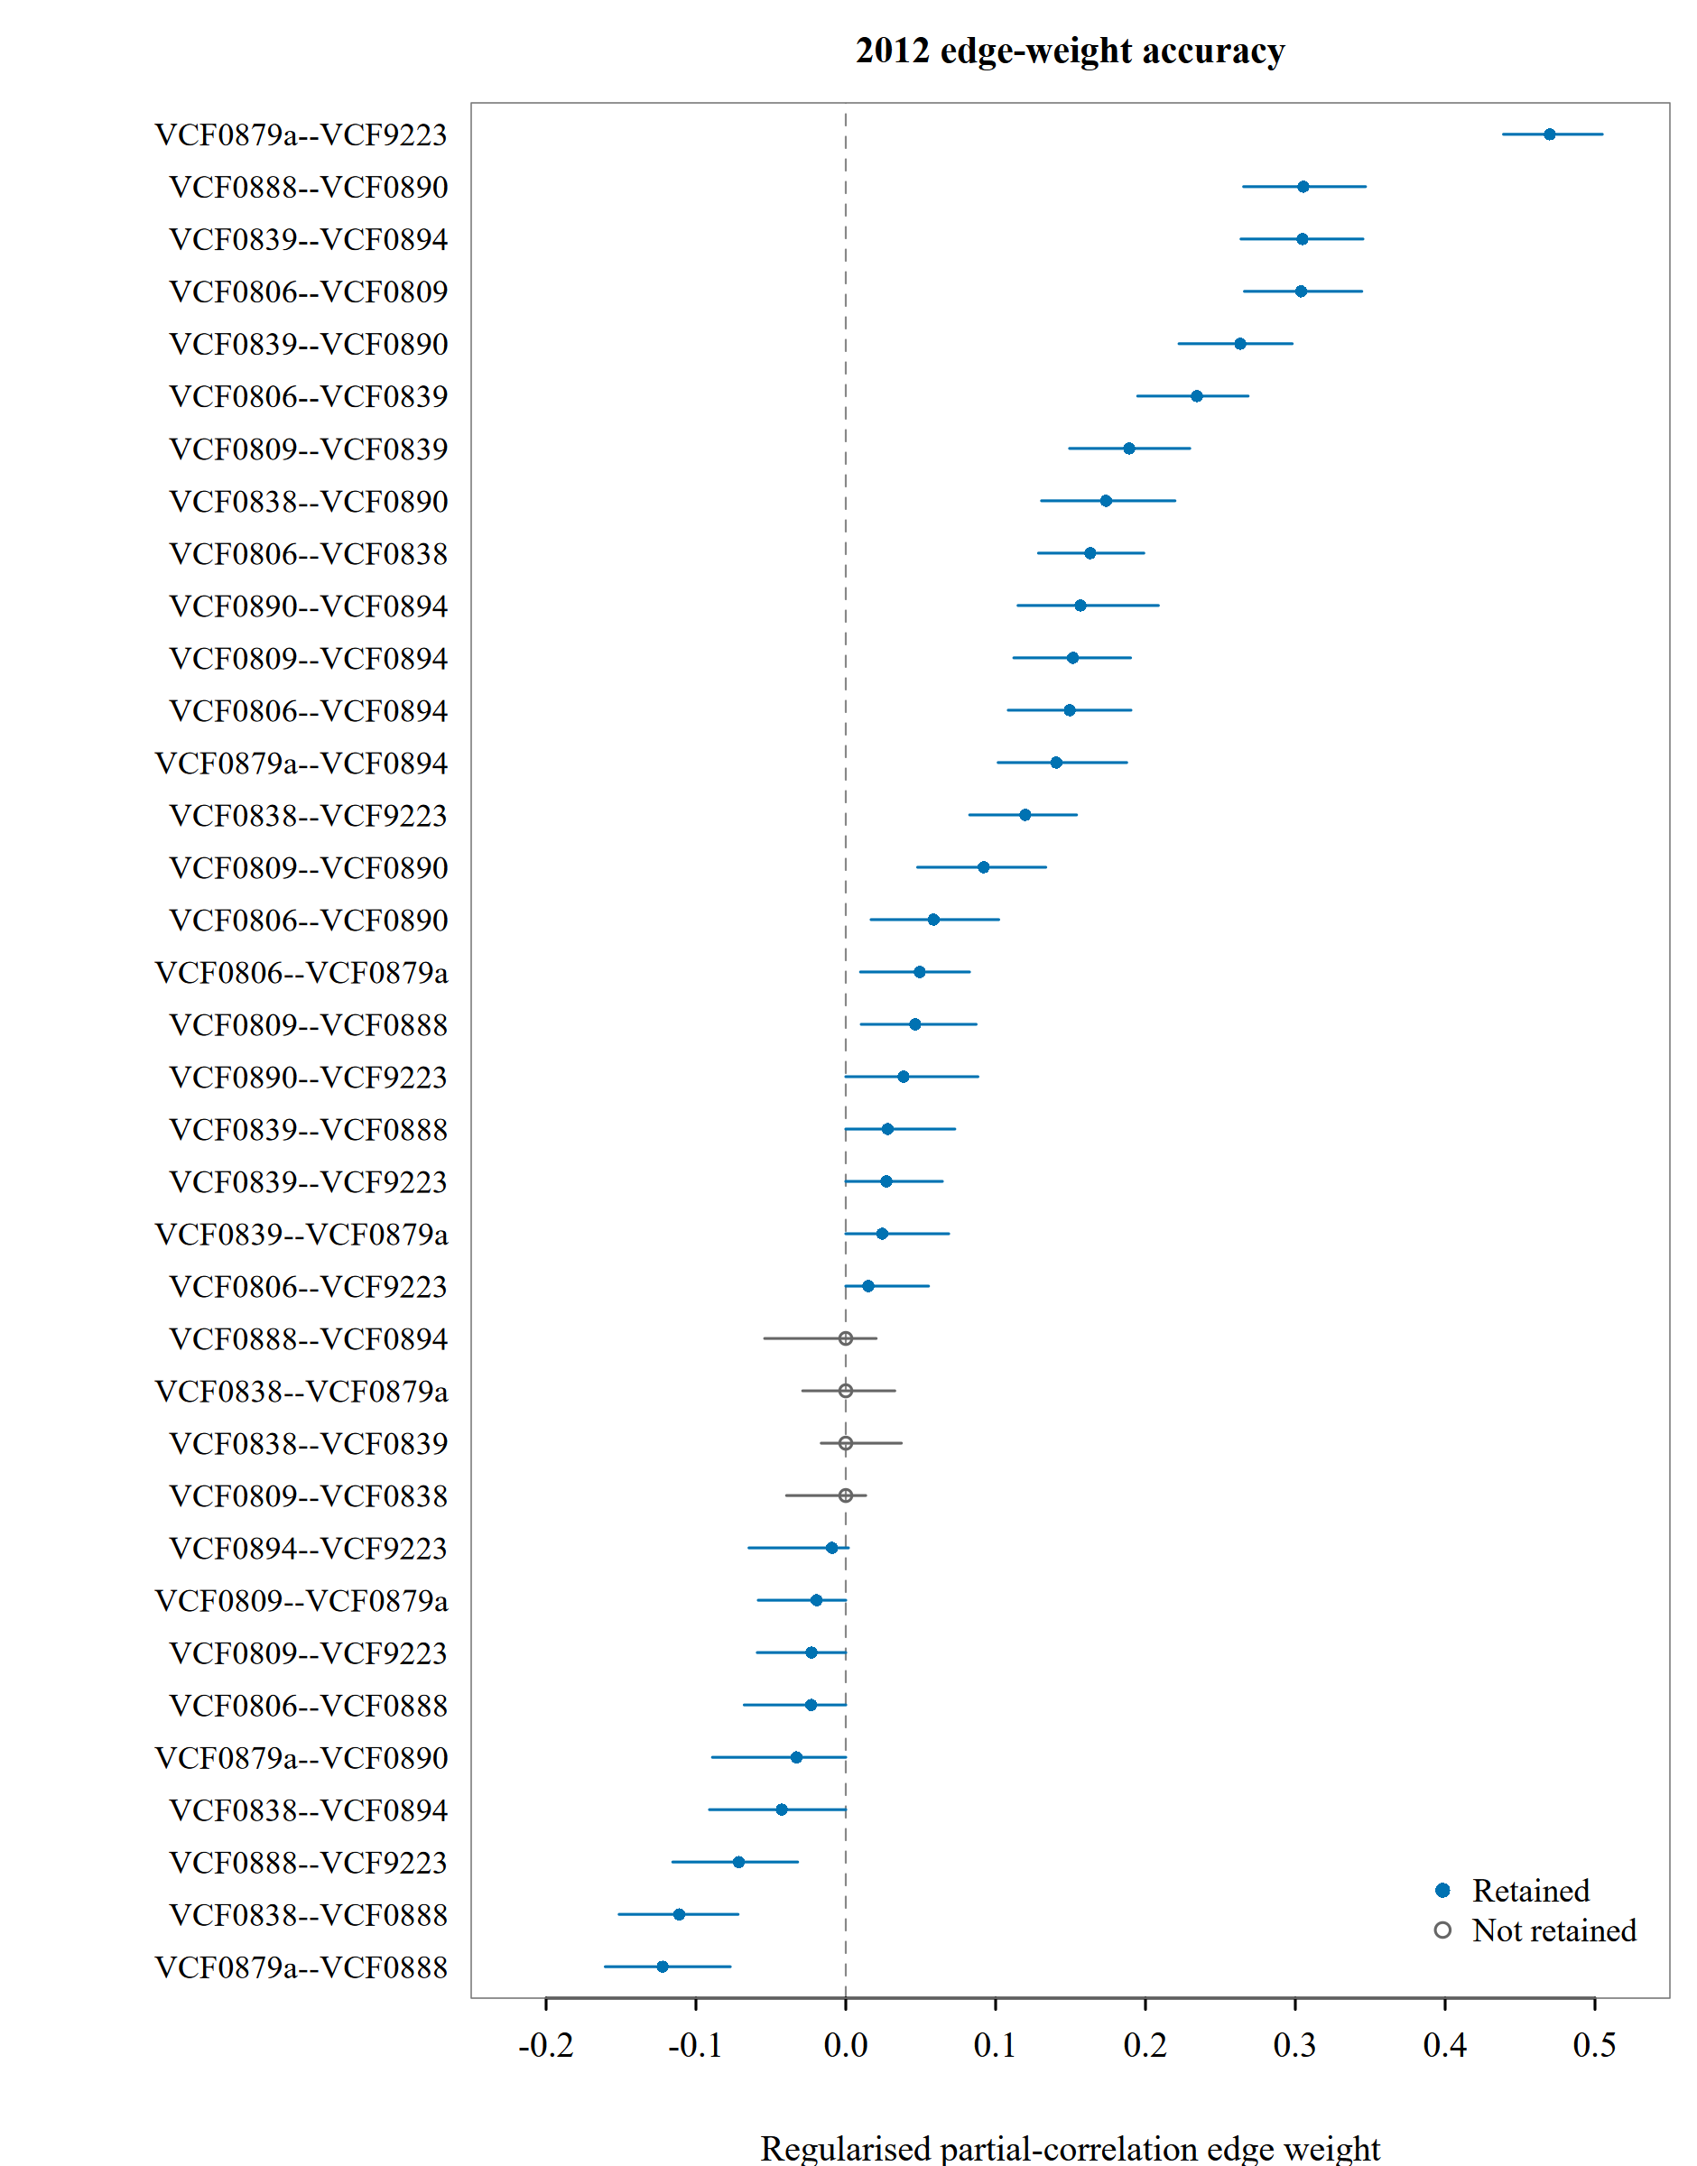
Figure C1 Edge estimates and 95% bootstrap percentile intervals for 2012
Note: Points show regularised edge estimates and lines show 95% percentile intervals from 1,000 nonparametric bootstrap repetitions. Blue filled circles denote retained edges; grey open circles denote edges not retained. All three plots use the same horizontal scale. Variable codes are defined in Table B1.
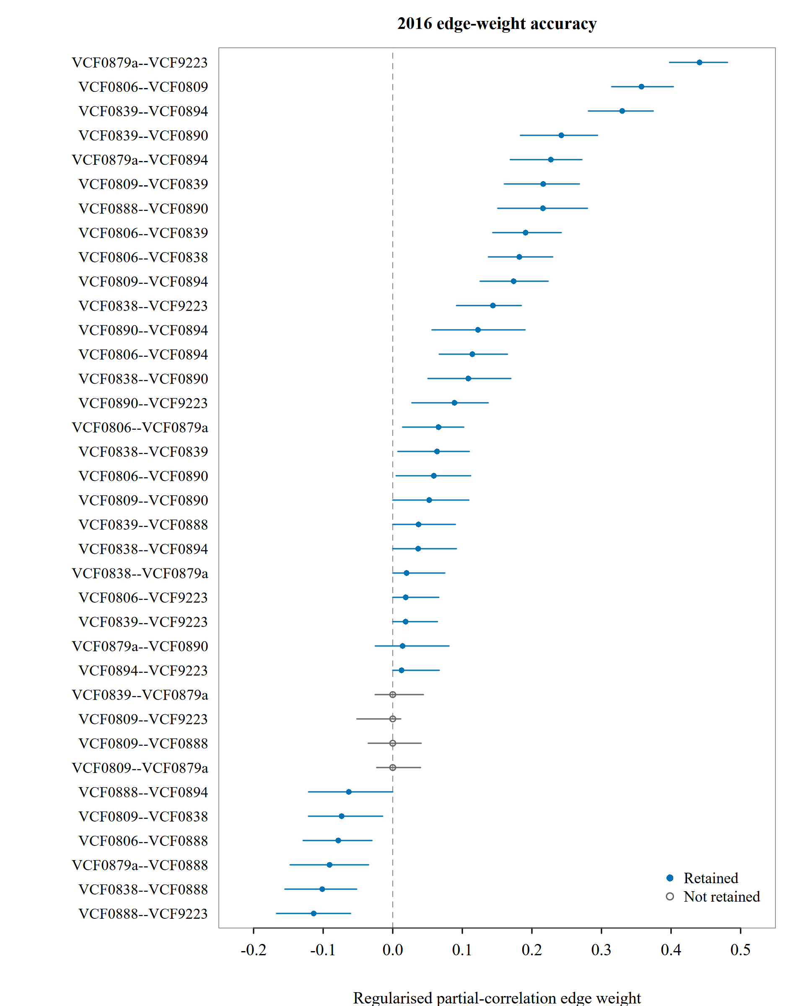
Figure C2 Edge estimates and 95% bootstrap percentile intervals for 2016
Note: Points show regularised edge estimates and lines show 95% percentile intervals from 1,000 nonparametric bootstrap repetitions. Blue filled circles denote retained edges; grey open circles denote edges not retained. All three plots use the same horizontal scale. Variable codes are defined in Table B1.
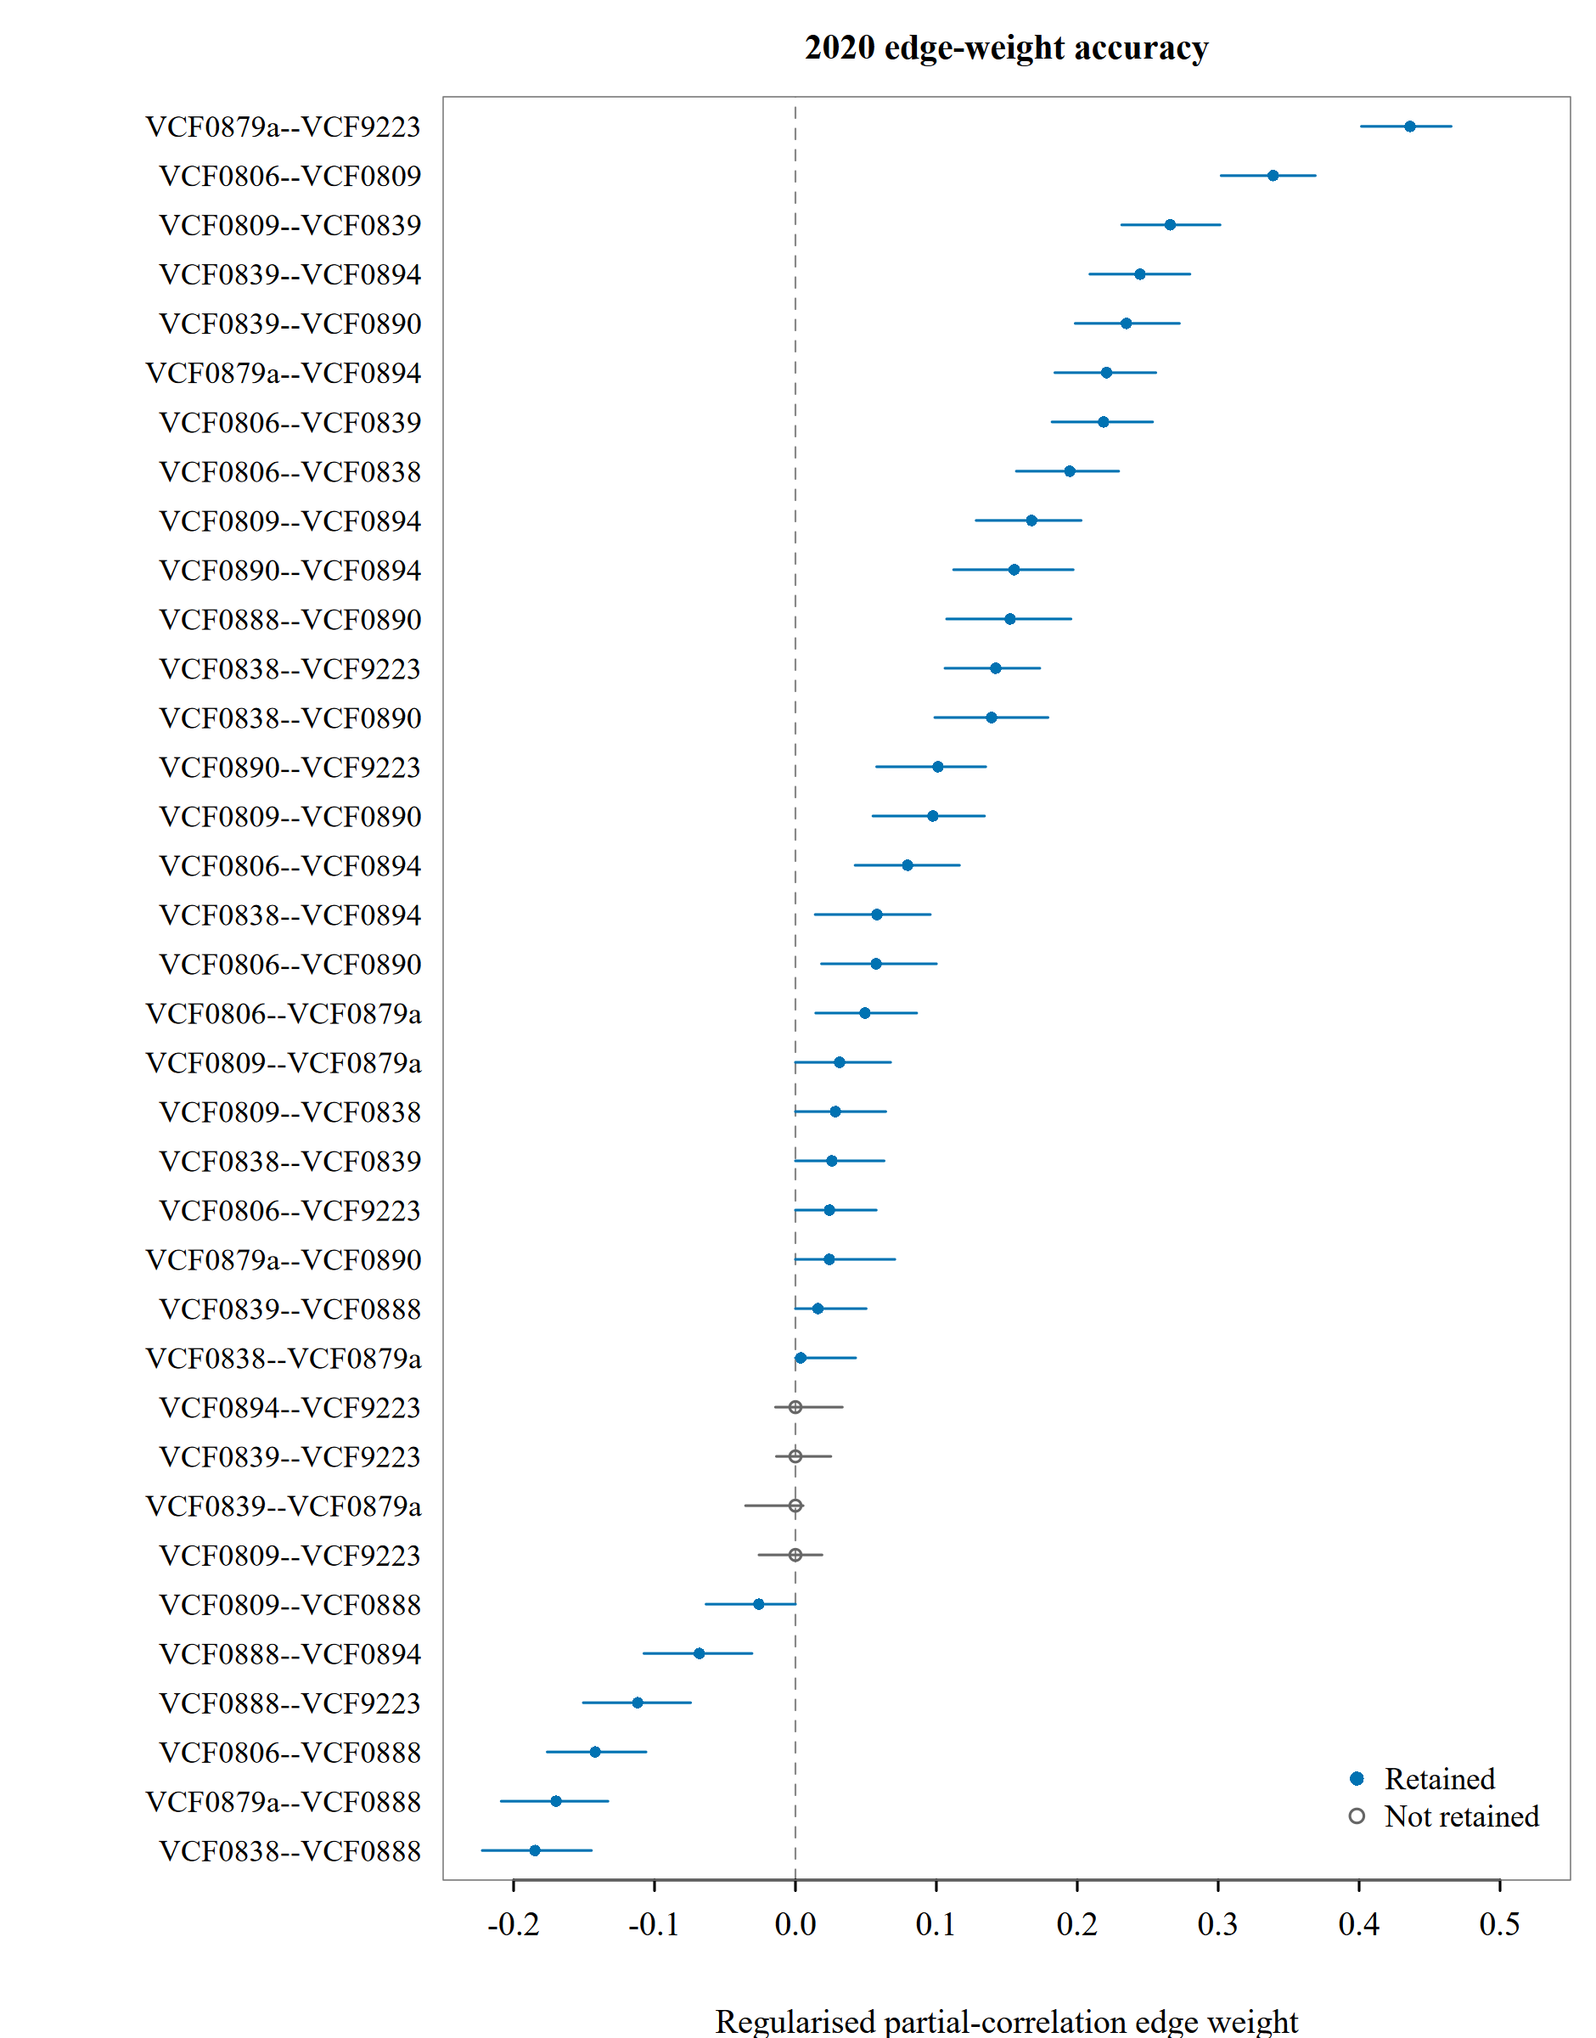
Figure C3 Edge estimates and 95% bootstrap percentile intervals for 2020
Note: Points show regularised edge estimates and lines show 95% percentile intervals from 1,000 nonparametric bootstrap repetitions. Blue filled circles denote retained edges; grey open circles denote edges not retained. All three plots use the same horizontal scale. Variable codes are defined in Table B1.

APPENDIX D SENSITIVITY ANALYSES

D.1 Alternative specifications
Sensitivity analyses vary missing-data handling, regularisation, the node set, survey weights and survey mode. Other main settings are retained where applicable. Table D1 summarises the changes and the scope of each comparison.
Table D1 Sensitivity analysis specifications
Analysis | Change from the main specification | Comparison scope
Pairwise-available samples | Use all valid responses for each item pair; use the average pairwise sample size for EBIC selection. | Five years; 36 edges each
Lower EBIC tuning parameter | Reduce γ from 0.50 to 0.25. | Five years; 36 edges each
Remove VCF0839 | Re-estimate eight nodes in the original nine-node complete-case sample. | Five years; 28 common edges
Survey weights | Use two validated weighted point-network specifications. | Five years; 36 edges per specification
Internet-only samples | Restrict respondents to VCF0017 = 4. | 2012–2024; 36 edges each
Higher-specificity setting | Set threshold = TRUE. | Five years
Equal sample sizes | Subsample later years to N = 789 under both threshold settings. | Fixed 2004 reference
Removing VCF0839 changes the network from nine to eight nodes. Comparisons therefore use the 28 common edges; global strength is not directly compared across these different node sets. The 29 wave-specific sensitivity summary records and the corresponding edge-level comparisons are provided in the electronic supplementary materials.

D.2 Survey weight mapping
Weighted sensitivity analyses use a CDF full-sample specification and a wave-specific post-election-compatible specification. Both retain the main regularisation settings and the original analysis sample size for model selection.
Table D2 Wave-specific weight mapping
Year | CDF full-sample weight | Single-wave source | Post-election-compatible weight | Single-wave source
2004 | VCF0009z | V040101 | VCF9999 | V040102
2012 | VCF0009z | weight_full | VCF0009z | weight_full
2016 | VCF0009z | V160101 | VCF9999 | V160102
2020 | VCF0009z | V200010a | VCF9999 | V200010b
2024 | VCF0009z | V240107a | VCF9999 | V240107b
The two specifications use the same weight in 2012 and do not provide independent replications for that year. These analyses compare point estimates only; they do not include weighted bootstrap or full complex-survey uncertainty estimation.

D.3 Equal sample sizes and robustness classification
Equal-N analyses draw 789 respondents without replacement from each later main sample in 2012, 2016, 2020 and 2024, with 1,000 repetitions per specification. The 2004 sample remains fixed. The two specifications use threshold = FALSE and threshold = TRUE, respectively.
Cross-year comparisons use repetitions in which both networks were successfully estimated. Table D3 defines the evaluability and direction-matching rules.
Table D3 Robustness classification for between-year comparisons
Classification | Rule
NOT_EVALUABLE | The evaluable proportion is below 0.95 under either equal-N specification.
ROBUST | The higher-specificity full-sample direction matches the main direction, and the lower direction-match proportion across the two equal-N specifications is at least 0.90.
MIXED | The higher-specificity full-sample direction matches the main direction, and the lower direction-match proportion is at least 0.75 but below 0.90.
NOT_ROBUST | The higher-specificity full-sample direction does not match the main direction, or the lower direction-match proportion is below 0.75.
These categories describe how consistently a comparison direction recurs under the specified analytical changes. They are not significance-test results.

D.4 Equal-N results for the 2004–2024 comparison
All differences in Table D4 are calculated as the 2024 value minus the 2004 value.
Table D4 Equal-N results for the 2004–2024 endpoint difference
Metric | Threshold | Main difference | Median difference | 95% empirical percentile range | Direction-match proportion
Retained edges | FALSE | 8 | 6 | [2, 9] | 0.998
Retained edges | TRUE | 8 | 7 | [4, 11] | 1.000
Global strength | FALSE | 0.823 | 0.805 | [0.490, 1.181] | 1.000
Global strength | TRUE | 0.823 | 0.771 | [0.359, 1.151] | 1.000
Note: Each row contains 1,000 successful comparisons. Ranges describe repeated subsampling of the 2024 sample against the fixed 2004 sample. They are not confidence intervals that fully represent sampling uncertainty in both years.

