

Faculty of Engineering & Applied Science
Distributed System - SOFE 4790U

October 20th, 2026

Project Proposal

Group 14

First Name | Last Name | ID
Zachary | Matasic | 100918415
Lok Yung (Carson) | Chan | 100926449
Danial | Shaikh | 100698628
Ali | Hakkani | 100867456
Julian | Olano Medina | 100855732

Problem Definition
A public transportation system is essential for connecting a city's residential, commercial, and institutional hubs, making service reliability paramount. However, existing transit networks suffer from two critical flaws: inaccurate real-time tracking and rigid scheduling. Because vehicle telemetry is fragmented across unsynchronized scheduling software, onboard GPS units, and manual incident logs, signal drops or unreported traffic delays result in inaccurate arrival information for passengers. At the same time, reliance on static timetables prevents the system from adapting to fluctuating passenger volumes, resulting in severe overcrowding during peak hours and underutilized vehicles during off-peak periods. Furthermore, relying on a single centralized server creates a single point of failure; if connectivity drops in a specific region, vehicles are cut off from the dispatch network entirely.

Project Objectives
To address these challenges using distributed systems principles, this project aims to design and simulate a fault-tolerant, edge-assisted Public Transit System. The primary objectives are to:
- Implement Real-Time Vehicle Tracking: Synchronize distributed telemetry streams (GPS location, speed, and stop status) using publish-subscribe message passing so passengers and operators receive accurate, live updates.
- Optimize Peak and Off-Peak Schedules Dynamically: Analyze live passenger occupancy data across regional nodes to detect overcrowding (peak demand) or underutilization (off-peak demand) and dynamically adjust dispatch frequencies.
- Ensure Fault Tolerance, Load Balancing, and High Availability: Eliminate single points of failure by introducing regional edge servers with automated heartbeat monitoring, dynamic load migration, and state synchronization.
- Maintain Distributed Event Ordering: Prevent stale telemetry from overwriting newer updates during network delays by implementing physical clock synchronization, logical clocks, and sequence numbering.

Proposed Solution
A transit app is only useful if riders can trust what it tells them. The proposed system is designed around that trust: it provides live bus tracking that stays accurate, schedules that respond to actual demand, and a network that keeps running when individual parts fail. To do this, the work is split across three tiers, made up of the buses, regional edge servers, and a central server. Each tier handles what it is best suited for, so no single machine holds up the entire network.
Each simulated bus will act as an independent source of live information, reporting its location, speed, stops, passenger occupancy, and equipment status. Buses will publish their updates to their region rather than to a fixed server, so they never depend on one particular machine, and new buses, routes, or regions can be added without disrupting the rest of the system.
Regional edge servers will manage the buses in their area. They will check and clean incoming data, keep track of the current state of each bus, and notice quickly when a bus or sensor stops reporting. Only verified, summarized information is passed up to the central server, which keeps each region responsive and keeps the central server free to focus on the network as a whole.
The central server will combine information from every region into a single view of the network. From there it will estimate arrival times, recommend routes, monitor fleet health, and adapt the schedule to demand by recommending more buses on crowded routes and fewer on quiet ones.
To keep information accurate, every update will carry ordering information so that delayed or repeated messages never replace newer ones, meaning riders always see the latest position of each bus. When a serious event occurs, such as a disconnected bus or a cancelled route, the central server will notify every affected part of the system at once.
For reliability, each regional edge server will be paired with a backup. If a regional server fails, its buses will be moved to the backup so service in that area continues, and the backup will also share the load when a region becomes busy during peak hours. Once the failed server recovers, it will catch up before resuming its role.
All components will communicate through a shared message format, allowing them to be developed independently and extended later. Access will be role-based, with passengers able to view information and operators able to manage the system. The system will be used through three interfaces: a passenger app showing nearby buses, their locations, occupancy, arrival times, and recommended routes; an operator dashboard showing the health of the network and live alerts; and a simulation interface for introducing scenarios such as demand surges, delays, and failures.

Draft Architecture
Our proposed solution uses a multi-tier distributed architecture consisting of Simulated Bus Nodes, Regional Edge Servers (with backup replicas), and a Central Coordination Server, connected via an MQTT Publish-Subscribe message broker, alongside Web Interfaces for passengers and operators. This goes beyond a basic client-server model by distributing data generation, validation, load balancing, and failure recovery across autonomous nodes.
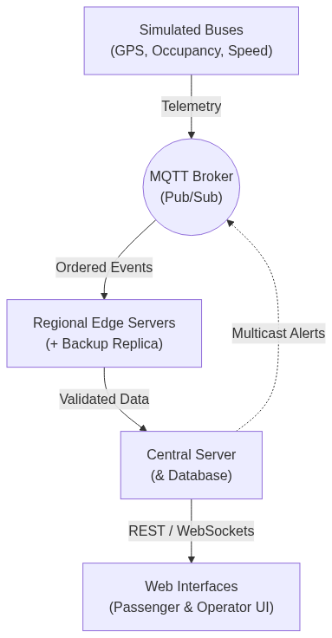

Artifact 1-1: System Architecture

Proposed Timeline
Our project runs from October 20 to November 24, followed by demos. The first week will focus on defining system interfaces and setting up a shared repository. Team members will then develop their components in parallel, with weekly integration and testing to identify issues early.
Member | Week 1 (Oct 27 to Nov 2) | Week 2 (Nov 3 to Nov 9) | Week 3 (Nov 10 to Nov 16) | Week 4 (Nov 17 to Nov 23)
Zachary Matasic | Define the bus telemetry format. Build a basic simulator with bus IDs, routes, locations. | Publish live telemetry through MQTT, add stop status, occupancy, and repeatable scenarios | Add on/off peak demand, delays, and missing updates. Also add sensor faults to test scheduling | Run full-system simulations with different conditions and bus counts.
Julian Olano Medina | Set up MQTT connections so that the bus data is sent to edge servers | Add clock synchronization, lamport clocks, and sequence numbers. | Handle delays, duplicate messages, and reconnections. Set up multicast between servers. | Test communication across the full system during delays, failures, and heavy workloads. Check message ordering and notification delivery.
Ali Hakkani | Build regional edge servers to validate the telemetry | Add passenger capacity calculations and caching. Forward data to the central server. | Add heartbeat monitoring, failure detection, fault isolation, and backup edge server recovery. | Test edge server functions during failures. Test failure detection, and system recovery
Lok Yung Chan | Define the database format and api relations, build a basic central server and database | Add route and scheduling recommendations, arrival estimates, ordering checks, and access restrictions. | Add health analysis, statistics, alerts, and APIs for dashboard updates and simulation controls. | Test central services, recommendations, alerts, and access restrictions.
Danial Shaikh | Make wireframes. Start the passenger app showing bus locations and routes. | Add occupancy and arrival times to the passenger app. Start the operator dashboard. | Display system health, failures, and live alerts. Connect simulation controls for demand, delays, sensor faults, and server failures. | Test all three interfaces with the complete system. Fix integration issues and finalize report diagrams.

Artifact 1-2: Task Responsibilities

