学习资源汇总：

**Probability:**

Brillant.org

STATS 110 by Harvard

**Statistics:**

**Prepare interview questions:**

● Glassdoor

● www.1point3acres.com

● [www.brilliant.org](http://www.brilliant.org)

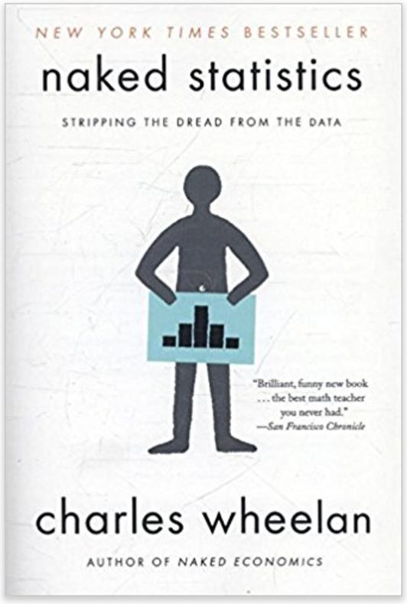

**Python materials**

If you are serious, you can also learn Python systematically on the internet.

● Udacity 免费的课，很有用，很好懂

● W3 School Python从零教起

● Google developers google edu 稍微technical

**A/B test**：

By Diane Tang, head of Data Science at Google

https://www.udacity.com/course/ab-testing--ud257