How MIT News Frames AI
Positive, cautious and risk-oriented language in headlines and article bodies
Group project | Member 5: how news shapes the image of AI through language | Data: 314 MIT News AI articles, Dec 2023 to Aug 2025
Key findings
1. Capability and progress lead. Positive framing is the largest group in both bodies (51%) and headers (47%), and positive vocabulary outnumbers risk vocabulary by about 4 to 1.
2. Risk is a real minority, concentrated by topic. 20% of bodies are risk-oriented, but only 13% of headers. Health and clinical articles are the most risk-heavy (61%), while materials and biology articles almost never are.
3. Headline and body often tell different stories. They carry the same framing in only 54.5% of articles. Headlines under-signal risk: 31 of the 64 risk-oriented bodies sit under a headline that does not.

1. Introduction
News language shapes how readers picture artificial intelligence: as a capability to be celebrated, a process to be handled with care, or a risk to be governed. This section examines MIT News and asks three questions. (1) Does its AI coverage emphasise capability and progress more than challenges, bias, safety and governance? (2) Which words characterise each type of framing? (3) Are the headline and the article body consistent with each other?

2. Data and method
The corpus contains 314 MIT News articles about AI published between 20 December 2023 and 19 August 2025 (4 from 2023, 179 from 2024 and 131 from 2025). Each article has a header (the title plus the summary line beneath it, about 30 words on average) and a body (the full text, about 1,050 words on average).
Each text was scored with three dictionaries: positive (e.g. improve, faster, accurate, breakthrough), cautious (could, might, challenges, limitations) and risk (bias, safety, privacy, ethics, regulation, adversarial). Every dictionary rate (hits per word) was divided by its corpus average so that 1.0 means a typical MIT AI article. This adjustment matters because positive words are far more common than risk words in science news, so raw counts would label almost everything positive. A text is Positive if its positive index exceeds its risk index by a clear margin, Risk-oriented if the risk index clearly exceeds the positive index, and Neutral/Cautious otherwise (the two are balanced, or the text has little evaluative wording). The margin is net = (pos − risk) / (pos + risk) with cut-offs at ±0.30. Representative vocabulary for each group was found with weighted log-odds, which highlights words that are unusually frequent in one group relative to the other two.

3. Findings

3.1 Overall framing: capability first, risk a substantial minority
Figure 1 shows that about half of the bodies (159 of 314, 51%) and 47% of the headers (148) are positive. Risk-oriented framing accounts for 20% of bodies (64 articles) and 13% of headers (42). Looking at vocabulary density, the body text contains 15.8 positive terms per 1,000 words against 4.1 risk terms, a ratio of roughly 3.9 to 1. Header densities are higher only because headers are very short; their ratio (about 4.9 to 1) points the same way.
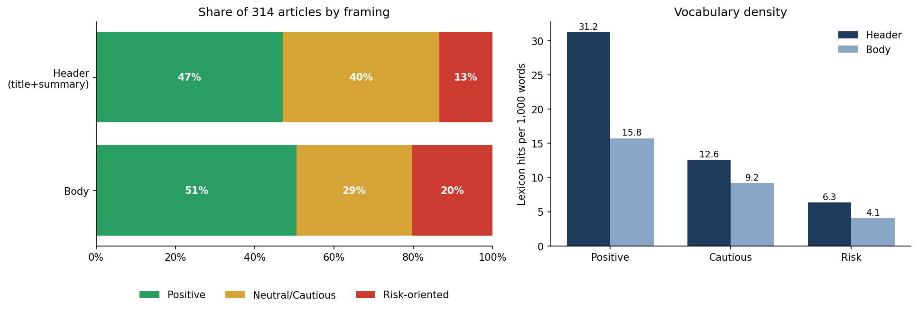
Figure 1. Share of articles by framing (left) and dictionary hits per 1,000 words (right).
The shares depend on the cut-off (see the Threshold_sensitivity sheet of the workbook). Across cut-offs from ±0.2 to ±0.5, risk-oriented bodies range from 11% to 25% and positive bodies from 37% to 56%. Risk-oriented is never the largest group, and positive is the largest header group at every cut-off. For bodies, positive is the largest group up to ±0.4, while at ±0.5 neutral/cautious overtakes it (52% against 37%).

3.2 Headline versus body: consistent in about half of the articles
Table 1 cross-tabulates the two labels. The diagonal (shaded) holds 171 articles, so headline and body agree in 54.5% of cases. Disagreement is not one-directional: in 72 articles the headline is more positive than the body and in 71 it is less positive. Two patterns stand out. First, 62 neutral headlines sit above positive bodies, which suggests that MIT headlines are often descriptive (“A new model predicts…”) while the body adds the praise. Second, the headline rarely announces risk: 33 of the 42 risk-oriented headlines lead to risk-oriented bodies, but 31 of the 64 risk-oriented bodies (14 under positive headlines, 17 under neutral ones) are not flagged at the top.
Header \ Body | Positive | Neutral/Cautious | Risk-oriented | Total
Positive | 93 | 41 | 14 | 148
Neutral/Cautious | 62 | 45 | 17 | 124
Risk-oriented | 4 | 5 | 33 | 42
Total | 159 | 91 | 64 | 314
Table 1. Header label (rows) by body label (columns), number of articles.

3.3 Representative vocabulary and contrast word clouds
Figures 2 and 3 show the words most distinctive of each group; larger words are more characteristic of that group than of the other two.
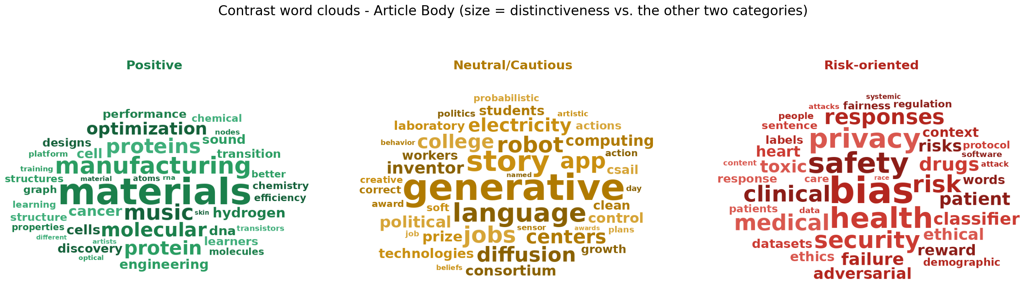
Figure 2. Contrast word clouds for article bodies.
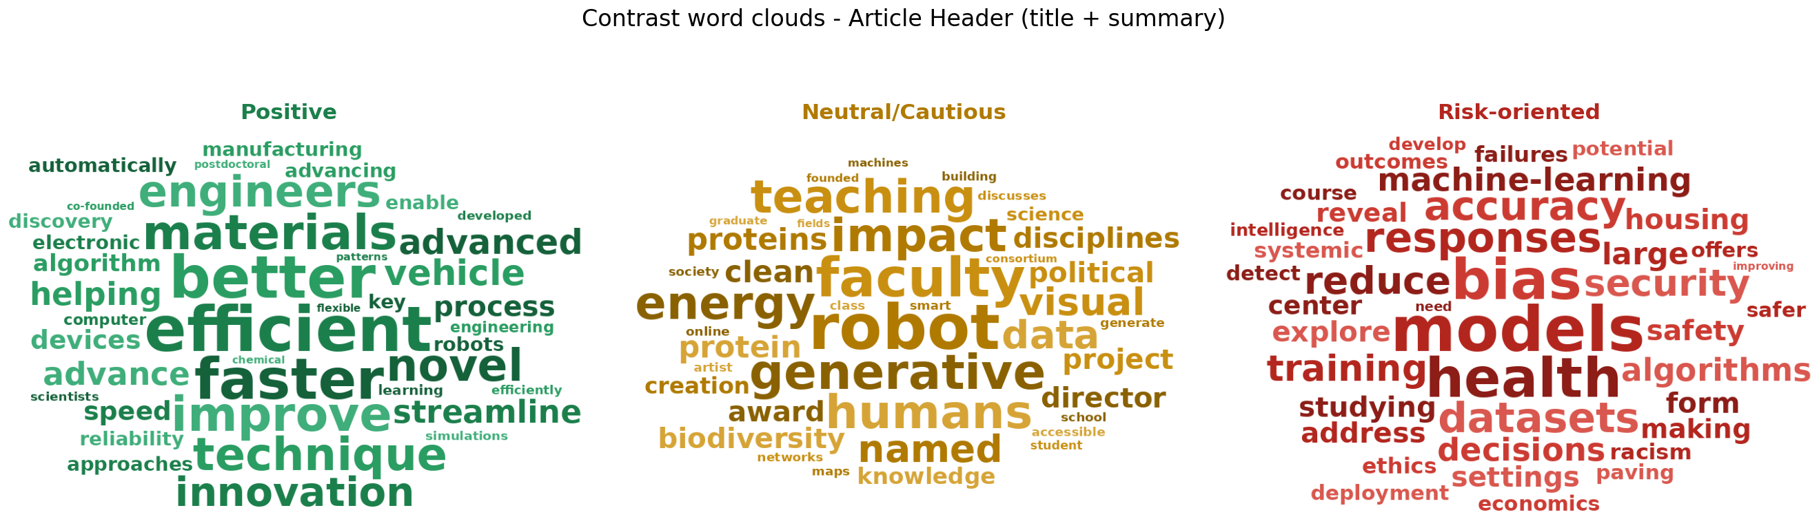
Figure 3. Contrast word clouds for article headers (title plus summary).
- Positive. Header vocabulary is explicit performance language: efficient, better, faster, improve, novel, innovation, streamline. Body vocabulary is topical: materials, manufacturing, proteins, molecular, optimization, hydrogen, i.e. applied science and engineering results presented as advances.
- Neutral/Cautious. Headers read like announcements (faculty, teaching, award, director, impact). Bodies centre on institutions and societal context (generative, language, jobs, college, students, political), where good and bad consequences are weighed rather than asserted.
- Risk-oriented. Both parts feature bias, safety, security; bodies add privacy, risk, ethical, adversarial, toxic, failure together with clinical, medical, patient, drugs. Risk language therefore clusters around health applications and the trustworthiness of models and data.

3.4 Themes: where risk language concentrates
To see whether framing depends on subject matter, the bodies were grouped into eight themes with non-negative matrix factorisation on TF-IDF weights, and each theme was named from its top terms. Figure 4 shows that framing varies strongly by theme. Health & clinical care (31 articles) is the only theme in which risk-oriented articles are the majority (61%); LLMs & language (24%) and Education & society (21%) come next. Materials & chemistry (7%) and Biology (0%) are overwhelmingly positive, at 81% and 76%. Robotics has the highest share of neutral/cautious articles (45%) alongside Education (41%).
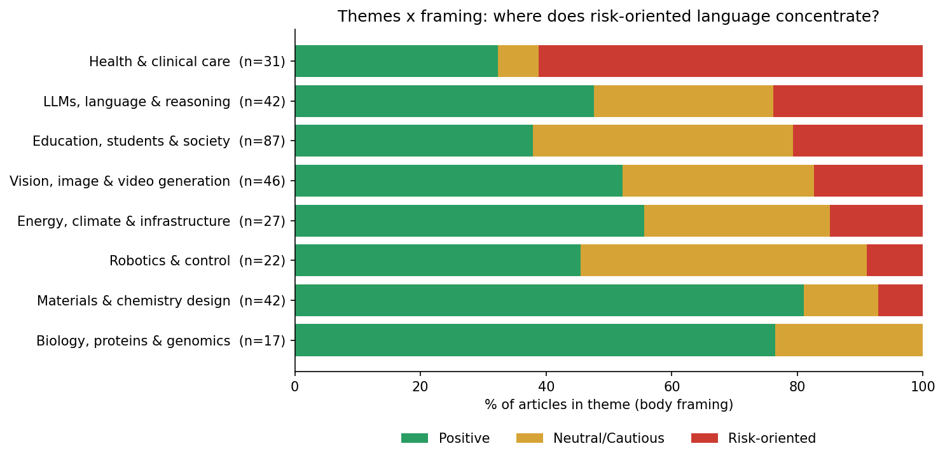
Figure 4. Body framing by theme (n = articles per theme).

4. Conclusions
MIT News mainly presents AI as a source of capability and progress: positive framing is the most frequent type at the chosen cut-off and its vocabulary outweighs risk vocabulary about four to one. This is not the whole picture, however. One article in five uses predominantly risk-oriented language, and these articles gather in health, language-model and societal topics, where bias, safety, privacy and governance are the natural concerns. In applied science domains such as materials and biology, AI appears almost entirely as an enabler.
Headlines and bodies are only moderately consistent (54.5%). Headlines are more often neutral and descriptive and less often risk-oriented than the text beneath them, so a reader who only scans headlines will see a more optimistic and less cautionary picture of AI than a reader of the full articles.

5. Limitations
- The method counts words from dictionaries defined for this analysis, not meaning. It misses negation and irony, and it has not been validated against human coding. A manual check of a random sample of 30 to 50 articles is recommended.
- Risk vocabulary captures any risk talk, not only risks of AI. Some flagged articles concern flooding, equipment failure or nuclear-waste safety, where AI is a tool for analysing risk.
- Hedging words appear at similar rates (about 11 to 12 per 1,000 words) in all three groups, so Neutral/Cautious means balanced or non-evaluative rather than distinctly hedged.
- MIT News is a university press office, which favours positive coverage, and a single outlet limits generalisation to “news” at large. Themes come from an unsupervised model with eight topics named by hand.

