Rising Prices and Singapore's Birth Rate
Short report on three views from the Streamlit dashboard (annual data, 2016–2025)

1. Purpose and data
This report asks whether there is evidence that rising prices affect Singapore's birth rate. It reads three views from the interactive dashboard, which combines birth-rate measures with the HDB Resale Price Index and the Consumer Price Index (CPI). Both price indices are set to 100 in 2016, and the real HDB price is the HDB index divided by the CPI. The data are annual, so each result rests on ten observations.

2. Findings

2.1 Births fall as prices rise
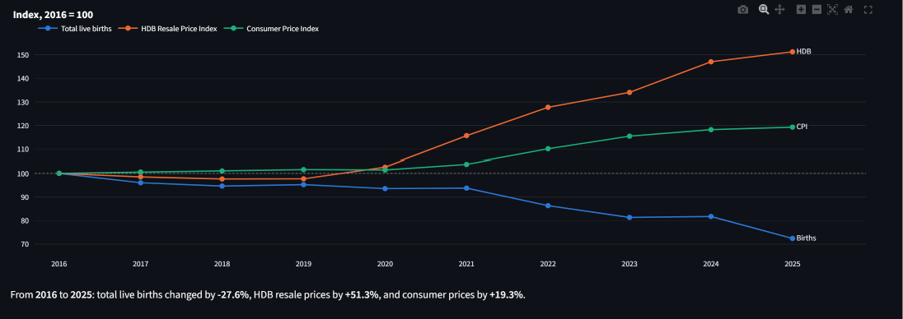
Figure 1. Total live births, HDB Resale Price Index and CPI, all rebased to 2016 = 100
- Opposite directions. Total live births fell 27.6% between 2016 and 2025 (41,251 to 29,864), while HDB resale prices rose 51.3% and consumer prices rose 19.3%.
- Two phases. From 2016 to 2020 all three series stayed within 7% of their 2016 level. From 2021 HDB prices rose every year, and births fell sharply in 2022 (−7.9%), 2023 (−5.8%) and 2025 (−11.4%).
- Housing outpaced inflation. HDB prices rose much faster than the CPI, so housing became about 27% more expensive in real terms.
- Strength of the link. The correlation between live births and the HDB index is −0.94 in levels. Same-year changes are unrelated (r = +0.06), but price growth one year earlier is related to the change in births (r = −0.75, p = 0.03, n = 8), which fits a delayed response.

2.2 The decline is concentrated in mothers aged 25–34
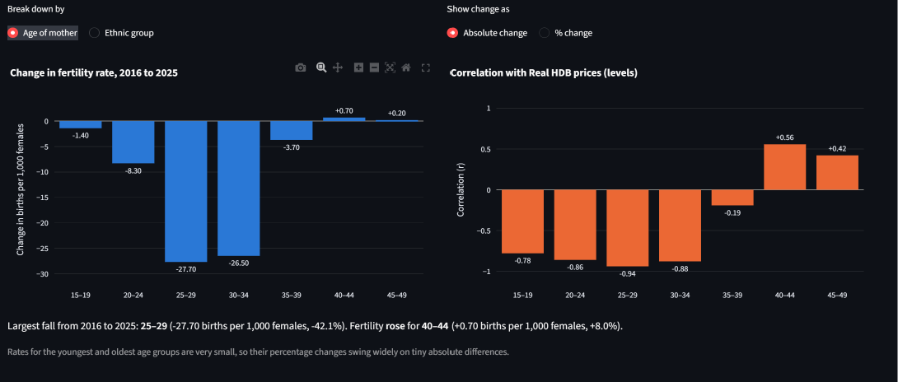
Figure 2. Change in age-specific fertility, 2016 to 2025, and correlation with real HDB prices
- Where the fall happened. Fertility fell most for mothers aged 25–29 (−27.7 births per 1,000 females, −42.1%) and 30–34 (−26.5, −27.5%). These two groups account for about 80% of the total fall across all age groups.
- Limited postponement. Rates for mothers aged 40–44 and 45–49 rose slightly (+0.7 and +0.2), which suggests some births are being delayed. The gain of 0.9 is far too small to offset the combined fall of 67.6 in the younger groups.
- Link with housing cost. The correlation with real HDB prices is strongest for ages 25–29 (−0.94), 30–34 (−0.88) and 20–24 (−0.86), weak for 35–39 (−0.19), and positive but not statistically significant for mothers aged 40 and over. The ages at which couples usually marry and buy a first flat are the ages where fertility moves most closely against housing prices.

2.3 Fertility fell in every ethnic group
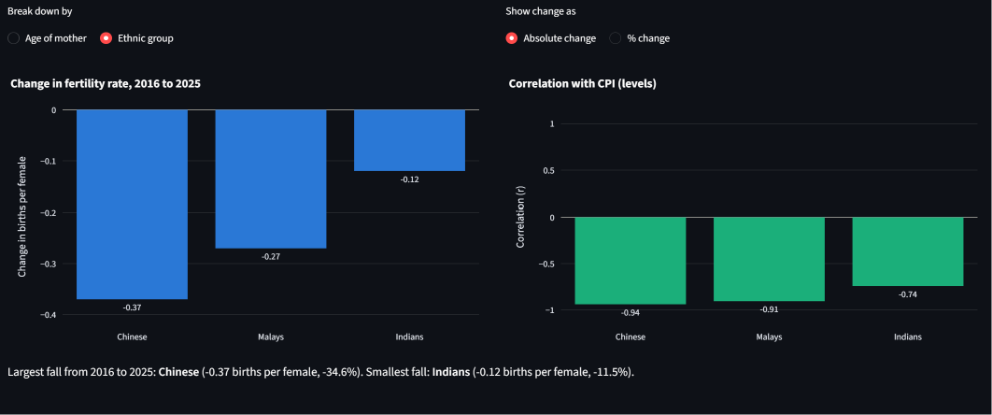
Figure 3. Change in fertility rate by ethnic group, 2016 to 2025, and correlation with CPI
- A broad decline. The fertility rate fell for Chinese (1.07 to 0.70, −34.6%), Malays (1.80 to 1.53, −15.0%) and Indians (1.04 to 0.92, −11.5%). All three stayed below the replacement level of 2.1 births per female throughout.
- Link with consumer prices. In levels, each group's fertility is negatively correlated with the CPI: −0.94 for Chinese, −0.91 for Malays and −0.74 for Indians.
- Different timing. Chinese fertility declined steadily across the period. Malay fertility held near 1.8 until 2022 and then fell to 1.53 by 2025, after CPI inflation picked up in 2022 (+6.1%) and 2023 (+4.8%). Indian fertility stayed close to 1.0 and showed the smallest fall.

3. Conclusion and limitations
The three views point the same way. As housing and consumer prices rose, births fell, and the fall is concentrated among women aged 25–34 and appears in every ethnic group. This is consistent with higher living and housing costs discouraging or delaying childbearing.
The evidence is suggestive rather than conclusive, for three reasons:
- Few observations. Ten annual points give little statistical power, and results can change with one unusual year.
- Shared trends. Births trend down and prices trend up over the whole period, which inflates correlations in levels. Year-on-year changes are mostly weakly related; the main exception is HDB price growth one year earlier.
- Other drivers. The analysis does not control for marriage rates, income, education, working hours or the COVID-19 period, so correlation here does not show causation.
A useful next step is to add marriage and income measures from the consolidated dataset to the dashboard and test whether the price relationship remains once they are included.

