5. Decision Tree, Random Forest and Booking Segments
Prepared by Chen Chen (Member 5)
The logistic regression in the previous section estimates how each factor shifts the odds of cancellation. This section answers the same question in a form that needs no statistical training to read. It asks the data to produce a set of if-then rules (a decision tree), combines 500 such trees into a more accurate scoring model (a random forest), and then groups bookings into four segments that the hotel can manage differently. All three were run in R on the cleaned dataset of 36,275 bookings.
Key findings
- Three simple rules flag the riskiest 31% of bookings. Between 63% and 96% of the bookings they flag are cancelled, and together they capture 69% of all cancellations.
- The random forest is right on 90% of unseen bookings and catches 81% of all cancellations. Assuming that no booking cancels would be right only 67% of the time and would catch none.
- Lead time, special requests, room price and booking channel drive cancellation. One segment, long-lead planners, is 20% of bookings but 41% of cancellations.

5.1 How the models were built and tested
The bookings were split at random into a training set (70%, 25,393 bookings) used to build the models and a test set (30%, 10,882 bookings) that the models never saw. Both sets keep the hotel’s overall cancellation rate of 32.8%. Every performance figure in this section comes from the test set, so it shows how the models behave on bookings they have not seen before, not how well they memorised past ones.

5.2 CART: a decision tree that managers can read
CART (Classification and Regression Tree) repeatedly splits the bookings into two groups, each time using the question that best separates cancelled from kept bookings, such as “was the room booked more than 151 days ahead?”. The result reads like a flowchart. We grew the tree to its maximum size and then pruned it back using cross-validation, so that only the splits that hold up on fresh data remain. The resulting optimal tree has 181 end groups: accurate, but too large to print. Figure 1 therefore shows a smaller management tree with eight end groups that carries the main logic, and Table 1 restates it in plain language.
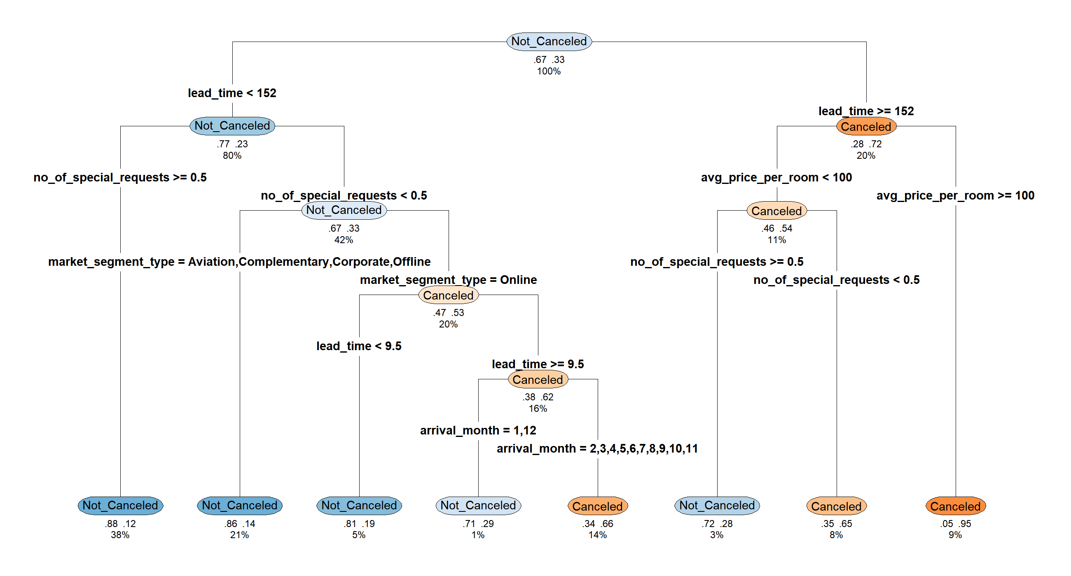
Figure 1. Management decision tree (R output). Each node shows the predicted outcome, the proportions kept and cancelled, and the share of all bookings that reach it.
Table 1. The eight rules of the management tree, checked on the test set
# | Booking profile | Share of bookings | Cancellation rate | Risk
1 | Booked 152+ days ahead, room price €100 or more | 8.5% | 96% | High
2 | Booked 152+ days ahead, price below €100, no special request | 7.6% | 64% | High
3 | Booked online 10–151 days ahead, no special request, Feb–Nov stay | 15.0% | 63% | High
4 | Booked online 10–151 days ahead, no special request, Dec–Jan stay | 1.4% | 32% | Medium
5 | Booked 152+ days ahead, price below €100, 1+ special requests | 3.3% | 29% | Medium
6 | Booked online under 10 days ahead, no special request | 5.0% | 22% | Low
7 | Booked under 152 days ahead, not online, no special request | 21.0% | 15% | Low
8 | Booked under 152 days ahead, 1+ special requests | 38.2% | 12% | Low
Prices are the average room price per night in euros. Shares and cancellation rates are measured on the 10,882 test bookings.
Three profiles stand out (rows 1 to 3). They cover 31% of bookings, most of which are cancelled, and flagging only these three would catch 69% of all cancellations. Long lead time is the common thread: a room reserved five months or more ahead at €100 or above is cancelled 96% of the time. In contrast, a special request is the clearest sign of commitment. Bookings made under 152 days ahead with at least one request cancel only 12% of the time, and they are 38% of the business. The rules are stable: in every group the test-set cancellation rate was within 4 percentage points of the training rate.

5.3 Random forest: giving up readability for accuracy
A single tree is easy to read but can be unstable: a small change in the data can change its rules. A random forest builds 500 trees, each from a different random sample of bookings and factors, and lets them vote. The trees can no longer be read one by one, but their vote is more accurate and more stable (Table 2).
Table 2. Performance on 10,882 unseen bookings
Model | Accuracy | Precision | Recall | AUC
No model (assume no booking cancels) | 67.2% | – | 0% | 0.500
Management tree (8 rules) | 81.3% | 72.6% | 68.8% | 0.818
Optimal CART (181 rules) | 87.4% | 83.3% | 76.9% | 0.920
Random forest (500 trees) | 90.0% | 87.5% | 80.9% | 0.952
Precision: of the bookings flagged, the share that did cancel. Recall: of the bookings that cancelled, the share that was flagged. AUC: ability to rank a cancelled booking above a kept one (0.5 is chance, 1 is perfect).
Of the 3,565 cancellations in the test set, the random forest flagged 2,885 and missed 680, while raising 411 false alarms among 7,317 kept bookings. More useful than a yes or no flag is the risk score the forest gives each booking. Table 3 sorts the test bookings into four bands by that score: 4% of low-risk bookings were cancelled, against 96% of very-high-risk bookings. The top band alone, one booking in five, holds 61% of all cancellations.
Table 3. Random forest risk bands on the test set
Risk band (random forest score) | Share of bookings | Actually cancelled | Share of all cancellations
Low (score up to 20%) | 57.4% | 4.4% | 7.7%
Moderate (20–50%) | 12.3% | 30.3% | 11.4%
High (50–80%) | 9.5% | 68.6% | 19.9%
Very high (above 80%) | 20.8% | 96.2% | 61.0%
Where to set the alert threshold is a business choice, not a statistical one. Lowering it from a score of 50% to 30% raises the share of cancellations caught from 81% to 88%, at the cost of more false alarms (precision falls from 88% to 79%). If a reminder e-mail is cheap and an empty room is expensive, the lower threshold is the better choice.
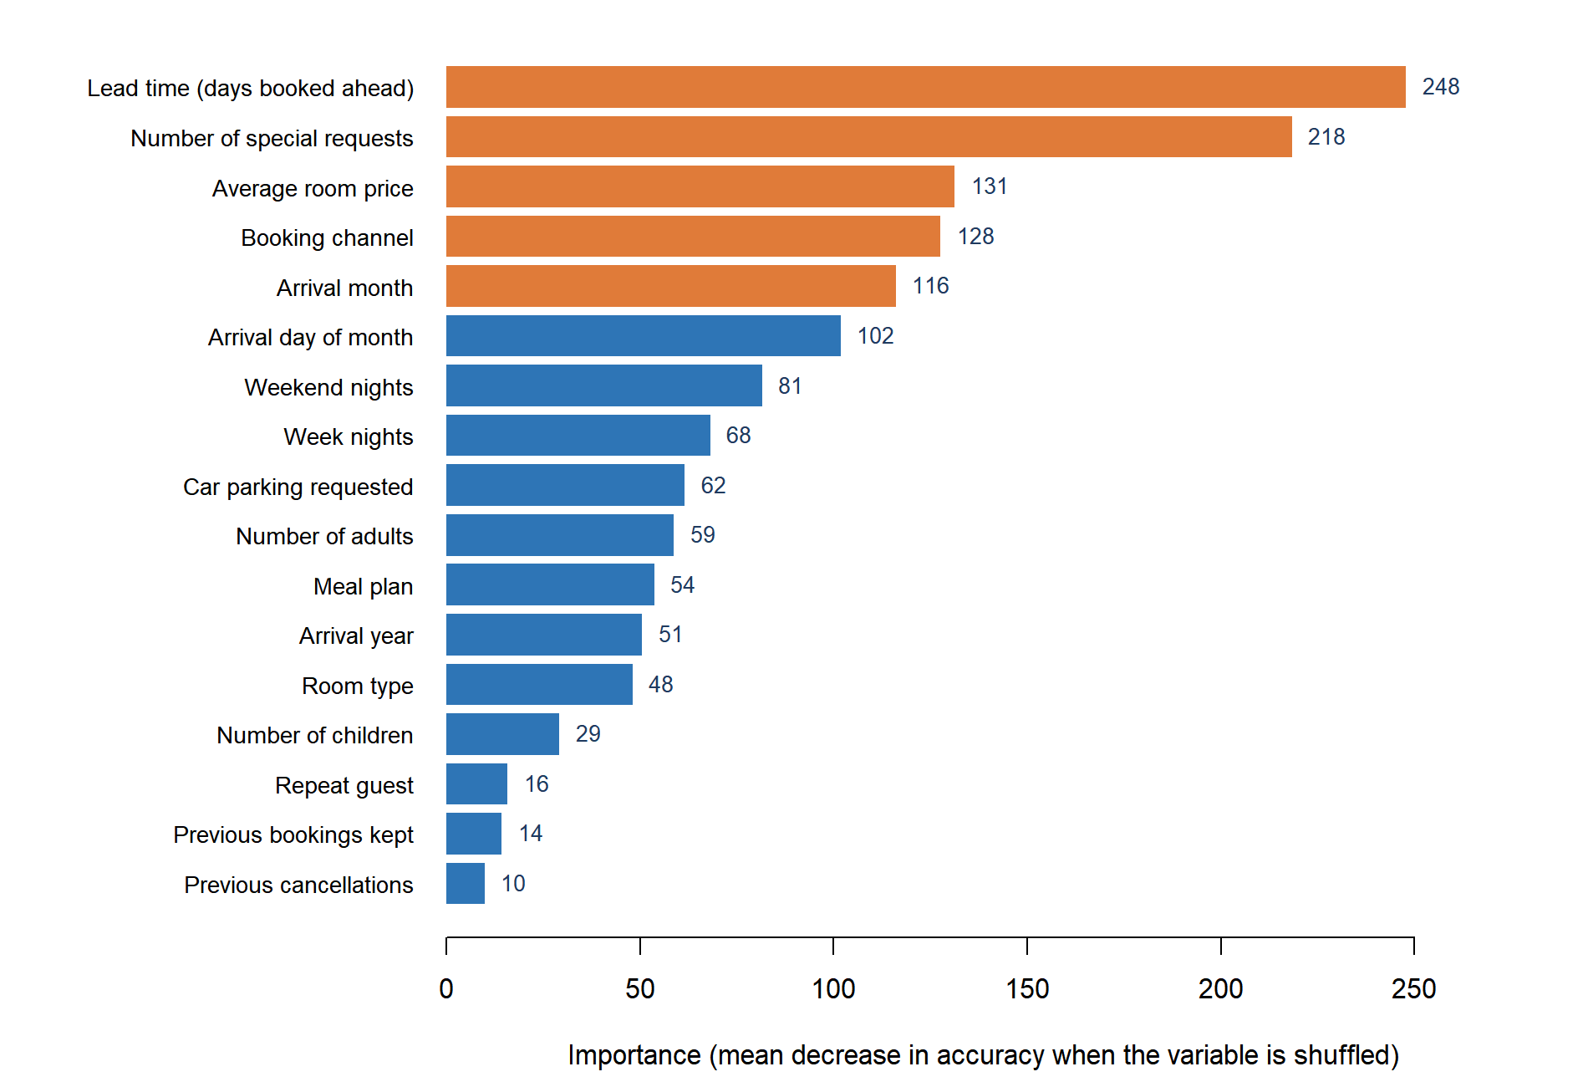
Figure 2. What drives cancellation: random forest variable importance (R output). Longer bars mean the model loses more accuracy when that factor is scrambled; the five strongest are in orange.
The forest also ranks the factors (Figure 2). Lead time is clearly first, followed by special requests, room price, booking channel and arrival month. These are the same factors the decision tree chose for its splits, which gives confidence that the patterns are genuine. Guest history ranks last only because 97% of bookings come from first-time guests.

5.4 Clustering: four types of booking
The two models above predict. Clustering describes: it groups bookings that look alike without being told which ones were cancelled. We applied k-means clustering to five characteristics (lead time, room price, special requests, length of stay and party size) and obtained four segments. Cancellation rates were compared only afterwards (Table 4 and Figure 3).
Table 4. Four booking segments from k-means clustering (all 36,275 bookings)
Segment | Share of bookings | Typical profile | Cancellation rate | Share of all cancellations | Suggested handling
A Long-lead planners | 19.5% | Booked 223 days ahead on average; room price €96; few special requests | 68% | 41% | Deposit or non-refundable rate; reconfirm before arrival
B Premium groups and families | 12.3% | Highest price (€158); 3.1 guests per booking; 93% online | 39% | 14% | Pre-arrival contact; review free-cancellation terms
C Short-notice, short stay | 42.4% | Booked 41 days ahead; 2.3 nights; lowest price (€91) | 25% | 32% | Standard policy; automated reminder
D Engaged guests | 25.8% | 1.4 special requests on average; longest stays (4.0 nights) | 16% | 13% | Keep terms flexible; prioritise service
Segment A deserves the most attention. It is one booking in five but two in five cancellations: guests who reserve about seven months ahead, at ordinary prices, with few special requests. Segment D is the mirror image, since guests who ask for something specific rarely cancel. The segments overlap at the edges, so they are best used to design policy for groups of bookings, while the random forest score is used to judge individual bookings.
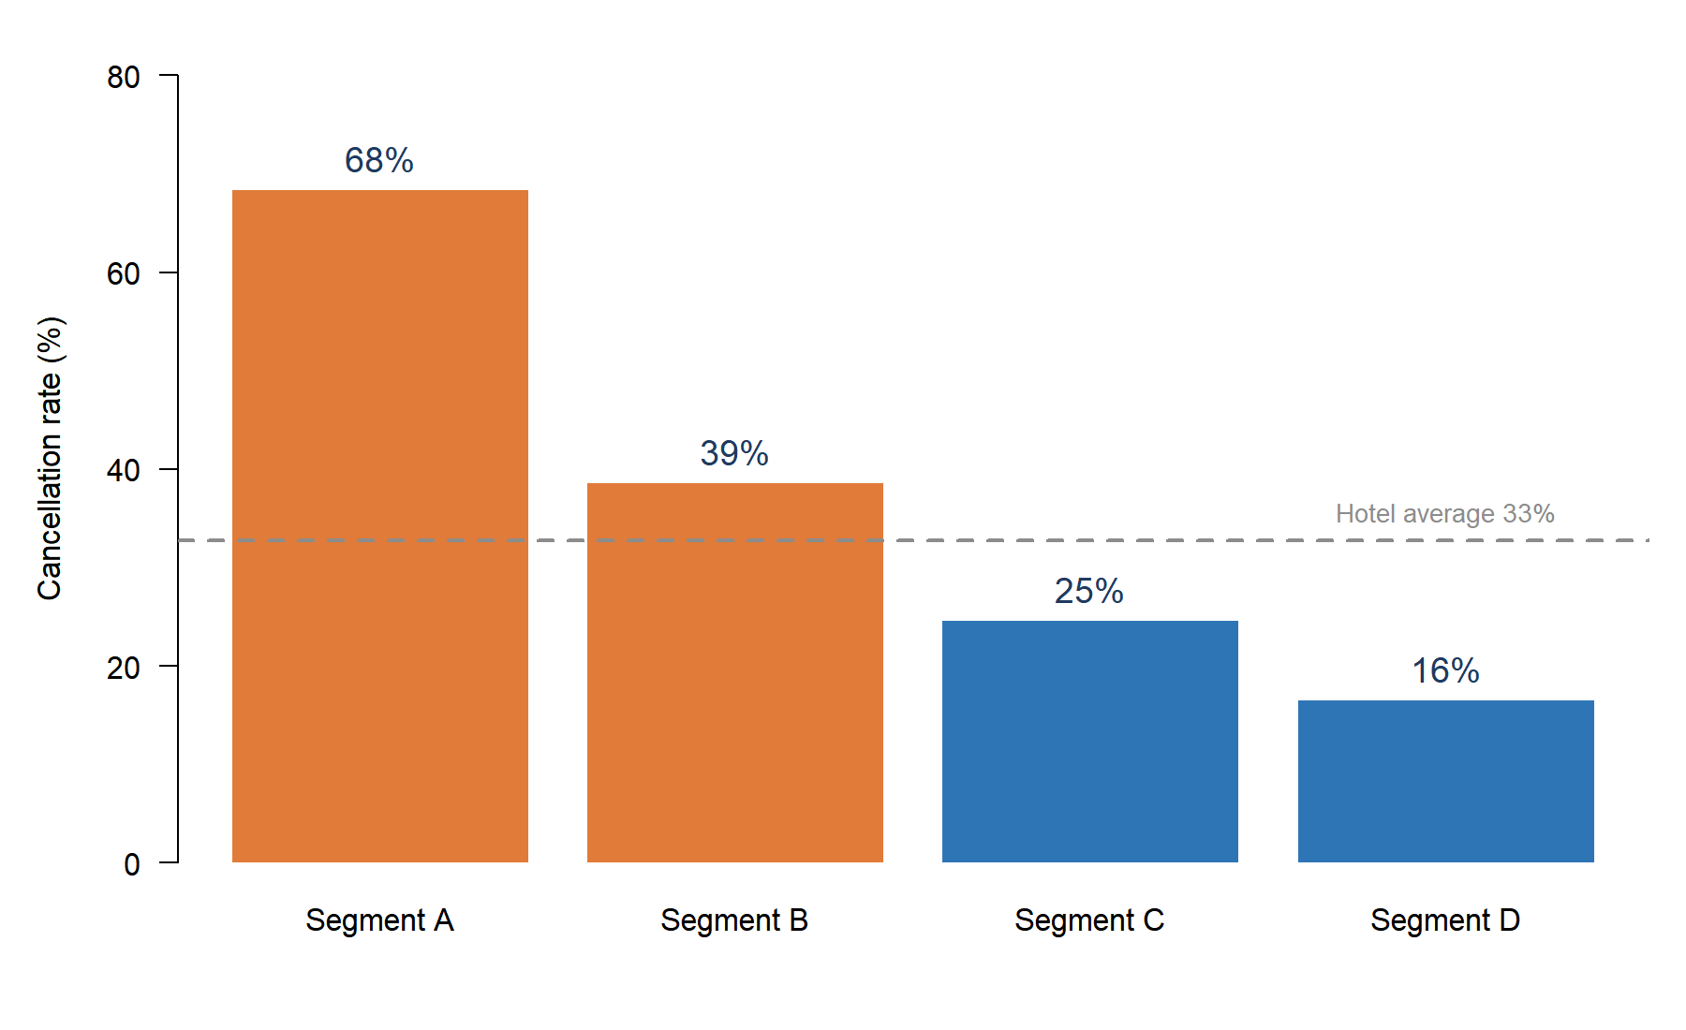
Figure 3. Cancellation rate by booking segment (R output). The dashed line is the hotel average of 33%.

5.5 What this means for management
- Score every new booking with the random forest and act on the high and very high bands. These are 30% of bookings and 81% of cancellations.
- Give front-line staff the three red-flag rules in Table 1 as a quick check that needs no software.
- Set policy by segment: deposits and reconfirmation for long-lead planners, and flexible terms for engaged guests who seldom cancel.
Limitations. The results describe one hotel’s bookings in 2017 and 2018, and a high score signals risk, not cause. About 28% of records are exact repeats of another record once the booking ID is removed, so accuracy on entirely new bookings may be somewhat lower than reported. Arrival year was kept as a predictor for consistency with the cleaned dataset and should be dropped before live use. The model should be re-trained and monitored regularly. Full output is in the accompanying R script.
Technical notes
Software. R 4.6.1 with the rpart, rpart.plot, randomForest and cluster packages; random seed 2026.
Data split. 70% training and 30% test, stratified by booking status; all 17 predictors in the cleaned dataset were used.
CART. Grown with cp = 0 and minsplit = 2 (2,696 end groups), then pruned by 10-fold cross-validation using the 1-standard-error rule to cp = 0.00038 (180 splits, cross-validated error 12.0%). The management tree is the same tree pruned to cp = 0.0179 (7 splits).
Random forest. 500 trees, 4 variables tried at each split; out-of-bag error 9.76%. Importance is the mean decrease in accuracy.
K-means. Five standardised variables, k = 4 chosen from the elbow plot and interpretability, 50 random starts. The four clusters explain 41.6% of the variance; average silhouette width 0.22, which indicates overlapping segments.

