1. **#define __STDC_CONSTANT_MACROS 的作用**

__STDC_LIMIT_MACROS and __STDC_CONSTANT_MACROS are a workaround(工作区) to allow C++ programs to use stdint.h

macros specified in the C99 standard that aren't in the C++ standard.The macros, such as UINT8_MAX, INT64_MIN, and INT32_C() may be defined already in C++ applications in other ways. To allow the user to decide

if they want the macros defined as C99 does, many implementations require that __STDC_LIMIT_MACROS and __STDC_CONSTANT_MACROS be defined before stdint.h is included.

This isn't part of the C++ standard, but it has been adopted by more than one implementation.

1. **#error 的作用**

编译程序时，只要遇到 #error 就会跳出一个编译错误，既然是编译错误，要它干嘛呢？其目的就是保证程序是按照你所设想的那样进行编译的。

1. **Do {} while(0) 的妙用**
2. 消除goto语句
3. 宏定义
4. **‘pkg-config –libs libavformat’**

帮我们寻找“libavformat”库的路径在哪里。相当于命令：

-L/usr/local/ffmpeg/lib -lavformat

1. **可变参数宏**

__VA_ARGS__， 可以将宏中的参数…展开。

#define OneArgument(a) // ...action with one argument

#define TwoArguments(a, b) // ...action with two arguments

#define GetMacro(_1, _2, NAME, ...) NAME

#define Macro(...) GetMacro(__VA_ARGS__, TwoArguments, OneArgument, ...)(__VA_ARGS__)

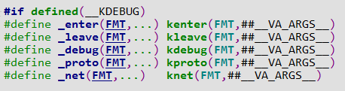

1. 宏定义连接字符串

#define CAT(x,y)    #(x##y)