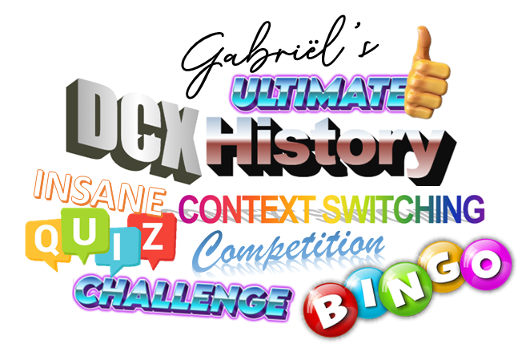 **MAKER MANAGER**

**%**

**%**



Name:

Cluster:

**Question 1!** – 2 points per correct answer

1. 

**Question 2!** – Maximum of 5 points

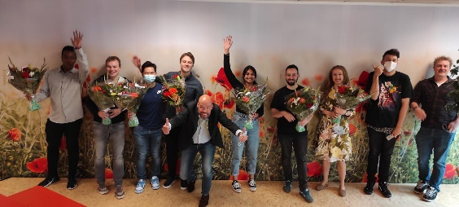

**Question 3!** – Maximum of 5 points **CHALLENGE!** – Worth 5 points



**Question 4!** – 1 point for every correct answer

Operations Icons - Free SVG & PNG Operations Images - Noun ProjectHead - Free people iconsHead - Free people icons

A3

A2

A1

  
  
**Bonus bingo!** – 1 point for every correct slide number per face **TIE BREAKER!**

When completed, send to [gabriel.moawad@capgemini.com](mailto:gabriel.moawad@capgemini.com)



B2

B1