CERTIFICATE
This is to certify that
Student's Name
completed
CCAA Preteen Course
in month/year
with an average of average.

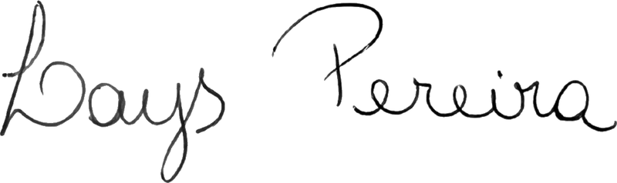
______________________________
Director

