LAB#4 Induction motor drive modelling

Name:Li Xin

HDU ID:22320404

ITMO ID:375334

Var:a_1

* LAB#4 is aimed at study reference frame, math.models of IM in different frames, and scalar control techniques for IM motors
* LAB#4 is performed in MATLAB / Simulink

In LAB4_IM_Actuator_modelling.PDF (with simulation results) following topics are presented

1. Transformation between reference frames (Transformation of *abc* variables into *dq (Clarke Transform) and inverse* transformation, *Park’s transformation* )

**2** Mathematical models of IM in stationary and synchronous reference frames

**3.** Scalar control of IM: open-loop system

**Task 1.** Transformation between reference frames (Transformation of *abc* variables into *dq (Clarke Transform) and inverse* transformation, *Park’s transformation* ) this is your Attendance task #2

* 1. Transformation of *abc* variables into *dq (Clarke Transform) and inverse* transformation
     1. 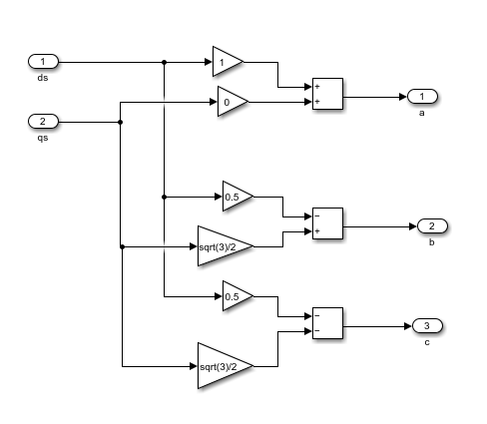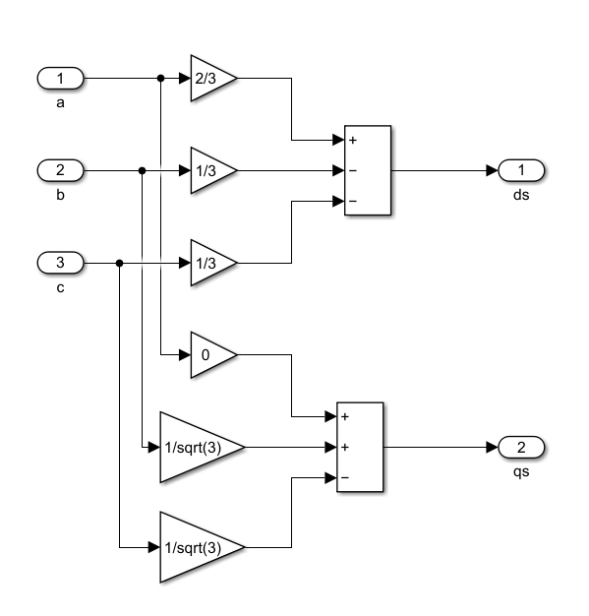Create blocks of transformation of *abc* variables into *dq and inverse* transformation using MATLAB Simulnk (1st way or 2nd way)

Figure 1. abc2dp & dq2abc models.

* + 1. Check right work of these blocks

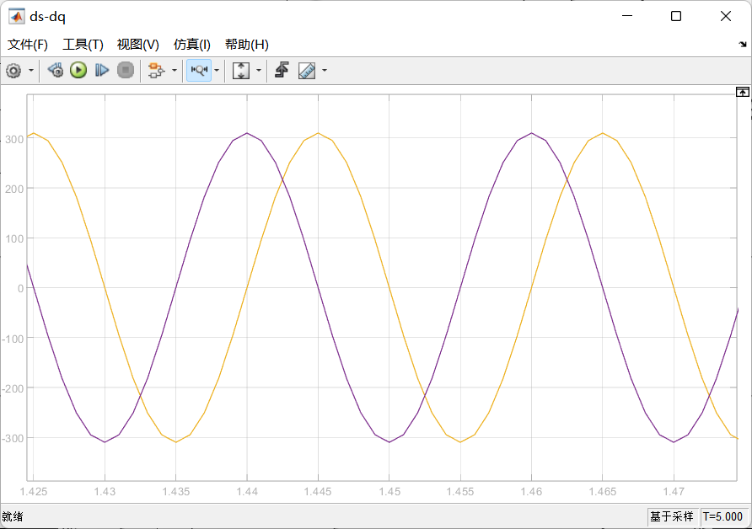

Figure2. Scope_ds-qs

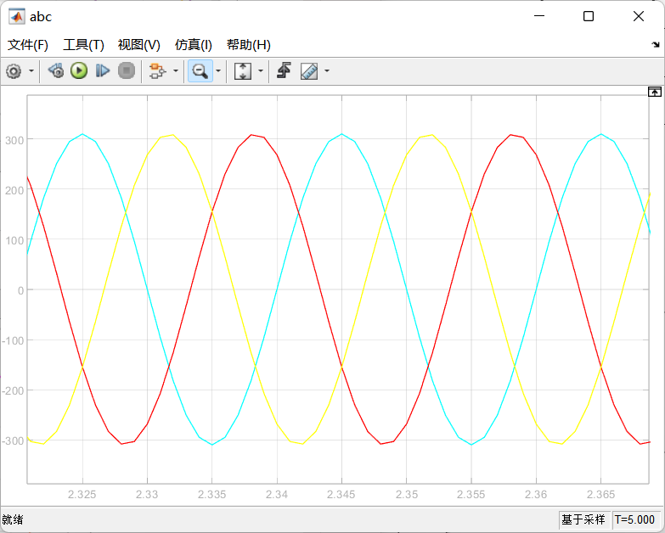

Figure3. Scope_abc

* 1. Park’s transformations
     1. Create blocks of Park’s transformations using MATLAB Simulnk (1st way or 2nd way)

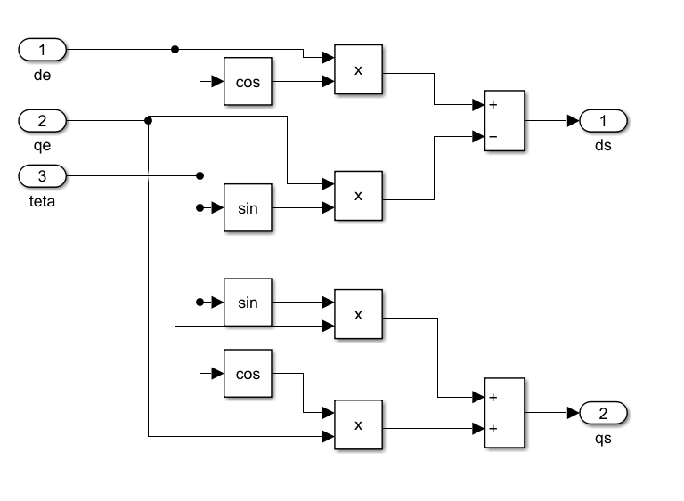

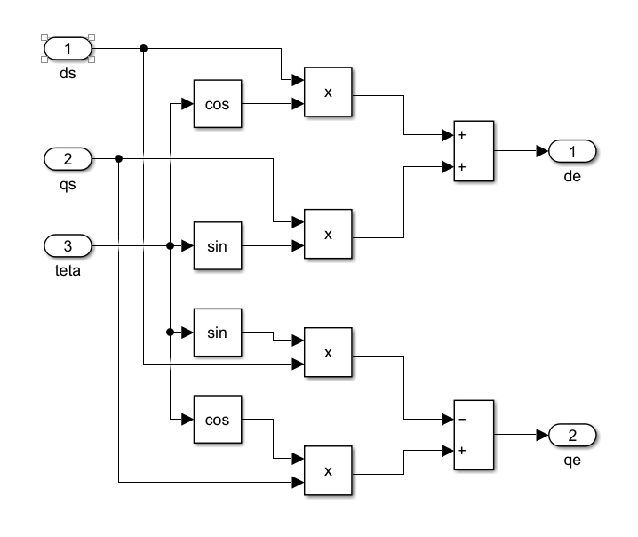

Figure4. blocks of Park’s transformations

* + 1. Check right work of these blocks

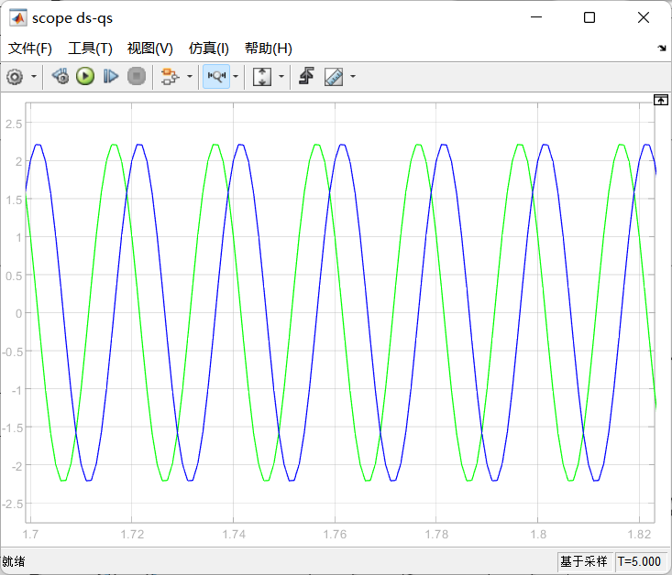

Figure4. right work of these blocks

* 1. Show in your report right work of all these blocks

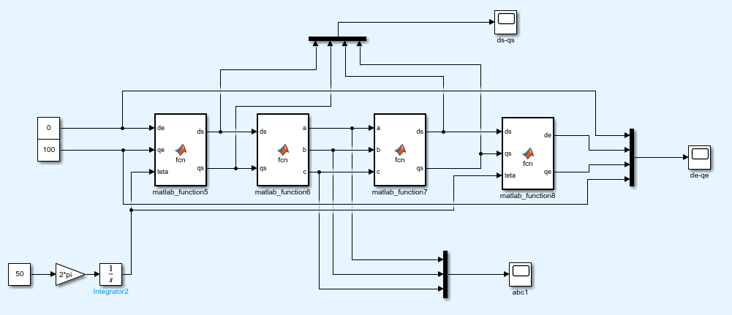

Figure5. whole model

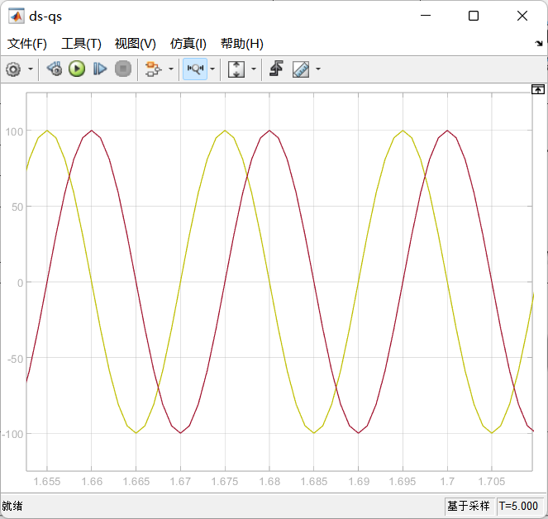

Figure6.plot of ds-qs

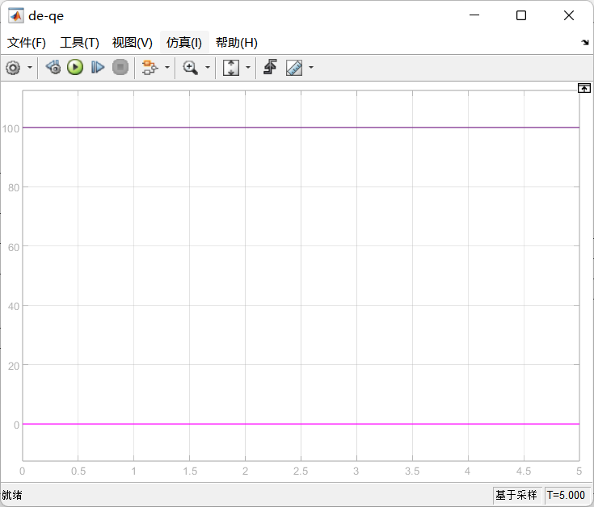

Figure7.plot of de-qe

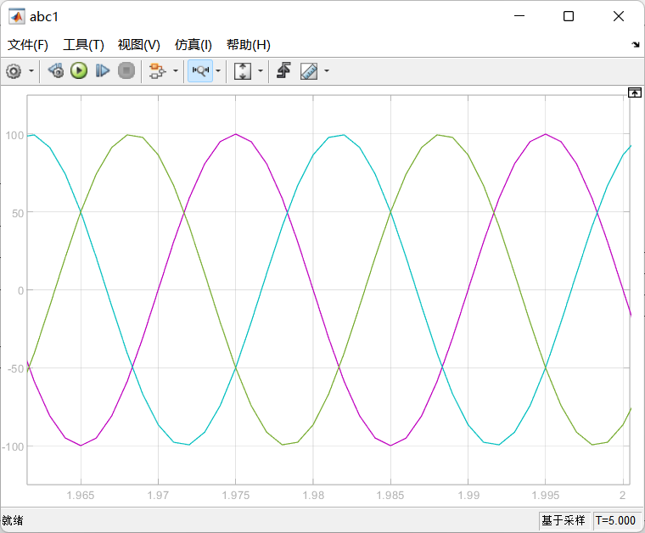

Figure8.plot of abc

Draw conclusions

I used Simulink to implement the Clarke and Park transformations. First, I applied the Clarke transform to convert the 3-phase signals into a 2-phase (αβ) stationary reference frame, and verified the output using an oscilloscope. Then, I applied the Park transform to shift the αβ components into the rotating dq frame, suitable for motor control. Both transformations functioned as expected, supporting effective field-oriented control.

**Task 2.** Mathematical model of IM in stationary and synchronous reference frames and at input signals of voltage

2.1. Create mathematical model of IM in stationary reference frames. Supply this model by input sinusoidal voltage (nominal values of amplitude and frequency – see table below) and obtain graphs of speed and torque. You need to create *.m file with appropriate variables (see table with IM parameters below)

2.2. Create mathematical model of IM in synchronous reference frames. Supply this model by input sinusoidal voltage (nominal values of amplitude and frequency – see table below) and obtain graphs of speed and torque. You need to create *.m file with appropriate variables (see table with IM parameters below)

2.3. Compare graphs of speed and torque in these models of IM with graphs of speed and torque for Library Simulink Blocks «Asynchronous Machine SI Units» and « Induction Motor »

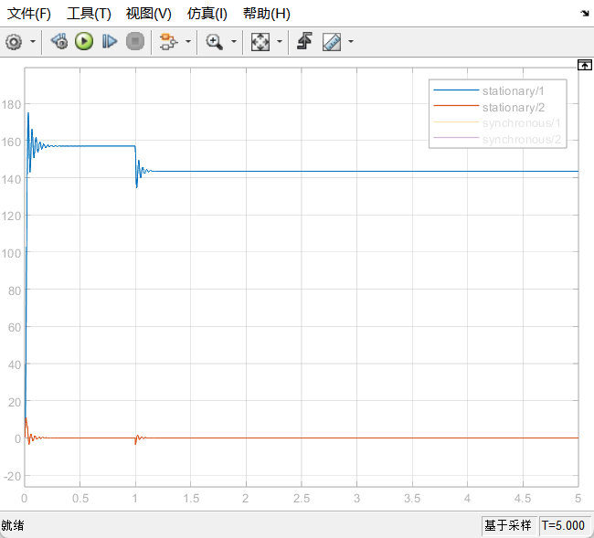

Figure9. speed and torque in these models

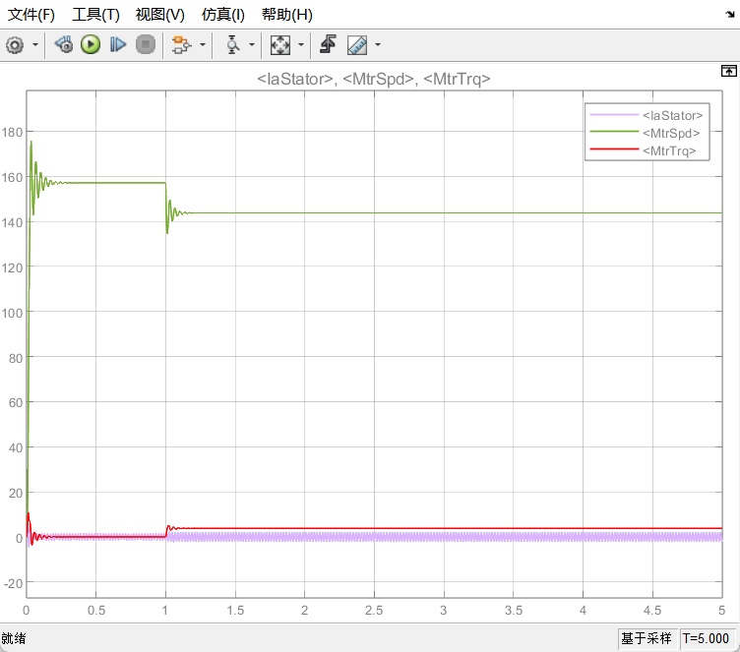 Figure10.speed and torque for Induction Motor

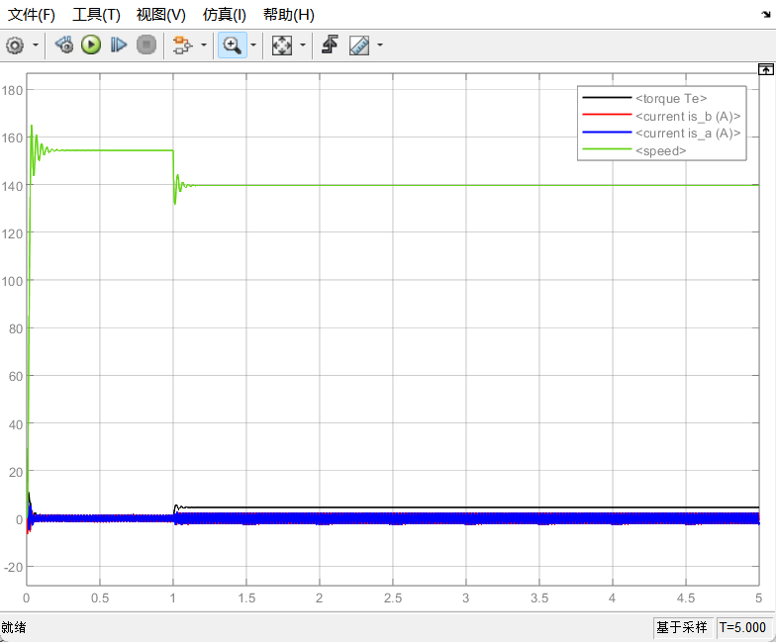

Figure11. speed and torque in Asynchronous Machine SI Units.

Draw conclusions

The consistent results in speed, torque, and the speed-torque curve between the Induction Motor and Asynchronous Machine blocks validate the correctness of the models. This demonstrates that the choice of reference frame does not alter the core behavior of the induction motor.

**Task 3.** Open-loop scalar control of IM ~~(~~*~~not necessary, additional task~~* ~~)~~

3.1. Create mathematical model of open loop scalar control system with any math. model of IM that created above with linear motion profile

3.2. Show results in open-loop scalar control system with/without motion profile

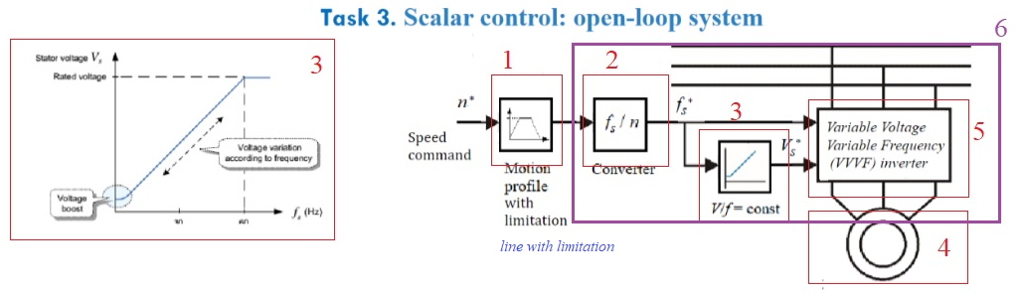

1 - slope (ramp with saturation)

2 - only coefficient (formula no-load speed for IM)

3 - only coefficient V/f

4 - block of IM (previous TASK2 in LAB4)

5- inverter (3ph sourse) with V_abc in the output

6- this combination of blocks is "Scalar controller" that you used in 3.1

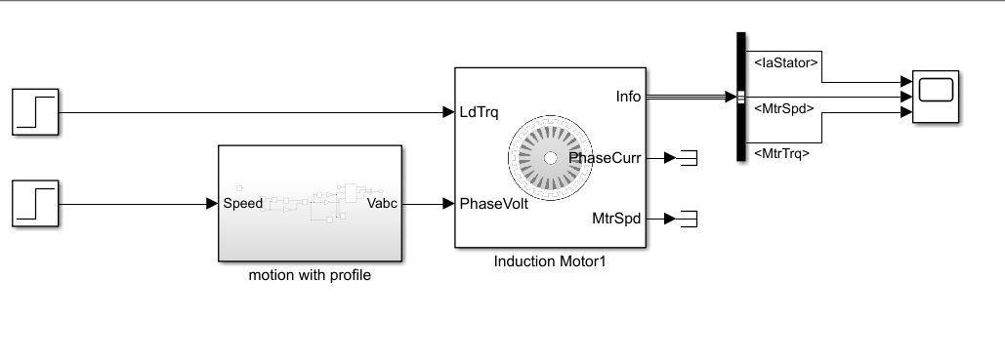

Figure 12. model

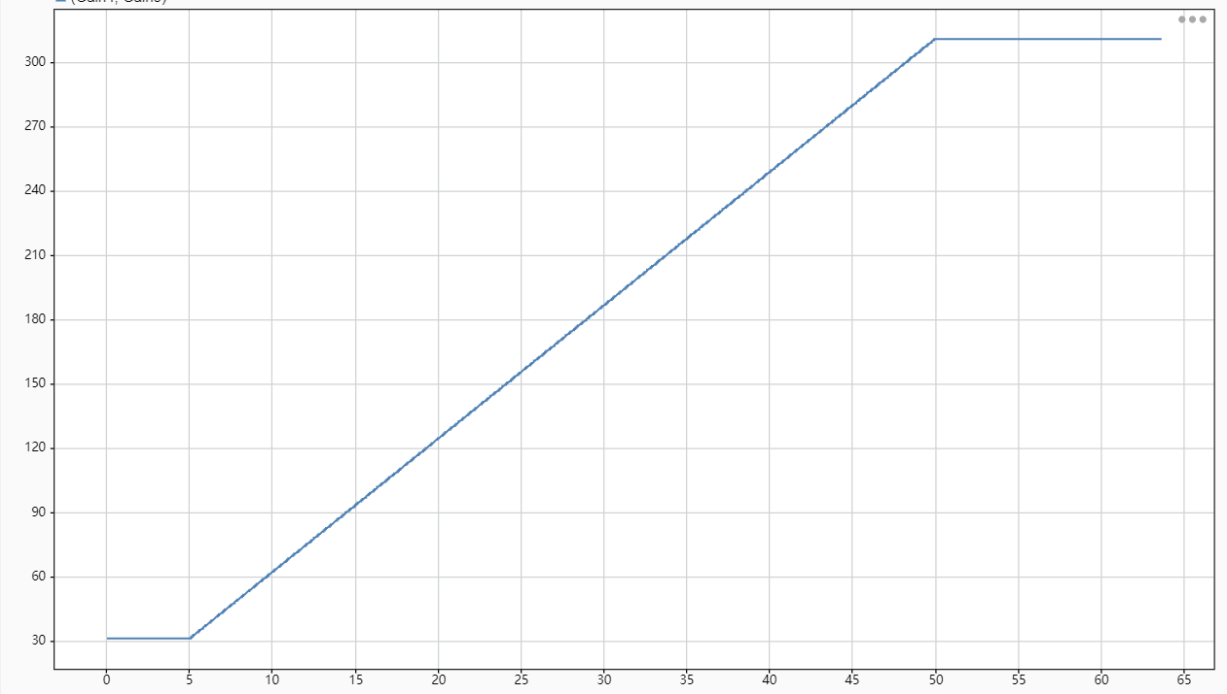

Figure 13. f-v signal with profile

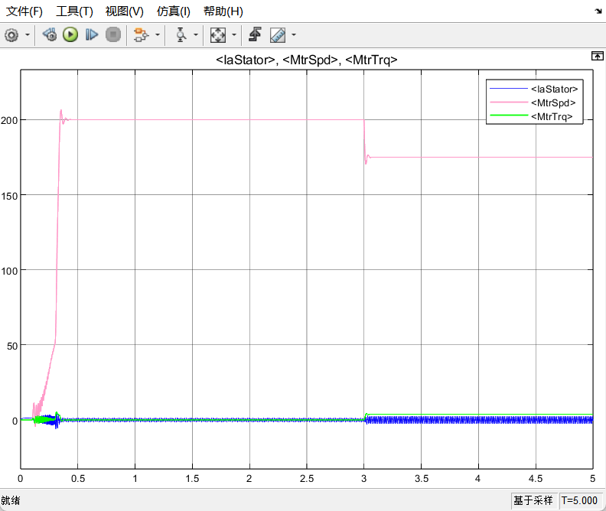

Figure 14. speed and torque with motion profile

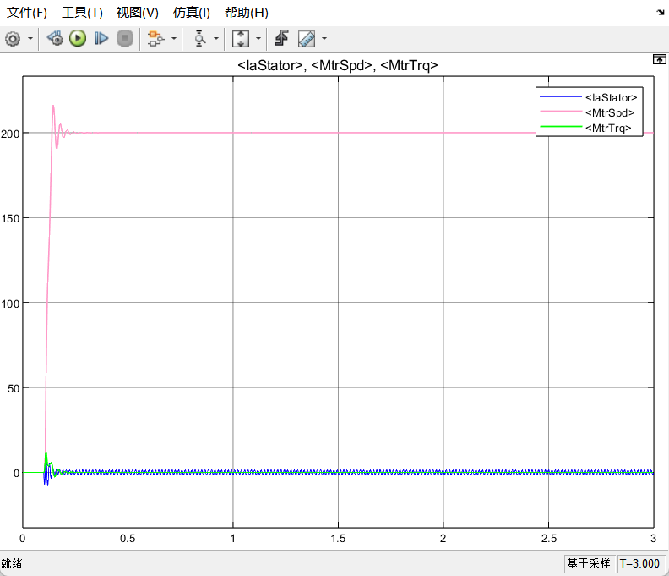

Figure 15. speed and torque without motion profile

Draw conclusions

In this experiment, I explored an open-loop scalar control system using the voltage-to-frequency control method, both with and without the integration of a linear motion profile. Introducing a ramp-based motion profile effectively smoothed the acceleration process by controlling the rate of frequency increase, thereby minimizing mechanical stress and reducing peak current spikes. The comparative results indicated that the system with the motion profile exhibited significantly more stable responses in both speed and torque, while the system without it suffered from abrupt transitions and oscillations. Nonetheless, the inherent limitation of open-loop control, its inability to account for load-induced slip, makes it less accurate under varying load conditions. This study highlights the balance that must be struck between control simplicity and system performance when employing scalar strategies.

|  |  |  |  |  |  |  |
| --- | --- | --- | --- | --- | --- | --- |
|  |  | a_1 | a_2 | a_3 | a_4 | a_5 |
| U_s | rated phase voltage, V | 220 | 220 | 220 | 220 | 220 |
| f_s | rated frequency , Hz | 50 | 50 | 50 | 50 | 50 |
| I_n | rated current, А | 1.58 | 2.66 | 11.1 | 54.97 | 99.31 |
| Lm | mutual inductance, H | .624 | .447 | .164 | .0489 | .0287 |
| Ls | stator inductance, H | .663 | .484 | .169 | .05 | .0294 |
| Lr | rotor inductance, H | .7015 | .476 | .1715 | .051 | .0297 |
| Rs | stator resistance, Оhm | 16.39 | 9.53 | 1.32 | .16 | .067 |
| Rr | rotor resistance, Оhm | 15.08 | 5.619 | .922 | .078 | .032 |
| J | moment of inertia , kg*m2 | .00108 | .00255 | .0202 | 0.2202 | 0.6092 |
| Pn | rated power, W | 550 | 1100 | 5500 | 30000 | 55000 |
| s_n | nominal slip | 0.075 | 0.056 | 0.035 | 0.019 | 0.014 |
| z | pairs of poles | 2 | 2 | 2 | 2 | 2 |
| i_lim | ratio of max current | 4.5 | 4.5 | 4.5 | 4.5 | 4.5 |

% Data of IM type 4A80A4 (example a_1)

global Lm Lr Rr I_n J_m f_e Tn z s_n i_lim

U_s=220; % rated phase voltage, V

f_s=50 % rated frequency , Hz

I_n=1.58 % rated current, А

Lm=0.624 % mutual inductance, H

Ls=0.663 % stator inductance, H

Lls=Ls-Lm % stator leakage inductance, H

Lr=0.7015 % rotor inductance, H

Llr=Lr-Lm % rotor leakage inductance, H

Rs=16.39 % stator resistance, Ohm

Rr=15.08 % rotor resistance, Ohm

J_m=0.0108 % moment of inertia, kg*m2

Pn=550 % rated power, W

s_n=0.075 % nominal slip

z=2 % pairs of poles

Tn=Pn*z/((1-s_n)*2*pi*f_s) % rated torque, Nm

i_lim=4.5 % ratio of max current

Tr = Lr/Rr

K1 = Lm/Ls

K2 = Lm/Lr

R_s = (K2^2)*Rr+Rs

R_r = (K1^2)*Rs+Rr

L_s = Ls*(1-K1*K2)

L_r = Lr*(1-K1*K2)

T_s = L_s/R_s

T_r = L_r/R_r

U=U_s;

U_m=sqrt(2)*U_s % amplitude of rated phase voltage, V