**DC Lab**

**Name:Li Xin**

**ITMO ID:375334**

**HDU ID:22320404**

**1.Data**







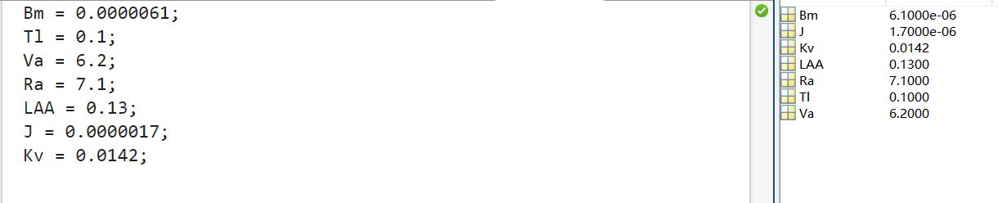

**2.Transfer function**

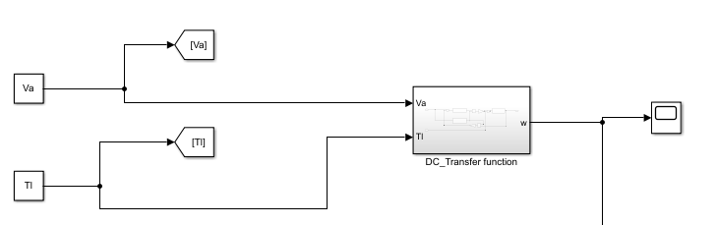

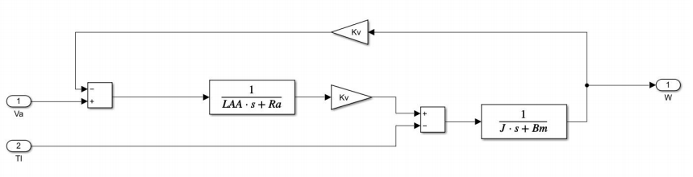

speed-time characteristics

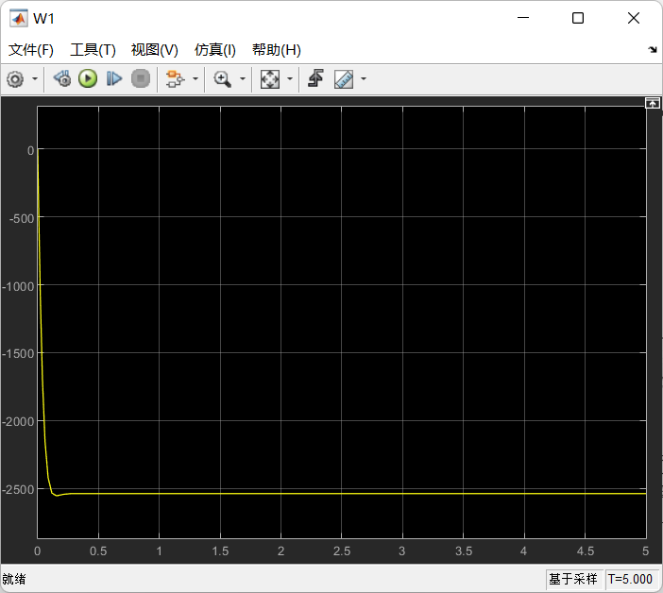

**3.Simscape model using electrical components**

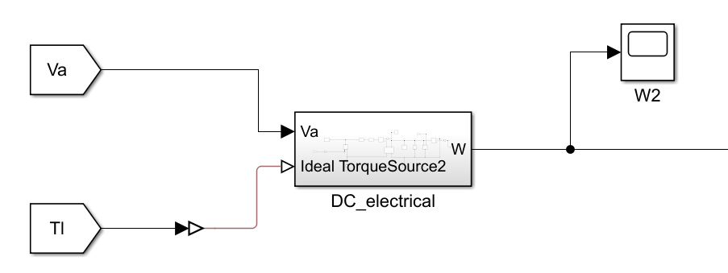

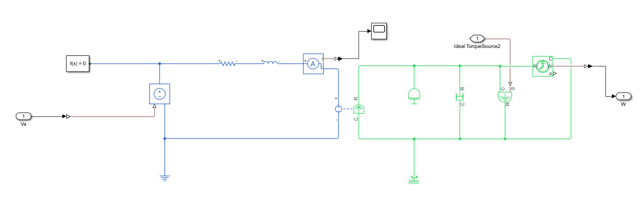

speed-time characteristics

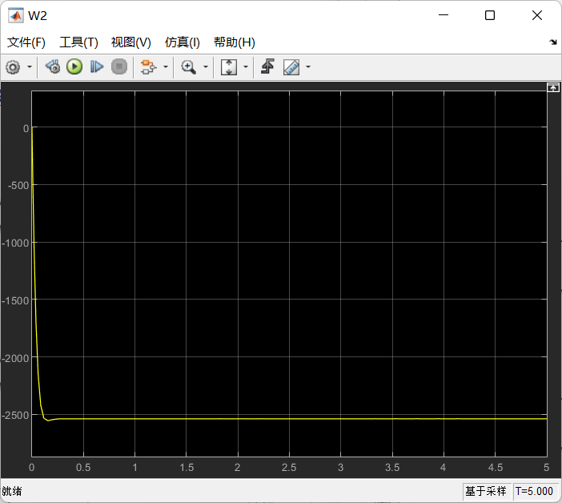

**4.By using the DC machine block in Simulink**

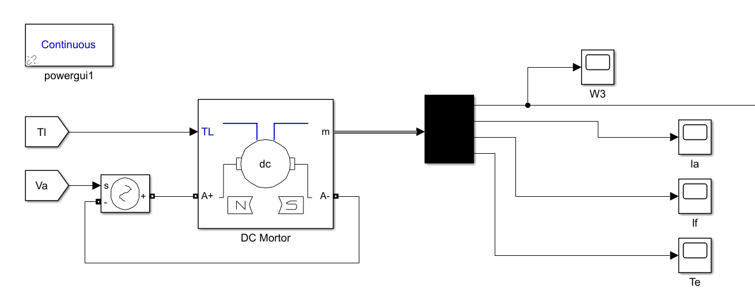

speed-time characteristics

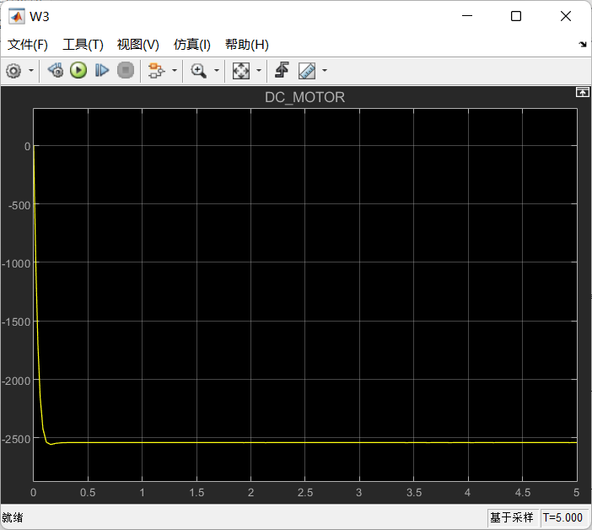

1. **Analyze the output speed-time characteristics**

**The motor's speed, as depicted in speed-time graphs, begins at zero and surges quickly. It briefly overshoots the target speed before settling into a steady pace. This minor overshoot, possibly due to inertia or control settings, doesn't hinder the system's swift return to stability. The system's rapid stabilization post-overshoot highlights its strong dynamic response and stability, making it ideal for applications that need precise speed control.**

**6.Compare the results**

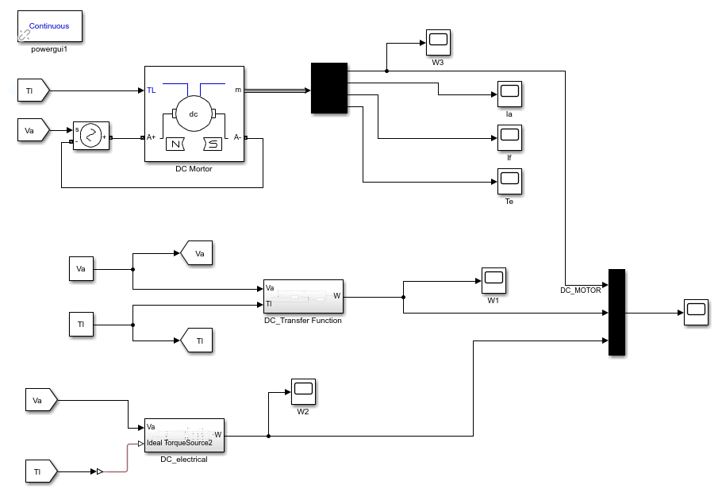

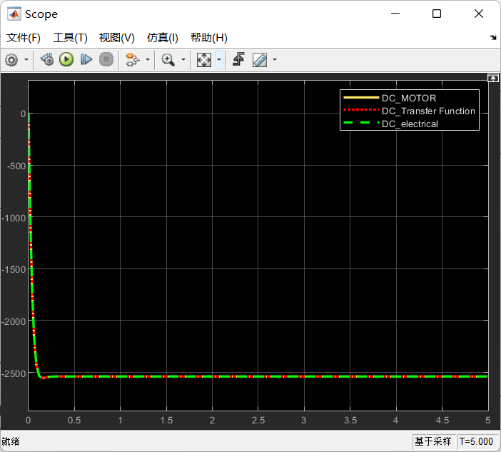

In the experiment, the transfer function model showed an ideal speed-time response due to its simplified assumptions. The Simscape model, considering more real-world electrical characteristics, provided results closer to actual conditions. The Simulink DC motor block model offered the most accurate speed response by detailing the motor's dynamics.

Minor differences in final speeds among the models were likely due to the solver. Despite these differences, all models showed consistent speed-time characteristics.

Overall, the level of accuracy in the simulation results depended on the model's complexity. The transfer function model was ideal but less realistic, while the Simscape and Simulink models were more accurate, with the latter being the most detailed.