**Lab 2.**

**Simulation components of dynamic systems**

1. My name and HDU ID

Name:Li Xin

HDU ID:22320404

1. My variant and initial data



1. Simscape model of DC-motor

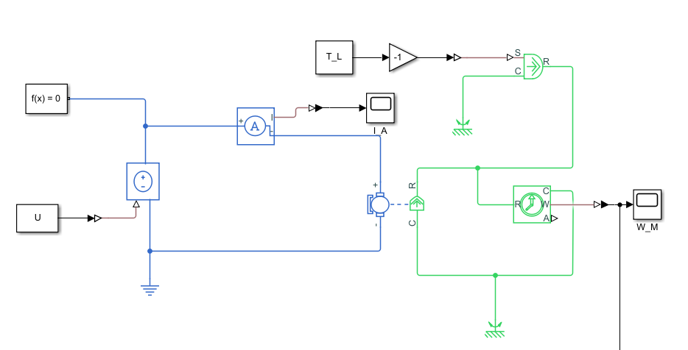

1. Block diagram model of DC-motor

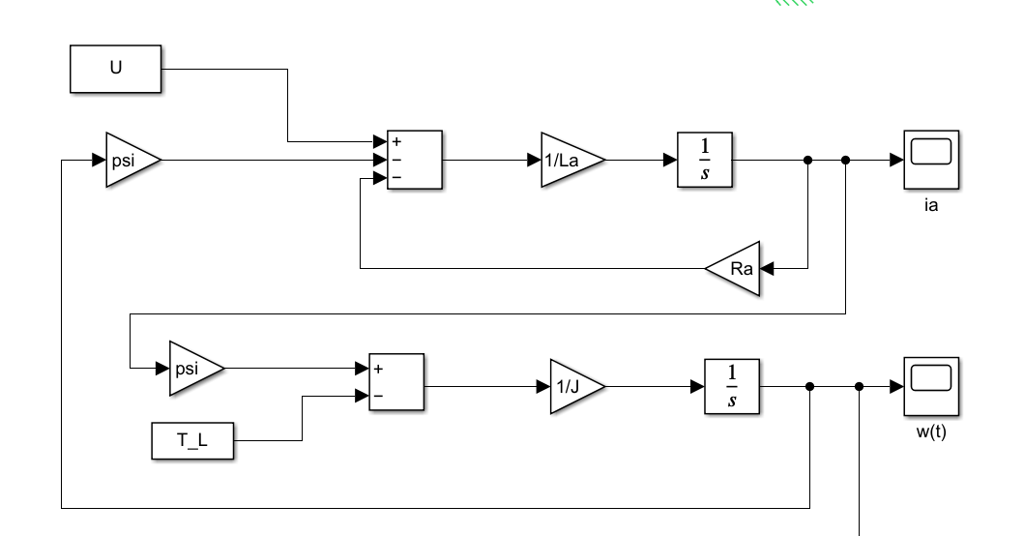

1. Transfer functions of DC-motor

$$L_{a}sI_{a}\left(s\right)=U\left(s\right)-R_{a}I_{a}\left(s\right)-Ψw\left(s\right)$$

$$Jsw\left(s\right)=ΨI_{a}\left(s\right)-T_{L}\left(s\right)$$

$$I_{a}\left(s\right)=\frac{U\left(s\right)-Ψw\left(s\right)}{L_{a}s+R_{a}}$$

$$Jsw\left(s\right)=Ψ\frac{U\left(s\right)-Ψw\left(s\right)}{L_{a}s+R_{a}}-T_{L}\left(s\right)$$

$$\text{Let} T_{L}=0$$

$$W_{1}\left(s\right)=\frac{w\left(s\right)}{U\left(s\right)}=\frac{Ψ}{JL_{a}s^{2}+JR_{a}s+Ψ^{2}}$$

$$\text{Let} U(s)=0$$

$$Ω\left(s\right)=\frac{-\left(L_{a}s+R_{a}\right)}{Js\left(L_{a}s+R_{a}\right)+Ψ^{2}}T_{L}\left(s\right)$$

$$W_{2}\left(s\right)=\frac{-\left(L_{a}s+R_{a}\right)}{Js\left(L_{a}s+R_{a}\right)+Ψ^{2}}$$

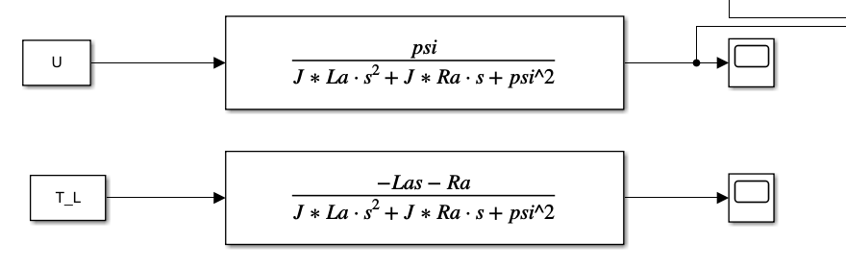

1. State space model of DC-motor

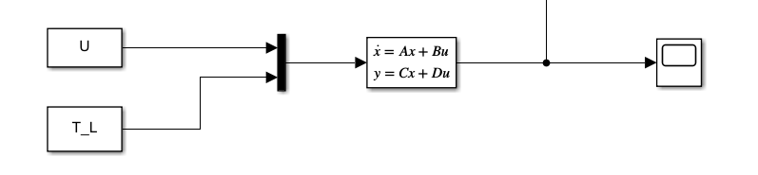

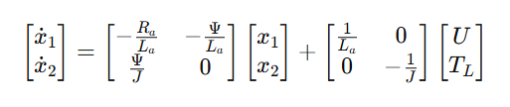

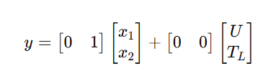



1. Simulation results for 2 cases

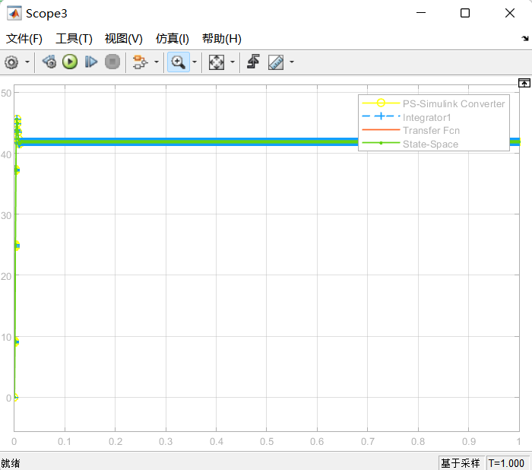

With rated voltage and zero load torque

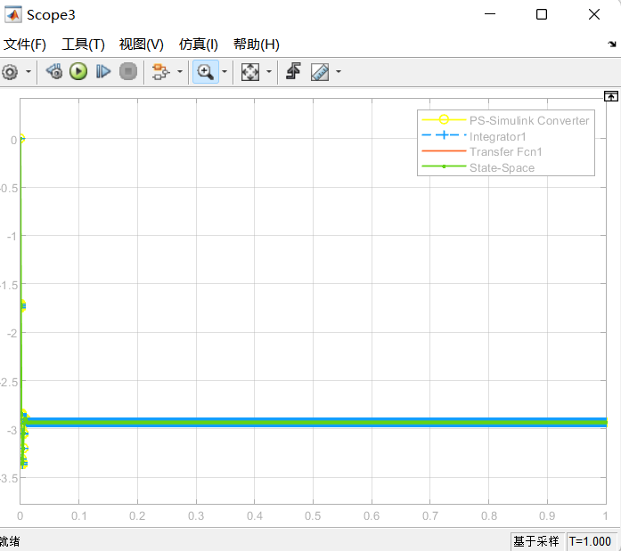

With zero voltage and rated load torque

1. Calculation of transient response function based on transfer function of DC-motor for two values of inertia

$$JL_{a}s^{2}+JR_{a}s+Ψ^{2}=0$$

$$s^{2}+2ζω_{n}s+ω_{n}^{2}=0$$

$$ω_{n}^{2}=\frac{Ψ^{2}}{JL_{a}}$$

$$2ζω_{n}=\frac{JR_{a}}{JL_{a}}=\frac{R_{a}}{L_{a}}$$

$$ω_{n}=\sqrt{\frac{Ψ^{2}}{JL_{a}}}$$

$$ζ=\frac{R_{a}}{2}\sqrt{\frac{J}{Ψ^{2}L_{a}}}$$

$ζ1=0.6109$*<1*

$ζ2=1.5795$*>1*

*So the transient response function ω(t) for U(t) = U_rated , J=J1 is underdamped.*

*After inverse Laplace transform,*

$$ω\left(t\right)=\frac{U_{rated}}{φ}\left(1-e^{-ζω_{n}t}\left(\cos\left(ω_{d}t\right)+\frac{ζ}{\sqrt{1-ζ}}\sin\left(ω_{d}t\right)\right)\right)$$

1. Graphs of transient responses

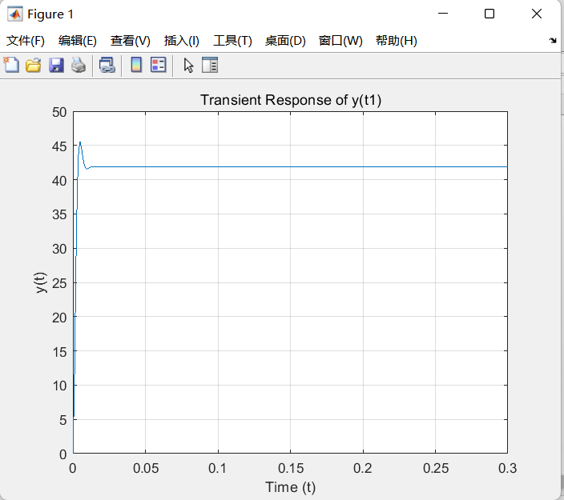

With J=J1

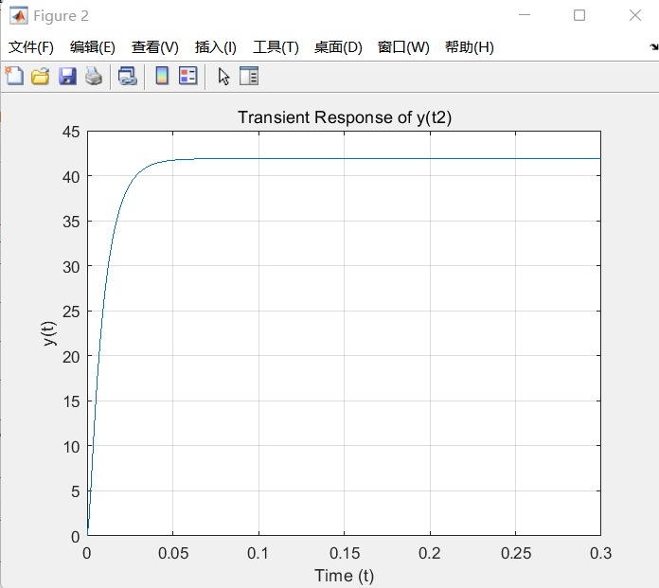

With J=J2

1. Values of rise time, maximum overshoot and settling time

For J1

Rise Time (10% to 90%): 0.003 s

Max Overshoot: 8.85%

Settling Time (5% tolerance): 0.008 s

For J2:

Rise Time (10% to 90%): 0.0197 s

Max Overshoot: 0.00%

Settling Time (5% tolerance): 0.0358 s

1. Bode plot of underdamped model of DC-motor

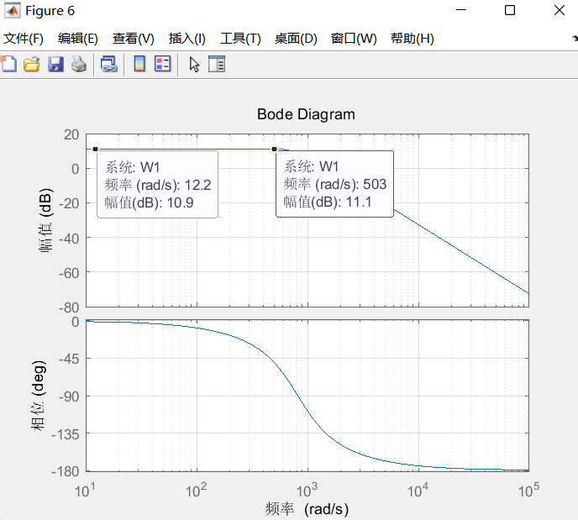

12.Values of the static gain and damped natural frequency calculated from Bode plots

Static Gain K = $\frac{10.9}{20}={10}^{0.545}$ =3.50

Damped Natural Frequency wd = 503 rad/s

13.conclusion

**Model Validation**  
The derived transfer function and state-space model of the DC motor align with the physical principles of electromechanical systems. The transfer function  and state-space matrices were successfully validated through Simulink simulations, confirming their accuracy in describing the motor’s dynamics under both no-load and rated load conditions.

**Impact of Inertia (*J*) on Transient Response**

For *J*=*J*1​: The system exhibited ​**underdamped behavior** (*ζ*1​=0.61), resulting in a fast rise time (0.003s) but with an overshoot of 8.85%.

For *J*=*J*2​: The system became ​**overdamped** (*ζ*2​=1.58), eliminating overshoot at the cost of slower response (rise time 0.0197s).

**Frequency Domain Analysis**  
The Bode plot of the underdamped model (*J*=*J*1​) revealed a ​**static gain *K*=3.50** and ​**damped natural frequency *ωd*​=503rad/s**. These values align with theoretical predictions, confirming the system’s bandwidth and resonance characteristics.