**Lab 3.**

**Simulation of mechanical systems**

1. My name and HDU ID

Name:Li Xin

HDU ID:22320404

1. My variant and initial data



1. Simscape model of DC-motor with two-mass load

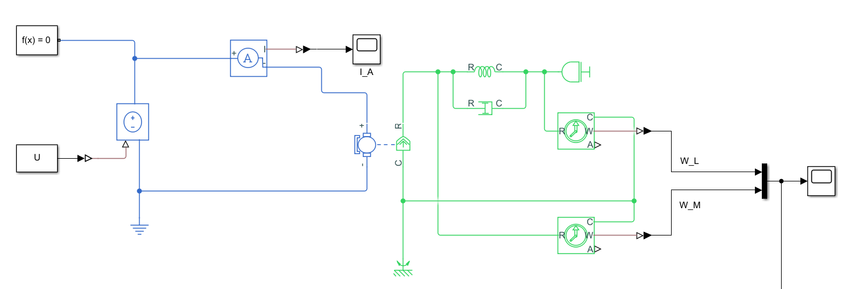

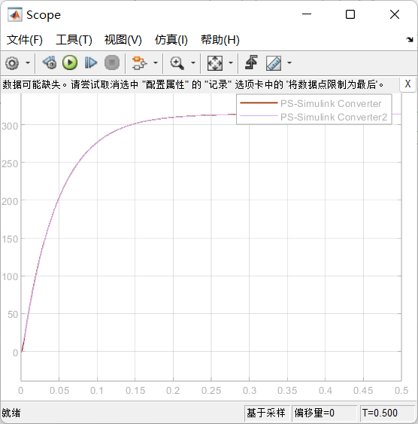

1. Block diagram model of DC-motor with two-mass load

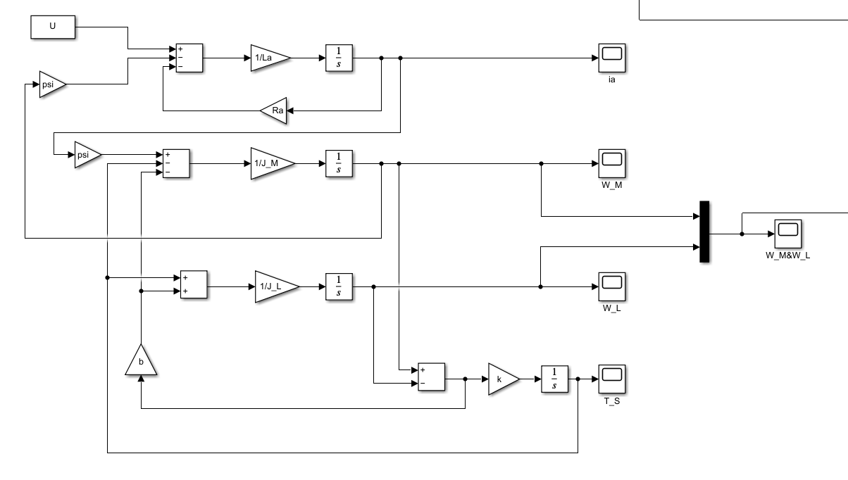

equations:

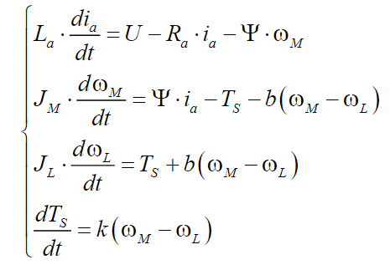

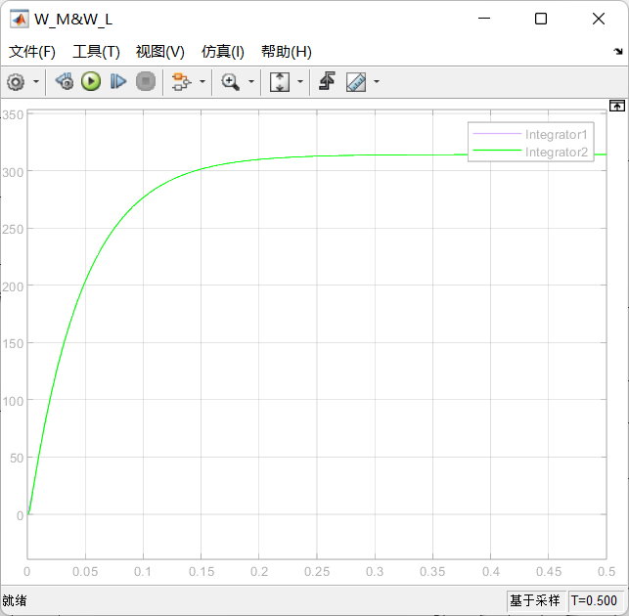

1. Transfer functions of DC-motor with two-mass load

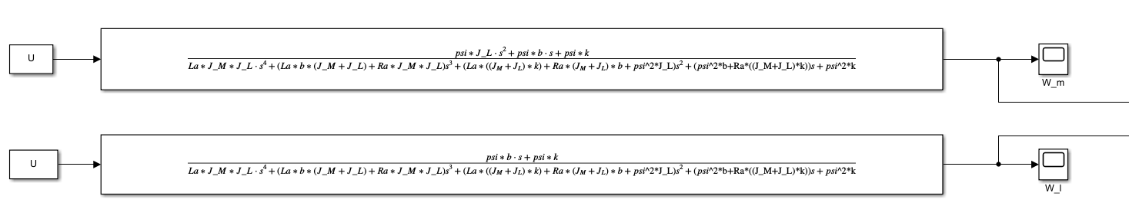

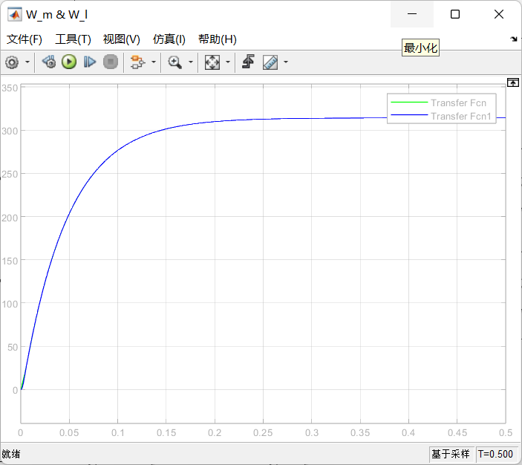

1. State space model of DC-motor with two-mass load

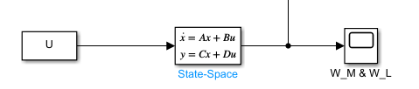

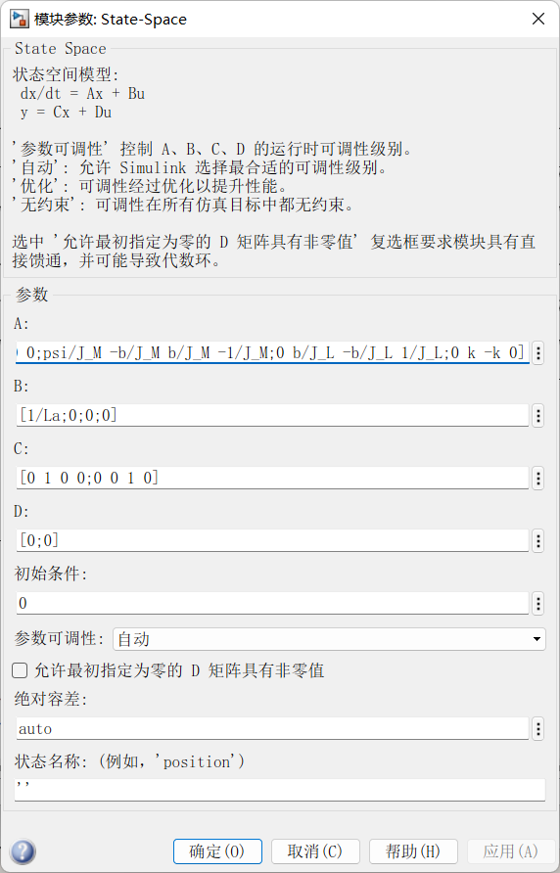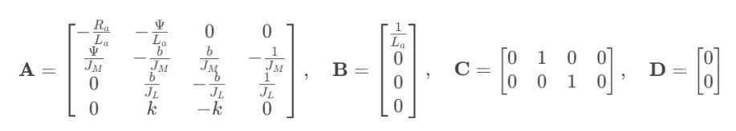

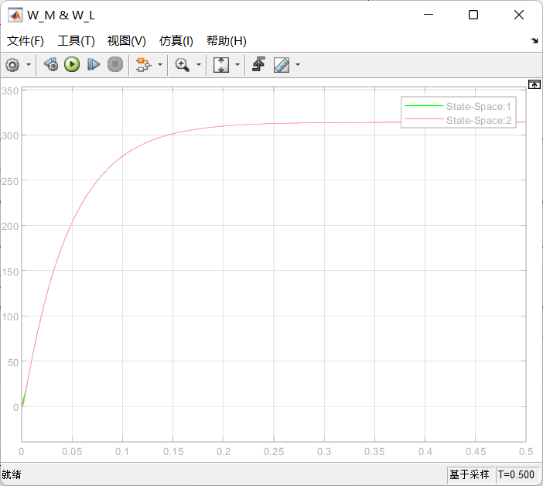

1. Simulation results of all methods

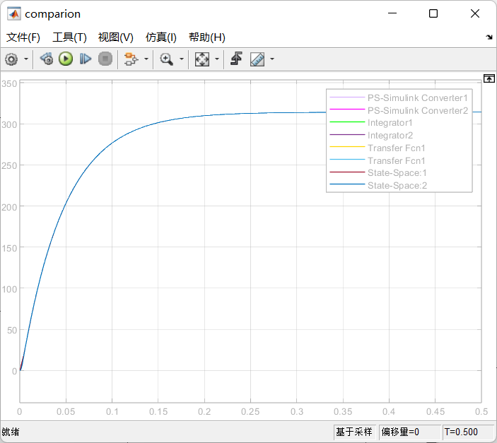

1. Bode plots of transfer functions

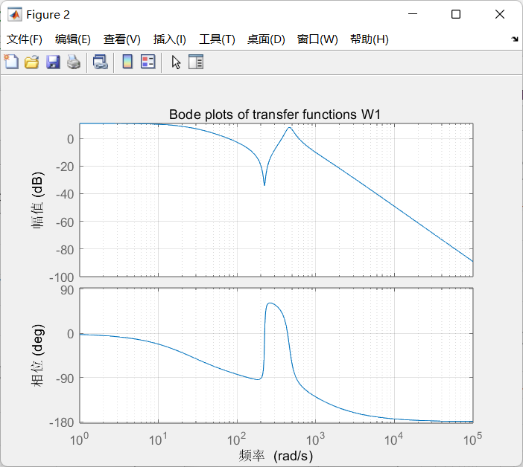

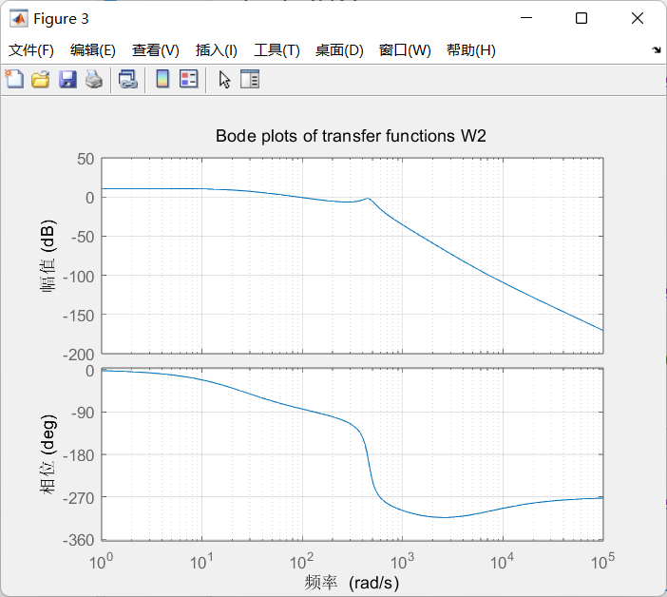

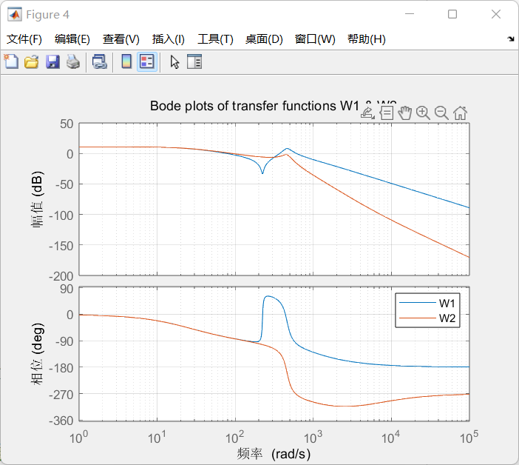

1. Value of resonant frequency

The Bode diagram for $W_{1}(s)$:

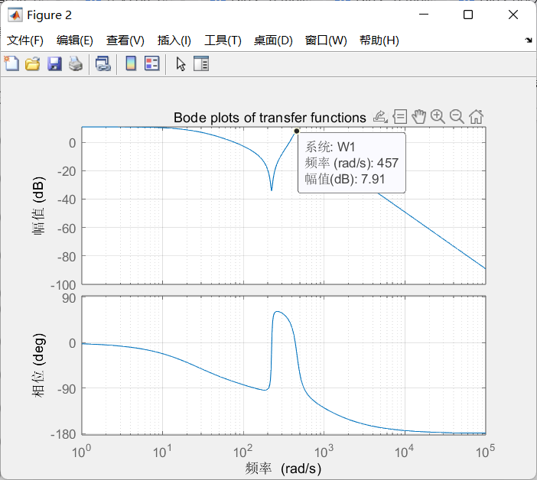

$$W1 value of resonant frequency is 457 rad/s$$

The Bode diagram for $W_{2}(s)$:

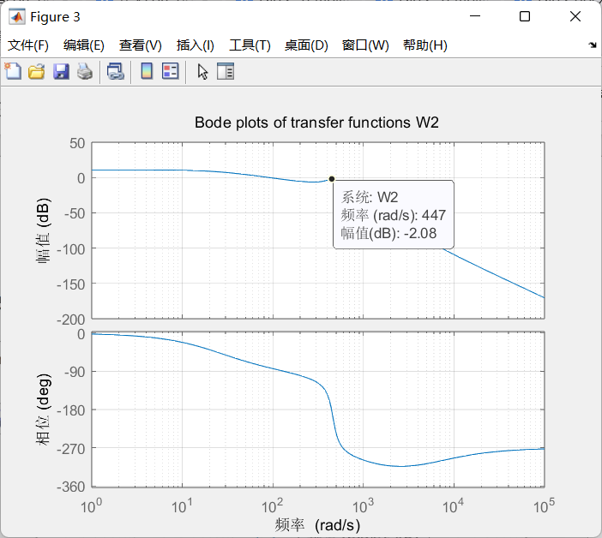

$$W2 value of resonant frequency is 447 rad/s$$

1. Experimentally estimated frequency response function

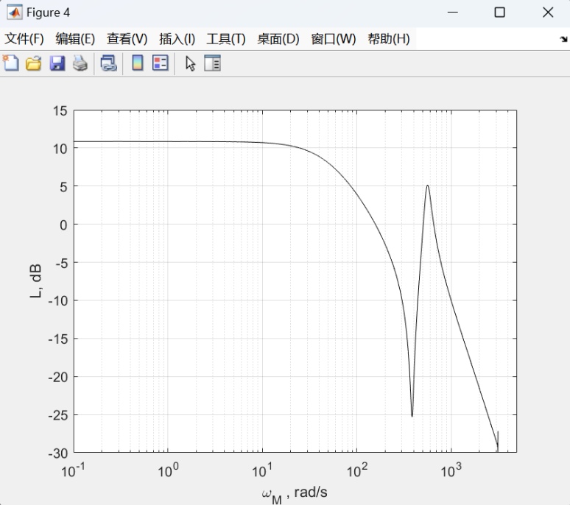

1. Experimentally estimated transfer function

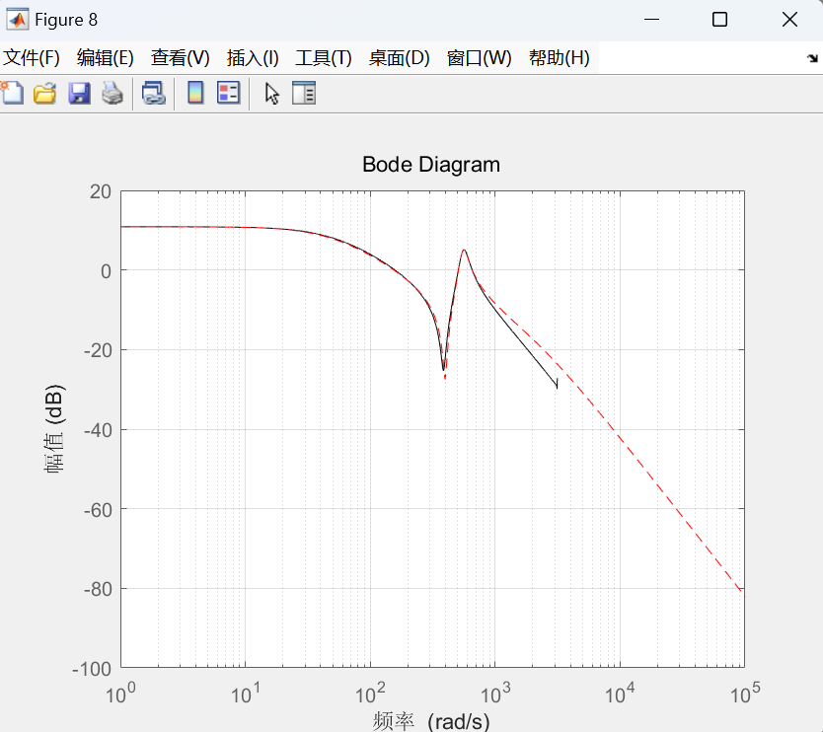

12.Comparison of estimated transfer function with original one

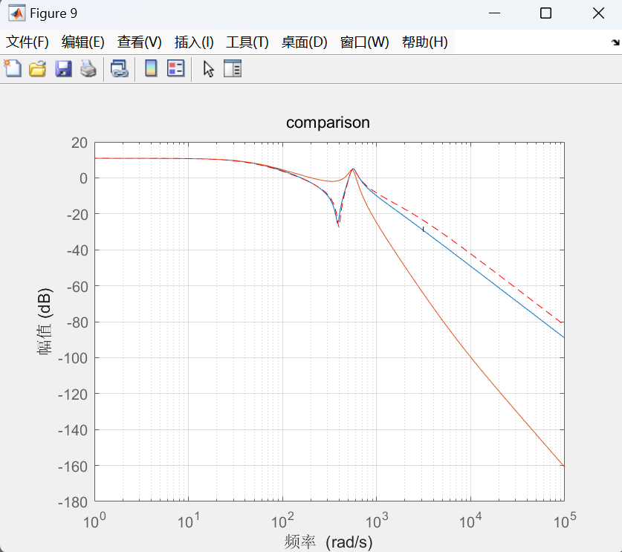

13.conclusion

In this lab, I successfully conducted simulations and analyses of a mechanical system comprising a DC motor connected to a two-mass load. Utilizing MATLAB and Simulink, I explored multiple modeling methods, including transfer function representations, state-space modeling, and Simscape simulations. By comparing the outcomes from these distinct modeling strategies, I confirmed their consistency, affirming the reliability and accuracy of my simulation approaches.

A primary objective of the lab was generating and interpreting the Bode plots for specific transfer functions of the system. These plots significantly enhanced my comprehension of the system's frequency response characteristics. Furthermore, I identified resonant frequencies from these analyses, which were determined to be approximately 457 rad/s for one transfer function and around 447 rad/s for another. Recognizing these resonant frequencies provided valuable insights into the dynamic behavior of the system across various frequency ranges.

Moreover, I undertook an experimental assessment of the system's frequency response utilizing MATLAB's tfestimate function. The resulting experimentally derived transfer function showed a high degree of similarity with my theoretical models, as demonstrated by closely overlapping Bode plots. This comparison served to validate the precision of both my theoretical modeling and the experimental data collection process.

In summary, this lab significantly enriched my understanding of mechanical systems involving DC motors and load dynamics. It provided practical skills and insights into the use of MATLAB for complex system modeling, simulation, and frequency analysis, laying a solid foundation for future explorations in the fields of automation and control engineering.