Homework 1
Cesar Cabrera Garcia
COP 4045-042 Python Programming
Fall 2026

Problem 1 - Quadratic Equations
Source file: Homework1/p1_CabreraGarcia_Cesar.py
# Author Cesar Cabrera Garcia
# Course COP 4045-042 Python Programming
# Term Fall 2026
# Description Solve and graph quadratic equations entered from the terminal

import math
import matplotlib.pyplot as pyplot

# -----------------------------
# Initial variable declarations
# -----------------------------
number_of_points = 150
domain_padding = 2.0
default_domain_radius = 5.0
a_text = ""
a_value = 0.0
b_value = 0.0
c_value = 0.0
discriminant = 0.0
x_one = 0.0
x_two = 0.0
x_opt = 0.0
x_min = 0.0
x_max = 0.0
dx = 0.0
x_value = 0.0
y_value = 0.0
point_counter = 0
xs = []
ys = []

while True:
a_text = input("Enter a: ")

if a_text == "":
break

a_value = float(a_text)
b_value = float(input("Enter b: "))
c_value = float(input("Enter c: "))

discriminant = b_value**2 - 4 * a_value * c_value
x_opt = -b_value / (2 * a_value)

# Pick the graph domain so the roots or vertex are visible.
if discriminant < 0:
print("no real solutions")
x_min = x_opt - default_domain_radius
x_max = x_opt + default_domain_radius
elif discriminant == 0:
x_one = -b_value / (2 * a_value)
print("one solution:", x_one)
x_min = x_one - default_domain_radius
x_max = x_one + default_domain_radius
else:
x_one = (-b_value - math.sqrt(discriminant)) / (2 * a_value)
x_two = (-b_value + math.sqrt(discriminant)) / (2 * a_value)
print("two solutions: x1=", x_one, "x2=", x_two)

if x_one < x_two:
x_min = x_one - domain_padding
x_max = x_two + domain_padding
else:
x_min = x_two - domain_padding
x_max = x_one + domain_padding

xs = []
ys = []
dx = (x_max - x_min) / (number_of_points - 1)
x_value = x_min
point_counter = 0

while point_counter < number_of_points:
y_value = a_value * x_value**2 + b_value * x_value + c_value
xs.append(x_value)
ys.append(y_value)
x_value = x_value + dx
point_counter = point_counter + 1

pyplot.plot(xs, ys, "ro-")
pyplot.xlabel("x")
pyplot.ylabel("y")
pyplot.title("Quadratic Function")
pyplot.grid(True)
pyplot.show()
pyplot.clf()

Output Evidence
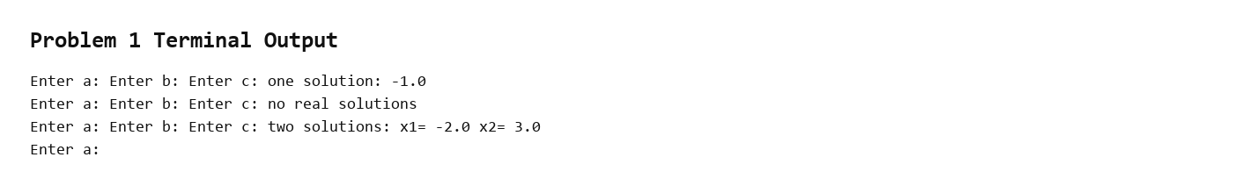
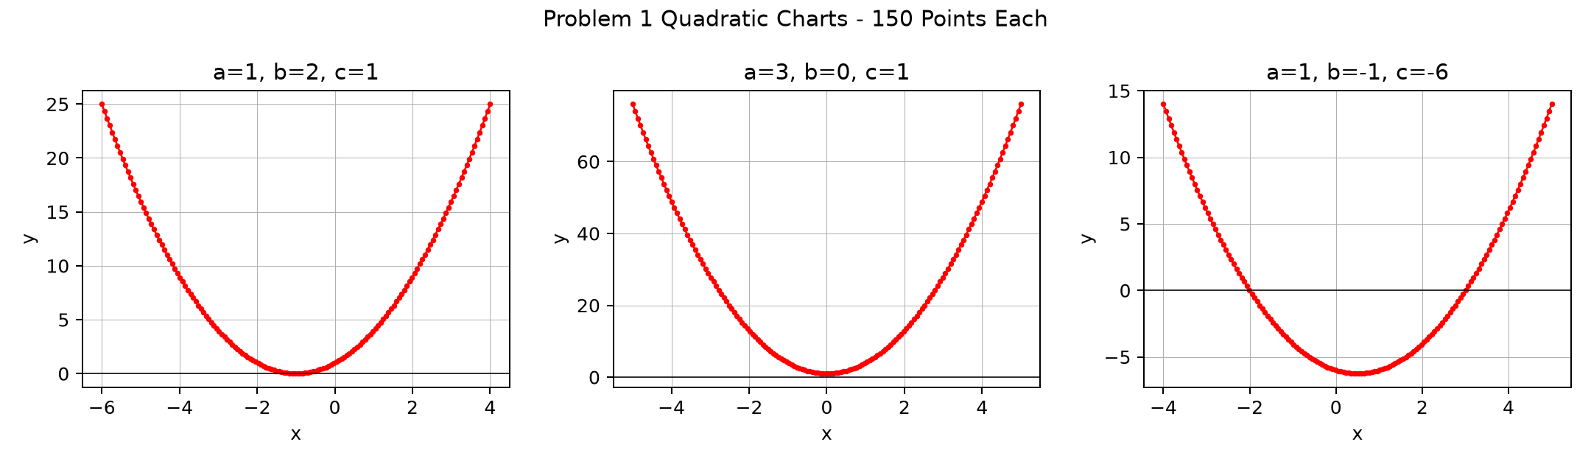

Problem 2 - Pythagorean Numbers
Source file: Homework1/p2_CabreraGarcia_Cesar.py
# Author Cesar Cabrera Garcia
# Course COP 4045-042 Python Programming
# Term Fall 2026
# Description Find all Pythagorean triples up to a user-entered bound

# -----------------------------
# Initial variable declarations
# -----------------------------
n_value = 0
a_value = 0
b_value = 0
c_value = 0
triples = []
triple_index = 0

def find_Pythagorean(n):
found_triples = []

# Try every ordered value so both (3, 4, 5) and (4, 3, 5) are included.
for a_value in range(1, n + 1):
for b_value in range(1, n + 1):
for c_value in range(1, n + 1):
if a_value**2 + b_value**2 == c_value**2:
found_triples.append((a_value, b_value, c_value))

return found_triples

n_value = int(input("Enter n: "))
triples = find_Pythagorean(n_value)

triple_index = 0

while triple_index < len(triples):
print(triples[triple_index])
triple_index = triple_index + 1

if len(triples) == 0:
print("No triples found.")

Output Evidence
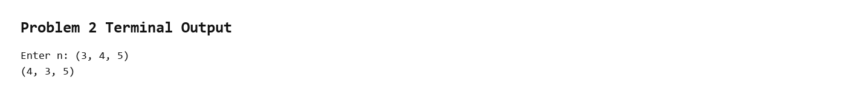

Problem 3 - Duplicated Substrings
Source file: Homework1/p3_CabreraGarcia_Cesar.py
# Author Cesar Cabrera Garcia
# Course COP 4045-042 Python Programming
# Term Fall 2026
# Description Locate duplicated substrings in user-entered text

# -----------------------------
# Initial variable declarations
# -----------------------------
s = ""
n_value = 0
duplicated_substring = ""
maximum_duplicated_substring = ""

def find_dup_str(s, n):
text_length = 0
start_one = 0
start_two = 0
first_piece = ""
second_piece = ""

for current_character in s:
text_length = text_length + 1

if n <= 0:
return ""

# Start the second substring after the first one ends so they do not overlap.
while start_one <= text_length - n:
first_piece = s[start_one:start_one + n]
start_two = start_one + n

while start_two <= text_length - n:
second_piece = s[start_two:start_two + n]

if first_piece == second_piece:
return first_piece

start_two = start_two + 1

start_one = start_one + 1

return ""

def find_max_dup(s):
text_length = 0
current_length = 0
current_result = ""

for current_character in s:
text_length = text_length + 1

current_length = text_length - 1

# Search from longest to shortest so the first match is the answer.
while current_length > 0:
current_result = find_dup_str(s, current_length)

if current_result != "":
return current_result

current_length = current_length - 1

return ""

s = input("Enter string: ")
n_value = int(input("Enter substring length: "))

duplicated_substring = find_dup_str(s, n_value)
print("Duplicated substring:", duplicated_substring)

maximum_duplicated_substring = find_max_dup(s)
print("Longest duplicated substring:", maximum_duplicated_substring)

Output Evidence
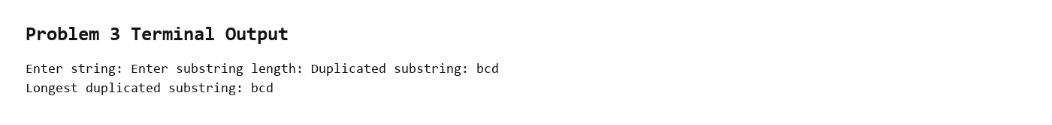

Problem 4 - Function Visualization
Source file: Homework1/p4_CabreraGarcia_Cesar.py
# Author Cesar Cabrera Garcia
# Course COP 4045-042 Python Programming
# Term Fall 2026
# Description Display a table and chart for a user-entered math function

import math
import matplotlib.pyplot as pyplot

# -----------------------------
# Initial variable declarations
# -----------------------------
fun_str = ""
xmin = 0.0
xmax = 0.0
domain = (xmin, xmax)
ns = 0

def plot_function(fun_str, domain, ns):
xs = []
ys = []
xmin = domain[0]
xmax = domain[1]
sample_counter = 0
dx = 0.0
x = xmin
y = 0.0

if ns == 1:
dx = 0.0
else:
dx = (xmax - xmin) / (ns - 1)

# Evaluate the typed expression for each x value.
while sample_counter < ns:
xs.append(x)
y = eval(fun_str)
ys.append(y)
x = x + dx
sample_counter = sample_counter + 1

print("{:>10} {:>10}".format("x", "y"))
print("--------------------")

sample_counter = 0
while sample_counter < ns:
print("{:+10.4f} {:+10.4f}".format(xs[sample_counter], ys[sample_counter]))
sample_counter = sample_counter + 1

pyplot.plot(xs, ys, "ro-")
pyplot.xlabel("x")
pyplot.ylabel("y")
pyplot.title(fun_str)
pyplot.grid(True)
pyplot.show()
pyplot.clf()

fun_str = input("Enter function with variable x: ")
ns = int(input("Enter number of samples: "))
xmin = float(input("Enter xmin: "))
xmax = float(input("Enter xmax: "))
domain = (xmin, xmax)

plot_function(fun_str, domain, ns)

Output Evidence
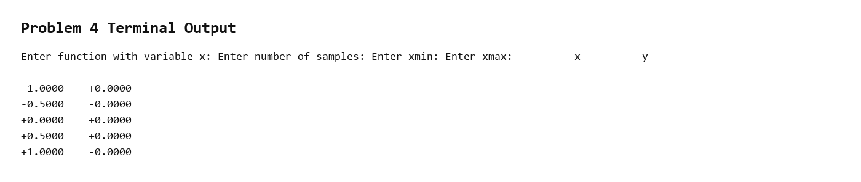
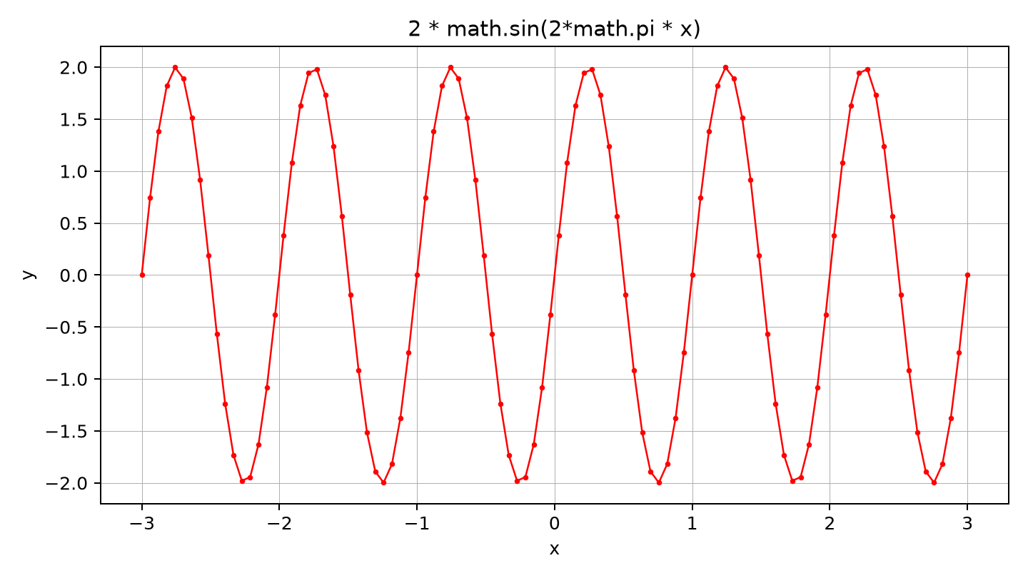

Problem 5 - Interactive Caesar Cipher
Source file: Homework1/p5/p5_CabreraGarcia_Cesar.py
# Author Cesar Cabrera Garcia
# Course COP 4045-042 Python Programming
# Term Fall 2026
# Description Interactive Caesar cipher tool with letter frequency reporting

import string

ALPHABET_LENGTH = 26
LOWERCASE_ALPHABET = string.ascii_lowercase
UPPERCASE_ALPHABET = string.ascii_uppercase

def caesar_cipher(text, shift):
encrypted_text = ""
normalized_shift = shift % ALPHABET_LENGTH

for current_character in text:
if current_character in LOWERCASE_ALPHABET:
original_index = LOWERCASE_ALPHABET.index(current_character)
shifted_index = (original_index + normalized_shift) % ALPHABET_LENGTH
encrypted_text = encrypted_text + LOWERCASE_ALPHABET[shifted_index]
elif current_character in UPPERCASE_ALPHABET:
original_index = UPPERCASE_ALPHABET.index(current_character)
shifted_index = (original_index + normalized_shift) % ALPHABET_LENGTH
encrypted_text = encrypted_text + UPPERCASE_ALPHABET[shifted_index]
else:
encrypted_text = encrypted_text + current_character

return encrypted_text

def caesar_decipher(cyphertext, shift):
return caesar_cipher(cyphertext, -shift)

def letter_frequency(text):
frequency_report = ""

for current_letter in LOWERCASE_ALPHABET:
letter_count = 0

for current_character in text:
if current_character.lower() == current_letter:
letter_count = letter_count + 1

frequency_report = frequency_report + current_letter + ": " + str(letter_count)

if current_letter != "z":
frequency_report = frequency_report + "\n"

return frequency_report

def main():
print("Caesar Cipher Tool")

while True:
print("")
print("1. Encrypt, analyze, and decrypt a message")
print("2. Quit")
menu_choice = input("Enter menu option: ")

if menu_choice == "1":
plain_text = input("Enter message: ")
shift_value = int(input("Enter shift value: "))

cipher_text = caesar_cipher(plain_text, shift_value)
frequency_report = letter_frequency(cipher_text)
deciphered_text = caesar_decipher(cipher_text, shift_value)

print("")
print("Ciphered text:")
print(cipher_text)
print("")
print("Letter frequency breakdown:")
print(frequency_report)
print("")
print("Deciphered text:")
print(deciphered_text)
elif menu_choice == "2":
print("Program finished.")
break
else:
print("Invalid menu option. Please enter 1 or 2.")

if __name__ == "__main__":
main()

Output Evidence
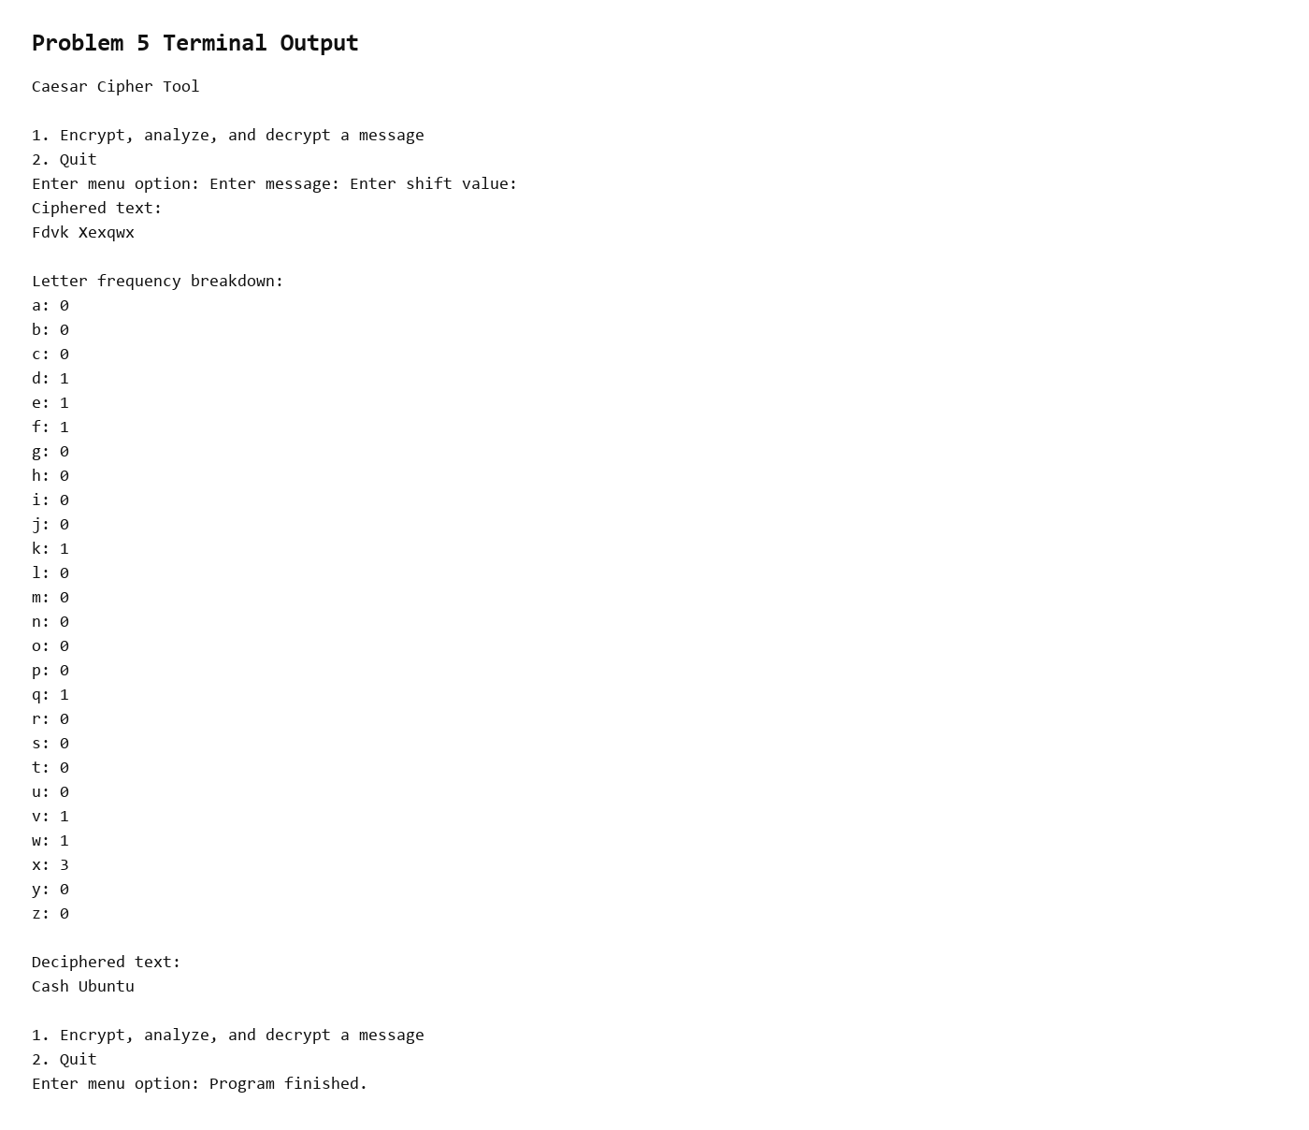
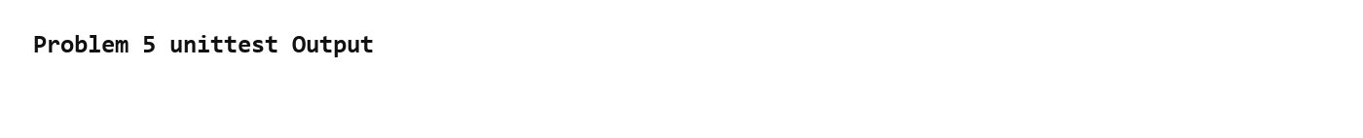

Coding-Agent Screenshots
Problem 5 coding-agent screenshot 1: Screenshot 2026-09-01 221053.png
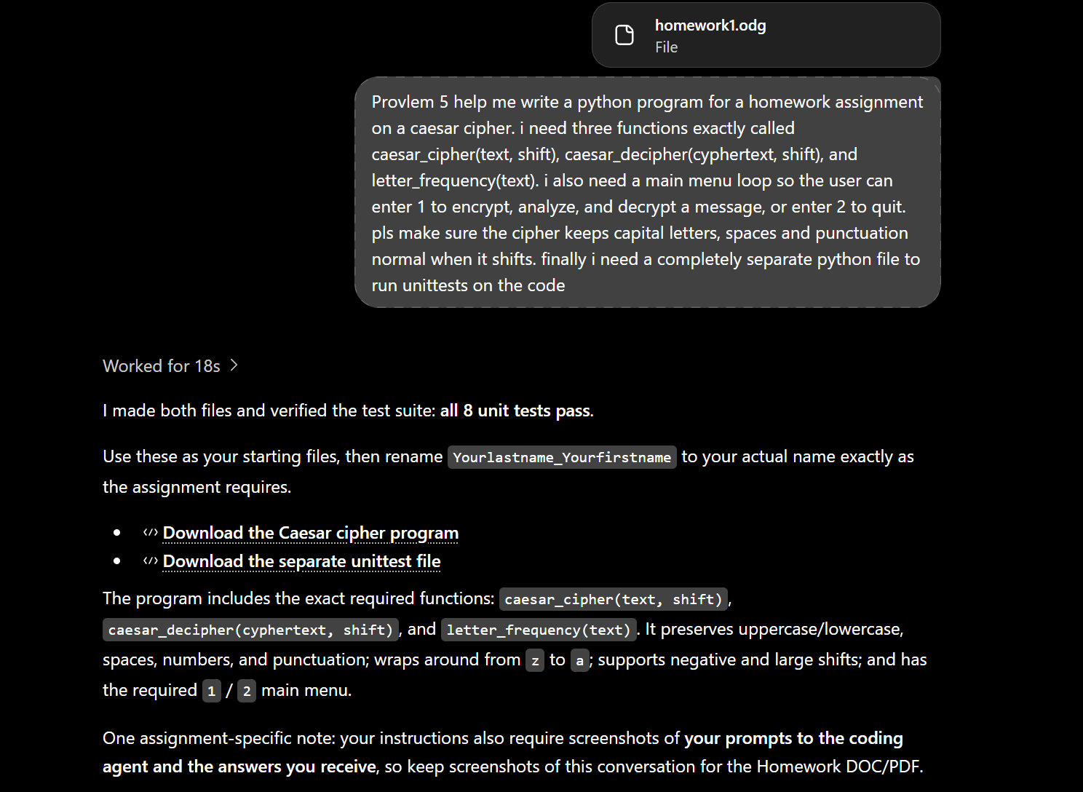

Problem 5 Test File - unittest
Source file: Homework1/p5/p5_CabreraGarcia_Cesar_test.py
# Author Cesar Cabrera Garcia
# Course COP 4045-042 Python Programming
# Term Fall 2026
# Description Unit tests for the interactive Caesar cipher tool

import unittest

import p5_CabreraGarcia_Cesar

class TestCaesarCipher(unittest.TestCase):
def test_caesar_cipher_preserves_case_and_spaces(self):
cipher_text = p5_CabreraGarcia_Cesar.caesar_cipher("Cash Ubuntu", 3)
self.assertEqual(cipher_text, "Fdvk Xexqwx")

def test_caesar_cipher_wraps_alphabet(self):
cipher_text = p5_CabreraGarcia_Cesar.caesar_cipher("Zorin OS", 2)
self.assertEqual(cipher_text, "Bqtkp QU")

def test_caesar_decipher_returns_clear_text(self):
clear_text = p5_CabreraGarcia_Cesar.caesar_decipher("Njou", 1)
self.assertEqual(clear_text, "Mint")

def test_letter_frequency_ignores_case_and_non_letters(self):
frequency_report = p5_CabreraGarcia_Cesar.letter_frequency("Cash! cash?")
self.assertIn("a: 2", frequency_report)
self.assertIn("c: 2", frequency_report)
self.assertIn("h: 2", frequency_report)
self.assertIn("s: 2", frequency_report)
self.assertIn("b: 0", frequency_report)

if __name__ == "__main__":
unittest.main()

