**THE JAZZICIANS**

*present the*

**4th Annual Festival of *Jazz***

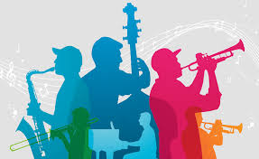

* Join us for a fun-filled day of entertainment for the whole family.
* The fun starts at 10:00 a.m. and ends at 11:00 p.m. on **Saturday, October 14, 2012**, at Riverfront Park.
* Festival attractions include games, rides, food, crafts, and live music from the talented artists of The Brass
* Beat, Dave and the Hornets, and The Nance Lance Band.

Hope to see you there!