





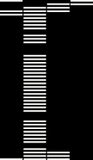
OpenStack on OpenStack
TripleO (OOO)

TripleO is a project aimed at installing, upgrading and operating OpenStack clouds using OpenStack’s own cloud facilities as the foundation.

Useful links
tripleo.org
bit.do/tripleo
freenode.net #tripleo
List failures when deploying an Overcloud
$ openstack stack failures list overcloud --long
Stack Debugging

The goal of this upstream cheatsheet is to show some relevant commands related to how to debug a TripleO deployment.
$ heat resource-list --nested-depth 5 overcloud | grep FAILED
$ heat deployment-show <deployment_ID>
$ openstack image list
$ openstack image delete <image_ID>
Show resources, filtering to get those who have failed.
Get the deployment details for <deployment_ID>.
List images.

Delete <image_ID>.





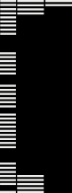
OpenStack on OpenStack
DEVELOPER NOTES:
- Official troubleshooting URL: http://tripleo.org/troubleshooting/troubleshooting.html

$ swift download overcloud
$ wget \
http://buildlogs.centos.org/centos/7/cloud/x86_64/tripleo_images/<release>/delorean/overcloud-full.tar
$ openstack overcloud image upload --update-existing
Once downloaded the images, this command will upload them to glance.
Download the overcloud swift container files in the current folder (With the rendered j2 templates).
Download <release> overcloud images tar file [liberty|mitaka|newton|...]

