Craig Campbell

HW1

Machine Learning

1). Plotting data

First step in program is to import the following packages:

>> import numpy as np

>> import matplotlib.pyplot as plt

>> import tensorflow as tf

I plotted the data in python and saved the figure using the following commands

>> x_data = np.load(‘x_hw.npy’)

>> y_data = np.load(‘y_hw.npy’)

>> plt.plot(x_data,y_data)

>> plt.show()

The figure is here:

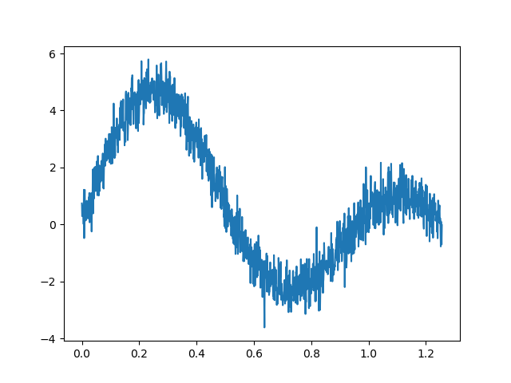

2). Adapt Regression Model

$$y=A_{1}*sin⁡(F_{1}*X)+A_{2}* sin⁡(F_{2}*X)$$

First, I created the container variables for our model variables:

>> a1 = tf.Variable(tf.ones([1]))

>> a2 = tf.Variable(tf.ones([1]))

>> f1 = tf.Variable(tf.ones([1]))

>> f2 = tf.Variable(tf.ones([1]))

I then defined the model as:

>> y = a1 * tf.sin(f1*x_data) + a2 * tf.sin(f2 * x_data)

I then defined our loss function, optimizer and train steps before we create the session:

>> loss = tf.reduce_mean(tf.square(y-y_data))

>> optimizer= tf.train.AdamOptimizer(0.005)

>> train_step = optimizer.minimize(loss)

I then defined the session along with tensorboard for later problem:

>> session = tf.InteractiveSession()

>> tf.global_variables_initializer().run()

>> #tensorboard initizalation

>> tf.summary.scalar('loss',loss)

>> merged_file = tf.summary.merge_all()

>> file_writer = tf.summary.FileWriter('777')

>> file_writer.add_graph(session.graph)

>> N=10000

>> for k in range(N):

>> session.run(train_step)

>> loss_log=session.run(merged_file)

>> file_writer.add_summary(loss_log,k)

>> if(k%200)==0:

>> print("k=",k,"a1",session.run(a1),"f1=",session.run(f1),"a2=",

>> session.run(a2),"f2=",session.run(f2),"loss=",session.run(loss))

>> A1,F1,A2,F2 = session.run([a1,f1,a2,f2])

I then captured the output of the session and printed the model:

>> A1=A1[0]

>> F1=F1[0]

>> A2=A2[0]

>> F2=F2[0]

>> print("\n The line of this equation is: \n")

>> print("y(f1,f2)=" + str(A1) + "*sin(" + str(F1) +"X)" + " + " + str(A2) +"*sin(" + str(F2) + "X)")

The successful run of the program is the following program:

k= 0 a1 [0.995] f1= [0.995] a2= [0.995] f2= [0.995] loss= 6.8480687

k= 200 a1 [0.49211055] f1= [0.42796484] a2= [0.49211055] f2= [0.42796484] loss= 5.821359

k= 400 a1 [0.4238301] f1= [0.3324979] a2= [0.4238301] f2= [0.3324979] loss= 5.809896

k= 600 a1 [0.4105816] f1= [0.32149822] a2= [0.4105816] f2= [0.32149822] loss= 5.8096976

k= 800 a1 [0.4042718] f1= [0.32485238] a2= [0.4042718] f2= [0.32485238] loss= 5.809674

k= 1000 a1 [0.3974519] f1= [0.33073908] a2= [0.3974519] f2= [0.33073908] loss= 5.809646

k= 1200 a1 [0.38923806] f1= [0.33824044] a2= [0.38923806] f2= [0.33824044] loss= 5.809609

k= 1400 a1 [0.37938502] f1= [0.34770477] a2= [0.37938502] f2= [0.34770477] loss= 5.8095617

k= 1600 a1 [0.36761907] f1= [0.35972735] a2= [0.36761907] f2= [0.35972735] loss= 5.8095

k= 1800 a1 [0.35359594] f1= [0.37519595] a2= [0.35359594] f2= [0.37519595] loss= 5.8094163

k= 2000 a1 [0.33690152] f1= [0.3954578] a2= [0.33690152] f2= [0.3954578] loss= 5.809299

k= 2200 a1 [0.31708246] f1= [0.42260128] a2= [0.31708246] f2= [0.42260128] loss= 5.8091335

k= 2400 a1 [0.29375133] f1= [0.45991927] a2= [0.29375133] f2= [0.45991927] loss= 5.8088827

k= 2600 a1 [0.2668376] f1= [0.51264143] a2= [0.2668376] f2= [0.51264143] loss= 5.808486

k= 2800 a1 [0.23701763] f1= [0.589083] a2= [0.23701763] f2= [0.589083] loss= 5.8078175

k= 3000 a1 [0.20613039] f1= [0.7028733] a2= [0.20613039] f2= [0.7028733] loss= 5.8066

k= 3200 a1 [0.17733783] f1= [0.87962294] a2= [0.17733783] f2= [0.87962294] loss= 5.804085

k= 3400 a1 [0.15686446] f1= [1.1852793] a2= [0.15686446] f2= [1.1852793] loss= 5.797311

k= 3600 a1 [0.1957322] f1= [1.9693803] a2= [0.1957322] f2= [1.9693803] loss= 5.748085

k= 3800 a1 [1.5114464] f1= [5.823793] a2= [1.5114464] f2= [5.823793] loss= 1.648147

k= 4000 a1 [1.4866353] f1= [6.058925] a2= [1.4866353] f2= [6.058925] loss= 1.5597668

k= 4200 a1 [1.4866353] f1= [6.058925] a2= [1.4866353] f2= [6.058925] loss= 1.5597668

k= 4400 a1 [1.4866353] f1= [6.058925] a2= [1.4866353] f2= [6.058925] loss= 1.5597668

k= 4600 a1 [1.4866353] f1= [6.058925] a2= [1.4866353] f2= [6.058925] loss= 1.5597668

k= 4800 a1 [1.4866353] f1= [6.058925] a2= [1.4866353] f2= [6.058925] loss= 1.5597668

k= 5000 a1 [1.4866353] f1= [6.058925] a2= [1.4866353] f2= [6.058925] loss= 1.5597668

k= 5200 a1 [1.4866352] f1= [6.058925] a2= [1.4866352] f2= [6.058925] loss= 1.5597669

k= 5400 a1 [1.4866352] f1= [6.058925] a2= [1.4866352] f2= [6.058925] loss= 1.5597669

k= 5600 a1 [1.4866352] f1= [6.058925] a2= [1.4866352] f2= [6.058925] loss= 1.5597669

k= 5800 a1 [1.4866352] f1= [6.058925] a2= [1.4866352] f2= [6.058925] loss= 1.5597669

k= 6000 a1 [1.4866352] f1= [6.058925] a2= [1.4866352] f2= [6.058925] loss= 1.5597669

k= 6200 a1 [1.4866352] f1= [6.058925] a2= [1.4866352] f2= [6.058925] loss= 1.5597669

k= 6400 a1 [1.4866352] f1= [6.058925] a2= [1.4866352] f2= [6.058925] loss= 1.5597669

k= 6600 a1 [1.4866352] f1= [6.058925] a2= [1.4866352] f2= [6.058925] loss= 1.5597669

k= 6800 a1 [1.4866352] f1= [6.058925] a2= [1.4866352] f2= [6.058925] loss= 1.5597669

k= 7000 a1 [1.4866352] f1= [6.058925] a2= [1.4866352] f2= [6.058925] loss= 1.5597669

k= 7200 a1 [1.4866352] f1= [6.058925] a2= [1.4866352] f2= [6.058925] loss= 1.5597669

k= 7400 a1 [1.4866352] f1= [6.058925] a2= [1.4866352] f2= [6.058925] loss= 1.5597669

k= 7600 a1 [1.4866352] f1= [6.058925] a2= [1.4866352] f2= [6.058925] loss= 1.5597669

k= 7800 a1 [1.4866352] f1= [6.058925] a2= [1.4866352] f2= [6.058925] loss= 1.5597669

k= 8000 a1 [1.4866352] f1= [6.058925] a2= [1.4866352] f2= [6.058925] loss= 1.5597669

k= 8200 a1 [1.4866352] f1= [6.058925] a2= [1.4866352] f2= [6.058925] loss= 1.5597669

k= 8400 a1 [1.4866352] f1= [6.058925] a2= [1.4866352] f2= [6.058925] loss= 1.5597669

k= 8600 a1 [1.4866352] f1= [6.058925] a2= [1.4866352] f2= [6.058925] loss= 1.5597669

k= 8800 a1 [1.4866352] f1= [6.058925] a2= [1.4866352] f2= [6.058925] loss= 1.5597669

k= 9000 a1 [1.4866352] f1= [6.058925] a2= [1.4866352] f2= [6.058925] loss= 1.5597669

k= 9200 a1 [1.4866352] f1= [6.058925] a2= [1.4866352] f2= [6.058925] loss= 1.5597669

k= 9400 a1 [1.4866351] f1= [6.0589256] a2= [1.4866351] f2= [6.0589256] loss= 1.5597669

k= 9600 a1 [1.4866351] f1= [6.0589256] a2= [1.4866351] f2= [6.0589256] loss= 1.5597669

k= 9800 a1 [1.4866352] f1= [6.0589256] a2= [1.4866352] f2= [6.0589256] loss= 1.5597669

The line of this equation is:

y(f1,f2)=1.4866351*sin(6.0589256X) + 1.4866351*sin(6.0589256X)

3): Plot the regression function over the model

I plotted the regression function over the data using the following commands:

>> y_model = 1.4866351*np.sin(6.0589256*x_data) + 1.4866351*np.sin(6.0589256*x_data)

>> plt.plot(x_data,y_data,'r')

>> plt.plot(x_data,y_model,'b')

>> plt.show()

This is the output figure:

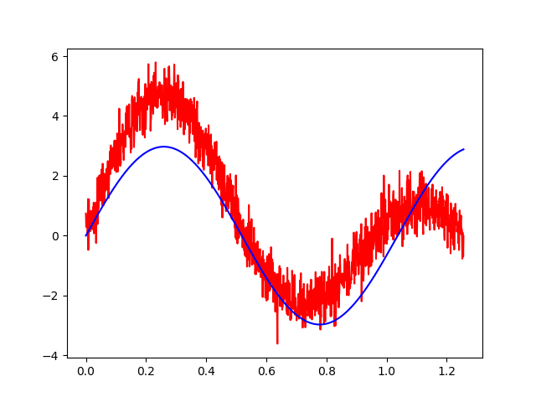

4). Value at 0.6*np.pi

Using the model creating in the session I added the value into the model

yvalue = 1.4866351*np.sin(6.0589256*(0.6*(np.pi))) + 1.4866351*np.sin(6.0589256*(0.6*(np.pi)))

print(yvalue)

>> -2.708480554807646

5. Tensorboard

I created the tensor board log directory with the merged file with the ‘777’. I then used the the tensorboard command to open the tensorboard log file into a localhost server on port:6006

$ tensorboard --logdir [path-to-log-dir]

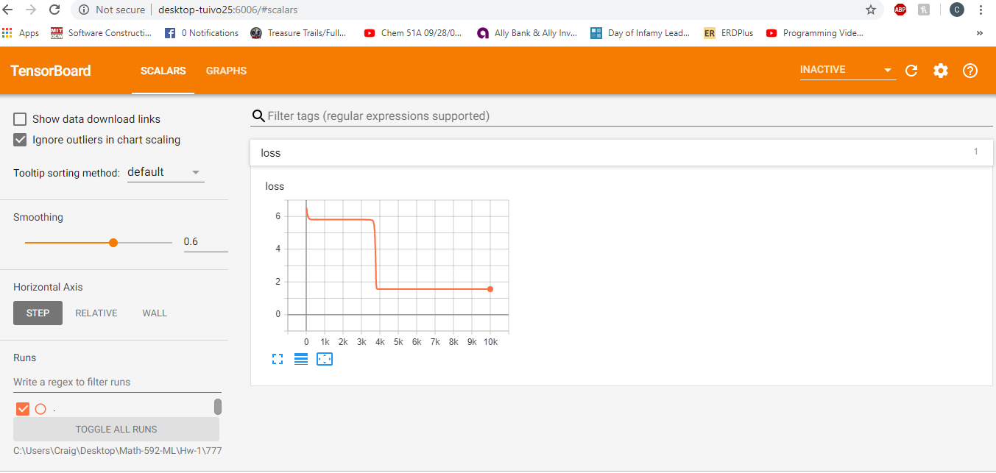

This looks like roughly at about 3800 iteration the machine has stopped learning.