**Wavicle to CCAO ETL Code Handoff Readme**

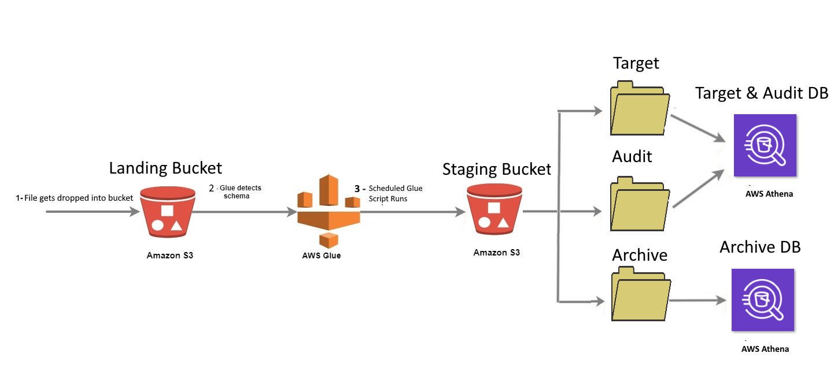

**Table of Contents**

1. Glue Job Configuration
2. YAML Configuration File
3. Glue Job Code (ETL Code)
4. Glue Crawlers
5. Athena Tables
6. Errors to Watch out For
7. Paths
8. Simple Walkthrough Example

Explanation Table of Contents, each section contains a (things - to - watch out for) section

1. **Glue Job configuration**

The config file is written in yaml format due to it’s compatibility with python which the POC is written in.  
For the reader’s convenience if you would like a general introduction to yaml please see the link below

<https://www.cloudbees.com/blog/yaml-tutorial-everything-you-need-get-started>

Below are explanations with pictures explaining the current configuration and what is important to know moving forward

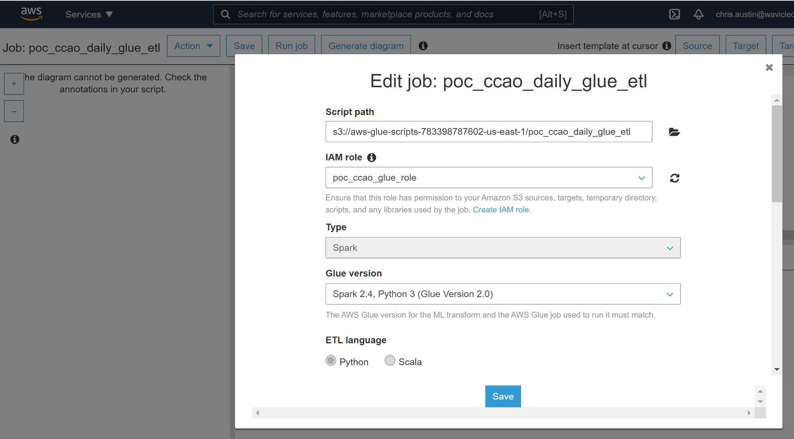



1. Script Path (ref 7g) will output the physical copy of the script to be run by the job
2. The IAM Role must be picked to execute the job ( it should have full s3 and glue access)
3. Type and Glue Version must be kept the same, or for future updates be in alignment with what AWS Glue and Apache Spark are compatible with. See (ref 7h)
4. Referenced file path allows Glue to easily access any files you include, for now it only includes the config file
5. Worker type picks the type of works (not driver/master node) that AWS glue will distribute the work to
6. Number of workers and Max concurrency will specify the number of workers per job (max 299), max concurrency is how many instances of this job can run at the same time.
7. Job timeout simply sets an upper limit on how long the job can take before it is cancelled for taking too long
8. The other options in the Glue job configuration are delay notification, # of retries, and job parameters. All of which we are not using and are irrelevant at the time of handoff.
9. **YAML Configuration File**

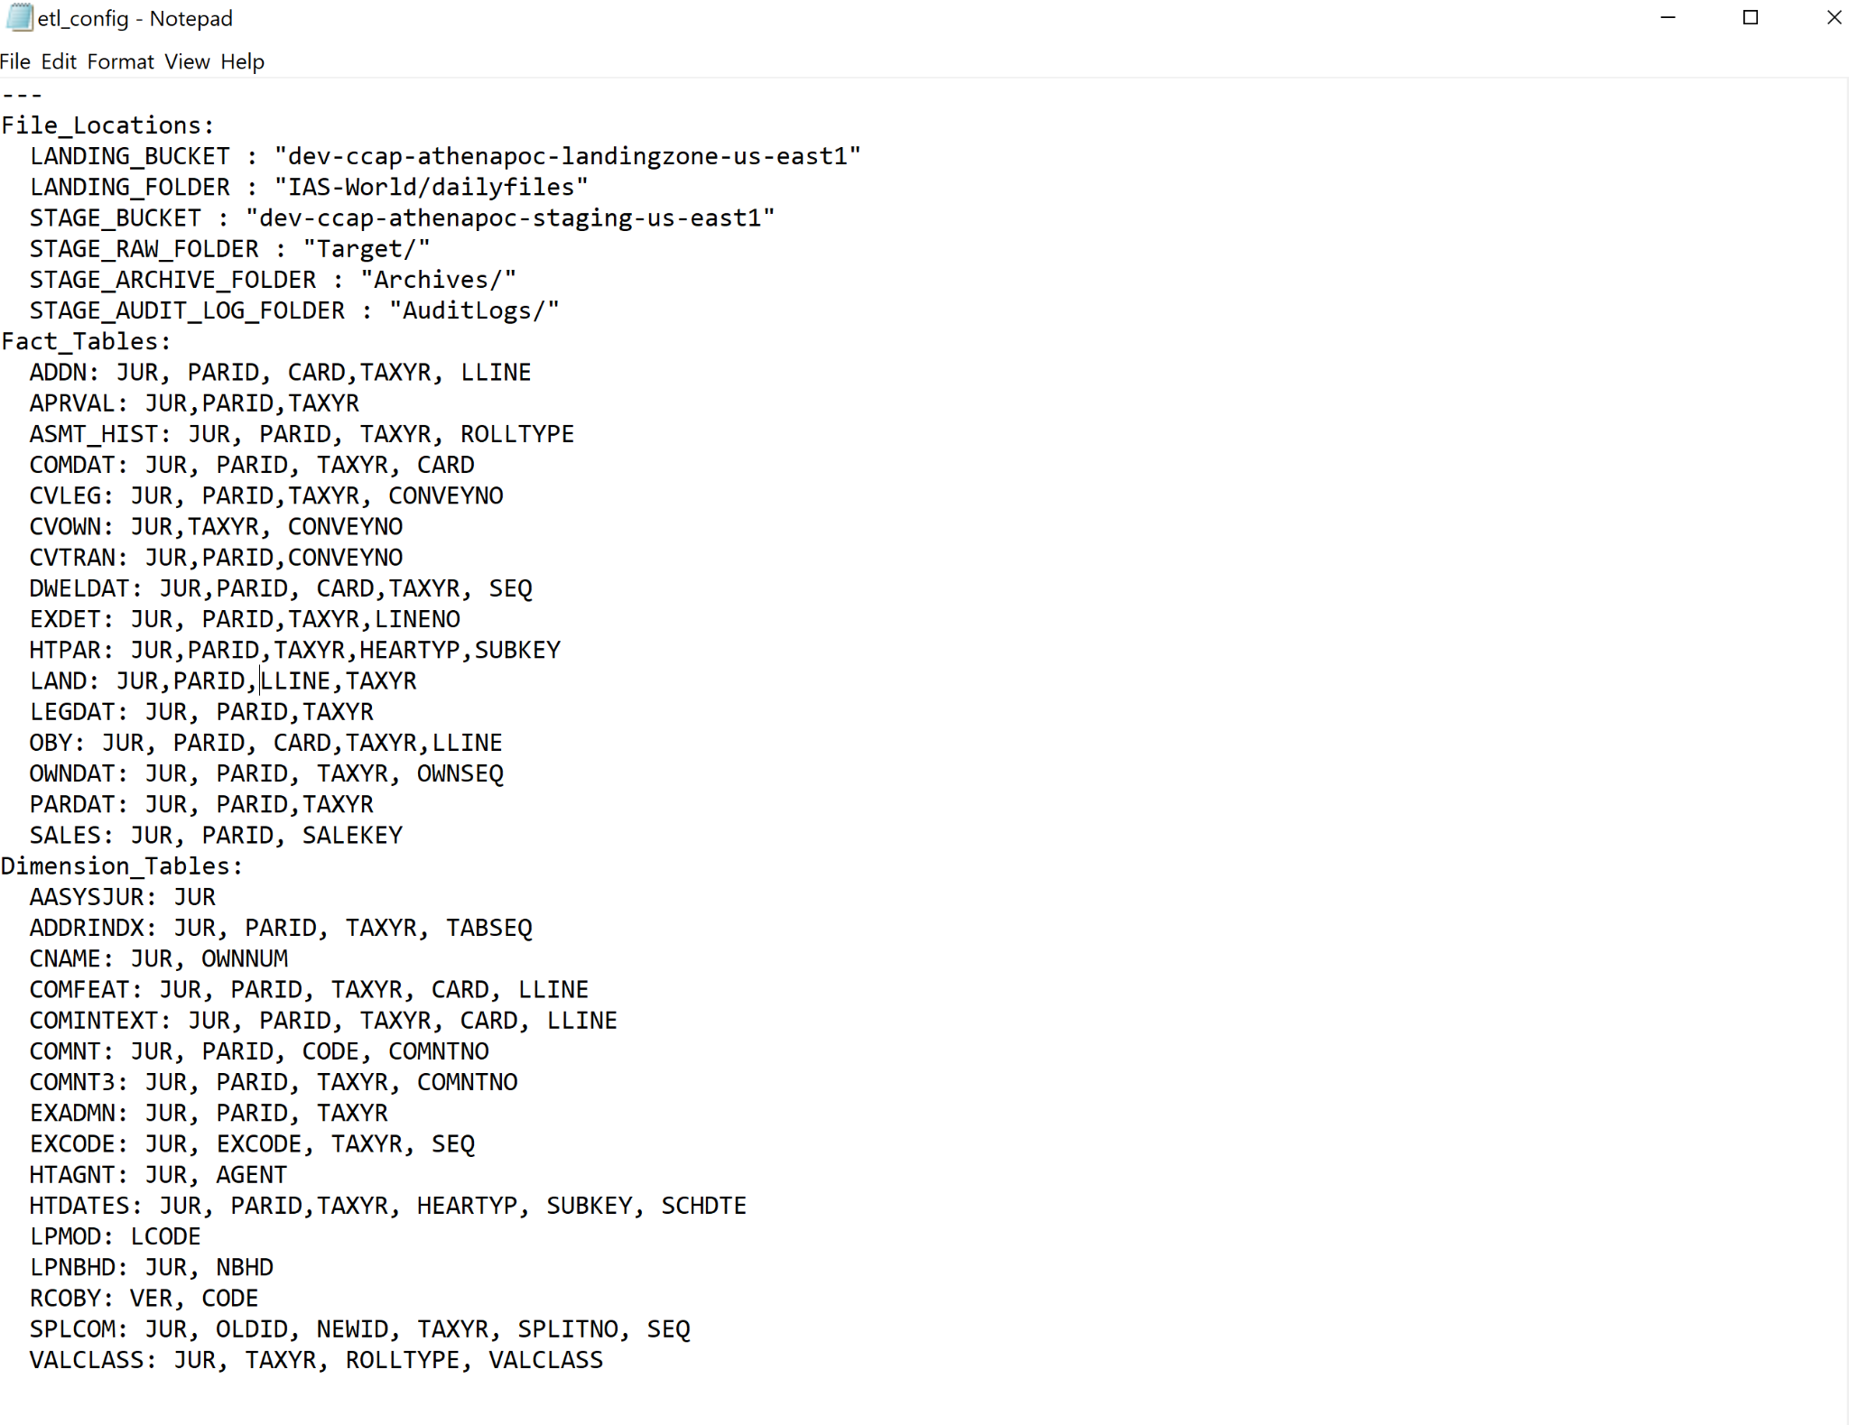

Things-to-watch out for

1. The values for all three parameters must be comma delimited for the program to parse them, the way it is setup
2. When creating a yaml file or editing it, if you copy and paste from somewhere else it sometimes creates an issue with how the characters are encoded into the file which can then result in the aws glue job not properly being able to read the file.
3. The format which the file is currently in regarding colons must be used. The program is only setup to parse three parameters (File_location,Fact_tables,Dimension_tables) and the key,value pairs associated with them.
4. **Glue job code**

When the python code runs it will follow the process shown below. It is of note however that since the program uses pyspark it will not actually run completely linearly because pyspark will partition the data and automatically divy up the work for fastest processing time.

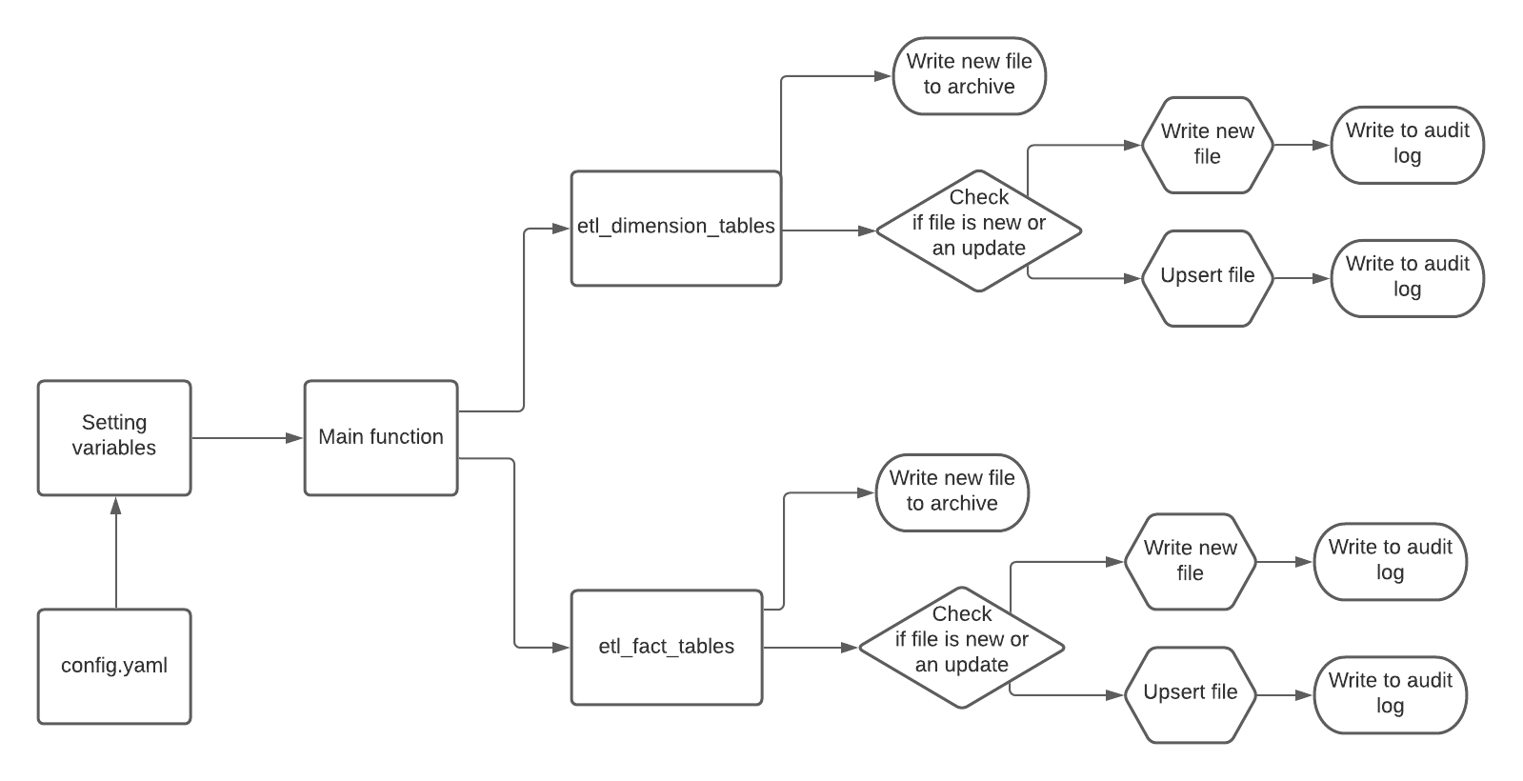

The first step in the code is to grab the etl_config.yaml file and read from it, followed by setting the global variables needed by the program to read and write from s3.   
*See the below image to observe where that occurs in the code*

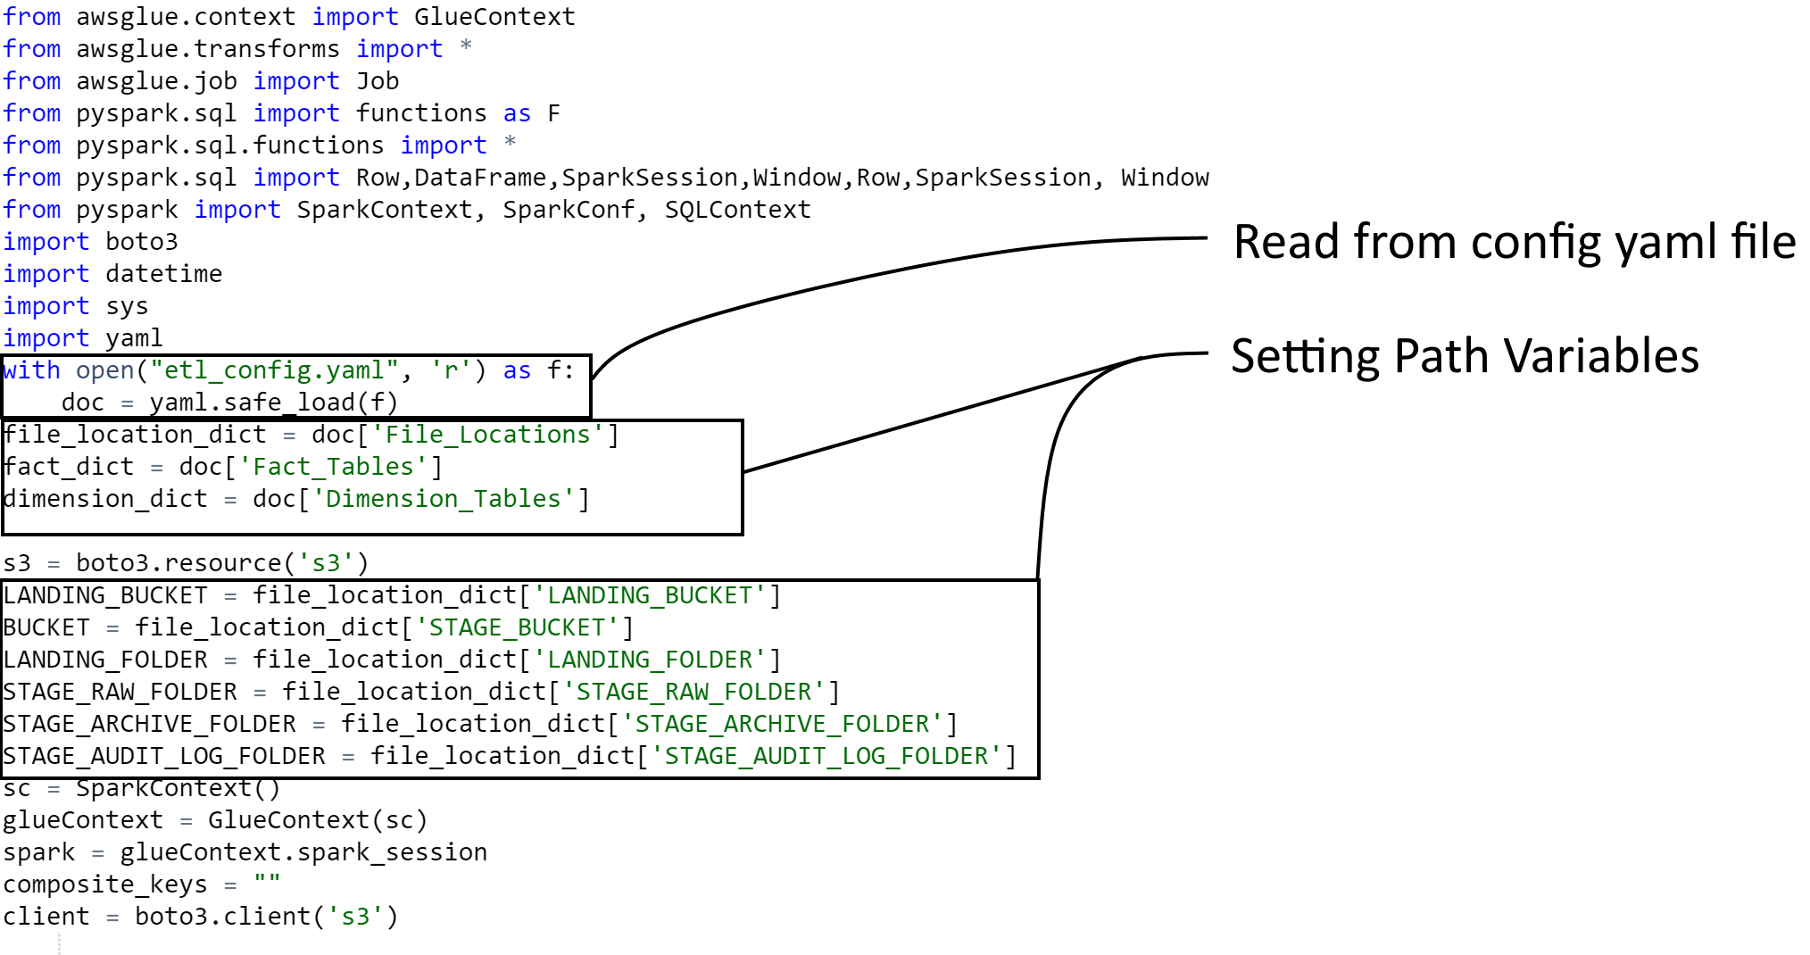

After all the global variables have been set the main function will be called which will call the function move_from_landing_to_stage() which will subsequently call the functions etl_dimension_tables() and etl_fact_tables() to begin the etl process for both.  
*See the below image to observe where that occurs in the code*  
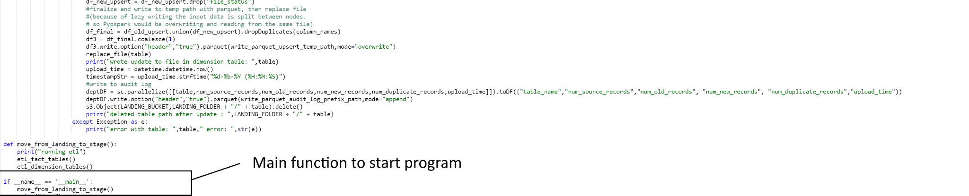

The code will check if there is an old copy of the file using a try statement, if there is not then it will immediately begin the process of writing a new file  
*See the below image to observe where that occurs in the code*

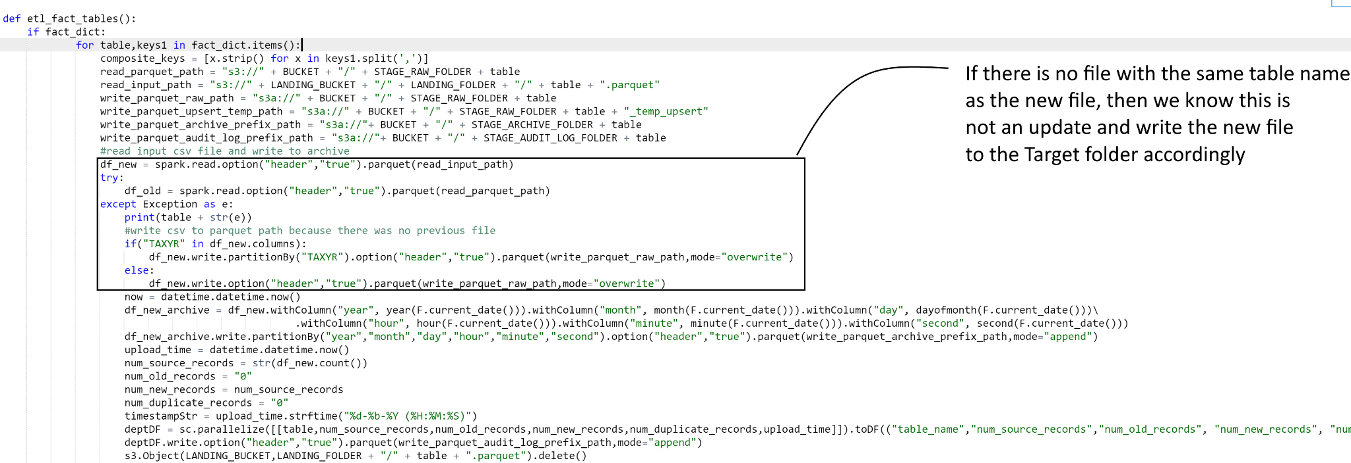

If the code did find an old copy of the file already in the Target folder it will begin the process of updating the file using the non-scd upsert logic as shown below.  
*See the below image to observe where that occurs in the code*

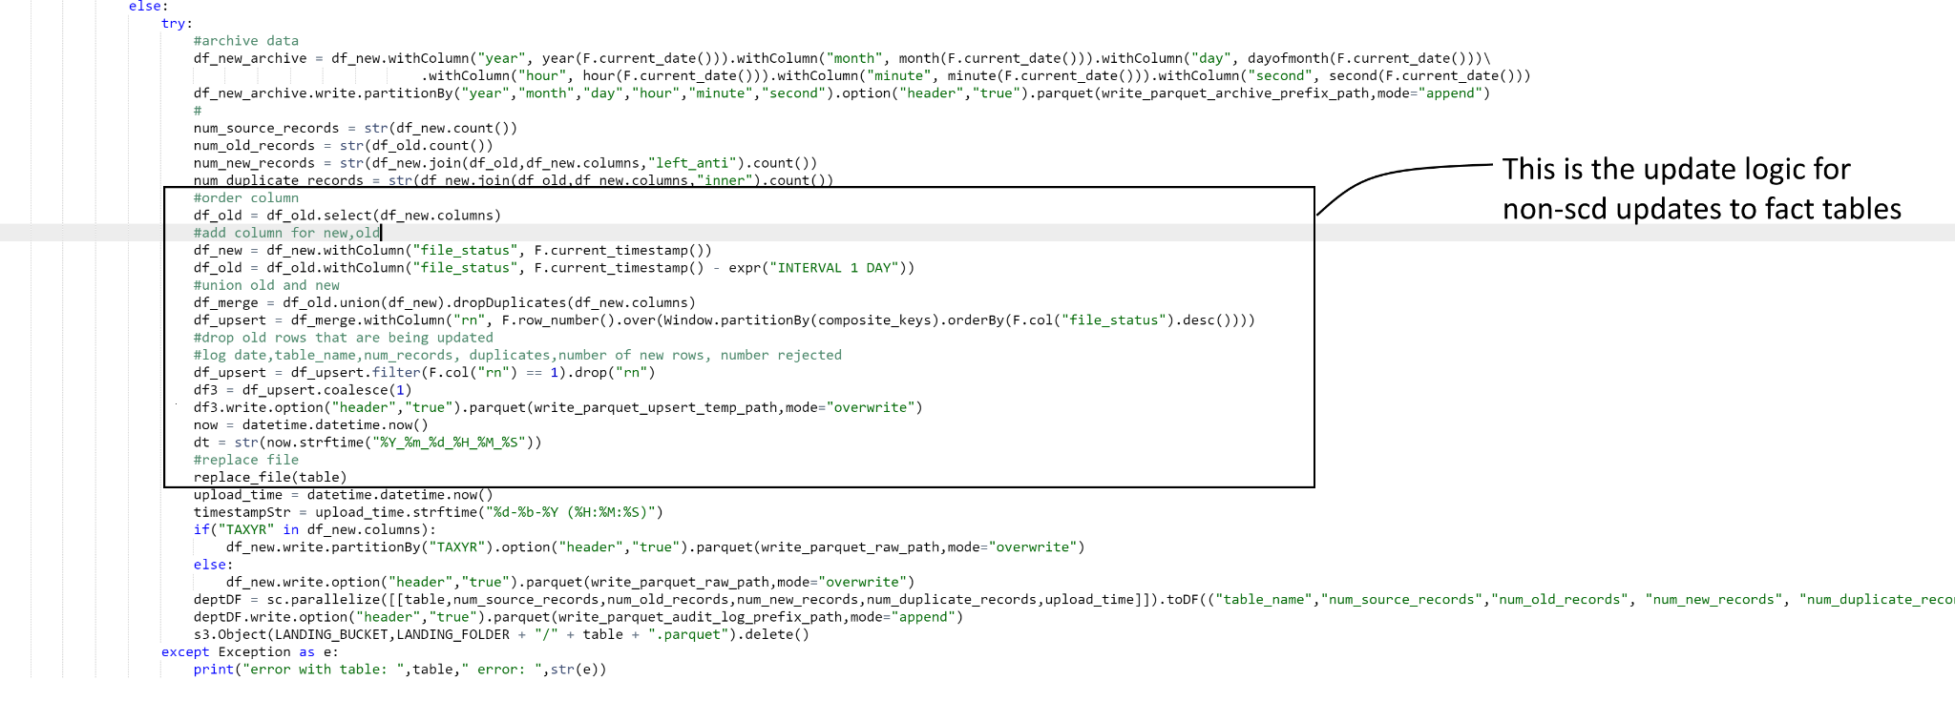

In the etl_dimension_tables() function, it will follow a very similar flow the the etl_fact_tables() function and begin by checking if there is an old copy of the file using a try statement, if there is not then it will immediately begin the process of writing a new file  
*See the below image to observe where that occurs in the code*

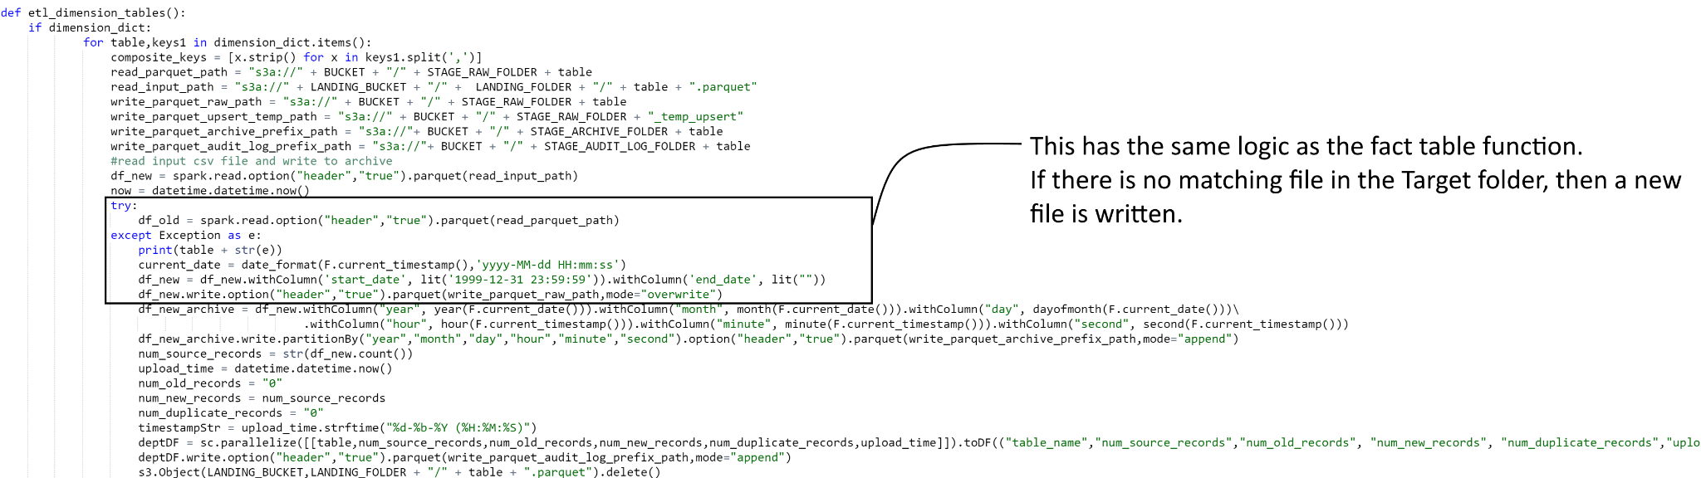

If the code did find an old copy of the file already in the Target folder it will begin the process of updating the file using the scd upsert logic as shown below.  
*See the below image to observe where that occurs in the code*

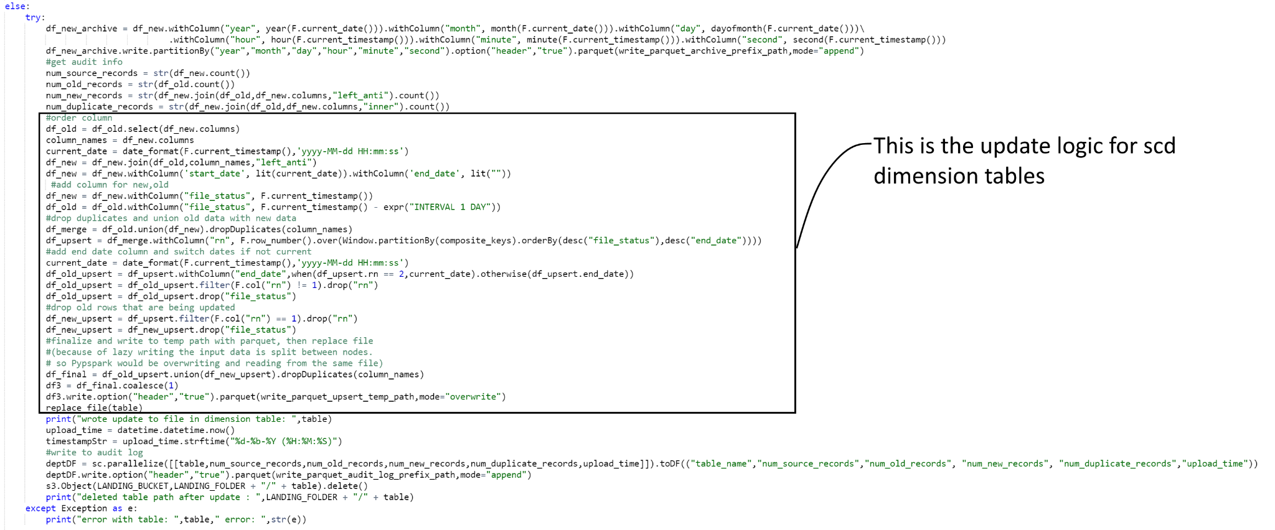

Below the update functions in both dimension and fact tables, there will be auditing and archive of the new file, as well as the file being deleted once the update, audit, and archiving are done. The version of the code in github is slightly different regarding deletion than in this file, because of the change in which the parquet file is saved from “filename.parquet” to “filename/” with the parquet files inside the filename folder. This is because the contents inside the folder need to be deleted instead of only the file associated with the file name.

1. **Glue Crawlers**

There are 3 glue crawlers shown below.

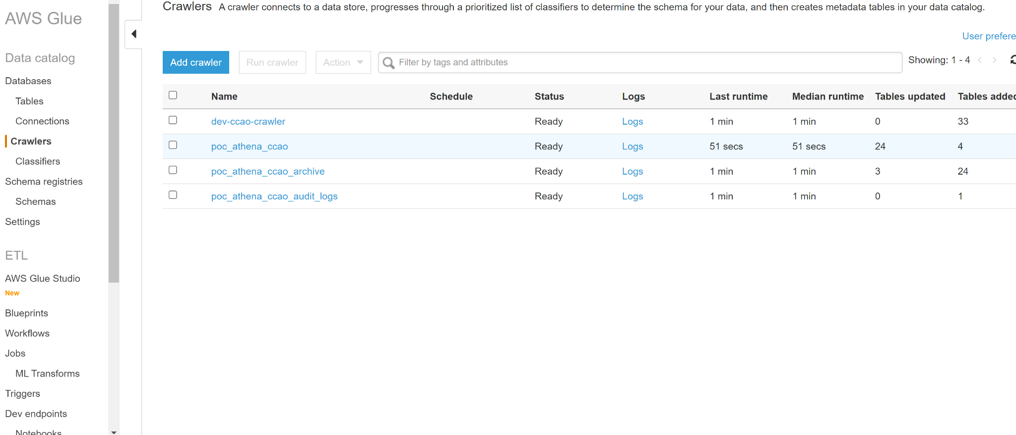

They are as follows

1. Poc_athena_ccao

-This crawler will setup the athena tables based on the files in the Target Folder  
s3://dev-ccap-athenapoc-staging-us-east1/Target/

1. Poc_athena_ccao_archive

-This crawler will setup the athena tables based on the files in the ArchiveFolder  
s3://dev-ccap-athenapoc-staging-us-east1/Archives/

1. poc_athena_ccao_audit_logs

-This crawler will setup the athena tables based on the files in the AuditLogs folder  
s3://dev-ccap-athenapoc-staging-us-east1/AuditLogs/

1. **Athena Tables**

List of tables in dev_poc_ccao:

1. Aasysjur
2. addn
3. addrindx
4. aprval
5. asmt_hist
6. auditlogs
7. cname
8. comdat
9. comfeat
10. comintext
11. comnt
12. comnt3
13. cvleg
14. cvown
15. cvtran
16. dweldat
17. exadmn
18. excode
19. exdet
20. htagnt
21. htdates
22. htpar
23. land
24. legdat
25. lpmod
26. lpnbhd
27. oby
28. owndat
29. pardat
30. rcoby
31. sales
32. splcom
33. Valclass

List of tables in dev_poc_ccao:

1. archive_aasysjur
2. archive_addn
3. archive_addrindx
4. archive_aprval
5. archive_asmt_hist
6. archive_cname
7. archive_comdat
8. archive_comnt
9. archive_cvleg
10. archive_cvown
11. archive_cvtran
12. archive_dweldat
13. archive_exadmn
14. archive_excode
15. archive_exdet
16. archive_htagnt
17. archive_htpar
18. archive_land
19. archive_legdat
20. archive_lpmod
21. archive_lpnbhd
22. archive_oby
23. archive_owndat
24. archive_pardat
25. archive_rcoby
26. archive_sales
27. archive_splcom
28. archive_valclass

It’s important to note that the tables have datatypes for columns

1. **Errors to watch out for**
2. The Athena Tables and output parquet files are constricted by datatypes. So any parquet files which are uploaded in the future need to have the same column datatypes. If you want the datatypes to change then the Target files and athena tables need to be deleted and made fresh.
3. **Paths**
4. Landing Zone path   
   s3://dev-ccap-athenapoc-landingzone-us-east1/IAS-World/dailyfiles/
5. Config file path

s3://aws-glue-scripts-783398787602-us-east-1/etl_config.yaml

1. Target path  
   s3://dev-ccap-athenapoc-staging-us-east1/Target/
2. Auditlog path  
   s3://dev-ccap-athenapoc-staging-us-east1/AuditLogs/
3. Archive path   
   s3://dev-ccap-athenapoc-staging-us-east1/Archive/
4. Athena output folder  
   s3://dev-ccap-athenapoc-staging-us-east1/athena-output/
5. Glue Job Script Path  
   s3://aws-glue-scripts-783398787602-us-east-1/poc_ccao_daily_glue_etl
6. AWS Glue documentation for Spark compatibility  
   https://docs.aws.amazon.com/glue/latest/dg/release-notes.html

**8. Simple Walkthrough Example**

To setup a new file from scratch we will use an example of the table AASYSJUR

a) Upload the file to Landing Zone (ref 7a)

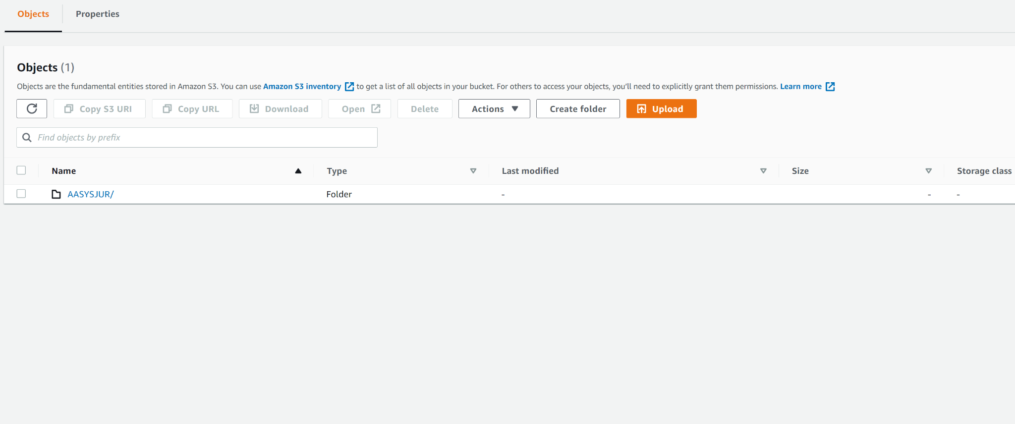

b) Upload config file which includes AASYSJUR and(or) any other files you wish to include(ref 3)

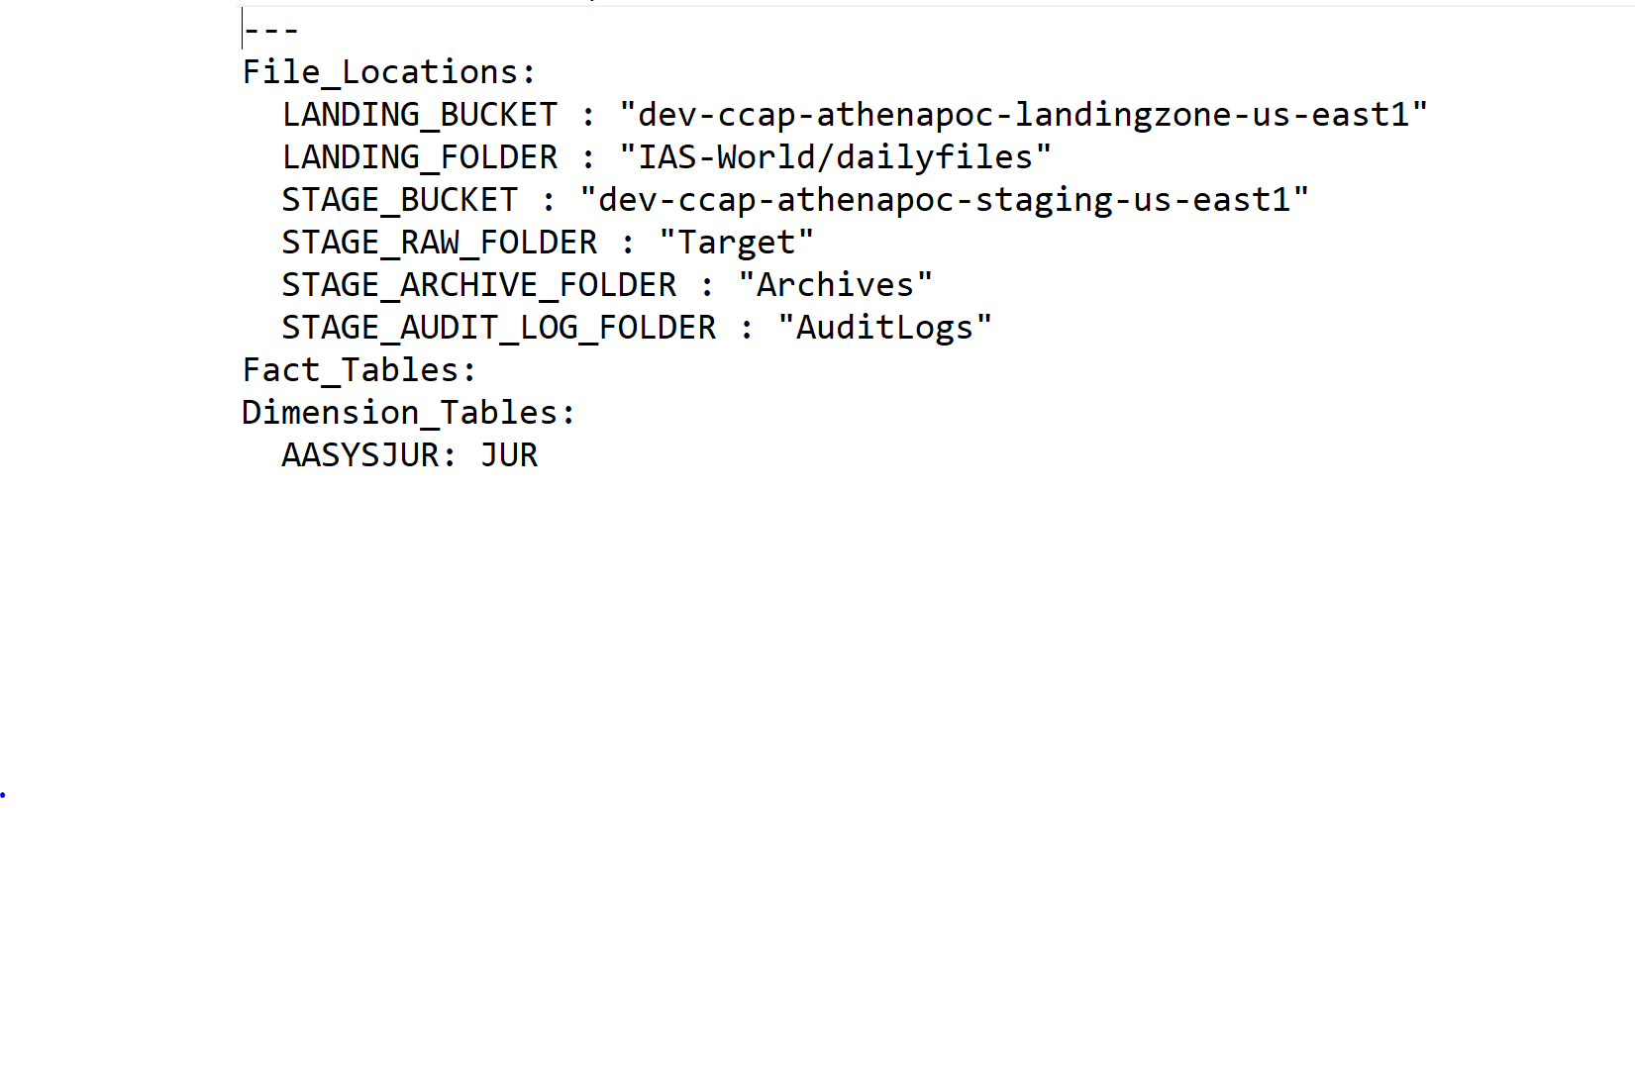

b) Run the Glue Job which is detailed in (ref 2), by left-clicking on poc_ccao_daily_glue_etl then left-clicking on action and next left-clicking on Run Job

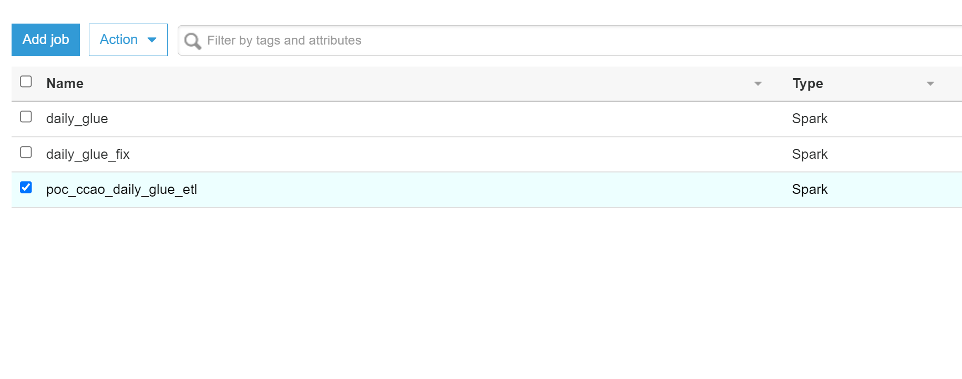

c) Upon successful completion of the job and output of the parquet file to theTarget(ref 7b),AuditLog(ref 7c) and Archive folders( ref 7d).

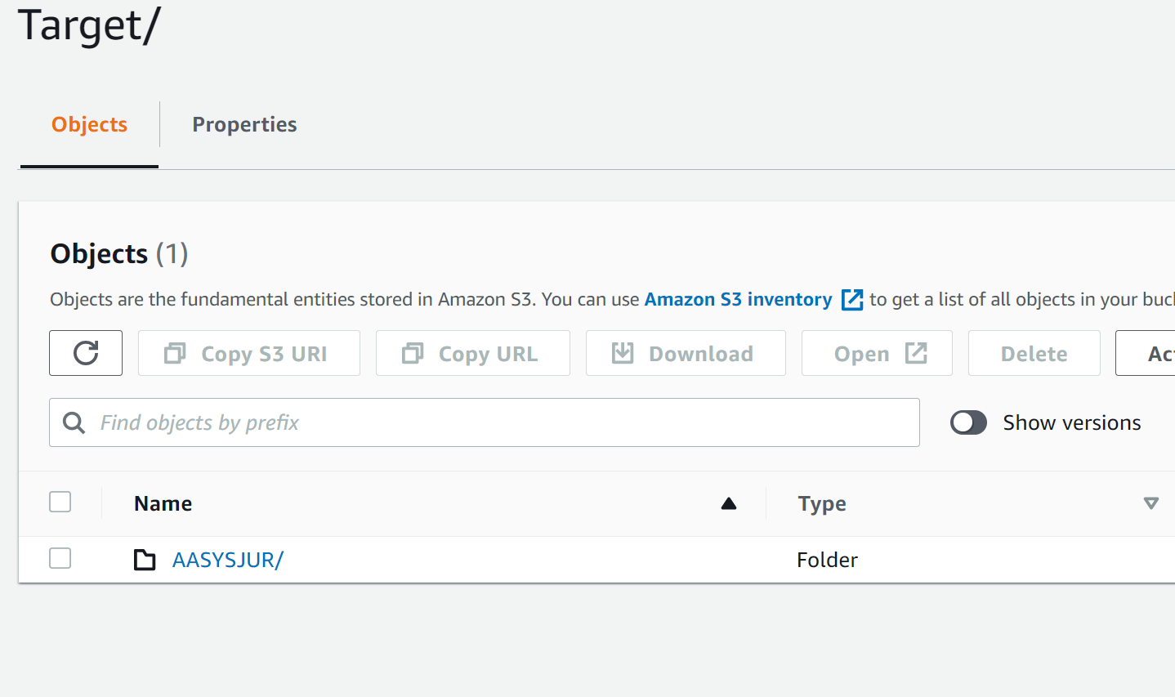

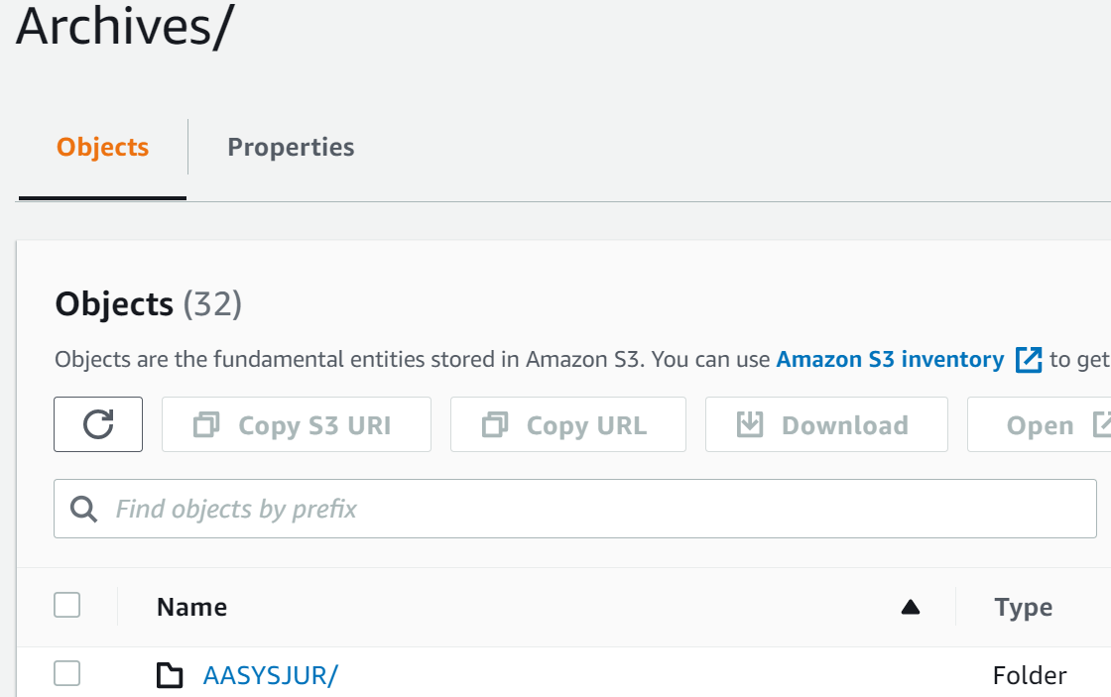

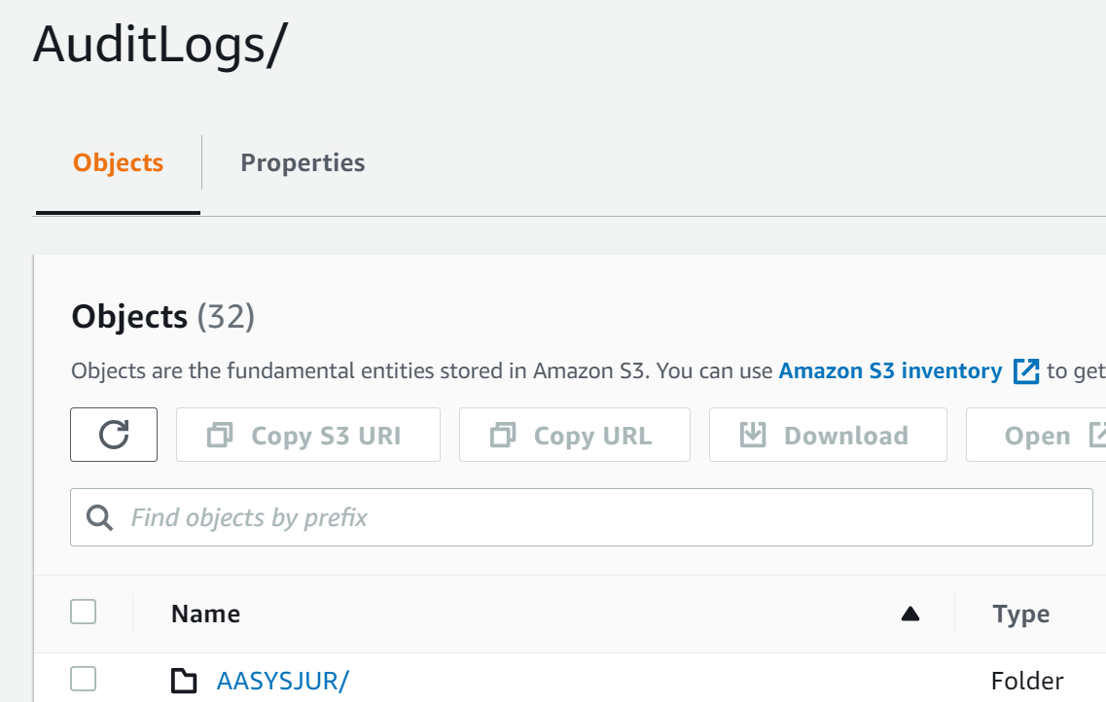

c) run the glue crawlers that creates Athena Tables for Target,AuditLog and Archive folders(ref 4)

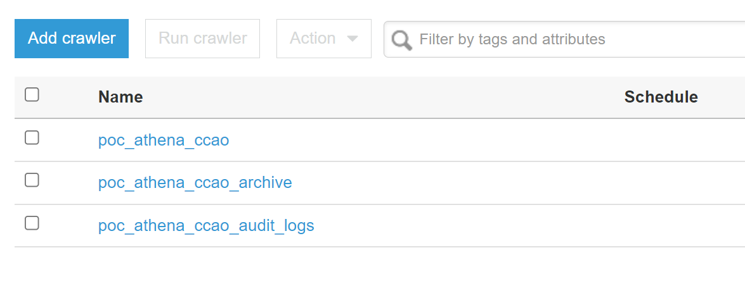

Following which you can check to see if AASYSJUR was added to the athena table by looking in the Athena section of AWS, then left-clicking on aasysjur and selecting preview table. It should show one row.

