# Fatigue Events Output file

* Each loading event has two lines corresponding to the max and min load effects noted during the event. The values are listed in chronological (time) order – whichever occurs first.
* The first column, first line is the time at which the event started and is a field 15 characters wide, and is left-aligned for clarity. The first column second line is the number of trucks in the event and is right-aligned.
* Each load effect has two columns of data: time at which the effect value occurred, followed by the effect value itself.
* All fields are tab separated so can be read by a CSV reader set to ‘\t’ as field delineation.

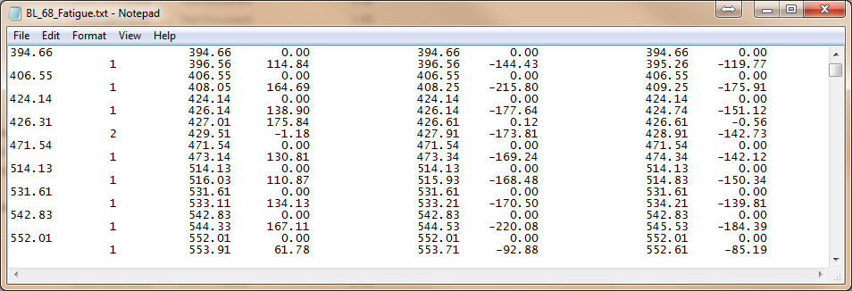

Load Effect 1

Load Effect 2

Load Effect 3

Time event started

No. trucks in event

Time load effect occurred

Values of extreme load effect