Random Forest Model Results

**Summary of regression result**

* Station: C01
* Lag time in minutes: 120
* Lag for rainfall rolling sum in minutes: 15
* Training data length: 251352
* Test data length: 62838
* Number of input features: 15
* List of futures: ['C01_lag_24' 'C01_lag_25' 'C01_lag_26' 'C01_lag_27' 'C01_lag_28'  
   'C01_lag_29' 'C01_lag_30' 'C01_lag_31' 'C01_lag_32' 'C01_lag_33'  
   'WOL4-2_rs3' 'WOL4-3_rs3' 'WOL4-4_rs3' 'WOL4-1_rs3' 'WOL4-5_rs3']

|  |  |  |  |  |  |  |
| --- | --- | --- | --- | --- | --- | --- |
| Method | Rsqured_train | Rsquared_test | rmse_train | rmse_test | NSE_train | NSE_test |
| RF | 0.69 | 0.30 | 52.37 | 72.43 | 0.68 | 0.26 |

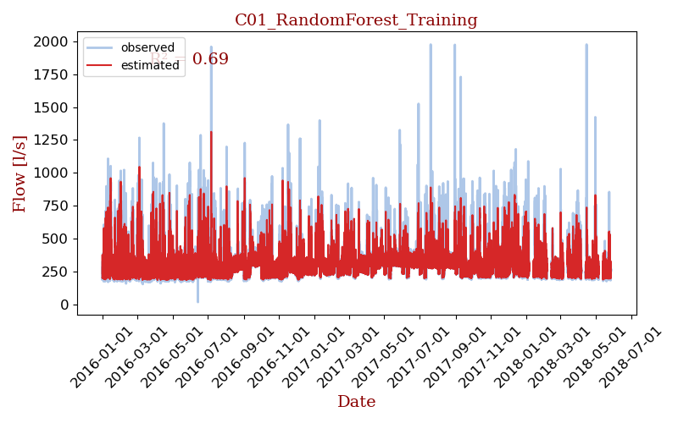

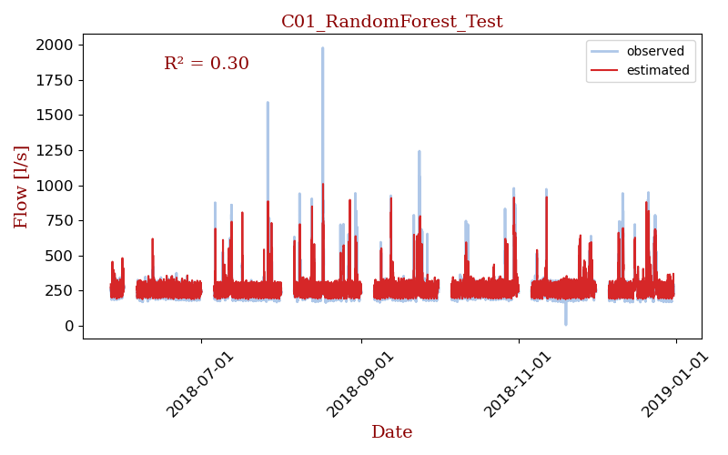

## Model details

[RandomForestRegressor(max_depth=80, max_features=3, min_samples_leaf=5,  
 min_samples_split=12, n_estimators=300, n_jobs=-1,  
 verbose=1)]