Random Forest Model Results

**Summary of regression result**

* Station: U05
* Lag time in minutes: 120
* Lag for rainfall rolling sum in minutes: 120
* Training data length: 251671
* Test data length: 62917
* Number of input features: 15
* List of futures: ['U05_lag_24' 'U05_lag_25' 'U05_lag_26' 'U05_lag_27' 'U05_lag_28'  
   'U05_lag_29' 'U05_lag_30' 'U05_lag_31' 'U05_lag_32' 'U05_lag_33'  
   'WOL5-1_rs18' 'WOL5-2_rs18' 'WOL5-1_rs21' 'WOL5-2_rs21' 'WOL5-5_rs18']

|  |  |  |  |  |  |  |
| --- | --- | --- | --- | --- | --- | --- |
| Method | Rsqured_train | Rsquared_test | rmse_train | rmse_test | NSE_train | NSE_test |
| RF | 0.65 | 0.05 | 723.08 | 1235.63 | 0.63 | -0.07 |

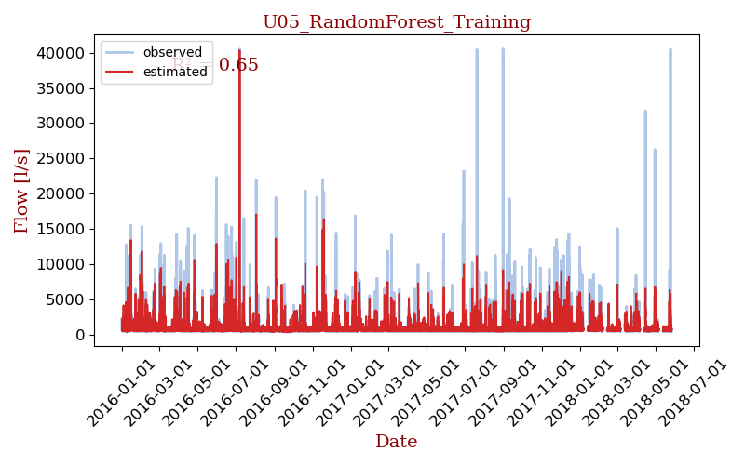

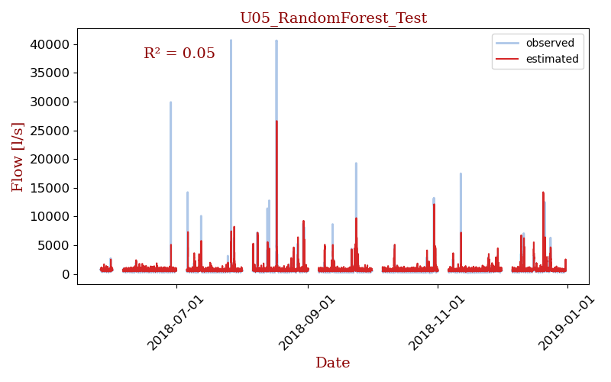

## Model details

[RandomForestRegressor(max_depth=80, max_features=3, min_samples_leaf=5,  
 min_samples_split=12, n_estimators=300, n_jobs=-1,  
 verbose=1)]