Random Forest Model Results

**Summary of regression result**

* Station: U17
* Lag time in minutes: 120
* Lag for rainfall rolling sum in minutes: 45
* Training data length: 250448
* Test data length: 62612
* Number of input features: 15
* List of futures: ['U17_lag_24' 'U17_lag_25' 'U17_lag_26' 'U17_lag_27' 'U17_lag_28'  
   'U17_lag_29' 'U17_lag_30' 'U17_lag_31' 'U17_lag_32' 'U17_lag_33'  
   'MOL5-2_rs9' 'MOL5-1_rs9' 'MOL5-5_rs9' 'MOL5-4_rs9' 'MOL5-3_rs9']

|  |  |  |  |  |  |  |
| --- | --- | --- | --- | --- | --- | --- |
| Method | Rsqured_train | Rsquared_test | rmse_train | rmse_test | NSE_train | NSE_test |
| RF | 0.63 | 0.13 | 521.20 | 666.04 | 0.61 | 0.02 |

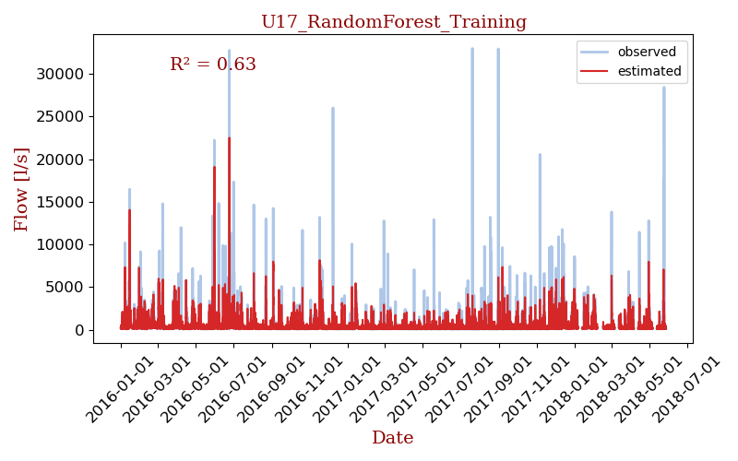

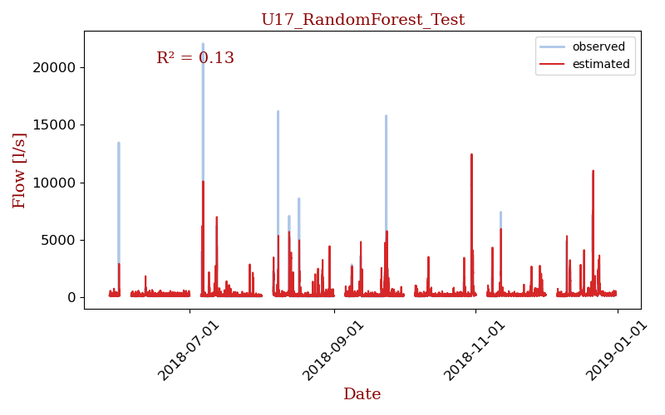

## Model details

[RandomForestRegressor(max_depth=80, max_features=3, min_samples_leaf=5,  
 min_samples_split=12, n_estimators=300, n_jobs=-1,  
 verbose=1)]