Random Forest Model Results

**Summary of regression result**

* Station: U19
* Lag time in minutes: 120
* Lag for rainfall rolling sum in minutes: 30
* Training data length: 248022
* Test data length: 62005
* Number of input features: 15
* List of futures: ['U19_lag_24' 'U19_lag_25' 'U19_lag_26' 'U19_lag_27' 'U19_lag_28'  
   'U19_lag_29' 'U19_lag_30' 'U19_lag_31' 'U19_lag_32' 'U19_lag_33'  
   'BNV8-1_rs6' 'BNV8-3_rs6' 'BNV8-2_rs6' 'BNV8-4_rs6' 'BNV8-1_rs3']

|  |  |  |  |  |  |  |
| --- | --- | --- | --- | --- | --- | --- |
| Method | Rsqured_train | Rsquared_test | rmse_train | rmse_test | NSE_train | NSE_test |
| RF | 0.72 | 0.19 | 449.45 | 589.63 | 0.71 | 0.05 |

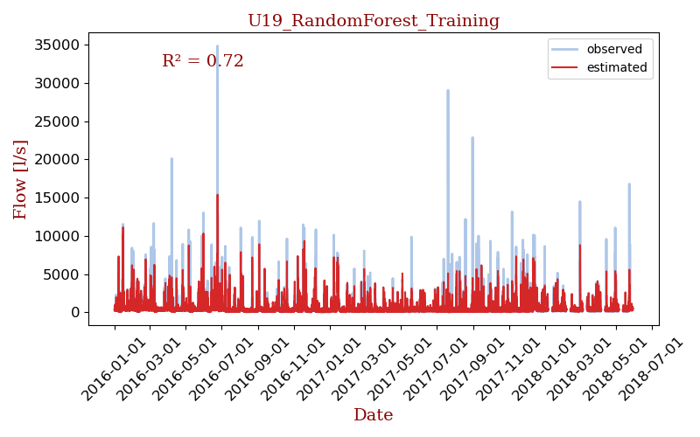

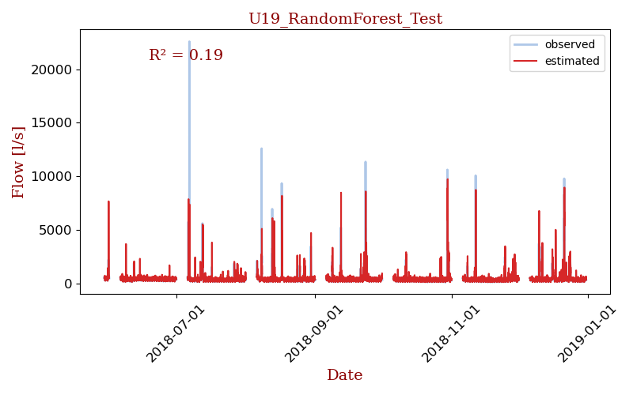

## Model details

[RandomForestRegressor(max_depth=80, max_features=3, min_samples_leaf=5,  
 min_samples_split=12, n_estimators=300, n_jobs=-1,  
 verbose=1)]