**Performance Assessment: D210**

**A. Interactive Data Dashboard**

**1.** A copy of the interactive data dashboard created using Tableau has been attached alongside this written assessment. The two data sets used to create the Tableau dashboard have also been attached to the submission of this assessment.

**2.** Below are each of the steps that I followed in order to create this interactive dashboard in Tableau:

* Created a new Tableau project by using the medical_clean text file
* Joined the population_by_zip_2010 text file to the medical_clean file by setting Zip = Zipcode
* Created each of the individual sheets listed below:
  + ReAdmis by Zip: set the count of ReAdmis as the rows and the Zipcode as the columns, then added Zipcode to filter where I created a conditional filter by field and set the count of ReAdmis as greater than 0. This would eliminate zip codes that did not have any counts of readmissions.
  + ReAdmis by Zip with Avg Income at Poverty: repeated the same steps as above but changed the filter to AVG(Income) where I set the condition to at most $12,880 to match with the federal poverty level of 1 individual in 2021 (ASPE, n.d.).
  + ReAdmis by State Interactive: set the count of ReAdmis as the rows and states as the columns, then added State to Pages to show the interactive drop-down box to select the state.
  + ReAdmis by State: repeated the same steps as above but did not add State to Pages. This allows the user to see the readmission count for all states at once.
  + Avg TotalCharge by Zip: set the rows as the AVG(TotalCharge) and set the columns as the Zipcode. Created a conditional filter by field by using the zip code and setting the field to the average total charge being greater than 0. This eliminates zip codes without any patients since they would not have had a total charge of $0.
  + Avg TotalCharge by State: repeated the steps as above by set the columns as state. This shows the average total charge for each state at once.
  + Avg TotalCharge by Zip Search: recreated the Avg TotalCharge by Zip sheet but turned on the “Show Filter” option. This allows the user to search for specific zip codes and review the total count for a specific zip code.
  + Avg TotalCharge Map: recreated the Avg TotalCharge by State sheet, then clicked on “Show Me” and chose “Symbol Map.” This created an interactive map if the average total charge. The darker the blue, the higher the average total charge would be. Users can hover over each state to get the exact averages.
* Created the following dashboards:
  + ReAdmis vs Poverty Line: added the ReAdmis by Zip sheet to the top and the ReAdmis by Zip with Avg Income at Poverty sheet to the bottom. This created a metric allowing the user to track the count of readmissions at all zip codes vs the zip codes where the average income is at or below the federal poverty level.
  + ReAdmis by State Interactive: simply added the ReAdmis by State Interactive sheet to this dashboard
  + ReAdmis by State Full: simply added the ReAdmis by State sheet
  + TotalCharge Zip vs State: added the Avg TotalCharge by Zip sheet to the left side and the Avg TotalCharge by State sheet to the right. This creates a metric allowing the user to track and compare the average total charge by zip and compare it to the state average.
  + Avg TotalCharge by Zip Interactive: added the Avg TotalCharge by Zip Search sheet to the top and the Avg TotalCharge Map sheet to the bottom. This creates an interactive dashboard where the user can search for zip codes in question and then compare it to the respective state(s) by using the map below.

**3.** Once the dashboard has been downloaded to the users PC and then opened, first hit the **F7** key on your keyboard. This will open the interactive dashboard in full-screen mode so the user can then use the arrow keys to scroll through the different dashboard. On the ReAdmis vs Poverty Line dashboard, simply move the cursor over each zip code on the metrics to see the actual count of readmissions in that zip code. You can compare with the zip codes where the average income is at or below the federal poverty level. On the ReAdmis by State Interactive dashboard, use the drop-down box in the top right corner to manually choose the state of interest for the readmissions count. The following ReAdmis by State Full dashboard will show each state if the user would like to see them all at once. The TotalCharge Zip vs State dashboard shows the user a metric in which they can compare the average total charge by zip vs state. Simply hover the cursor over to get an exact number. And lastly, the Avg TotalCharge by Zip Interactive dashboard lets the user use the search feature in the top-right corner to search for and add specific zip codes(s) to see the average total charge individually. Once you type in the zip code, click on the **+** symbol to add it. You can add as many as you need to and then use the map below to compare with the state average by hovering over the respective state(s).

**B. Reflection Paper**

**1.** This dashboard was created to showcase how many people within a particular zip code has been readmitted to the hospital within one month of release. A metric was created using this information as well as readmissions by zip code where the average income is at or less than the 2021 federal poverty level, in order to determine if poorer patients are at an increased likelihood of readmittance. This dashboard further expanded to showcase readmittance by state. And lastly, this dashboard goes to show the average total charge of the patient based on zip code and then compared to the average total charge by state. These functions the dashboard was created for align with the data dictionary as it is using the medical data set to showcase different trends with the ReAdmis variables and the TotalCharge variables.

**2.** By using the population_by_zip_2010 data set and joining it to the medical_clean data set, I was able further draw upon the Zipcode data in the medical dataset to be able to accurately compare the readmissions variable and the total charge variable within the zip codes.

**3.** 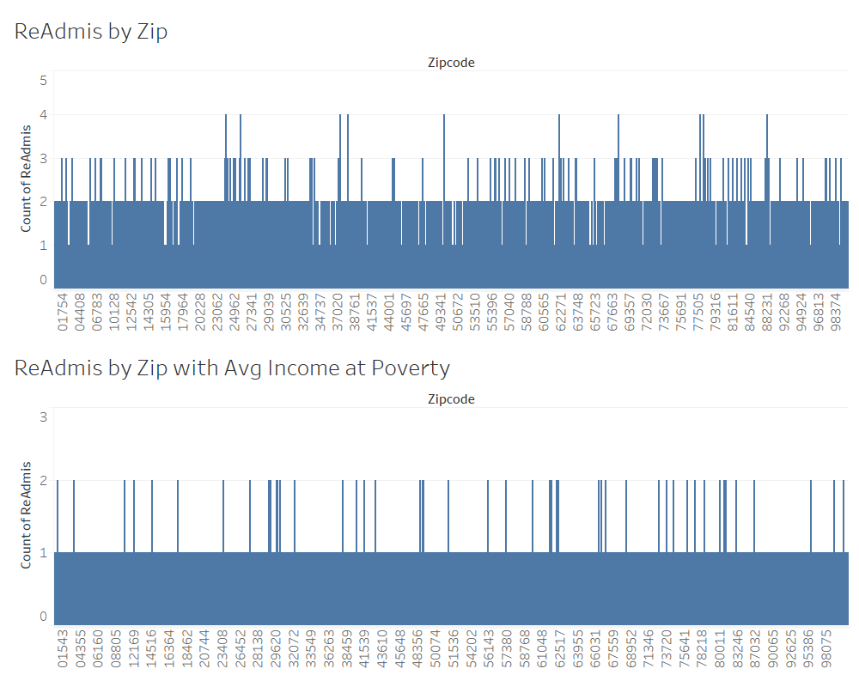

This dashboard showcases the readmission count by the patient’s zip code. It was then compared to the readmission count within zip codes where the average income is at or below the poverty level of $12,880 for 1 individual (ASPE, n.d.). This dashboard does not account for overall household income, nor does it use the poverty level of 2015 (when the data was recorded). This was to get a more accurate assessment of the readmissions based on poverty levels using today’s information. By using this information, executive leaders would be able to determine if there is a trend based on income and the likelihood of a patient being readmitted to the hospital within a month of release. As you can see, the readmissions count caps out at 2 counts in the zip codes at or below the poverty level. Other zip codes can be seen with as many as 3 or 4 counts of readmittance, and those zip codes are not at or below poverty. This would indicate that there is not a significant correlation between the poverty level of a zip code and the likelihood of getting readmitted.

This dashboard showcases the average total charge of the patient based on their zip code and then compares it with the average total charged based on the states. Executive leaders can use this information in order to determine if certain zip codes are paying more or less on average than their respective states. As you can see, the average total charge by state is relatively uniformly distributed around an average charge of $5500, whereas the average total charge by zip code is also uniformly distributed but at a level much higher (between $8-9,000).

**

This interactive dashboard was created to get a general sense of the readmission variable by looking at the states individually. By using the drop-down box located in the top-right corner, the user is able to interact with the dashboard by selecting the state that they would like to see the readmission count for.

This interactive dashboard showcases the average total charge of the patients based on their zip code. This can then be compared to the average total charge per state by looking at the map below. If the user would like to see a specific zip code(s), they can type in and add the respective zip code(s) in question by using the search feature in the top-right corner. The user can then compare the zip code(s) in question to their respective states by interacting with the map to see the average total charge by state.

**5.** In order to make my dashboard accessible to users with colorblindness, I used colorblind-friendly palettes when creating my visualizations. All of my visualizations use blue and only blue, which is generally considered to be a friendly color to those with CVD (Shaffer 2016).

**

These two dashboards provided the necessary visualizations that I wanted in order to tell a story of whether readmissions could be correlated to the poverty line and to compare the average total charge by zip vs by state. The visualizations provide depth and a way to see if any trends exist within those parameters.

**7/8.** This dashboard and presentation was designed to be understandable by both a non-technical and a technical audience. The visualizations clearly explain what is being presented and the interactive controls allow a user of any background to be able to gather insightful information from the dashboards. Labels are clear and the instructions in part **A3** are clear as to what is required in order to be able to use the dashboard. This information is accessible to users of any background. This also gives the presentation universal access to be accessible and useable to al audiences.

**9.** One element of effective storytelling that was implemented into the dashboards is interactivity. The interactive controls provided into the presentation allow the user to actively engage with the content in order to ascertain beneficial insights that they could use to make business decisions. Another element of effective storytelling was the lack of clutter that I implemented. Each dashboard is concise and to the point as far as what is being presented and how it is beneficial to gathering insightful information.

**C. Sources**

Shaffer COO and VP of Information Technology and Analytics, Jeffrey. “5 Tips on Designing Colorblind-Friendly Visualizations.” Tableau, 20 Apr. 2016, https://www.tableau.com/about/blog/examining-data-viz-rules-dont-use-red-green-together.

“2021 Poverty Guidelines.” ASPE, https://aspe.hhs.gov/topics/poverty-economic-mobility/poverty-guidelines/prior-hhs-poverty-guidelines-federal-register-references/2021-poverty-guidelines.