**Step 1: Prepare the Data Infrastructure**

1.Create the data lake and upload data

Storage Container

Three directories in storage container

Uploaded files in **dirpayrollfiles**

Uploaded file in **dirhistoryfiles**

2. Create an Azure Data Factory Resource

3. Create a SQL Database

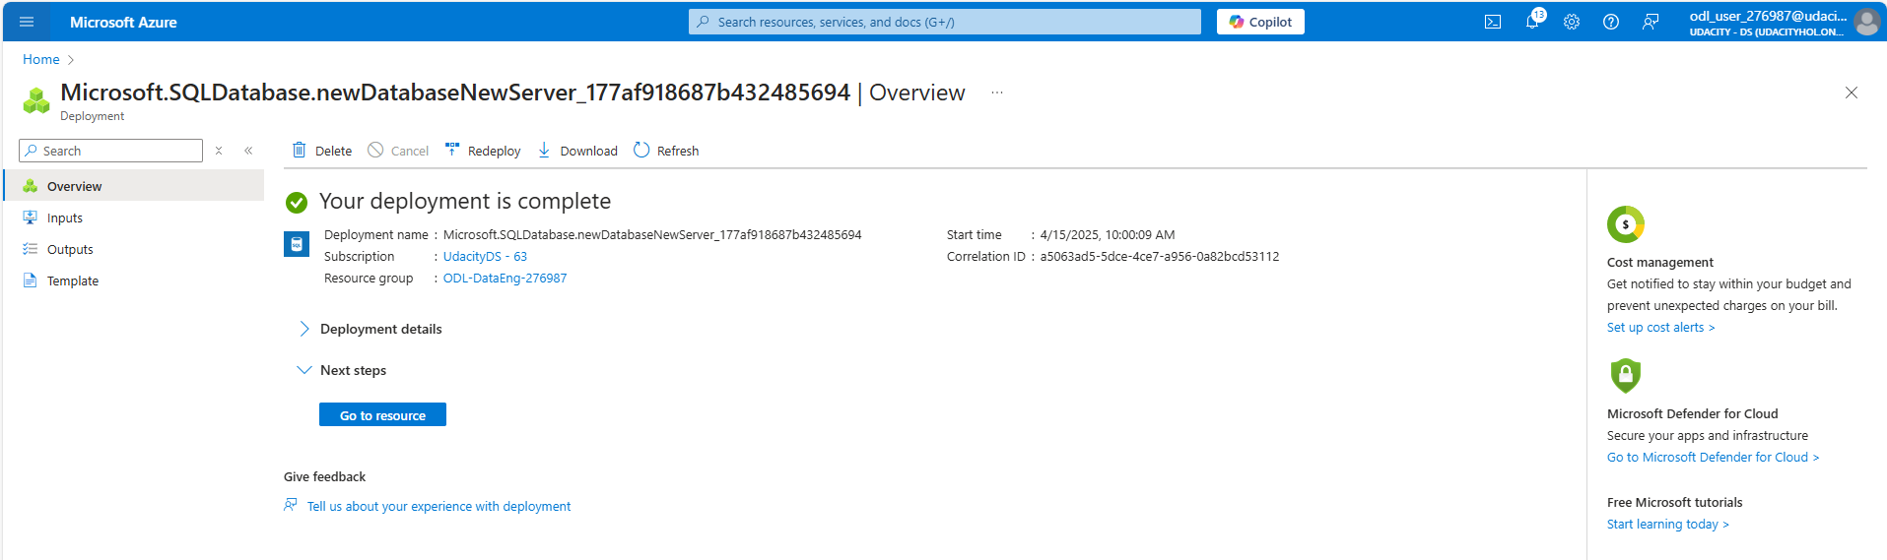

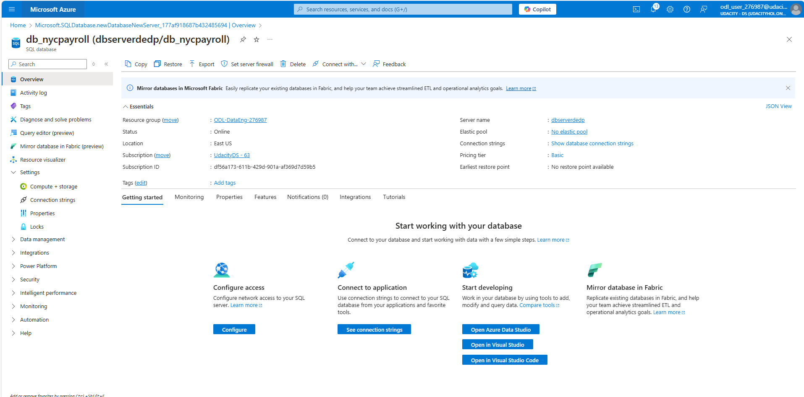

4. Create a Synapse Analytics workspace, or use one you already have created

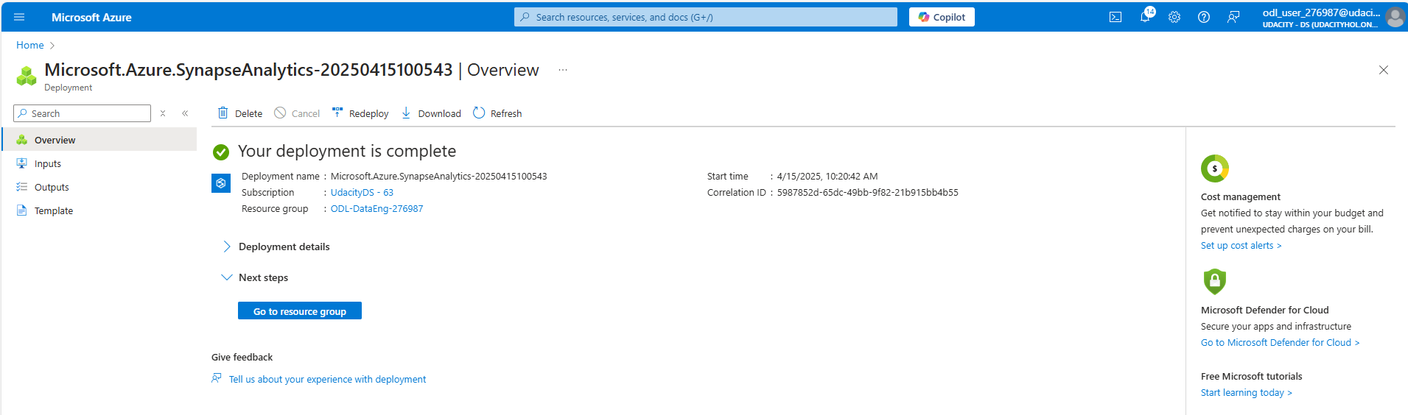

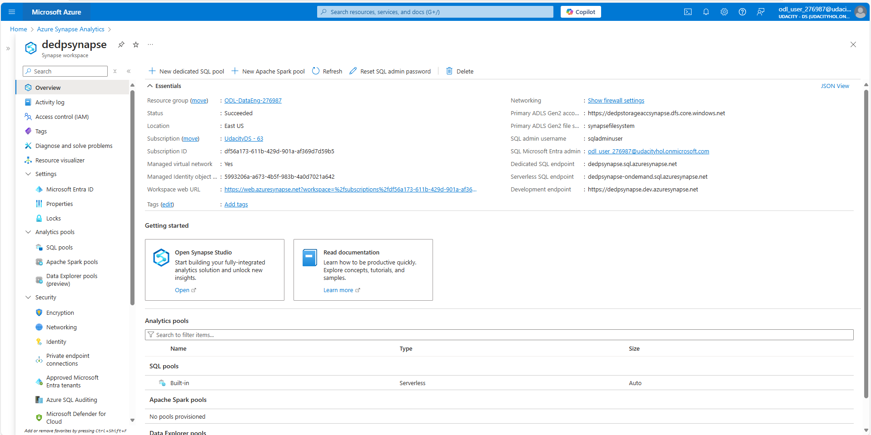

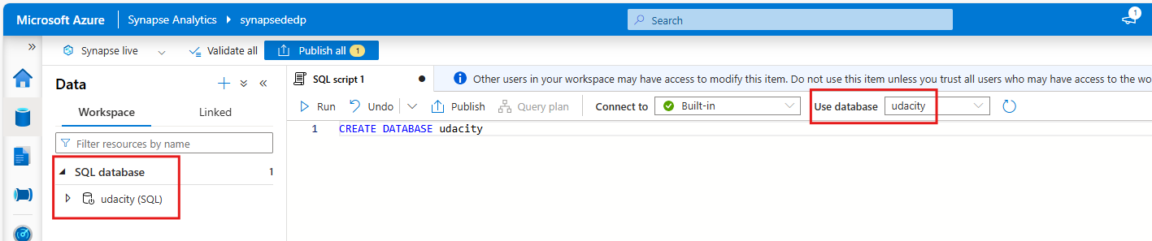

5. Create summary data external table in Synapse Analytics workspace

Created Data Source, File format and External tables

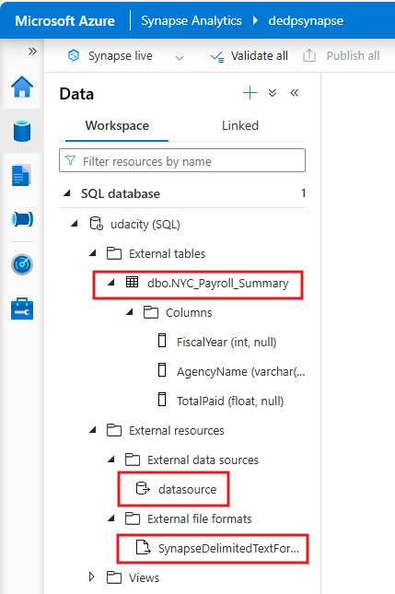

6. Create master data tables and payroll transaction tables in SQL DB

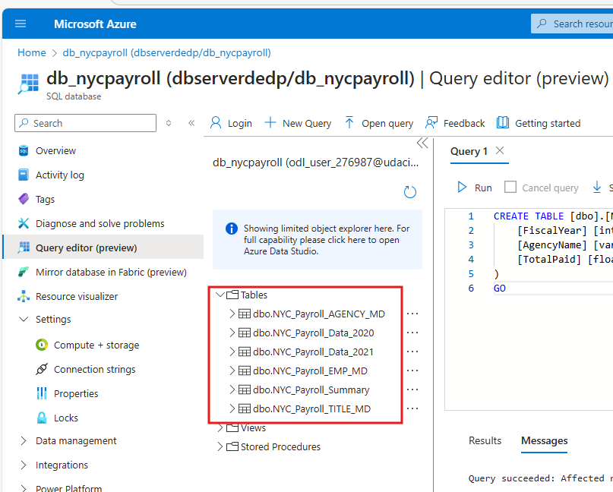

**Step 2: Create Linked Services**

1.Create a Linked Service for Azure Data Lake

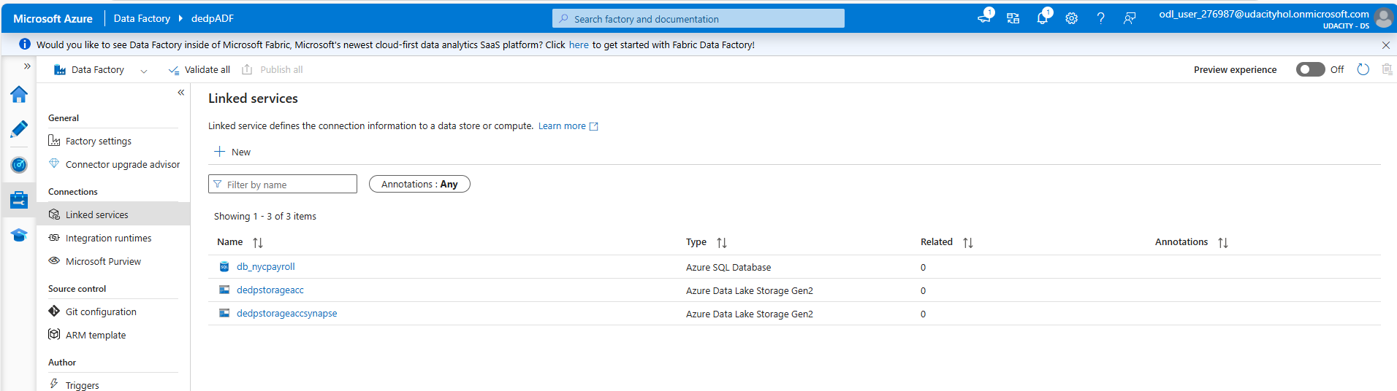

**Step 3: Create Datasets in Azure Data Factory**

1.Create the datasets for the 2021 Payroll file on Azure Data Lake Gen2

2. Repeat the same process to create datasets for the rest of the data files in the Data Lake

3. Create the dataset for all the data tables in SQL DB

4. Create the datasets for destination (target) table in Synapse Analytics

**Step 4: Create Data Flows**

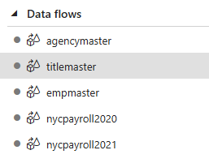

**agencymaster**

**titlemaster**

**empmaster**

**nycpayroll2020**

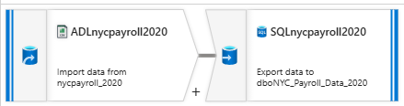

**nycpayroll2021**

**Step 5: Data Aggregation and Parameterization**

**Dataflow Summary**

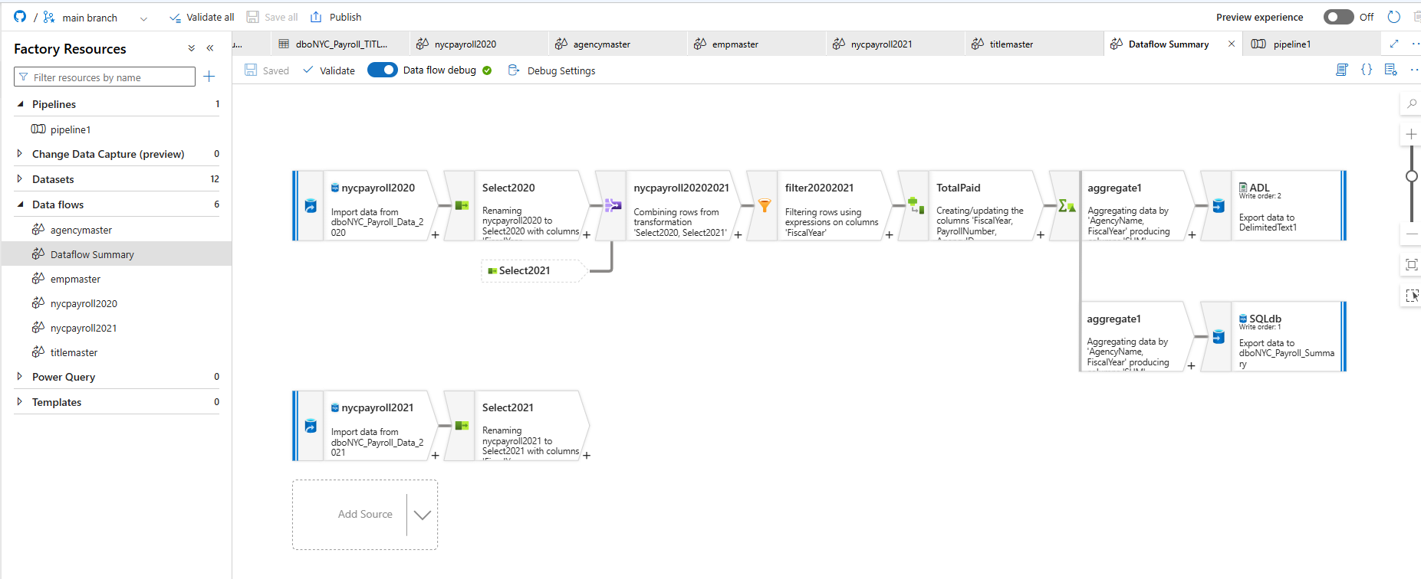

**Step 6: Pipeline Creation**

**Step 7: Trigger and Monitor Pipeline**

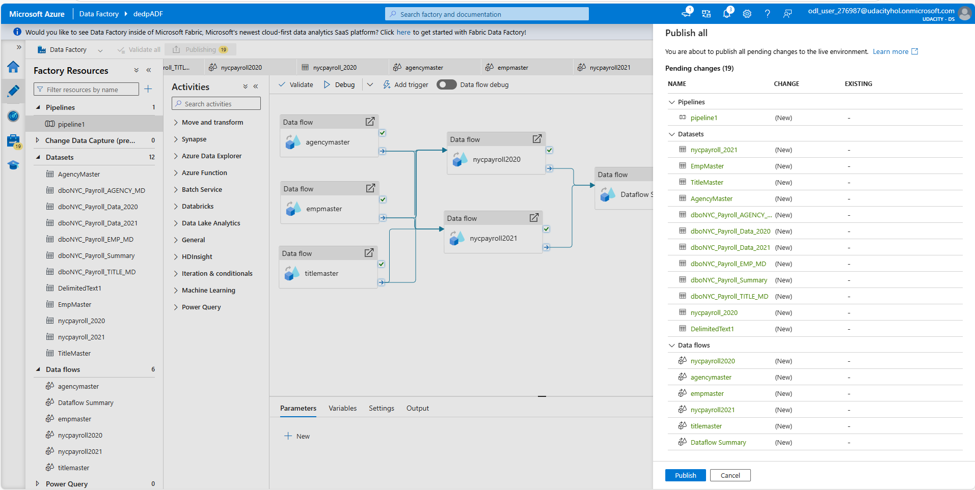

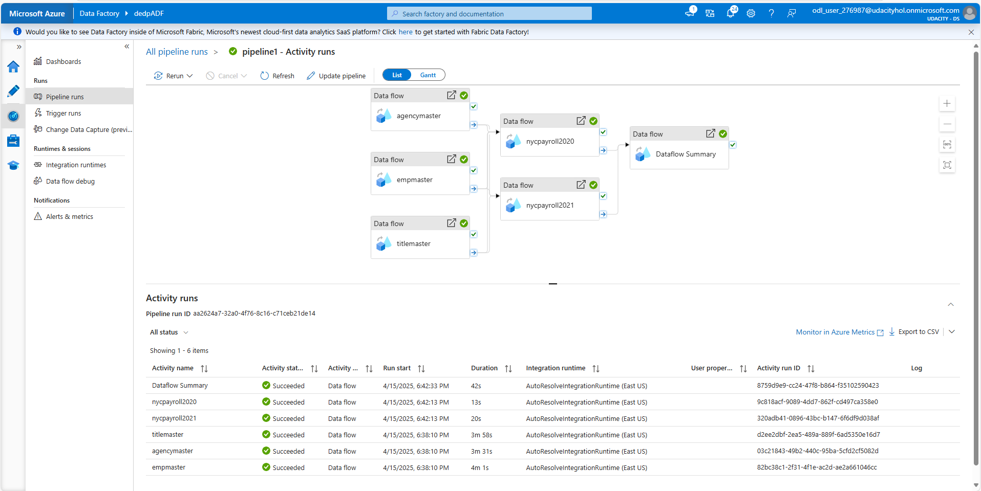

**Step 8: Verify Pipeline run artifacts**

dirstaging directory listing in Datalake

SQL DB summary table

Synapse summary external table

