
Functional Specification
&
Solution Blueprint

April 202
6

<CampusCare>

<TechMasterDevs>

<Seth Whitfield>
<Tarisai Rusike>
<Thakgatso Magampa >
<Vhuthuhawe Nekhavhambe>

TABLE OF CONTENTS

1 SYSTEM OVERVIEW 3
1.1 Problem Description 3
1.2 Business Rules / Assumptions 3
1.3 System Constraints 3
2 FUNCTIONAL REQUIREMENTS 4
2.1 Initial Use Case Model 4
2.2 Final Use Case Model 5
2.3 Use Case Glossary and Responsibilities 6
2.4 Use Case Narratives & UI Designs 7
2.4.1 Team Designs 7
2.4.1.1 Team User Interface Guidelines 7
2.4.1.2 Login / Logout Feature 7
2.4.1.3 Dashboard / Landing Page / Main Page 7
2.4.2 Individual Crew Member Use Case Narratives & UI Designs 9
2.4.2.1 Designed by Nekhavhambe Vhuthuhawe 9
2.4.2.2 Designed by Seth Whitfield 15
2.4.2.3 Designed by Thakgatso Bridgette Magampa 19
2.4.2.4 Designed by Tarisai Rusike 23
3 DATA REQUIREMENTS 27
3.1 List of data and attributes 27
3.2 Domain Class Diagram 28
3.3 Draft Implementation Ready Class Diagram 29
3.4 Implemented database structure 30
4 TECHNICAL REQUIREMENTS 31
4.1 System Environment 31
4.2 Start-up Instructions 31
4.3 Logins & Passwords 31

SYSTEM OVERVIEW

Problem Description
The university clinic is currently faced with severe operational inefficiency, with appointment wait times averaging one month. As a result of these delays, students suffering from immediate health needs are unable to get the assistance they need if they are unable to incur the costs of seeing outside medical professionals. The CampusCare Hub is designed to solve this by implementing a three-tier system that categorises student,s need according to the severity of their symptoms.

Business Rules / Assumptions
All nurses must be verified by admin
Tier 2 consultation times are limited to 15 minutes
Physical meetings are automatically approved based on availability
Online meetings remain pending until approved by a nurse
All users need to be registered
Ratings can only be submitted after a consultation has taken place

System Constraints
System operates around the physical clinic’s hours, all after hours inquiries are deferred to tier 3.
The system is strictly web based.
The system requires nurses to manually approve online meetings and create teams links.

FUNCTIONAL REQUIREMENTS

Initial Use Case Model
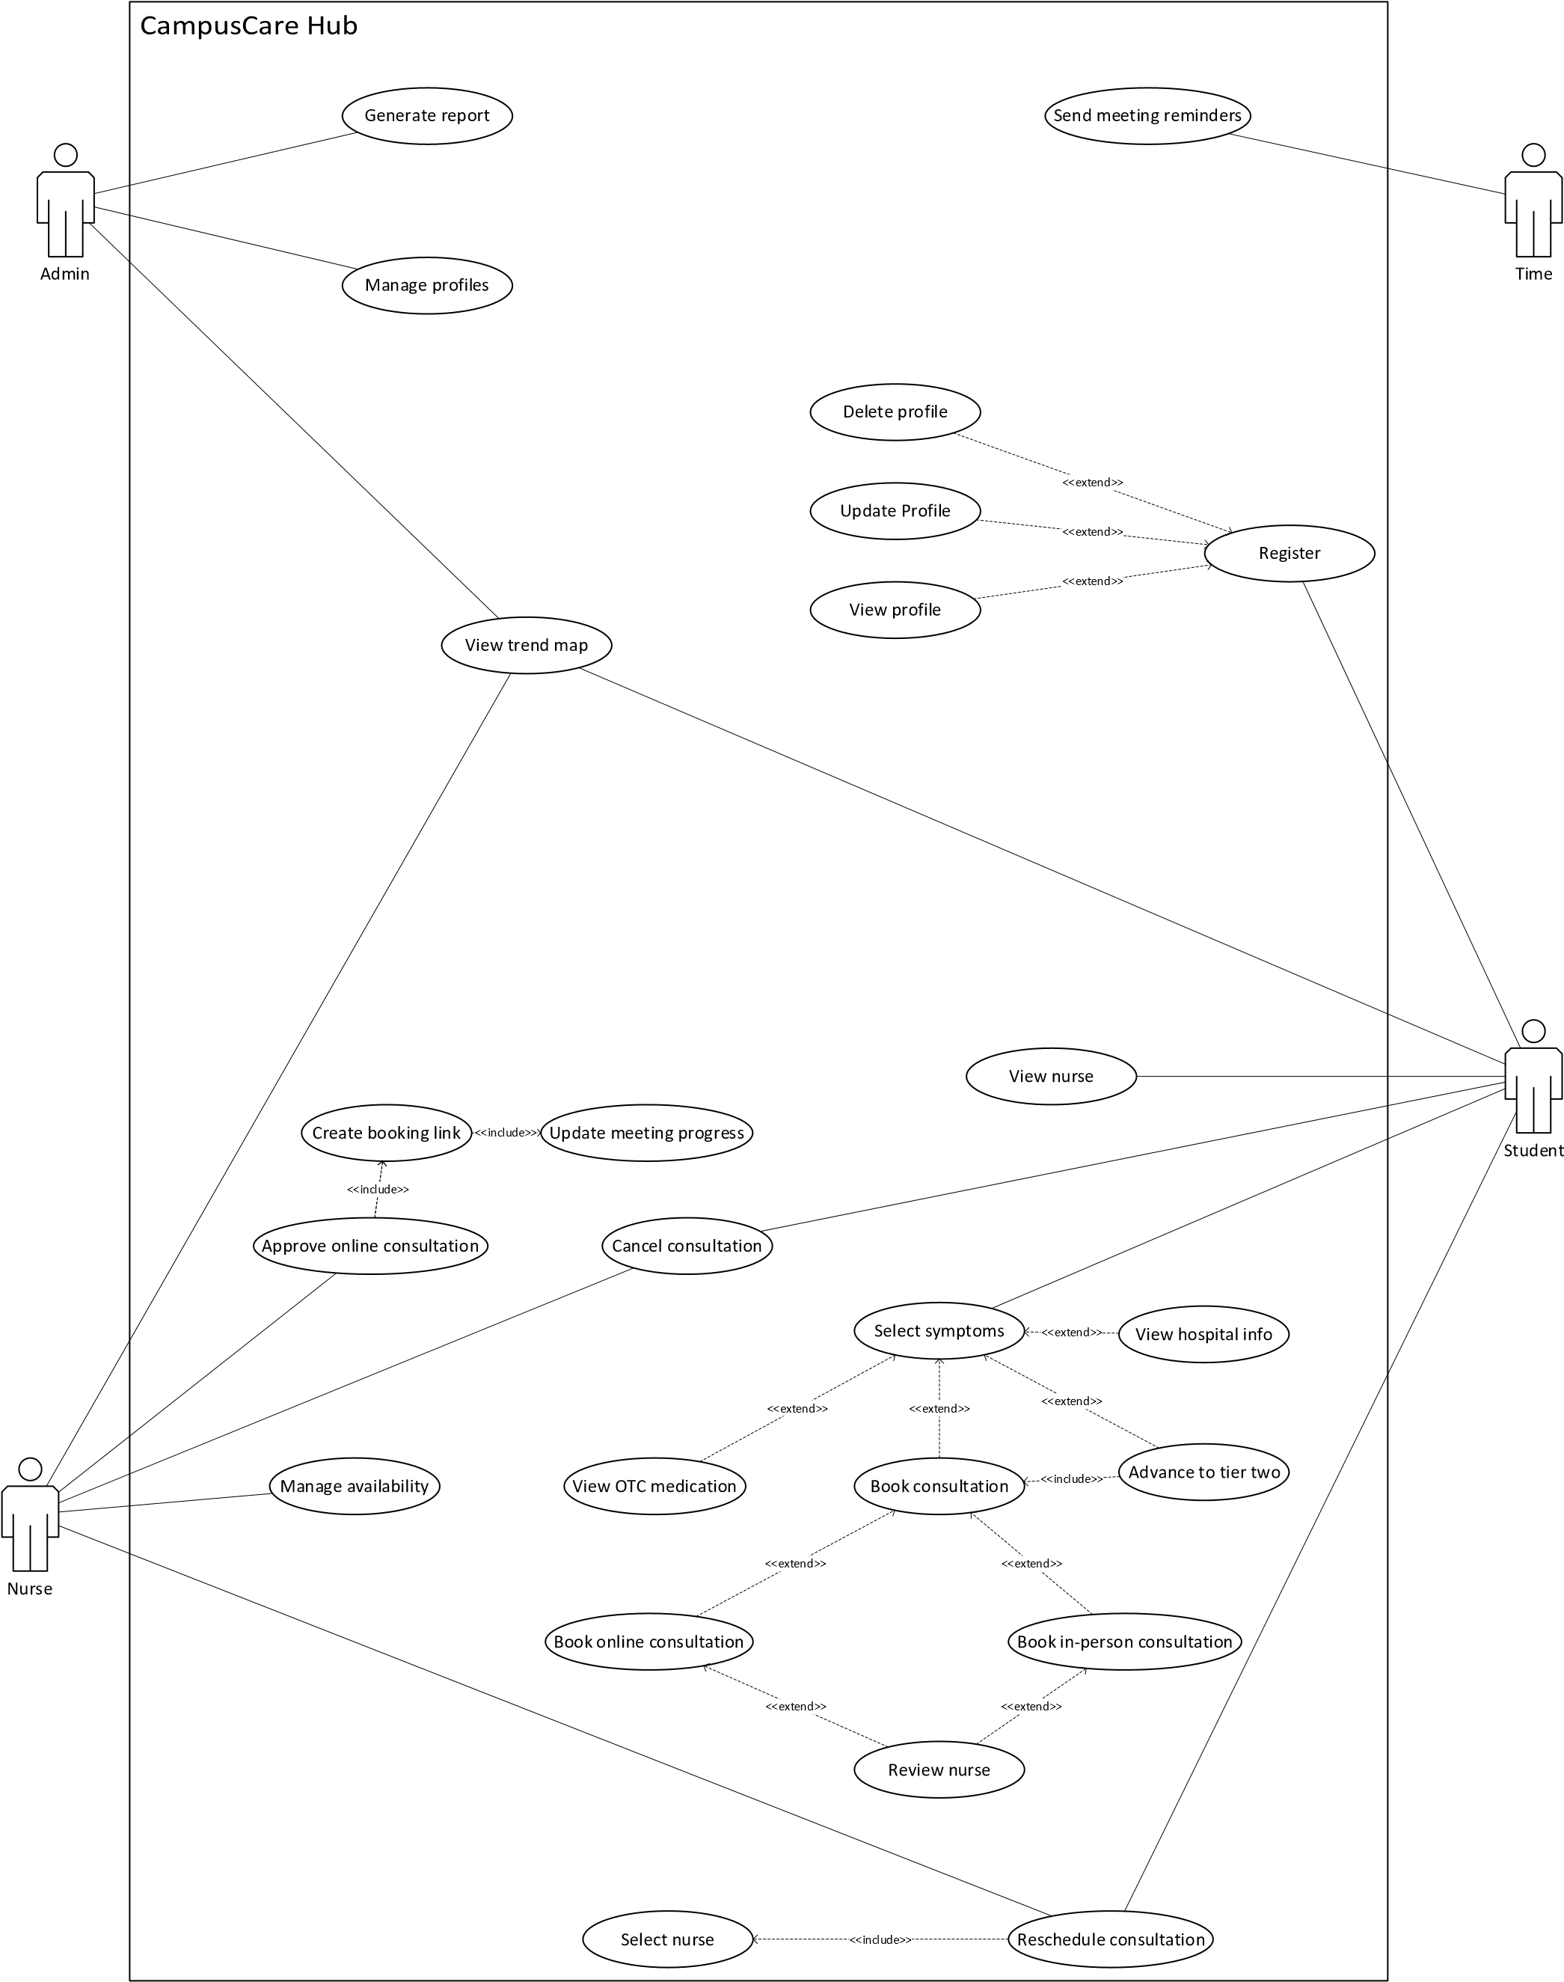

Final Use Case Model
[Replace this text with the Use Case diagram – this must be drawn in Visio.]

Use Case Glossary and Responsibilities
Allocated to Crew Member: <Nekhavhambe Vhuthuhawe >
Use Case Id | Use Case Name
A100 | Manage profiles
A200 | Input symptoms
A300 | View OTC medication
A400 | View trend map

Allocated to Crew Member: <Magampa Bridget Thakgatso>
Use Case Id | Use Case Name
B100 | Book in-person consultation
B200 | Book online consultation
B300 | View reviews
B400 | Review nurse

Allocated to Crew Member: <RusikeTarisai >
Use Case Id | Use Case Name
C100 | Register
C200 | View hospital info
C300 | Approve online meeting
C400 | Update meeting progress

Allocated to Crew Member: <Whitfield Seth>
Use Case Id | Use Case Name
D100 | Manage availability
D200 | Generate report
D300 | Send meeting reminders
D400 | Advance to tier two

Use Case Narratives & UI Designs

Team Designs

Team User Interface Guidelines
Platform used: Canva
Colours used: dark ocean, white, yellow
Fonts used: Headings-Open Sans, Other text-Canva Sans

Login / Logout Feature

Initial UI design
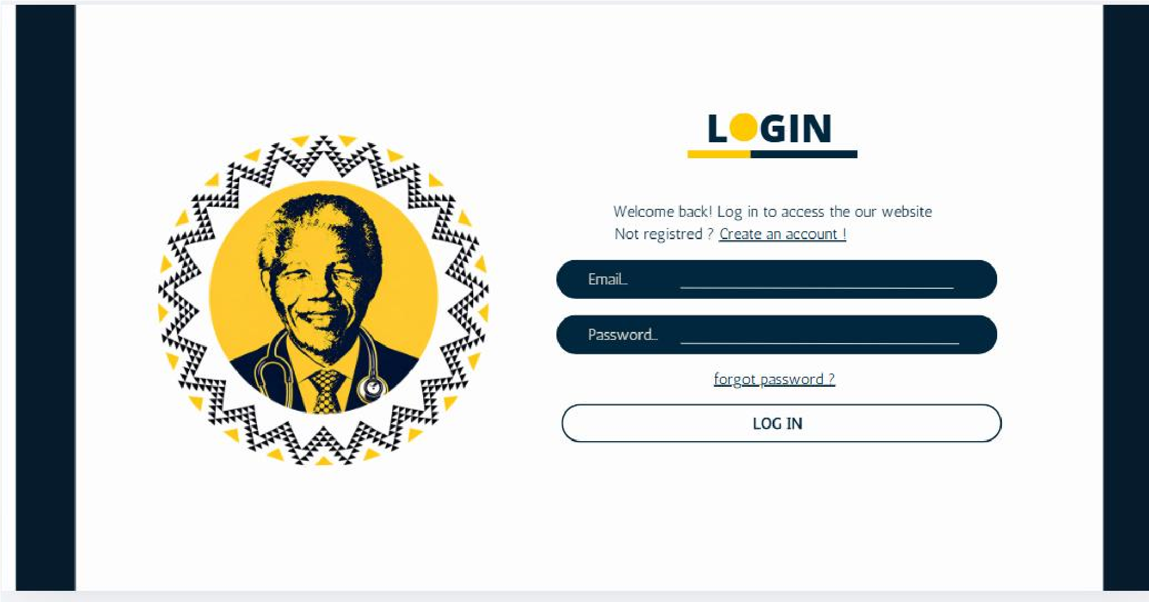
Final UI

Dashboard / Landing Page / Main Page

Initial UI design
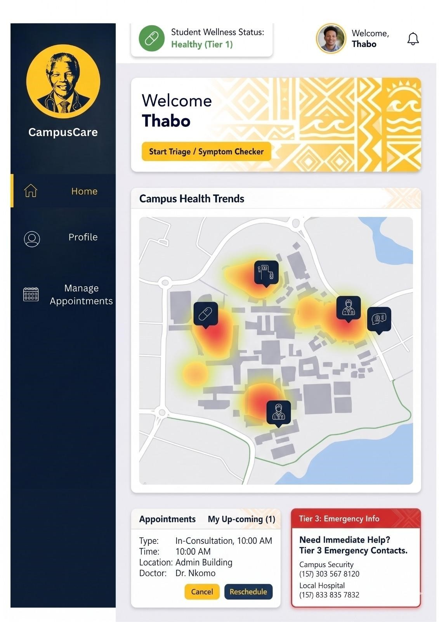
Final UI

Individual Crew Member Use Case Narratives & UI Designs

Designed by Nekhavhambe Vhuthuhawe

Use Case ID | Use Case Name
A100 | Manage profiles
Actors
Admin
Pre-Conditions | The Admin must be signed in on the Campus care hub website
Triggers | Admin clicks on manage profiles button
Post-Conditions | The system reflects any changes made to the user profile  Updated data is saved in the database  The admin is returned to the profile management interface.  A confirmation message is displayed.
Basic Flow of Events / Main Success Scenario
- System display a list of user profiles
- Admin selects the profile they want to manage
- The System displays the selected profile
- Admin chooses an Action (Edit details , delete or view) A100a : Edit profile
a1. System takes Admin to the edit page which displays the current details of the selected profile a2. Admin enters the updated profile details a3. Admin submits the changes. a2. System validates the input
a3. System updates the database with the updated profile details
a4. System displays the confirmation message that the profile was successfully updated

A100b : Delete
b1. System prompts the user to confirm deletion b2. Admin confirms deletion
b3. System deletes the profile form the database
b4. System displays the confirmation message that the profile was successfully deleted

A100c : View
a1. Admin clicks the details option of the profile they want to view
a2. System takes the admin to the details page which displays the current details of the selected profile

Initial UI Design

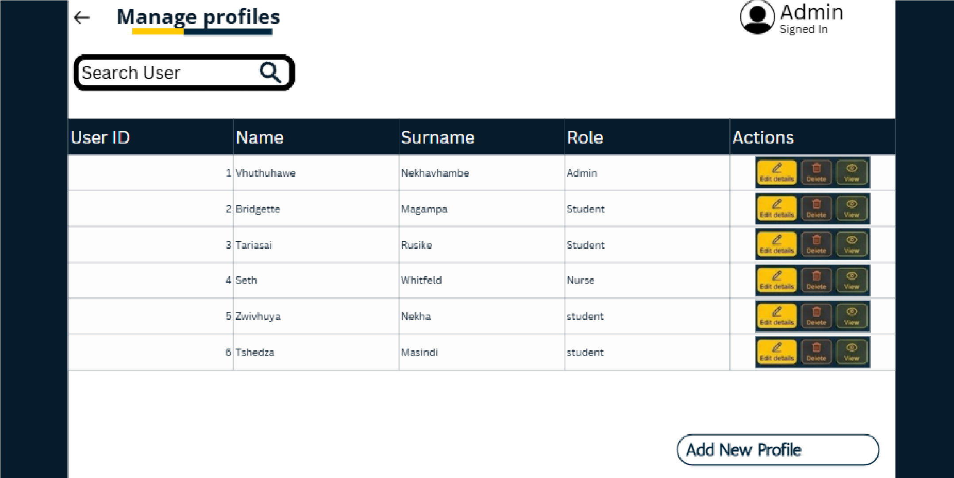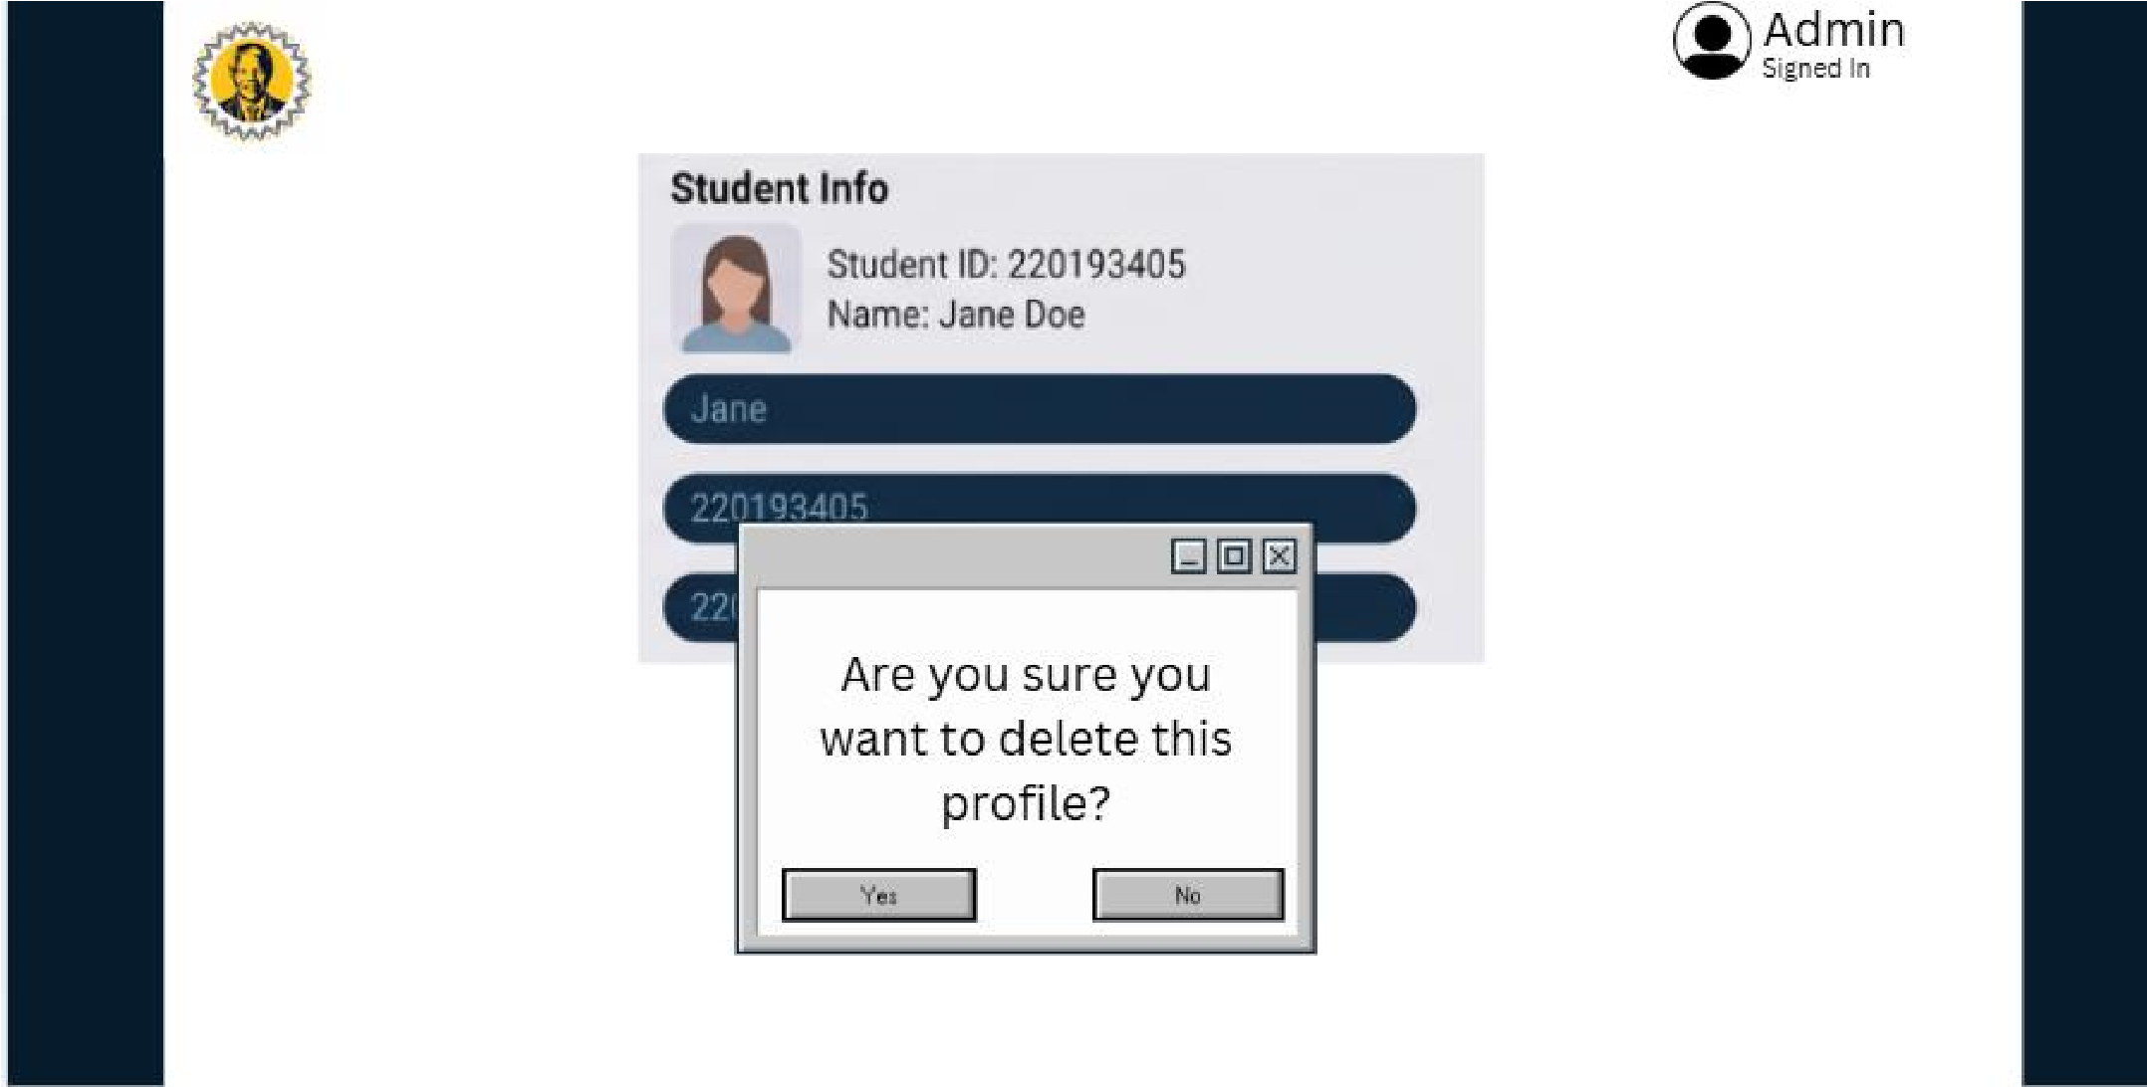

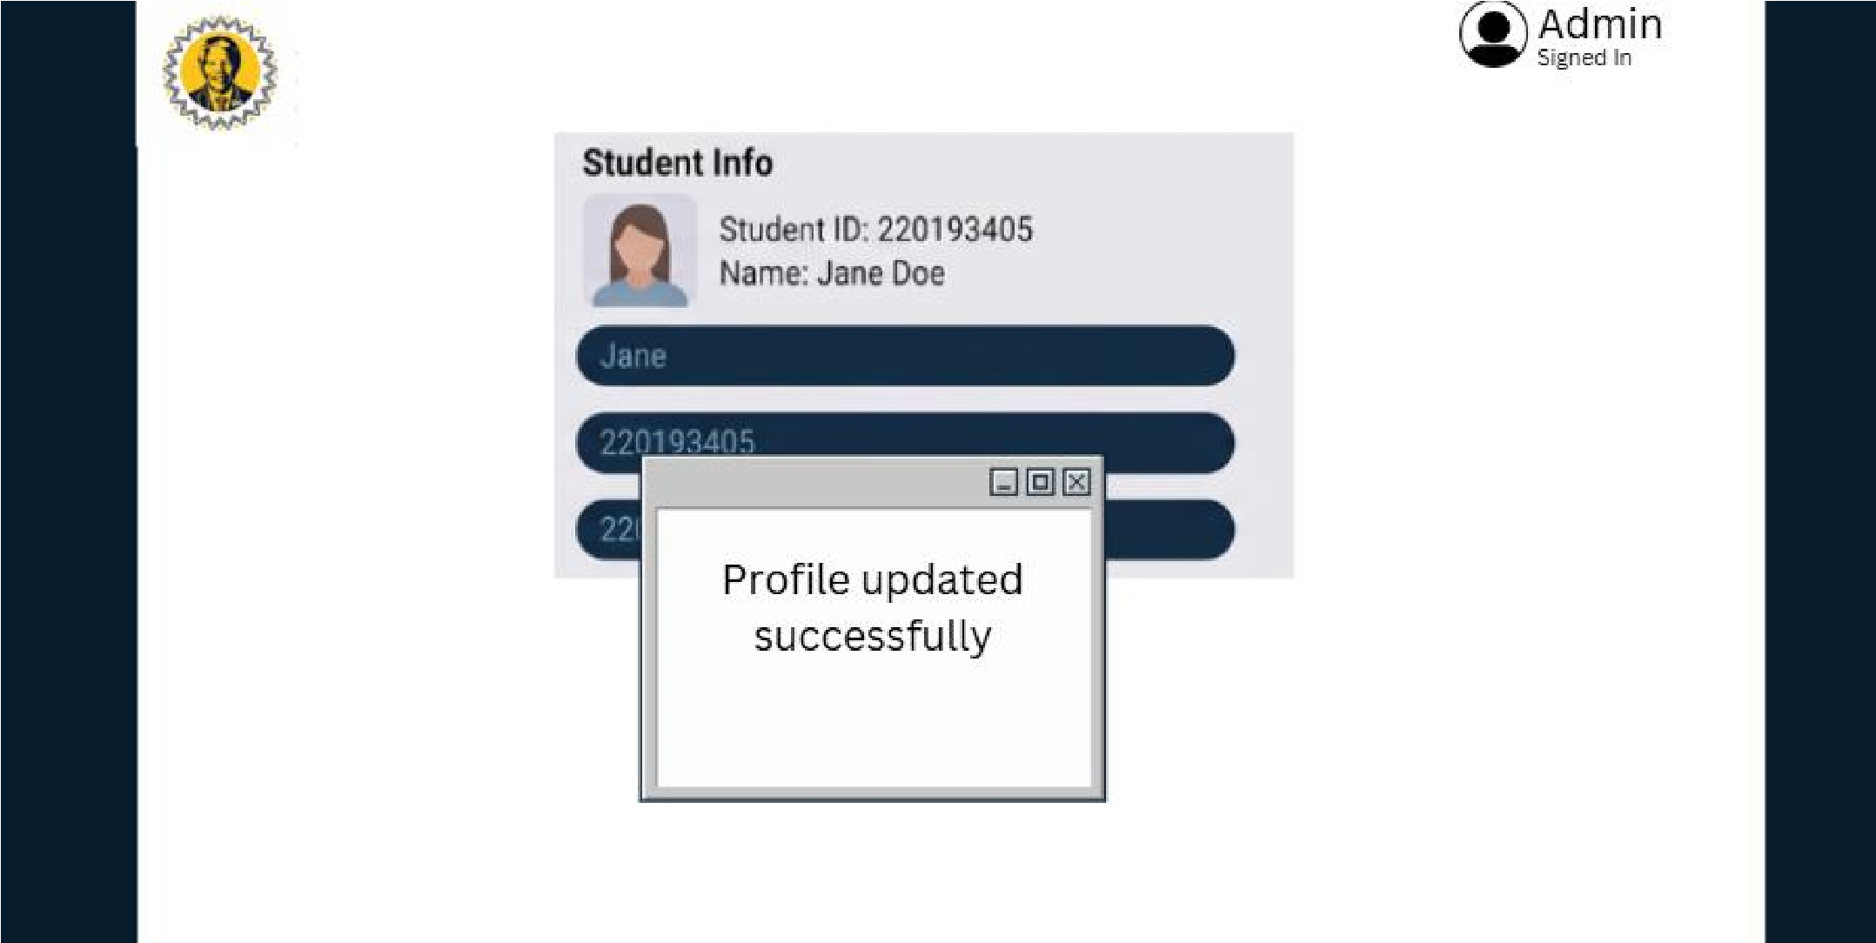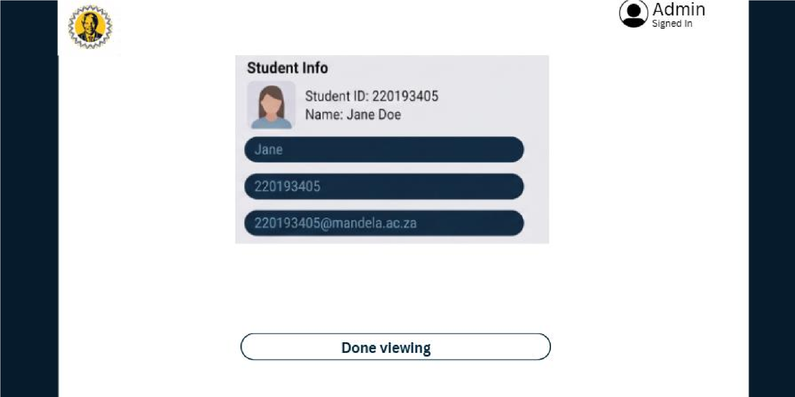
Final Implemented UI Design

Use Case ID | Use Case Name
A200 | Input symptoms
Actors
Student
Pre-Conditions | The student must be signed in on the campus care hub
Triggers | Student clicks on the input systems button
Post-Conditions | The System allocates the student to a specific tier bases on symptoms selected
Basic Flow of Events / Main Success Scenario
- The student selects the input symptoms button
- The system displays symptoms to select from
- The Student chooses symptoms that apply to them from a dropdown menu and other if their system is not on the dropdown menu
- student submit their symptoms
- The System allocates the student to a specific tier based on symptoms selected
- The system display a message tp the students showing them which tier they are in

Initial UI Design
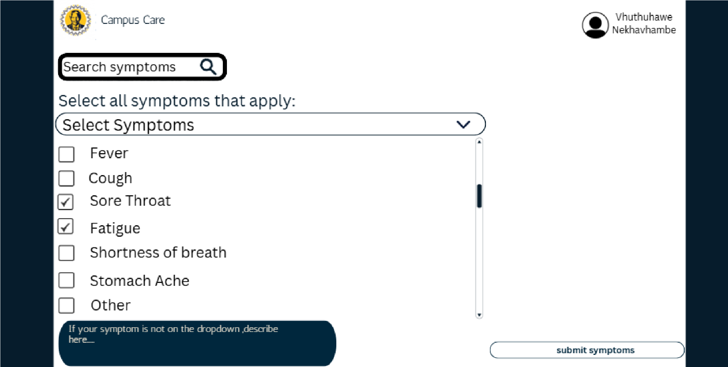
Final Implemented UI Design

Use Case ID | Use Case Name
A300 | View OTC medication
Actors
Student
Pre-Conditions | The student selected their symptoms and they were allocated to tier 1
Triggers | The student selected the view OTC medication button
Post-Conditions | A list of available OTC medication associated with the student’s symptoms is displayed along with their availability
Basic Flow of Events / Main Success Scenario
- The student select the view OTC medication button
- The system shows a list of available OTC medication associated with the student’s symptoms is displayed along with their availability
- The student views the OTC medications available and select done once they are done viewing
4.

Initial UI Design
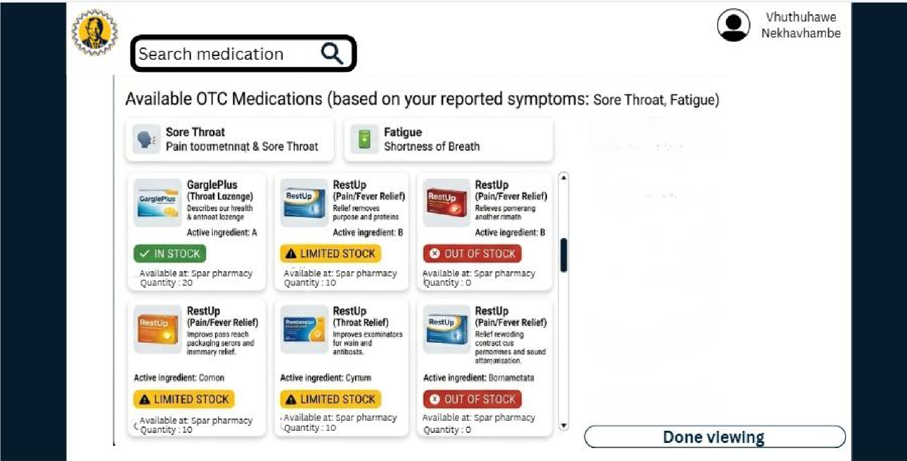
Final Implemented UI Design

Use Case ID | Use Case Name
A400 | View trend map
Actors
Student, Nurse and Admin
Pre-Conditions | The student, nurse and admin must be signed in on the campus care hub
Triggers | View trend map is selected
Post-Conditions | The system displays the requested trend map
Basic Flow of Events / Main Success Scenario
- The system retrieves available trend data
- The systems display a trend map
- User views the trend map and exits

Initial UI Design
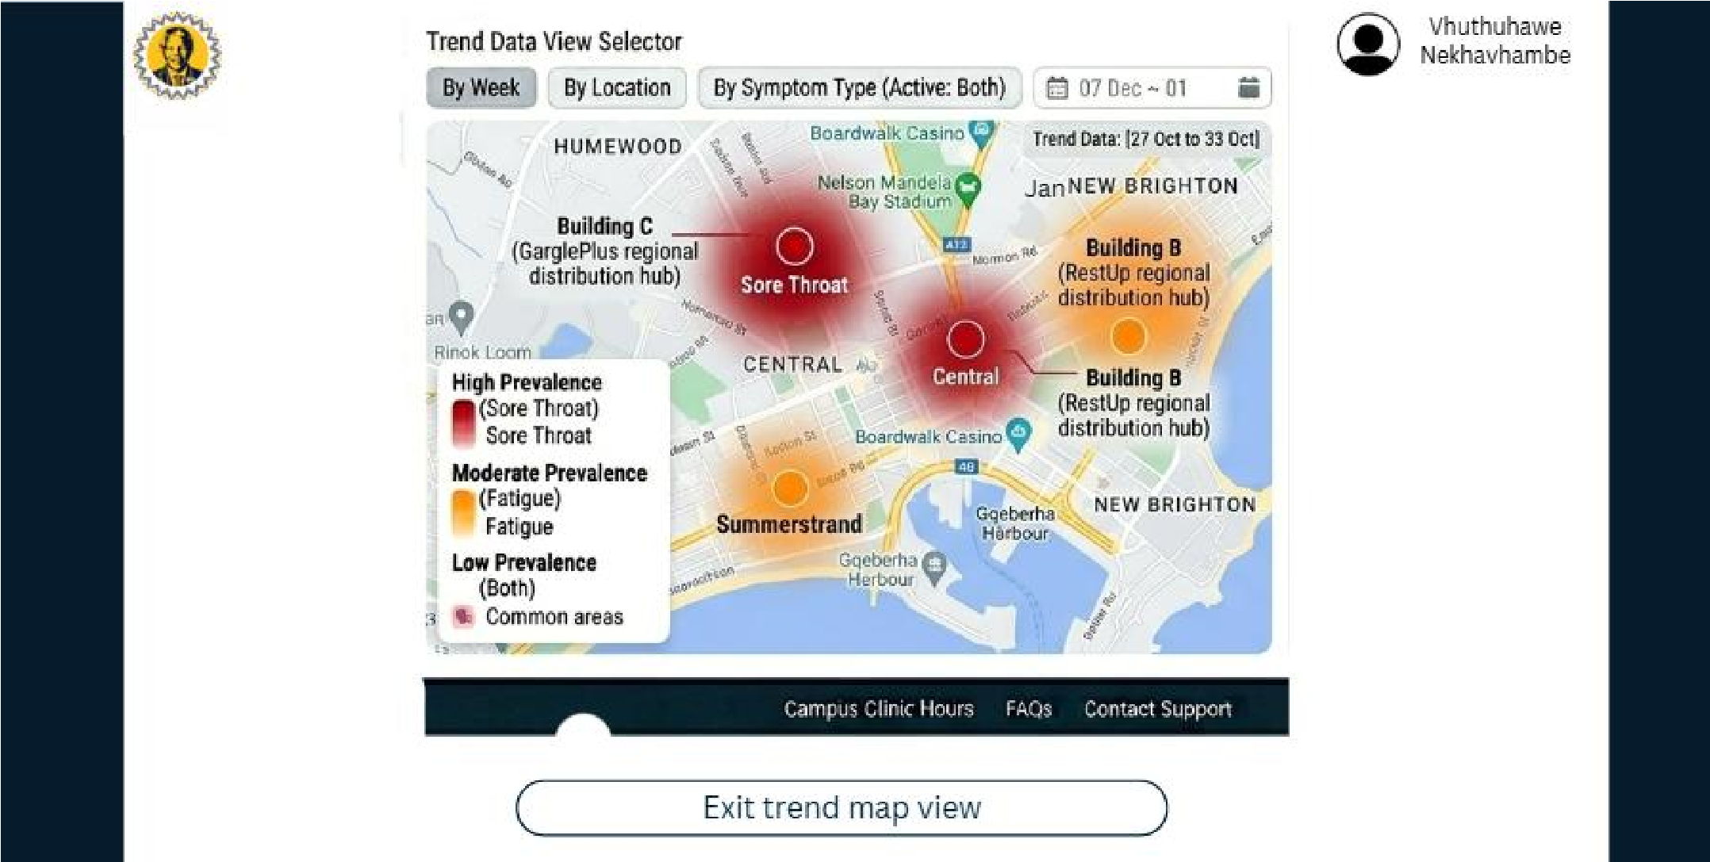
Final Implemented UI Design

Designed by Seth Whitfield

Use Case ID | Use Case Name
D100 | Manage Availability
Actors
Nurse
Pre-Conditions | Nurse is registered
Triggers | Nurse clicks manage availability button
Post-Conditions | Nurse has successfully managed the calendar in terms of the times they are available
Basic Flow of Events / Main Success Scenario
- The Nurse selects the Manage availability button
- The system fetches a calendar/list of times/timeslots
- The nurse marks a timeslot available/unavailable
- Nurse clicks save
- The system updates the timeslots that have changed

Initial UI Design
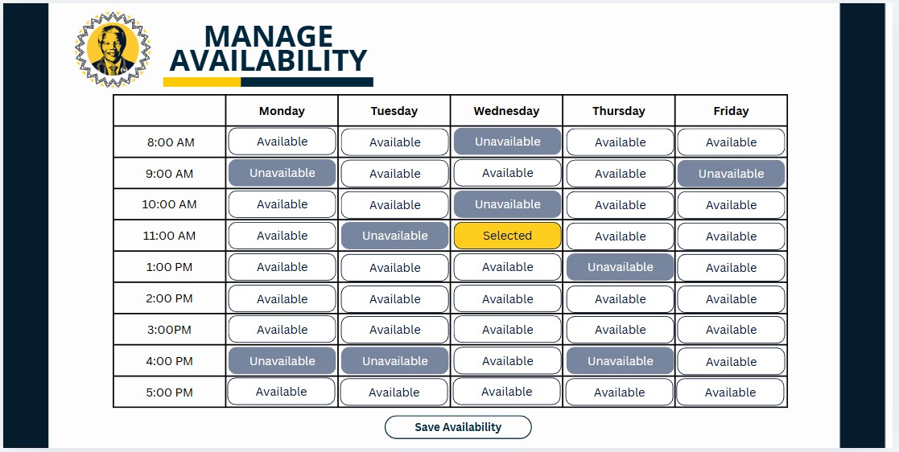
Final Implemented UI Design

D200 | Generate report
Actors
Admin
Pre-Conditions | Admin must be registered and logged into the  CampusCare
Triggers | The Admin clicks the "Generate report" button on the dashboard
Post-Conditions | A report is successfully generated and displayed or downloaded for the Admin
Basic Flow of Events / Main Success Scenario
- The Admin selects the "Generate report" option.
- The system displays a form with report criteria for example, Report Type, Start Date, End Date, Export Format.
- The Admin selects the desired parameters from the dropdowns and date pickers.
- The Admin clicks the "Generate Report" submit button.
- The system queries the database for records matching the selected criteria.
- The system generates the report in the requested format for example, PDF or CSV, and prompts the Admin to download it.
Initial UI Design
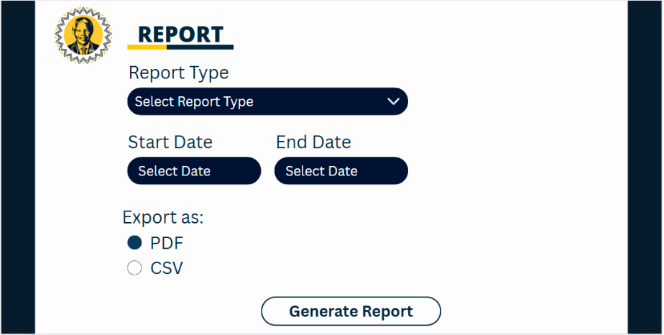
Final Implemented UI Design

D300 | Send meeting reminders
Actors
Time
Pre-Conditions | Student has a confirmed, upcoming consultation (in-person or online) booked with a nurse.
Triggers | The system clock reaches a predefined threshold for example: 1 hour before the scheduled consultation time
Post-Conditions | An automated reminder email is successfully sent to the student and the nurse.
Basic Flow of Events / Main Success Scenario
- The system continuously checks the database for upcoming appointments against the current time.
- The system identifies an appointment that is approaching within the designated reminder window.
- The system generates a reminder message containing the appointment details (Date, Time, Location or Teams link).
- The system automatically sends the reminder to the student's registered email address and the nurse's dashboard.
Initial UI Design
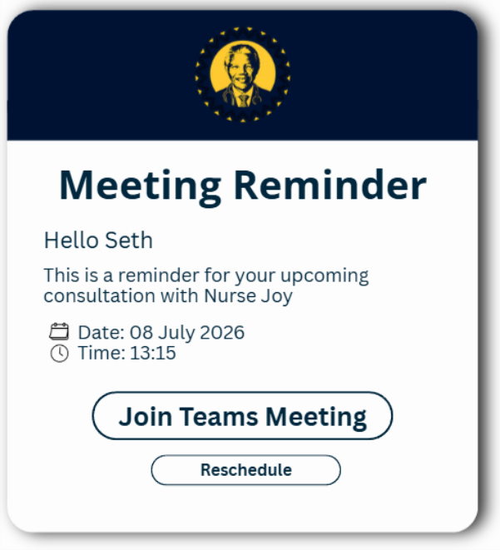
Final Implemented UI Design

D400 | Advance to tier two
Actors
Time
Pre-Conditions | A student is currently registered in the system under Tier 1, or has the Tier 2 symptom trigger
Triggers | Student inputs a tier 2 symptom or tier 1 symptoms have escalated/persisted
Post-Conditions | The student's profile is automatically updated to Tier 2
Basic Flow of Events / Main Success Scenario
- The system monitors the wait times of all students currently in the Tier 1 queue.
- The system detects that a specific student has waited longer than the allowed timeframe.
- The system automatically updates the student's status from Tier 1 to Tier 2 in the database.
- The system generates a priority alert notification.
- The system displays the alert on the active dashboard for Nurses and Admins to immediately review the student's profile.
Initial UI Design
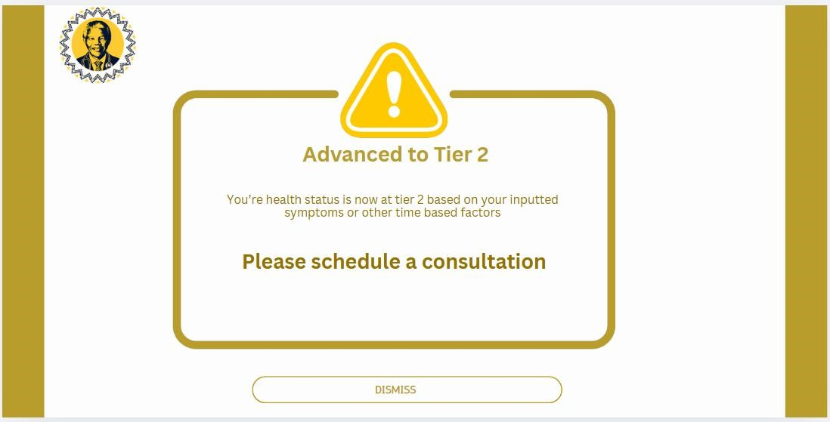
Final Implemented UI Design

Designed by Thakgatso Bridgette Magampa

Use Case ID | Use Case Name
B100 | Book in-person consultation
Actors
Student
Pre-Conditions | Student must have inserted their symptoms and the system must have automatically taken them to tier two
Triggers | The student clicks on the book in-person Consultation button on the booking page.
Post-Conditions | An in-person appointment is successfully booked and the student gets a confirmation notification on it.
Basic Flow of Events / Main Success Scenario
- The system shows two buttons that the user can choose from(book in person consultation and book online consultation)
- The student clicks on the book in-person consultation
- The student chooses the date and the time they prefer for the in-person consultation
- The system reveals nurses available on that particular day
- The student chooses their desired nurse
- The student choose the campus they are close to
- The student click on the confirm in person appointment button
- The in-person consultation gets successfully booked
- The student gets a notification on it via their preferred email address
Initial UI Design
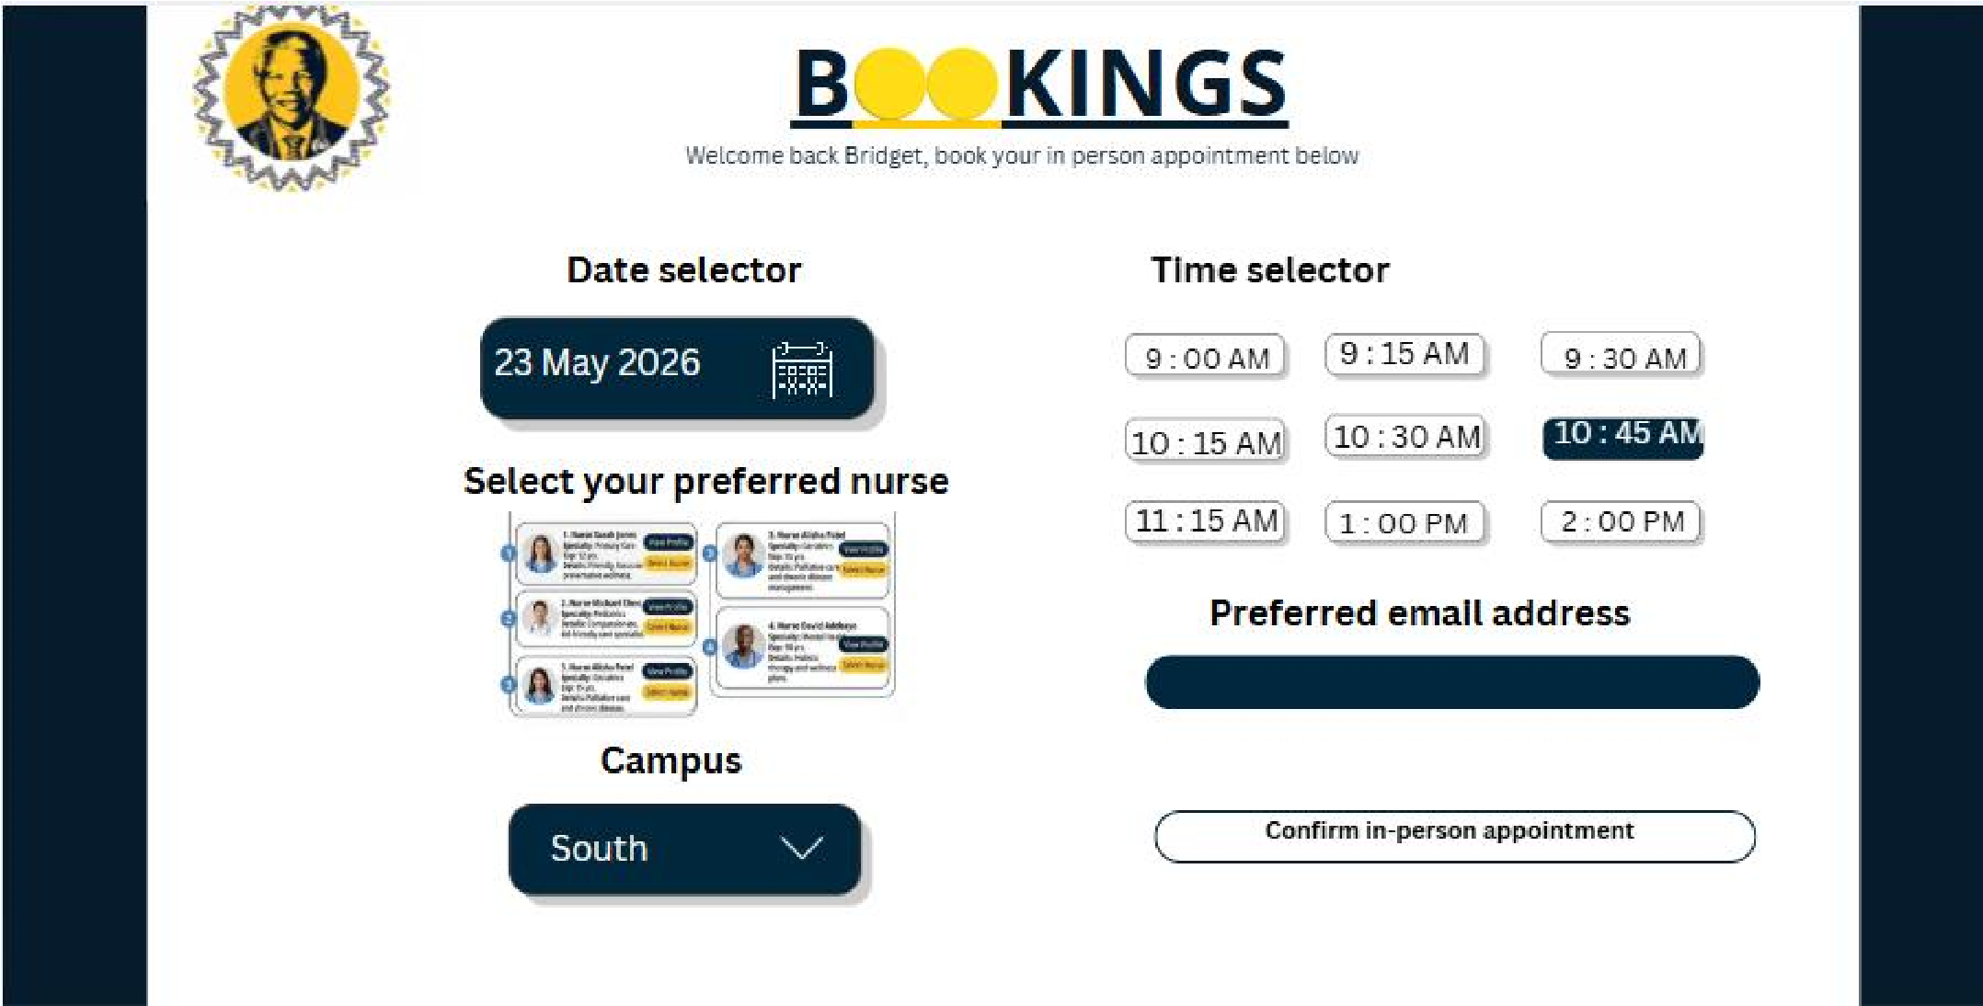
Final Implemented UI Design

Use Case ID | Use Case Name
B200 | Book online consultation
Actors
Student
Pre-Conditions | Student must have inserted their symptoms and the system must have automatically taken them to tier two
Triggers | The student clicks on the book online Consultation button on the booking page.
Post-Conditions | An Online appointment is successfully booked and the student gets a confirmation notification via email
Basic Flow of Events / Main Success Scenario
- The system shows two buttons that the user can choose from(book in person consultation and book online consultation)
- The student clicks on the book online consultation
- The student chooses the date and time they prefer for the meeting
- The system shows available nurses for that day
- The student chooses their preferred nurse
- The student choose the preferred language to be used on the teams meeting
- The student enters their preferred email address
- The student clicks on confirm online appointment
- The online appointment is successfully booked
- The student gets a confirmation notification via email
Initial UI Design
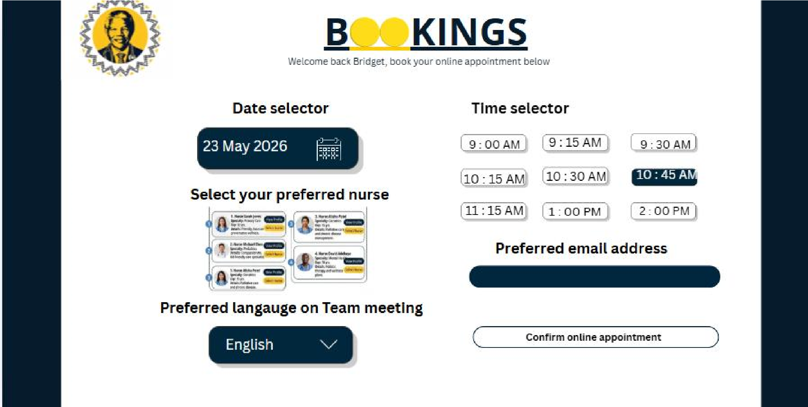
Final Implemented UI Design

Use Case ID | Use Case Name
B300 | View reviews
Actors
Student
Pre-Conditions | The system must have nurse reviews available from previous consultations
Triggers | The student selects review nurse on the navigation
Post-Conditions | The reviews that previous students left are displayed
Basic Flow of Events / Main Success Scenario
- The system queries the database to retrieve all the reviews previous students left on the website
- The reviews are then displayed
Initial UI Design
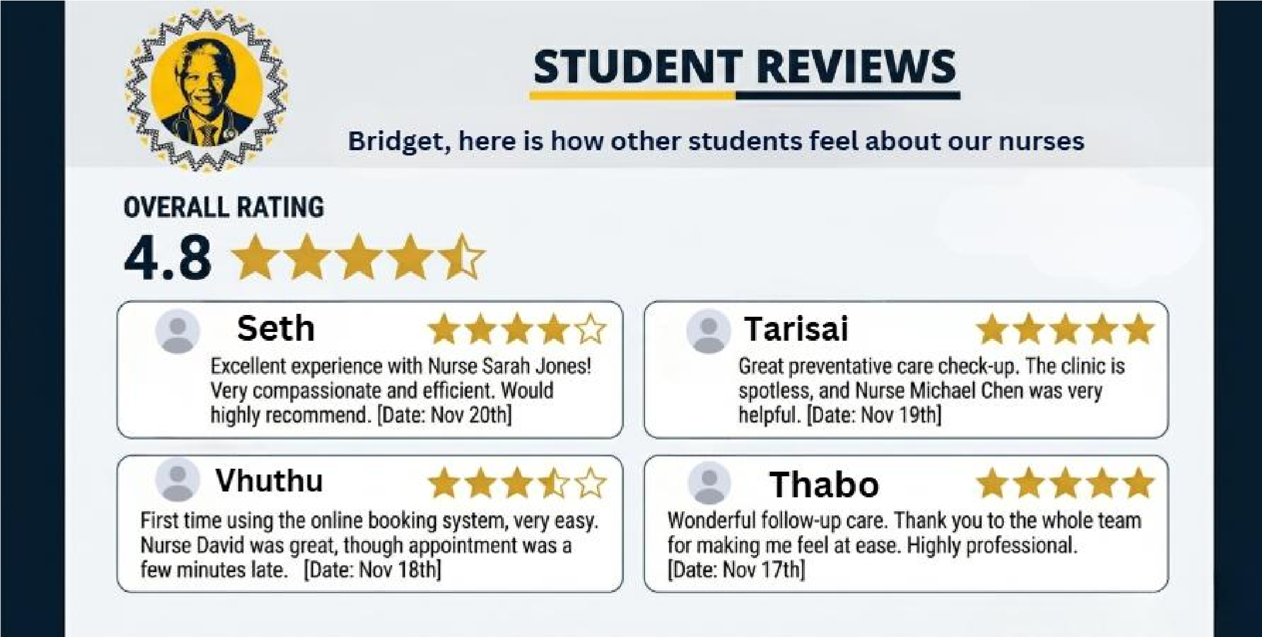
Final Implemented UI Design

Use Case ID | Use Case Name
B400 | Review Nurse
Actors
Student
Pre-Conditions | Student must have went through a consultation with a nurse(whether in person or online)
Triggers | The consultation is marked complete
Post-Conditions | The nurse is reviewed and the information is added to the database of the the nurse reviews
Basic Flow of Events / Main Success Scenario
- The system asks the student if they want to review the nurse
- The student clicks agrees or disagrees
- If the student agrees the system continues to give the student 5 stars that they should select and a message box to write their feelings on the experience with the nurse
- The system saves the information on the database
Initial UI Design
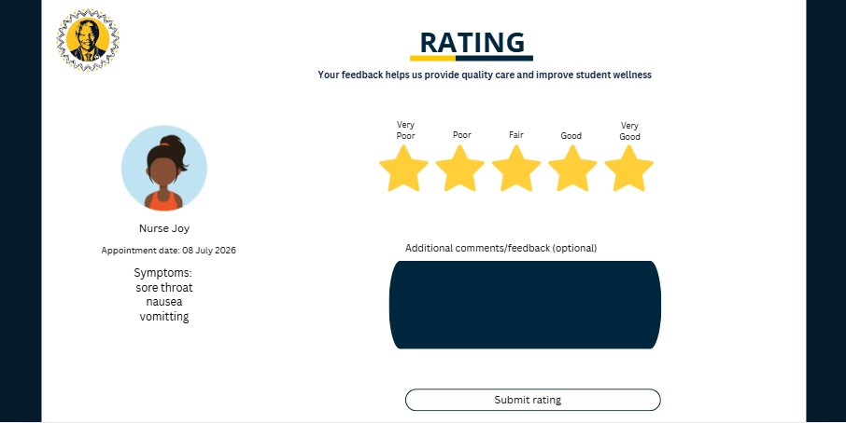
Final Implemented UI Design

Designed by Tarisai Rusike

Use Case ID | Use Case Name
C100 | Register
Actors
Student
Pre-Conditions | Student should have a valid student number
Triggers | Register button is clicked
Post-Conditions | Student is registered on CampusCare system
Basic Flow of Events / Main Success Scenario
- The student inputs their personal information
- The student clicks the register button
- The system captures student information into the database

Initial UI Design
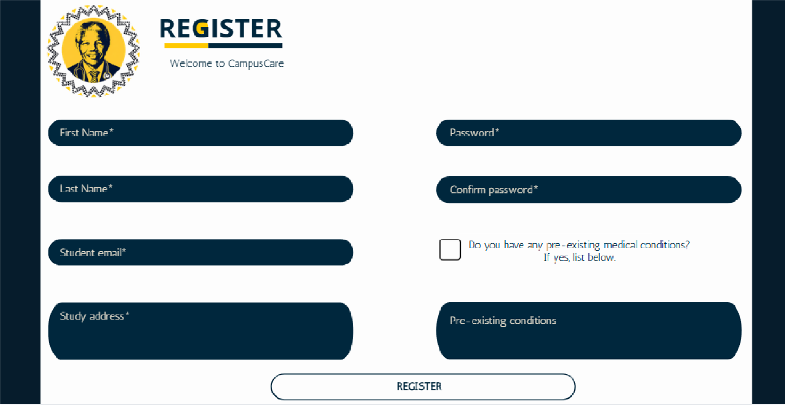
Final Implemented UI Design

Use Case ID | Use Case Name
Use Case ID |  | Use Case Name
C200 |  | View hospital info
Actors
Student
Pre-Conditions |  | Student should be logged in
Triggers |  | Student inputs symptoms warranting a tier three reaction
Post-Conditions |  | The system displays hospital information
Basic Flow of Events / Main Success Scenario
- The student selects their symptoms
- The system ranks them as tier three and displays hospital information

Initial UI Design
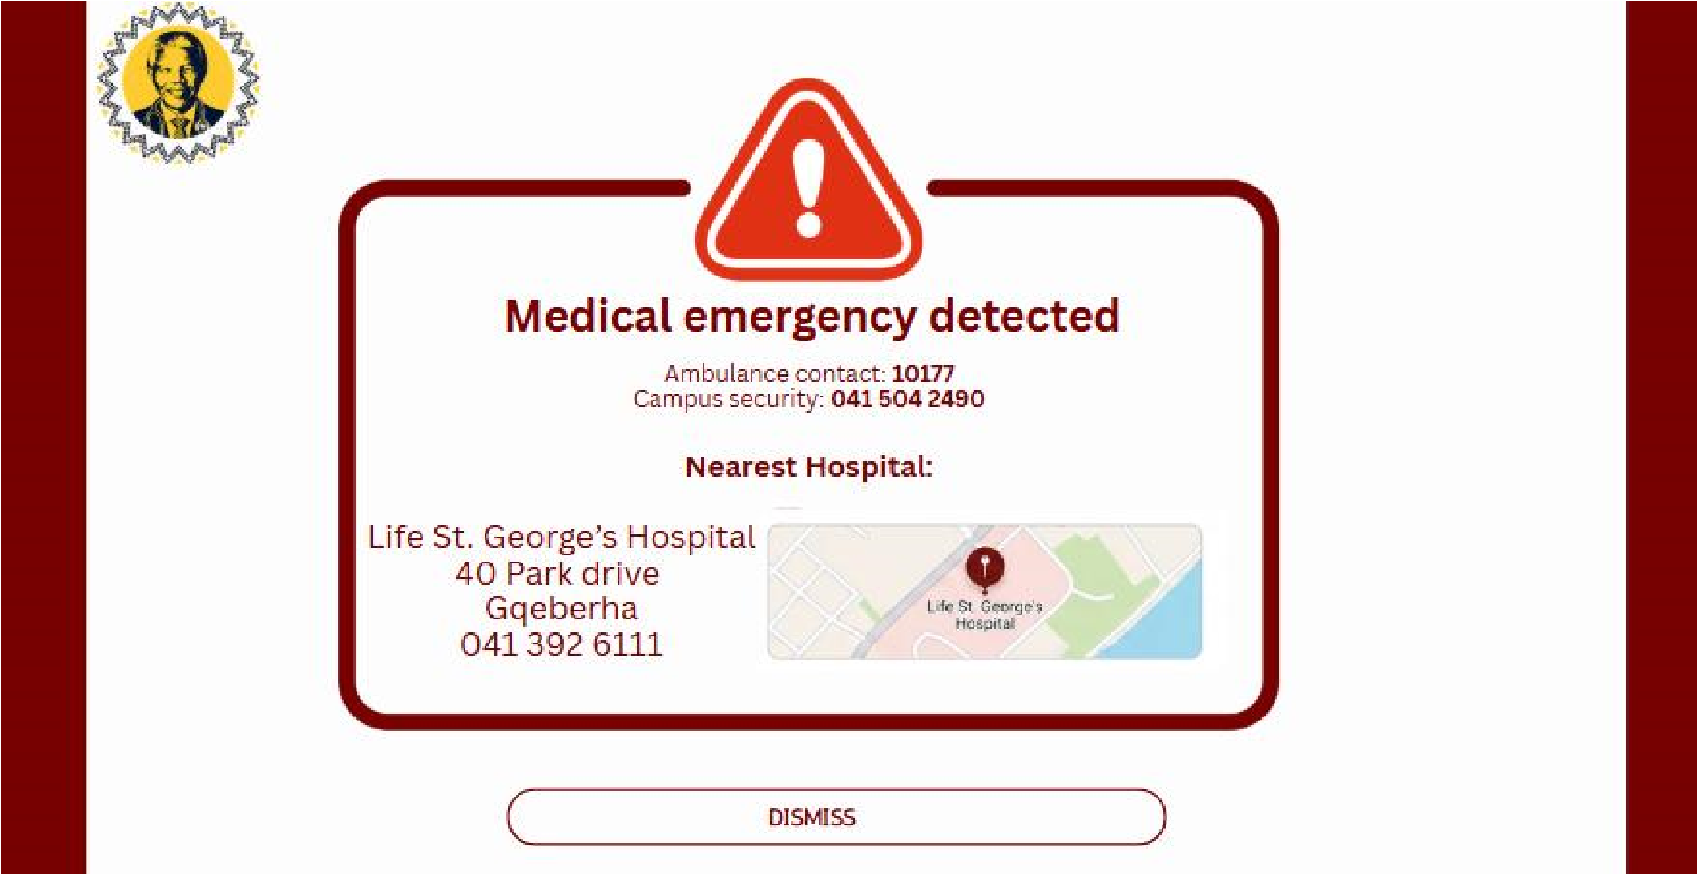
Final Implemented UI Design

Use Case ID | Use Case Name
C300 | Approve online meeting
Actors
Nurse
Pre-Conditions | An online meeting request would be submitted by the student
Triggers | Receipt of meeting request
Post-Conditions | Accepted/Rejected meeting
Basic Flow of Events / Main Success Scenario
- If request is accepted, the nurse creates a teams link
- The meeting is added to the calendar of both the student and the nurse
- The student is notified of the accepted meeting
- The nurse sends the teams link to the student

Initial UI Design
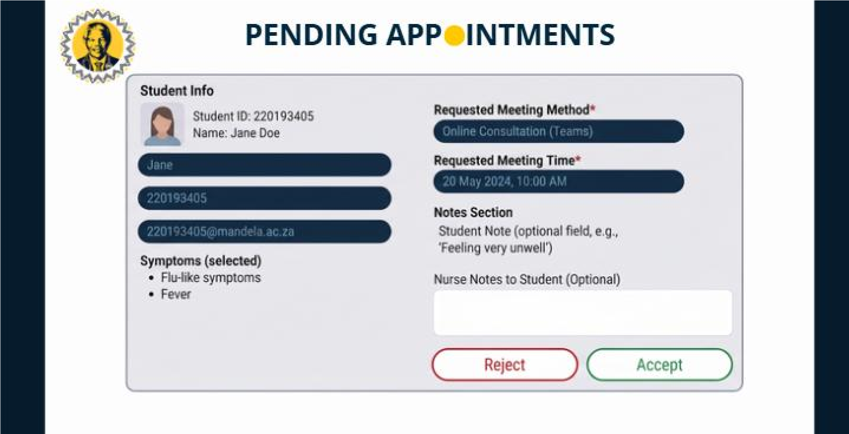
Final Implemented UI Design

C400 | Document progress
Actors
Nurse
Pre-Conditions | An online meeting request would be submitted by the student
Triggers | Receipt of meeting request
Post-Conditions | Consultation complete
Basic Flow of Events / Main Success Scenario
- The nurse navigates to the pending appointments dashboard
- The nurse reviews the appointment, adding additional notes if needed
- The nurse accepts or rejects the appointment, changing the status
- The nurse marks when the meeting starts, changing the status to in progress
- The nurse marks when the meeting concludes, changing the status
- The time taken for the meeting is recorded

Initial UI Design
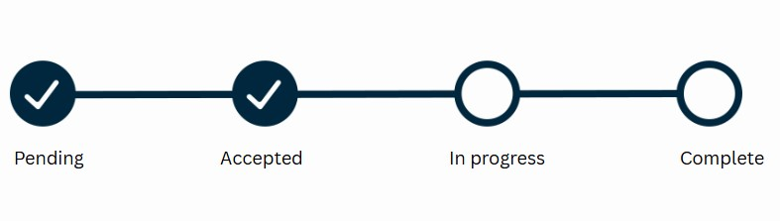
Final Implemented UI Design

DATA REQUIREMENTS

List of data and attributes

Entity | Entity Attributes
Student | name, studentNumber[pk], address, medicalHistory, email
Nurse | name, staffNumber[pk], address, phoneNumber, email
Appointment | appointmentID[pk], Appointmenttype, time, teamsID, staffNumber[fk], studentNumber[fk]
Admin | name, staffNumber[pk]
Medical Facility | facilityID[pk], type, address, phoneNumber
Symptoms | name, description, type, tier, cause
Clinic | regnum[pk], name, address, telephoneNumber, email
Medication | name, description, symptoms, expirationDate, facilityID[fk]
Rating | ratingID[pk], appointmentID[fk], score, reviewDescription

Domain Class Diagram
Student
Nurse
Appointment
Admin
MedicalFacility
Symptoms
Clinic
Medication
Rating
1..1
0..*
0..*
1..1
1..1
1..1
1..*
1..1
1..1
1..*
1..1
1..*
SymptomMedication
0..*
1..1
StudentNumber
Address
Name
StaffNumber
AppointmentID
AppointmentType
Name
StaffNumber
MedicalHistory
Email
Address
PhoneNumber
Time
TeamsID
StaffNumber
StudentNumber
FacilityID
Type
Address
PhoneNumber
Name
Descriptions
Type
Tier
Cause
RegNum
Name
Address
TelephoneNumber
Email
Name
Description
Symptoms
ExpiryDate
FacilityID
RatingID
AppointmentID
Score
ReviewDescription
MedicationCode
Name
MedicationCode

Draft Implementation Ready Class Diagram

Implemented database structure
We have used <DBMS> to create our database in.
The name of the database for our project is <DBNAME>

[Replace this text with screenshot of the relationship view of the implemented database]

TECHNICAL REQUIREMENTS

System Environment

Start-up Instructions

Logins & Passwords

