Deployment Test, Exploratory Session.

Charter:
Determine if the application can be deployed using a fresh LAMP stack. The deployment can be verified by performing a successful write action to the database using any interface of the application. Upon verification it is successful, this deployment can then be used for more functional testing as well.

Start Date: 9/15/209
End Date: 9/16/209

Test Notes:

Access new LAMP stack droplet which will run the application.

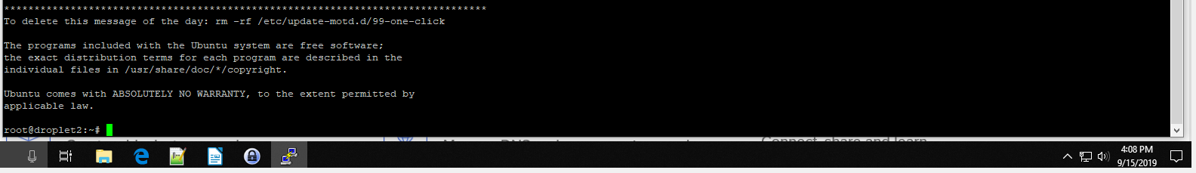
Download latest build.

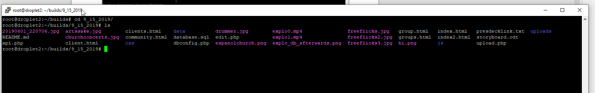
Copy latest build into /var/www/html/
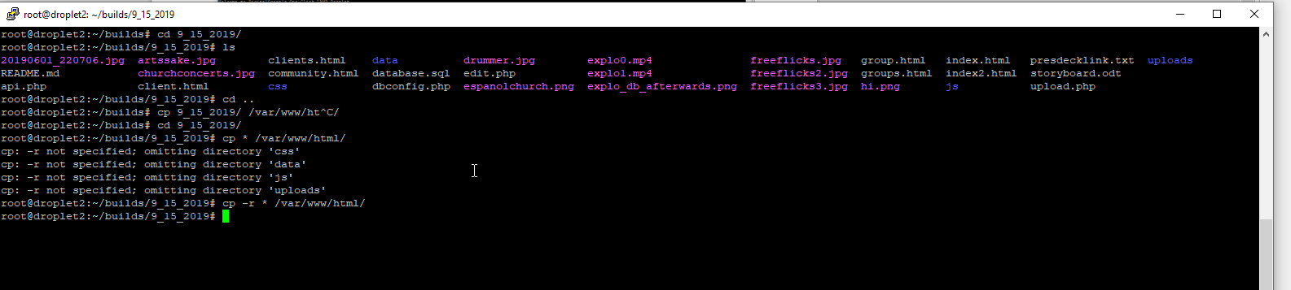
Change the authentication strategy and set a root password. (see links:
https://www.percona.com/blog/2016/03/16/change-user-password-in-mysql-5-7-with-plugin-auth_socket/
https://serverfault.com/questions/563714/allow-linux-root-user-mysql-root-access-without-password
)

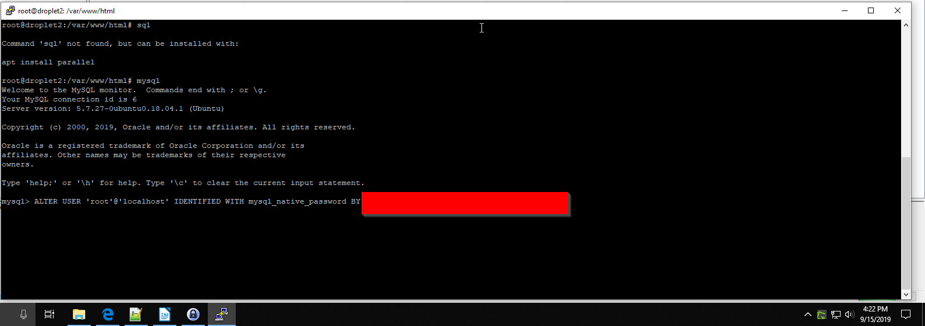
Run database.sql

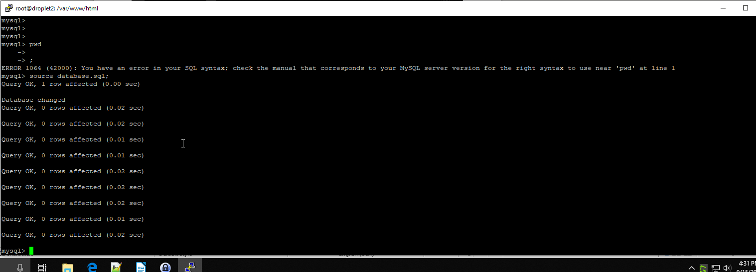
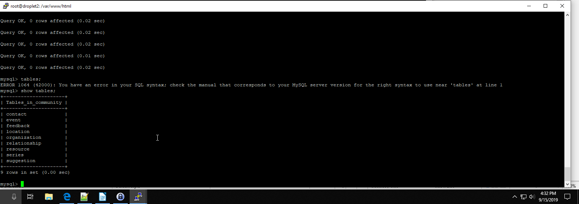
Update dbconfig.php files to use the db password.

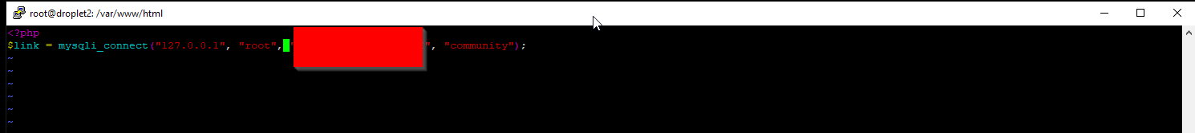
Verify the deployment with an entry from edit.php.

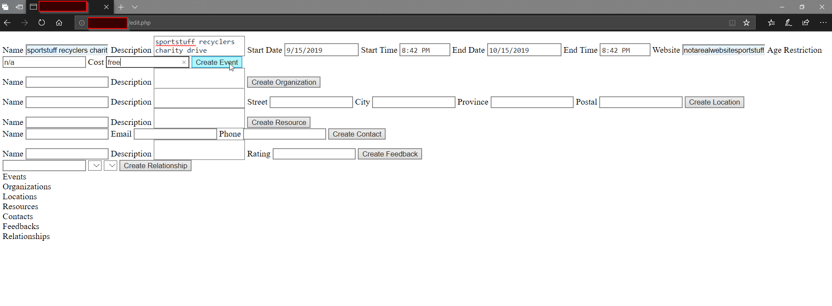
Seems to have no effect. The page does not list the event after clicking ‘Create Event.’

This was rectified by editing edit.php to not explicitly put apostrophe’s at the start and end of date-time fields, but around the mysqli_real_escape_string call (see Issue 1 in the Issues section, below):

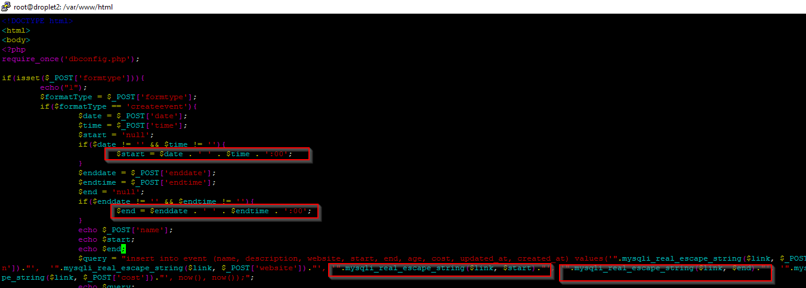
Another event was added.

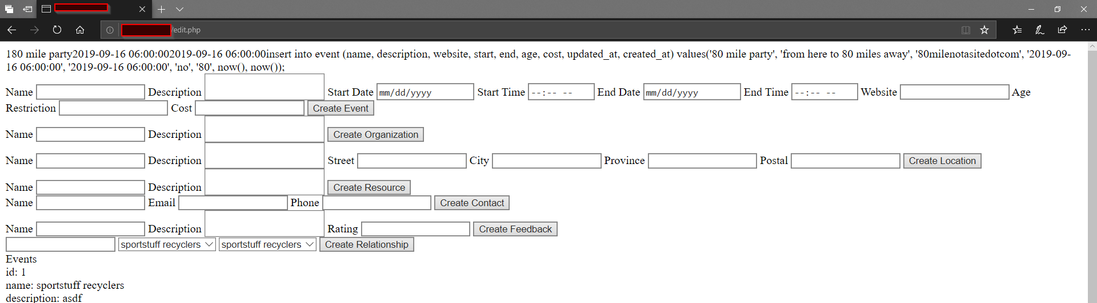
Scrolling down shows this event.

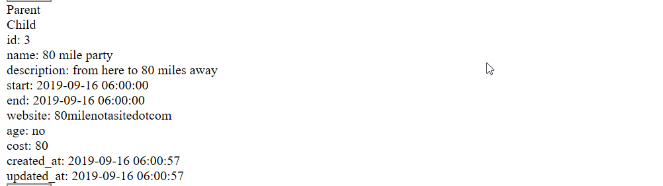
Querying the events table shows it as well:

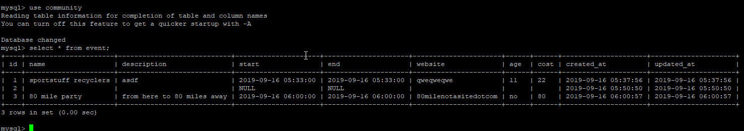

Issues:
1 - edit.php needs a small correction to work out of the box, but this is not expected to be customer facing. The impact could be felt on support and testing however, who may try to use this page to insert an ad-hoc event.

Conclusion:
These results confirm the application can be deployed on a fresh LAMP stack.

