Advanced Director Cockpit — Database Plan
  - Plan only — not approved

October 10, 2026
Prepared for Christian Caspers (Director)
Prepared by DevOps
Version 1.1

Date: Saturday, October 10, 2026. Prepared by DevOps for Director.
Status: PLAN ONLY. Nothing has been created, forked, or built. No DigitalOcean database exists. Execution waits for Director approval.

Contents
1. Summary 3
2. Architecture 4
3. Data model (row-per-card, chosen) 6
4. Endpoints 7
5. Offline queue, replay and conflict rules 8
6. Parallel build: "ADC DB" 9
Sequencing of current builds 9
7. Cutover and rollback 10
Cutover 10
Rollback 10
8. Estimate (agent wall-clock) 11
9. Gates 12
10. Risks 13
11. DigitalOcean database lineup (verified Oct 10, 2026) 14
October 15 cutoff 14
12. Open decisions 15

1. Summary
- One local API service on OmegaAlien is the single owner of all reads and writes for the Cockpit, CFD, and future local tools.
- DigitalOcean managed Postgres is the source of truth. A local JSON cache sits beside the API and is written only by the API.
- Apps stay dumb: they send updates to the local API and read from it (or its cache). No per-app queues or retry logic.
- Offline: the API keeps serving from cache and accepts writes into a durable local queue, then replays to Postgres when the connection returns.
- Storage: row-per-card (chosen), with Balls-compatible column names for a later promotion into Balls tables.
- Build: a parallel app, "ADC DB", in a new folder. The current WV2 cockpit stays untouched until cutover. Rollback = relaunch the old app.
- Cost: one Standard Postgres, 1 GiB / 1 vCPU / 10 GiB, NYC, $15.15/mo.
- Estimate: about 7–8 agent hours including the parallel build and row-per-card; calendar time is set by Director gates, realistically about one working day once approved.

2. Architecture
- Local API: the existing CFD settings server grown into the shared service. During development it runs on 127.0.0.1:8793 so the live CFD on 8792 is untouched; at cutover it takes over 127.0.0.1:8792.
- Loopback only. Browser pages are checked against a strict origin allowlist; the Cockpit host and scripts use a local key header.
- Postgres (DigitalOcean, NYC) is the source of truth. TLS with sslmode=verify-full and the DO CA certificate. The app never uses doadmin.
- Connection secret: a DPAPI-protected file read only by the API. Never in served JS, page code, command lines, logs, or Linear (avoids a repeat of the secrets.local.js exposure).
- JSON cache beside the API, rewritten only by the API: at startup (full pull before reporting healthy), after every committed write, and by a 30–60 s rev poll. A _revs.json file lists current revs for the pages.
- Cockpit host: the existing /adc-data save becomes a forwarder to the API; the host keeps serving the cache files so the page’s 3-second poll is unchanged.
- CFD: existing /settings (GET/PATCH/PUT) and /daily-export/claim routes stay as thin aliases, so CFD’s data code barely changes. Its client-side offline queue becomes a pass-through.
- Service watchdog: a per-user scheduled task on the same pattern as the Grok Bot link watchdog restarts the API if it stops responding.
- Vault: stays out of the database. It remains in the frame proxy on 127.0.0.1:8791, shared by both cockpits during the parallel build.
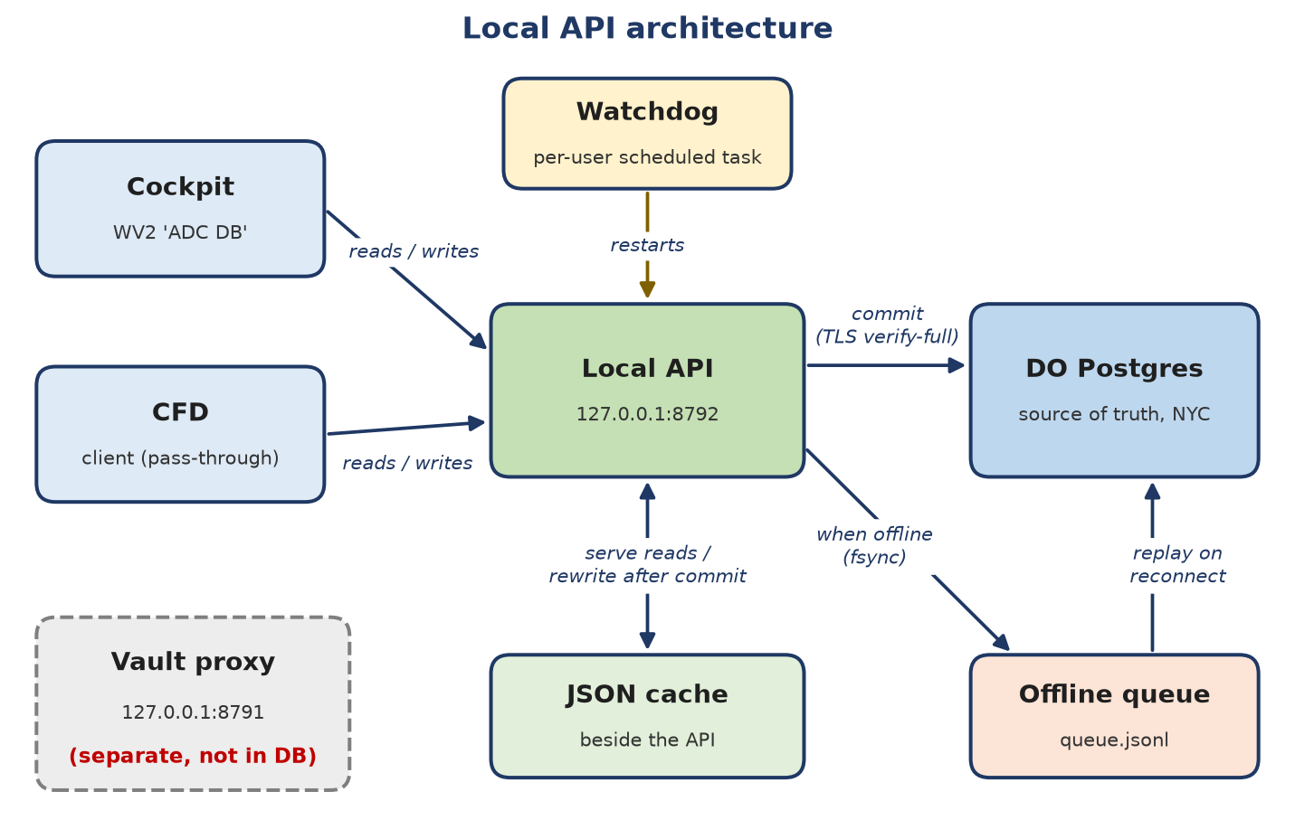
Figure 1. Local API architecture

3. Data model (row-per-card, chosen)
- Table app.docs: tenant_id, app, kind, id, parent_id, body jsonb, rev, updated_at, updated_by, deleted. Primary key (tenant_id, app, kind, id).
- Cockpit: one row per card, group, tab, and stage. One collection rev per kind for the page’s whole-array save, plus a per-row rev so conflicts resolve card by card.
- CFD: one settings document (carried over at rev 4) and one state document for the daily-export claim.
- Table app.docs_history: append-only, written by a trigger on every change; conflict losers are flagged.
- Table app.meta: schema version, forward-only NNNN_*.sql migrations.
- Balls-compatible names (tenant_id, kind, parent_id, body) keep a later move into meta.ball_instances to a simple INSERT…SELECT.

4. Endpoints
Endpoint | Purpose
GET /v1/{app}/{kind} | List: {rev, items:[{id, rev, updatedAt, body}]}
GET /v1/{app}/{kind}/{id} | One doc; rev in the ETag
PUT /v1/{app}/{kind}/{id} | If-Match: rev (or If-None-Match: * to create). 200 {rev} or 409 {current}
PATCH /v1/{app}/{kind}/{id} | JSON merge-patch with If-Match; same 409 rule
POST /v1/{app}/_batch | Several ops in one transaction, all or nothing (the Cockpit’s cards/groups/tabs/stages save)
DELETE /v1/{app}/{kind}/{id} | Soft delete (marks deleted, never removes)
GET /health | {ok, online, queued, conflicts, lastSyncAt}
GET /v1/_conflicts, POST /v1/_conflicts/ack | List conflicts; clear the badge
CFD aliases | /settings GET/PATCH/PUT and /daily-export/claim map onto cfd/settings/main and cfd/state/main

5. Offline queue, replay and conflict rules
- Every write is checked against the cached rev (409 on mismatch), applied to the cache, and appended to queue.jsonl with fsync before the API answers. Online, it then commits to Postgres and answers "saved"; offline, it answers "saved locally".
- Apps keep no queue and no retry logic. If the API itself is unreachable, the app shows an error and the user retries; the watchdog restarts the service.
- Postgres reachability is checked every 30 seconds and on any failed write.
- On reconnect the queue replays in order. Each operation carries an opId, so a crash during replay can’t apply anything twice.
- On a rev mismatch during replay, last writer wins by timestamp. The losing version goes to history flagged as a conflict and the conflict count rises. With row-per-card, this is decided per card, not per whole list.
- After replay the API pulls fresh data, rewrites the cache and _revs.json, and clears the queue.
- Both apps show a small badge: "offline, N queued" or "N conflicts", cleared by acknowledging it.

6. Parallel build: "ADC DB"
- New folder Source\NonBalls\Advanced Director Cockpit DB, its own Pub/install folder, and a local git repo for easy porting.
- Own identity: window title "ADC DB", new AppUserModelID and AssemblyName, its own start-menu shortcut, and its own virtual host (adc-db.local).
- Own data cache: a seeded copy, never the live data\ folder.
- Own WebView2 user-data folder (required; two running hosts can’t share one). Pane sign-ins start fresh unless the old profile is copied in once while the old cockpit is closed.
- Development needs no swap waiters and no cockpit closes. The current WV2 cockpit stays untouched.

Sequencing of current builds
- r7 (Copy card) lands in the current cockpit first, then the fork is taken from that Source.
- The vault allowlist change is proxy-side, so it serves both apps.
- r8 (Windows Hello vault unlock) is built only in the new app. The old app keeps PIN unlock until cutover. Hello adds fields to vault.dat that the old app ignores.
- Vault with two hosts: each unlocks separately with its own session; writes are serialized in the proxy. A proxy restart locks both, so the PIN is entered again in each.

7. Cutover and rollback

Cutover
- Close the old cockpit and freeze CFD edits.
- Final import of the old live data\ and cfd-settings.json into Postgres; verify counts and SHA-256 hashes.
- Stop the old 8792 settings server; the new API takes 8792 (CFD aliases make this transparent).
- Publish the CFD pass-through.
- Swap the start-menu and Startup shortcuts to ADC DB. Archive the old Source and Pub folders as zips (kept, never deleted).
- Director launches ADC DB and presses Ctrl+F5 once in the CFD pane.

Rollback
Stop the new API, restart the old 8792 server, and relaunch the old cockpit. Edits made after cutover are kept by copying the new cache (same JSON format) back into the old data\ folder; scripted, about two minutes.

8. Estimate (agent wall-clock)
Item | Build (min) | Verify (min) | Gate
Provisioning (cluster, per-tier DBs/users, schema, history trigger) | 10 | 15 | Director approves spend/region
psycopg, DPAPI secret, verify-full TLS | 10 | 20–45 | —
Service core, generic endpoints, rev/409, batch, merge-patch, CFD aliases | 30 | 30 | —
Durable queue and replay (fsync, opId, last-writer-wins, conflict log) | 25 | 45 | —
Cache writer, _revs.json, rev poll | 10 | 15 | —
Service watchdog | 10 | 10 | —
IP trusted-source updater | 15 | 15 | Director creates DB-only DO token
CFD pass-through, badge, publish | 15 | 15 | Director Ctrl+F5 once
Cockpit host forwarder, page states, badge | 25 | 30 | —
Migration (backup, import, verify, switch) | 15 | 25 | Cutover window
Row-per-card (chosen) | 10 | 15 | —
Parallel build: fork, identity, data path, WebView2 profile, shortcut | 20 | 20 | —
Cutover and rollback scripts | 15 | 15 | One cockpit close at cutover

- Base plan: about 6–7 agent hours (about 3.5–4.5 hours wall clock with two agents in parallel).
- Parallel-build delta: +0.5–1 hour, offset partly by building Hello only once. Row-per-card: about +25 minutes.
- Total: about 7–8 agent hours. Allow +30 minutes if psycopg needs a fallback and +30–60 minutes for a replay or install surprise.
- Calendar time is set by gates, not compute: realistically live within about one working day after approvals.

9. Gates
- Director approves this plan.
- Director approves creating the Postgres cluster (cost and region).
- Director creates a database-only DigitalOcean token for the IP updater.
- r7 install (needs all three current cockpit windows closed so r6 installs first).
- Windows Hello (r8) scope approval.
- Optional: one cockpit close to seed the new app’s browser profile.
- One cockpit close and a short CFD freeze at cutover.

10. Risks
- If the local API is down, saves fail with an error until the watchdog restarts it (about a minute). Reads keep working from the cache.
- Edits that are queued but not yet synced live only on C:; a disk failure in that window would lose them.
- Last writer wins by timestamp; a skewed clock on OmegaAlien could pick the wrong winner. Row-per-card limits the blast radius to one card.
- psycopg may have no binary build for Python 3.14 (fallback: pg8000 or a Python 3.13 environment for the service).
- Home IP changes: DigitalOcean trusted sources are IPv4 only and cloud firewalls don’t apply to databases. The updater must merge, not replace, the list. Writes queue locally during the gap.
- Each write is a round trip to NYC (estimated 50–300 ms, not measured).
- Point-in-time restore is only 7 days, so add a nightly pg_dump to V:.

11. DigitalOcean database lineup (verified Oct 10, 2026)
Engine | Smallest plan | Storage | Connections | Backups | Failover
PostgreSQL Standard | $15.15/mo (1 GiB) | 10 GiB, +$0.215/GiB | 22; 21 PgBouncer pools | Daily + 7-day PITR | Standby from 2 GiB; Advanced from $130
MySQL Standard | $15.15/mo | 10 GiB | 75; no pooling | Daily + 7 days | Same as Postgres
Valkey (Redis-compatible) | $15/mo | Fixed | Up to 10,000 | None | Standby from 2 GiB
MongoDB | $15.23/mo | 15 GiB | Unknown | Daily + 7 days | 3-node replica set
Kafka | $148.80/mo (3 brokers) | 120 GiB | Unknown | None | Brokers only
OpenSearch | $19.60/mo (2 GiB) | 40 GiB | Unknown | Daily PITR (retention unknown) | No standby

Recommended: one PostgreSQL Standard cluster, 1 GiB / 1 vCPU / 10 GiB, version 17 or 18, in nyc1 or nyc3, $15.15/mo. Sources: digitalocean.com/pricing/managed-databases and docs.digitalocean.com/products/databases/postgresql/details/limits.

October 15 cutoff
DigitalOcean’s plan change applies the new Standard limits on October 15, 2026 to teams that have never created a Postgres or MySQL cluster, which includes Ballbusters. After that, new Standard clusters max out at 4 GiB with no standby or read-only nodes. Creating a cluster before October 15 moves the cutoff to November 30 and keeps those options for existing clusters. The $15.15 plan is available either way; waiting only gives up future Standard failover (afterwards that needs Advanced, from about $130/mo). Source: docs.digitalocean.com/release-notes/upcoming/dbaas-plan-changes.

12. Open decisions
- Approve this plan.
- Create the Postgres cluster before October 15 (keeps the Standard failover option), and pick nyc1 or nyc3.
- Seed the new app’s browser profile from the old one (one cockpit close) or start fresh and sign in again in the panes.
- Create a database-only DigitalOcean token for the IP updater.
- Settle GROK-85’s "database on V:" against this DigitalOcean plan.

